Redemption

Brief Review

In the last two lessons, we said,

- An understanding of the identification truths is essential to grasping the meaning of our unfathomable riches in Christ (Ephesians 1:3; 3:8).

- In Christ, we are redeemed and forgiven, so as to be justified (Romans 3:24; Ephesians 1:7; Colossians 1:14)

- The related words redeem, redeemed and redemption were part of a family of words related to slavery, as it was practiced in biblical times. The inset below introduces some of those biblical words that were used in relationship to slavery.

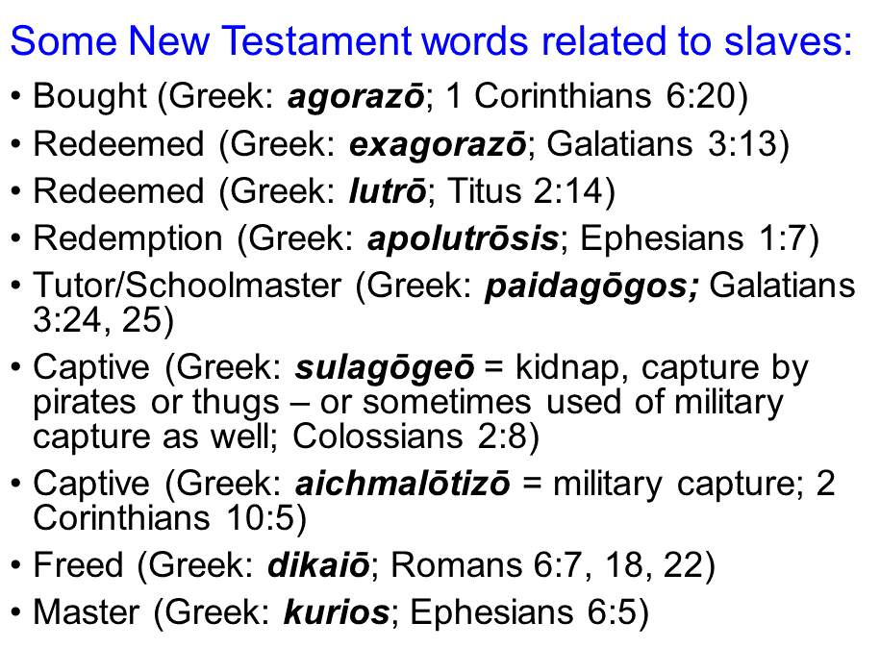
To achieve biblical clarity, we will explore more deeply the biblical use of the word ‘redeem’ (and ‘redeemed’ and ‘redemption’).

Redeemed (Greek: exagorazō) means ‘to buy out of the market’, and typically conveys rescuing from a bad position or situation. This Greek word for ‘redeem’ is used in:

Galatians 3:13 (NASU)
Christ redeemed (exagorazō) us from the curse of the Law, having become a curse for us…

Galatians 4:3-5
But when the fullness of the time came, God sent forth His Son, born of a woman, born under the Law, 5 so that He might redeem (exagorazō) those who were under the Law, that we might receive the adoption as sons.

A word of similar meaning, lutrō, has the idea of ‘ransom’ – to buy out of captivity or slavery.

Titus 2:11-14
For the grace of God has appeared, bringing salvation to all men, 12 instructing us to deny ungodliness and worldly desires and to live sensibly, righteously and godly in the present age, 13 looking for the blessed hope and the appearing of the glory of our great God and Savior, Christ Jesus, 14 who gave Himself for us to redeem (lutrō) us from every lawless deed, and to purify for Himself a people for His own possession, zealous for good deeds.
1 Peter 1:17-19
If you address as Father the One who impartially judges according to each one's work, conduct yourselves in fear during the time of your stay on earth; 18 knowing that you were not redeemed (lutrō) with perishable things like silver or gold from your futile way of life inherited from your forefathers, 19 but with precious blood, as of a lamb unblemished and spotless, the blood of Christ.

Finally, the verses that contain the Greek word apolutrosis convey being fully redeemed and ransomed, implying permanence.

Romans 3:21-26
But now apart from the Law the righteousness of God has been manifested, being witnessed by the Law and the Prophets, 22 even the righteousness of God through faith in Jesus Christ for all those who believe; for there is no distinction; 23 for all have sinned and fall short of the glory of God, 24 being justified as a gift by His grace through the redemption (apolutrosis) which is in Christ Jesus; 25 whom God displayed publicly as a propitiation in His blood through faith. This was to demonstrate His righteousness, because in the forbearance of God He passed over the sins previously committed; 26 for the demonstration, I say, of His righteousness at the present time, so that He would be just and the justifier of the one who has faith in Jesus.

Ephesians 1:7-8
In Him we have [the] redemption (apolutrosis) through His blood, the forgiveness of our trespasses [the trespasses of us], according to the riches of His grace 8 which He lavished on us. In all wisdom and insight…

Colossians 1:13-14
For He rescued us from the domain of darkness, and transferred us to the kingdom of His beloved Son, 14 in whom we have [the] redemption (apolutrosis), the forgiveness of sins.

The believer, on the basis of faith, is placed in Christ (position). Being in Christ (position), the believer is forgiven of the debt of sins by Christ’s payment for them. Being in Christ (position), the believer is redeemed, fully bought out from slavery to sin. On the basis of those things, which come from being in Christ (position), God can and does declare the believer righteous.

