Identification Truths: Joined to Christ & Separated From – I & II

The Big Picture: Where Are We going?

For the rest of the month of June, we will be exploring our unfathomable riches as follows:

Jun No Subject

17 22 Identification truths: joined to Christ & separated from - I
24 23 Identification truths: joined to Christ & separated from - II

The identification truths are ‘the front door’ to our unfathomable riches

This Sunday and the next we will be taking a look at one aspect and a set of outcomes of our having been joined to Christ. Our having been joined to Christ in His death brings about a separation from three things to which we were joined before we believe.

The most significant and direct passages conveying these truths are:

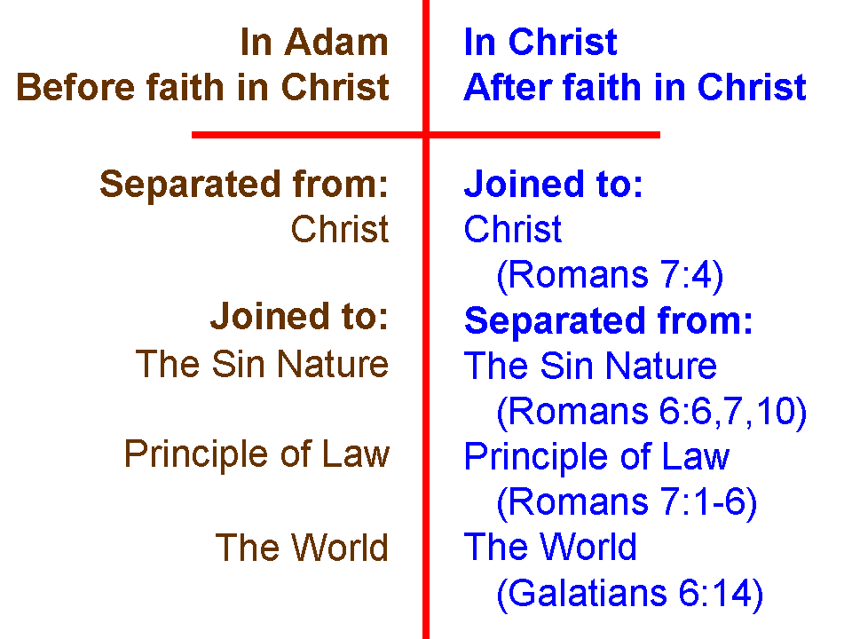
Romans 7:1-6 (NASU)
Or do you not know, brethren (for I am speaking to those who know the law), that the law has jurisdiction over a person as long as he lives? 2 For the married woman is bound by law to her husband while he is living; but if her husband dies, she is released from the law concerning the husband. 3 So then, if while her husband is living she is joined to another man, she shall be called an adulteress; but if her husband dies, she is free from the law, so that she is not an adulteress though she is joined to another man.

4 Therefore, my brethren, you also were made to die to the Law through the body of Christ, so that you might be joined to another, to Him who was raised from the dead, in order that we might bear fruit for God. 5 For while we were in the flesh, the sinful passions, which were aroused by the Law, were at work in the members of our body to bear fruit for death. 6 But now we have been released from the Law, having died to that by which we were bound, so that we serve in newness of the Spirit and not in oldness of the letter.
Romans 6:1-10
What shall we say then? Are we to continue in sin so that grace may increase? 2 May it never be! How shall we who died to sin still live in it? 3 Or do you not know that all of us who have been baptized into Christ Jesus have been baptized into His death? 4 Therefore we have been buried with Him through baptism into death, so that as Christ was raised from the dead through the glory of the Father, so we too might walk in newness of life. 5 For if we have become united with Him in the likeness of His death, certainly we shall also be in the likeness of His resurrection, 6 knowing this, that our old self [old man, or old person] was crucified with Him, in order that our body of sin might be done away with, so that we would no longer be slaves to sin [the sin nature]; 7 for he who has died is freed from sin [the sin nature].

8 Now if we have died with Christ, we believe that we shall also live with Him, 9 knowing that Christ, having been raised from the dead, is never to die again; death no longer is master over Him. 10 For the death that He died, He died to sin [the sin nature] once for all; but the life that He lives, He lives to God.

Galatians 6:11-15
See with what large letters I am writing to you with my own hand. 12 Those who desire to make a good showing in the flesh try to compel you to be circumcised, simply so that they will not be persecuted for the cross of Christ. 13 For those who are circumcised do not even keep the Law themselves, but they desire to have you circumcised so that they may boast in your flesh. 14 But may it never be that I would boast, except in the cross of our Lord Jesus Christ, through which the world has been crucified to me, and I to the world. 15 For neither is circumcision anything, nor uncircumcision, but a new creation.

Colossians 2:20-23
If you have died with Christ to the elementary principles of the world, why, as if you were living in the world, do you submit yourself to decrees, such as, 21 "Do not handle, do not taste, do not touch!" 22(which all refer to things destined to perish with use)--in accordance with the commandments and teachings of men? 23 These are matters which have, to be sure, the appearance of wisdom in self-made religion and self-abasement and severe treatment of the body, but are of no value against fleshly indulgence.

