Freed from the Law – Part I

The Big Picture: Where Are We going?

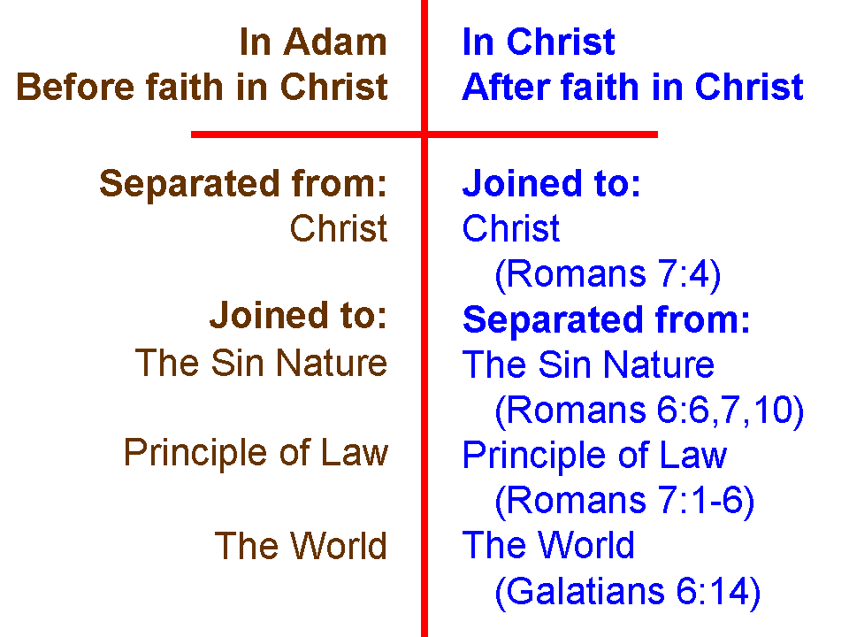
For the last two Sundays, we explored our unfathomable riches in Christ in terms of being joined to Christ and separated from the sin nature, the principle of law, and the world system. We pictured these truths by the diagram shown to the left.

For the next six Sundays we will be further exploring ways in which we have been freed from the law. Having been freed from the principle of Law means having been freed from the Law of Moses for the Jews among us, and having been freed from any law-based system for the Gentiles among us.

No longer under a tutor

Galatians 3:23-25 (NASU base, with added notes and minor edits)
But before the faith [Christian faith in Christ, growing doctrinally into the teachings of the apostles: ‘the faith’] came, we [Jews] were kept in custody under the law, being shut up to the faith which was later to be revealed [but now has been revealed]. 24 Therefore the Law [of Moses] became [perfect active indicative] our tutor [paidagōgos; KJV: schoolmaster] to lead us to Christ, so that we may be justified [declared righteous, having the redemption and the forgiveness in Christ] by faith. 25 But now that the faith has come, we are no longer under a tutor [paidagōgos; KJV: schoolmaster].

The people of Israel

When the people of Israel were given the Law of Moses out in the Sinai, God had His purpose in it. The Law of Moses, as given to Israel, was holy and righteous and good (Romans 7:12). The 613 individual statutes of the Law of Moses were given by the inspiration of God to Moses for the people of Israel, and the people of Israel were baptized into Moses (1 Corinthians 10:1, 2), as we in the body of Christ were baptized into Christ (Romans 6:3; Galatians 3:27).

