Freed from the Law – Part II

The Big Picture: Where Are We going?

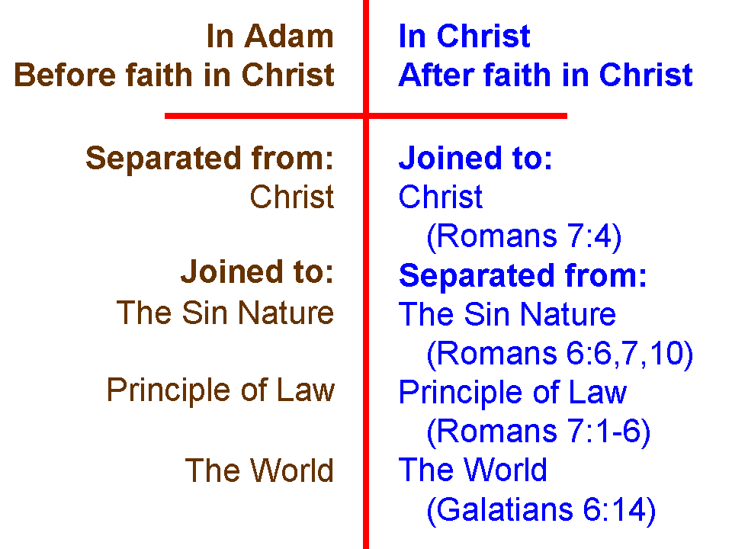
For the last two Sundays in June, we explored our unfathomable riches in Christ in terms of being joined to Christ and separated from the sin nature, the principle of law, and the world system. We pictured these truths by the diagram shown to the left.

Starting last Sunday, and for the next five Sundays, including today, we will be further exploring ways in which we have been freed from the law. Having been freed from the principle of Law means having been freed from the Law of Moses for the Jews among us, and having been freed from any law-based system for the Gentiles among us.

Died to the Law

Last Sunday we examined a passage written by Paul to the believers in Galatia (Galatians 3:23-25). Paul wrote that believing Jews are no longer under the law, which was a tutor (paidagōgos: a slave as tutor) to lead them to Christ. Today we will examine two passages that tell us that we have died to the principle of law, which means the 613 statutes of the Law of Moses for the Jews, and law in any form, including conscience, for the Gentiles.

Take note, in the two passages that follow, that we died to – that is, in relationship to – the principle of law (which includes the Law of Moses, for the Jews). That happened in our identification with Christ in His death on the cross. But also note that in both passages, that death in relationship to the principle of law was for a purpose: serving in newness of the Spirit and so that we might live to God.

Romans 7:4-6
Therefore, my brethren, you also were made to die to the Law through the body of Christ, so that you might be joined to another, to Him who was raised from the dead, in order that we might bear fruit for God. 5 For while we were in the flesh, the sinful passions, which were aroused by the Law, were at work in the members of our body to bear fruit for death. 6 But now we have been released from the Law, having died to that by which we were bound, so that we serve in newness of the Spirit and not in oldness of the letter.

Galatians 2:19-21
"For through the Law I died to the Law, so that I might live to God. 20 I have been crucified [perfect tense] with Christ; and it is no longer I who live, but Christ lives in me; and the life which I now live in the flesh I live by faith in the Son of God, who loved me and gave Himself up for me. 21 I do not nullify the grace of God, for if righteousness comes through the Law, then Christ died needlessly."

So we see from both of these passages that:

- We died, having been identified with Christ in His death, in relationship with the law.

- The death was for a present and ongoing purpose, that is, that we might serve in the newness of the Spirit, and that we might live to God.

- The living out of righteousness for the believer (serving and living) who has died in relationship to the principle of law is done by the Spirit and by the life of Christ.

- Having died in relationship to the law, righteousness is not achieved by the law in any way.

