Freed from the Law – Part III

The Big Picture: Where Are We going?

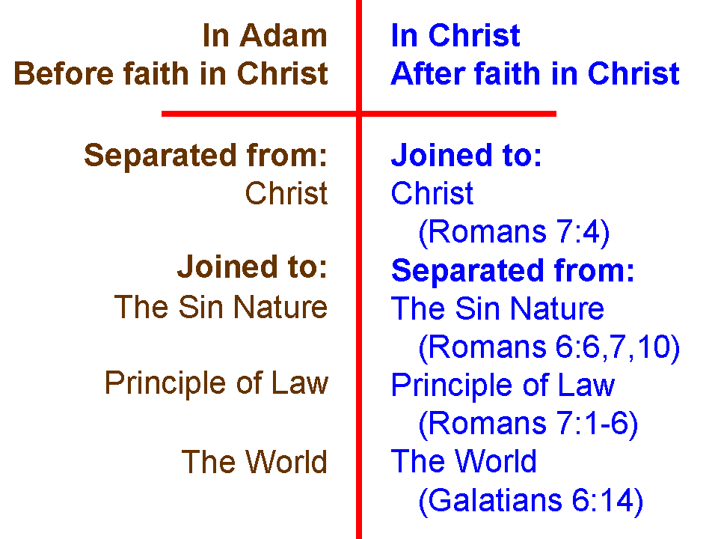
For the last two Sundays in June, we explored our unfathomable riches in Christ in terms of being joined to Christ and separated from the sin nature, the principle of law, and the world system. We pictured these truths by the diagram shown to the left.

For the third of five Sundays, we will be continuing to explore ways in which we have been freed from the law. Having been freed from the principle of Law means having been freed from the Law of Moses for the Jews among us, and having been freed from any law-based system for the Gentiles among us.

The New Covenant – what is it and how is it related to the church?

Jeremiah 31:31-34 (NASU; the classic starting passage, but see others on page 2)
"Behold, days are coming," declares the LORD, "when I will make a new covenant with the house of Israel and with the house of Judah, 32 not like the covenant which I made with their fathers in the day I took them by the hand to bring them out of the land of Egypt, My covenant which they broke, although I was a husband to them," declares the LORD. 33 "But this is the covenant which I will make with the house of Israel after those days," declares the LORD, " I will put My law within them and on their heart I will write it; and I will be their God, and they shall be My people. 34 "They will not teach again, each man his neighbor and each man his brother, saying, 'Know the LORD,' for they will all know Me, from the least of them to the greatest of them," declares the LORD, "for I will forgive their iniquity, and their sin I will remember no more."

There have been several proposals about the meaning of the term ‘New Covenant’ regarding the Church, including:

- The Church takes Israel’s place and the New Covenant that was for Israel, so that for believers in the church, ‘the law is written on your heart’
- The church is a partial participant, or beneficiary of the New Covenant with Israel
- The Church gets a New Covenant and Israel gets its New Covenant in the Millennial kingdom.
- The New Covenant for Israel replaces the old Mosaic Covenant, and the Eternal Covenant is the church’s New Covenant.
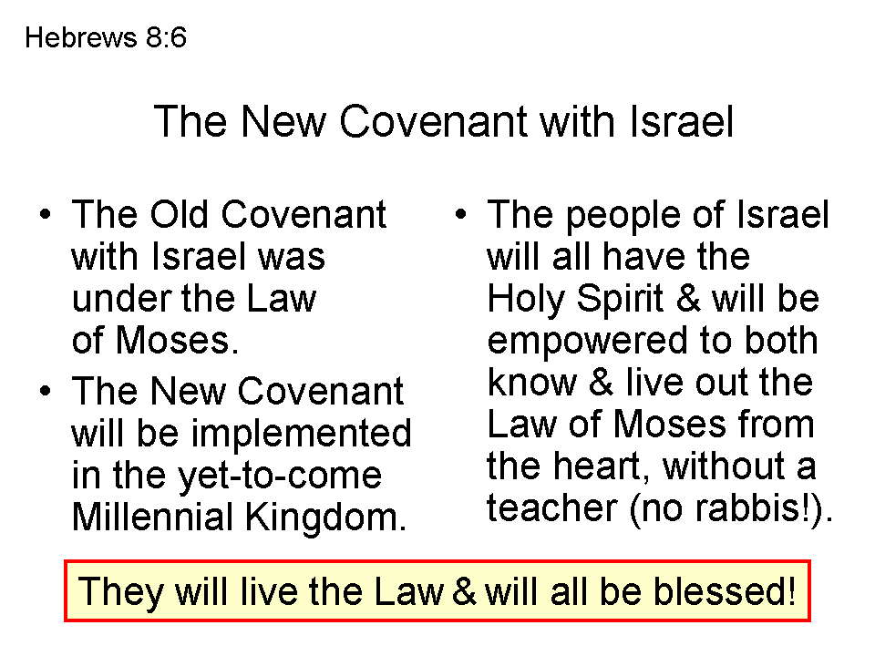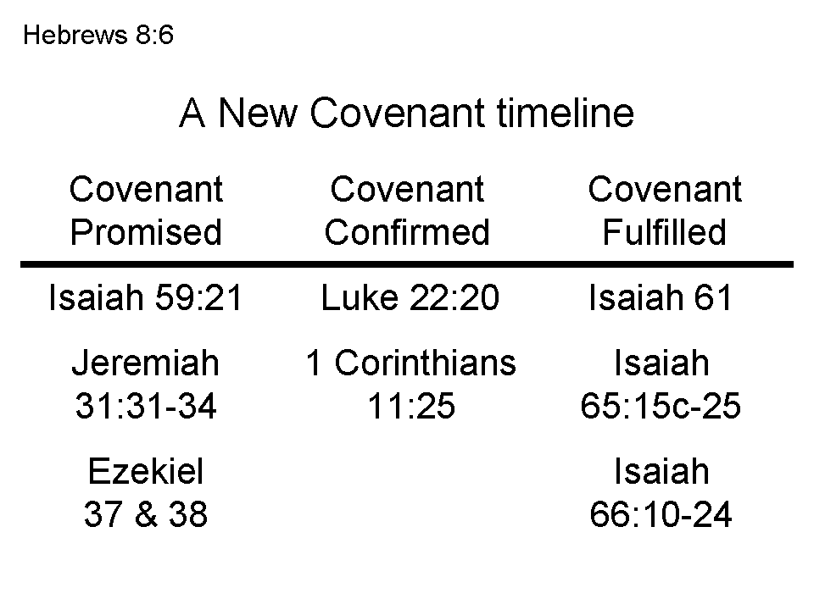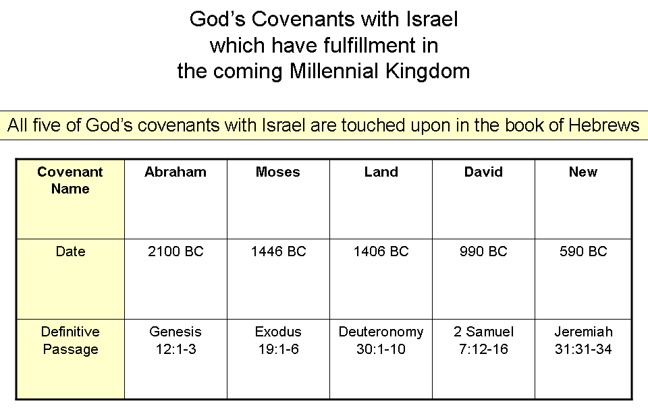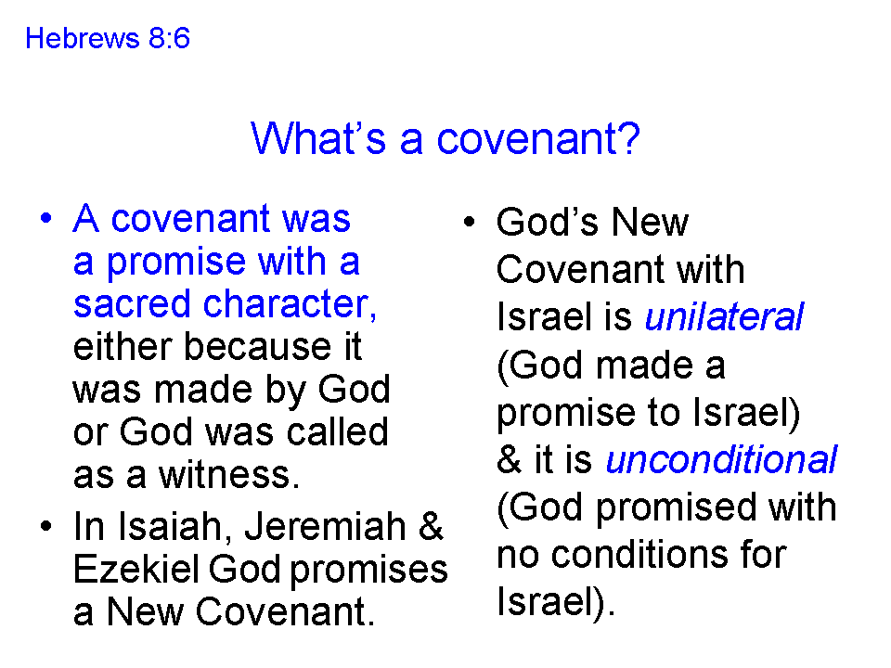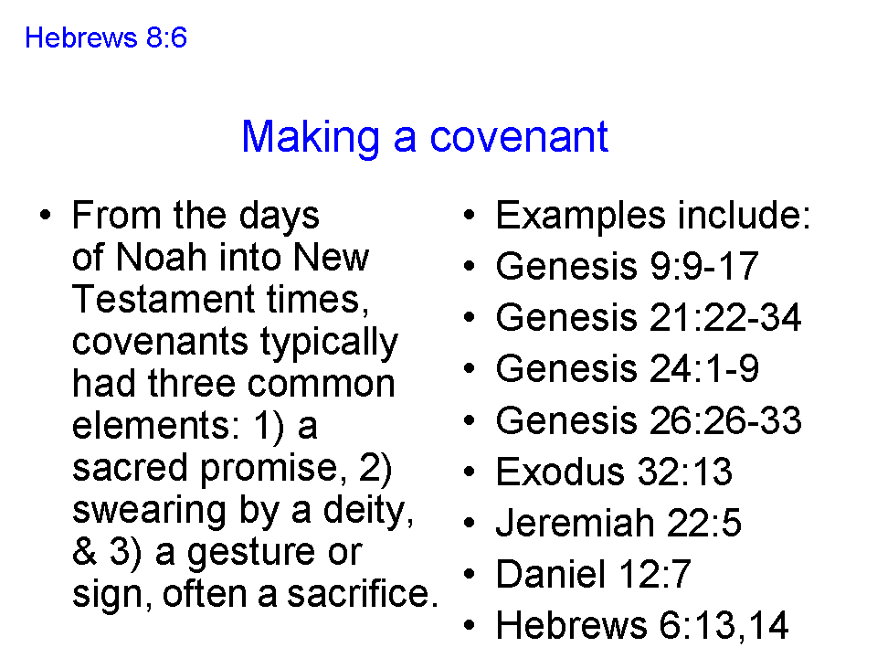
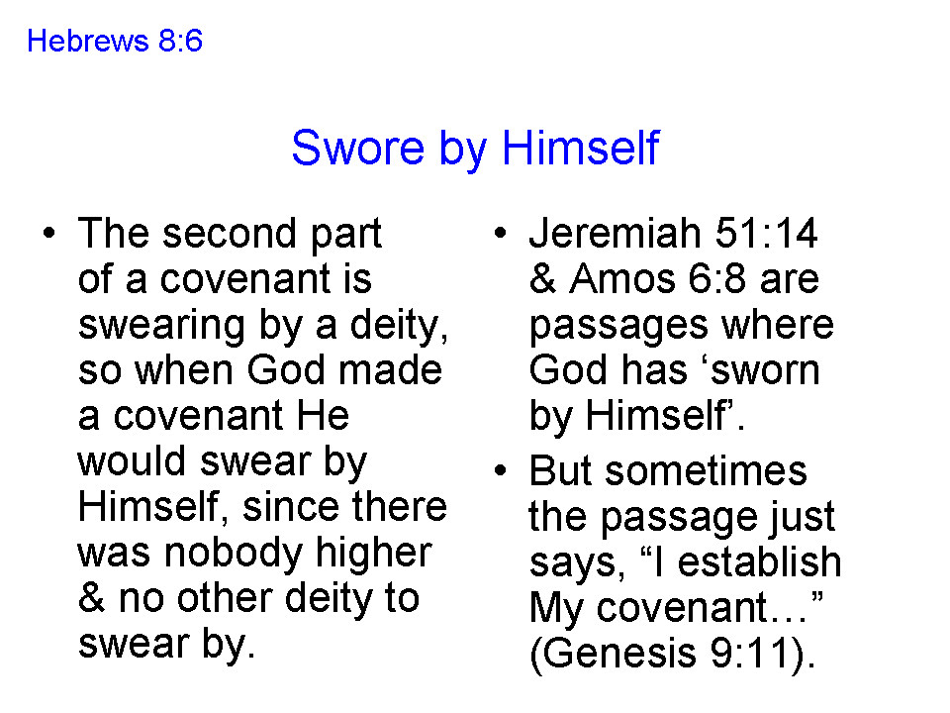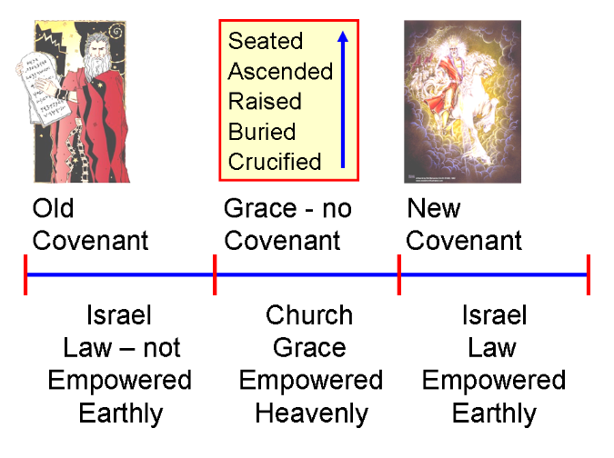

So, to bring all these points together about the New Covenant:

- The Old Covenant, the 613 individual statutes, was given specifically to Israel through Moses, but there was no empowerment to carry out even one of the individual statutes of the Law of Moses
- The New Covenant is the covenant in which the Jews in the Millennial Kingdom will be empowered to know and live out the Law of Moses by the Holy Spirit, and so be blessed (Deuteronomy 28)
- The New Covenant for Israel was ratified by Christ’s death on the cross, as one of the several purposes for Christ’s death on the cross
- The church, the body of Christ, has no covenant with relationship to God, and no relationship with Israel’s New Covenant, except by the death that Christ died.
- The law is not written on the hearts of Christian believers, who have died in relationship to any principle of law, but instead righteousness is lived out through the life of Christ and through the Holy Spirit

