Freed from the Law – Part VI

As we continue to explore what Scripture tells us about being ‘Freed from the Law’, another key passage is:
Colossians 2:8-23 (NASU)
See to it that no one takes you captive [Gk: sulagōgeō: capture by pirates or thugs] through philosophy and empty deception, according to the tradition of men, according to the elementary principles of the world [see also verse 20], rather than according to Christ.
9 For in Him all the fullness of Deity dwells in bodily form, 10 and in Him you have been made complete, and He is the head over all rule and authority; 11 and in Him you were also circumcised with a circumcision made without hands, in the removal of the body of the flesh by the circumcision of Christ; 12 having been buried with Him in baptism, in which you were also raised up with Him through faith in the working of God, who raised Him from the dead. 13
When you were dead in your transgressions and the uncircumcision of your flesh, He made you alive together with Him, having forgiven us all our transgressions, 14 having canceled out the certificate of debt consisting of decrees against us, which was hostile to us; and He has taken it out of the way, having nailed it to the cross. 15 When He had disarmed the rulers and authorities, He made a public display of them, having triumphed over them through Him.
16 Therefore no one is to act as your judge in regard to food or drink or in respect to a festival or a new moon or a Sabbath day-- 17 things which are a mere shadow of what is to come; but the substance belongs to Christ. 18 Let no one keep defrauding you of your prize by delighting in self-abasement and the worship of the angels, taking his stand on visions he has seen, inflated without cause by his fleshly mind, 19 and not holding fast to the head, from whom the entire body, being supplied and held together by the joints and ligaments, grows with a growth which is from God.

20 If you have died with Christ to the elementary principles of the world, why, as if you were living in the world, do you submit yourself to decrees, such as, 21 "Do not handle, do not taste, do not touch!" 22 (which all refer to things destined to perish with use)--in accordance with the commandments and teachings of men? 23 These are matters which have, to be sure, the appearance of wisdom in self-made religion and self-abasement and severe treatment of the body, but are of no value against fleshly indulgence.
The figure of speech ‘made with hands’ and ‘made without hands’ as used in the Bible:
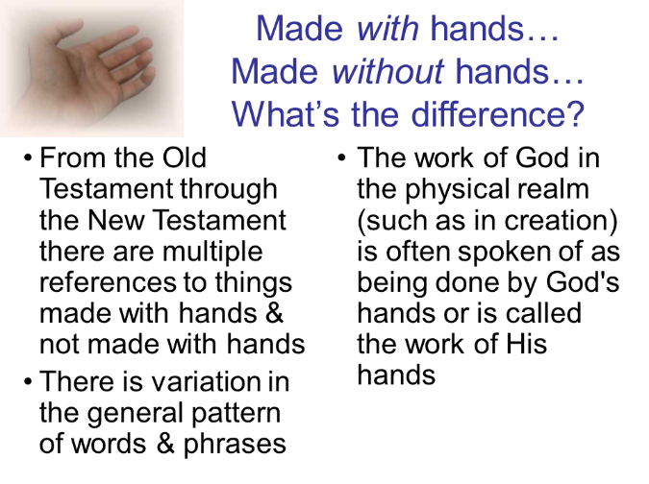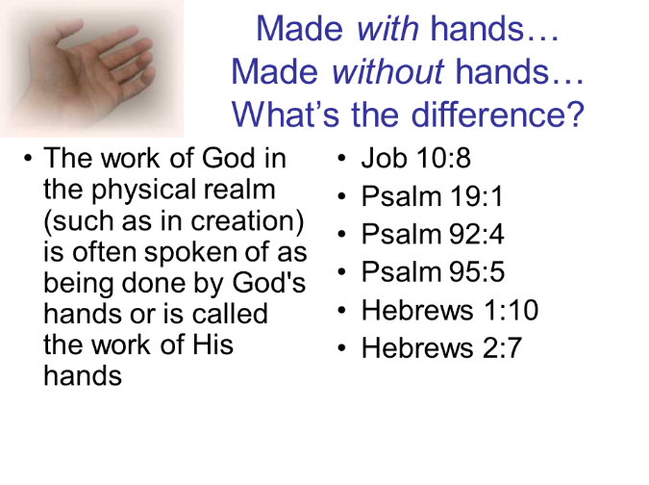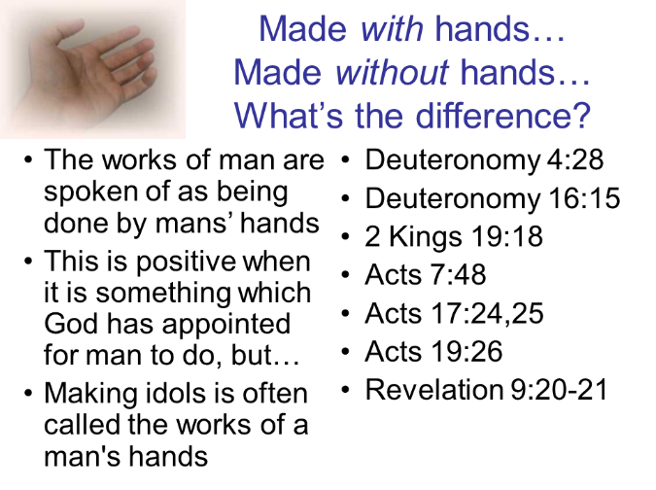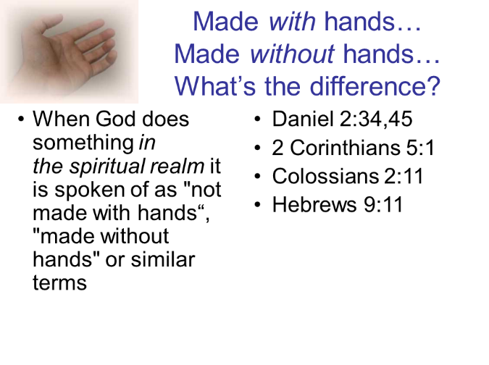

Underlined words are stating the believer’s identification with Christ or related truths.
‘Without hands’ in the Bible means for God to accomplish things in the spiritual realm, as opposed to the physical realm (‘with hands’). See slides on page 2 for more detail on the figures of speech ‘with hands’ and ‘without hands’ as used in the Bible.
‘cheirographon’, a handwritten debt note, such as in Philemon 18-19, “But if he [Onesimus] has wronged you in any way or owes you anything, charge that to my account; 19 I, Paul, am writing this with my own hand…”
Verses 16 through 23 are included to show how Paul urges the believers in Colossae not to submit themselves to anything under the principle of law or to unbiblical revelation and authority. Instead, he appeals to them to turn to Christ and submit to truth revealed by God.

