The Image of God – Part II

Last Sunday we began the topic, ‘The Image of God’. For the next several weeks we will build progressively on that topic, often using the more complete term from Genesis 1:26, 27, ‘the image and likeness of God’.

First, we will set a foundation for understanding what the Bible means – what God intended to reveal – with the words ‘image and likeness of God’. This is what God first revealed in Genesis 1:26, 27 (quoted below). Secondly, we will see how ‘the image and likeness of God’ is continued as a theme in the entire Bible, from Genesis to Revelation. And thirdly, we will see how ‘the image and likeness of God’ is essential to how God carried out our salvation, and how ‘the image and likeness of God’ is the basis for everything about the unfathomable riches that we have in Christ (Ephesians 3:1-8).

Genesis chapter 1 begins with the summary statement that God created the heavens and the earth. From there, Genesis chapter 1 continues, until Genesis 1:23, to set forth the creation from the first day until the fifth day. With Genesis 1:24, the sixth day of creation is set forth with special attention to the creation of mankind – human beings. Today we will present Genesis 1:26 and 27, which is a part of the sixth day of creation. Genesis 1: 26 and 27 lays a foundation for everything else the Bible teaches about what God intended and designed and revealed regarding ‘the image and likeness of God’ as an overarching and absolutely essential theme in the Bible, from Genesis chapter 1 to Revelation chapter 22!

Genesis 1:26, 27 (NASU)
Then God said, "Let Us make man in Our image, according to Our likeness; and let them rule over the fish of the sea and over the birds of the sky and over the cattle and over all the earth, and over every creeping thing that creeps on the earth." 27 God created man in His own image, in the image of God He created him; male and female He created them.

The image and likeness of God in mankind is observed in Genesis chapter 1 and throughout Scripture by six principles set forth in last Sunday’s lesson. We will restate the sixth principle here, because of its connection to the believer’s unfathomable riches:

- God has purposely made both time-based and eternal outcomes of having made mankind in His image and likeness, for the salvation of mankind, and for us in the body of Christ, as foundational principles for our unfathomable riches in Christ.

These will be explained in more detail, with Scriptural confirmation, in the weeks to come. There are a number of profound observations of Genesis 1:26 and 27, and the many related Bible passages that are the foundation of a broad spectrum of biblical teachings. These aspects of mankind having been made in the image and likeness of God were presented in last Sunday’s lesson, and are summarized as follows: It is a personal and spiritual and moral and interpersonal and authority and a creative image and likeness

We would do well to point out that the ways in which mankind differs from God include: God is not physical, but a spiritual being, is eternally righteous, is not subject to time, and He is infinite. There are specific and substantial exceptions to these statements, which God only does deliberately, mostly in the person of Jesus Christ. God also has other eternally important characteristics which we have not listed here.
Created in the image & likeness of God – Is that still present, or has it been terminated?

While some might draw the conclusion that the fall of mankind, as recorded in Genesis chapter 3, terminated the reality of mankind having been made in the image and likeness of God, Scripture itself tells us that mankind having been made in the image and likeness of God continues on into the New Testament, as shown in the chart below. Passages after Genesis 1:26, however, use either ‘the image of God’ or ‘the likeness of God’ as synonyms.
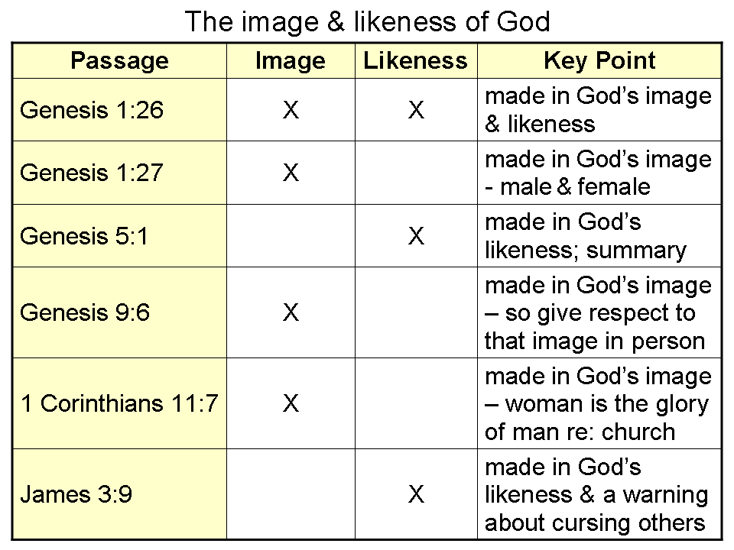
In the same way that mankind having been made male and female, after the image and likeness of God, continues to matter after the garden and after the fall of mankind (such as Genesis 5:2; Matthew 19:4; Mark 10:6), mankind having been made in the image of God continues to matter, even after the fall of mankind.

As we will see in the weeks to come, there will be many ways in which mankind having been made in the image and likeness of God will be essential to the plan of salvation and to our unfathomable riches in Christ. We will also see other ways in which mankind having been made in the image and likeness of God is made relevant in Scripture, from the Old Testament on into the New Testament.

God made mankind to have spiritual senses that were an analog to the physical senses.

In the same way that God made mankind to have the five classical physical senses, mankind also was made to have an analog to those physical senses in the spiritual realm.

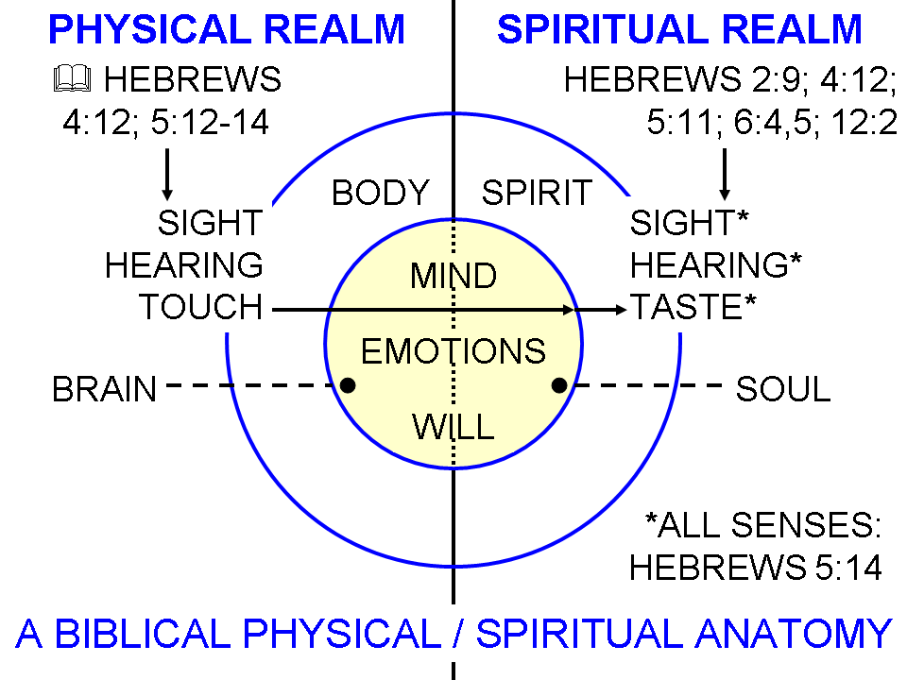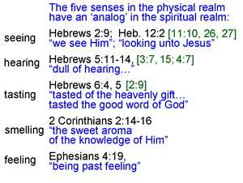
What we also discover in Scripture is that, speaking anthropomorphically, God is also said to have those same senses as mankind has both physically and spiritually:
The eyes of the Lord
Genesis 6:8; Deuteronomy 11:12; 21:9; 2 Chronicles 16:9; Psalm 34:15; Proverbs 5:21; 15:3; 22:12; Amos 9:8; Zechariah 4:10; 1 Peter 3:12
The ears of the Lord (see also ‘the Lord…heard…’)
Numbers 11:18; James 5:4
The Lord smelled
Genesis 8:21
A ‘soothing aroma’ to God
Genesis 8:21 to Ezekiel 20:41, 42 times total
Aroma…to God, or to God…. aroma
Ephesians 5:2; Philippians 4:8
Christ felt compassion
Matthew 9:36; 14:14; 15:32; 20:34; Mark 1:41; 6:34; 8:2; 9:22; Luke 7:13
Christ tasted death
Hebrews 2:9

These are all ways in which mankind has been made in God’s image and likeness so as to have aspects of the image and likeness of God in these respects, as we pointed out last Sunday:

- It is a personal image and likeness (Genesis 1:26; 2:19-23)
- It is a spiritual image and likeness (Genesis 1:26; 1 Corinthians 15:45)
- It is a moral image and likeness (Genesis 1:26-3:24; Ephesians 4:22-24; Colossians 3:9-10)
- It is an interpersonal image and likeness (Genesis 1:26; 1 John 1:3)
- It is an authority image and likeness (Genesis 1:26-2:25)
- It is a creative image and likeness (Genesis 1:1-2:25; Exodus 25:8,9)

Next time, as we continue to explore what it means to have been made in the image and likeness of God, we will examine what the diagram on the bottom left side of page 2 tells us about the mind, emotions and will of man, in both the physical and spiritual realms, and how those aspects of the soul (mind, emotions and will) relate to having been made in the image and likeness of God.

