The Image of God – Part III

For two Sundays in a row, we began to build on what the Bible conveys regarding, ‘The Image of God’. We will continue to build on that biblical foundation by presenting the ways in which the soul of man, consisting of mind, emotions, and will, have expressions in the physical realm. Those components of the soul are also expressed as having an analog in God Himself, as we will soon see. As before, our foundational passage is Genesis 1:26, 27, which speaks of ‘the image and likeness of God’.

Genesis 1:26, 27 (NASU)
Then God said, "Let Us make man in Our image, according to Our likeness; and let them rule over the fish of the sea and over the birds of the sky and over the cattle and over all the earth, and over every creeping thing that creeps on the earth." 27 God created man in His own image, in the image of God He created him; male and female He created them.

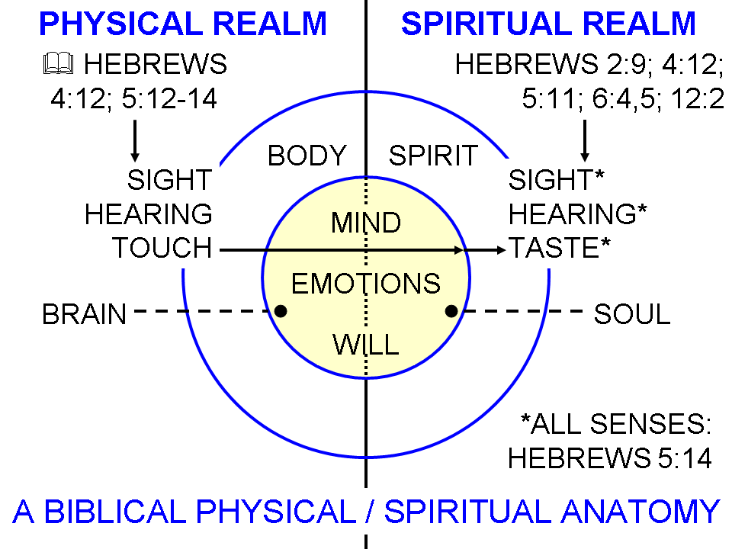
We presented in the diagram to the right that mankind was made in the image and likeness of God with physical senses and an analog of those senses in spiritual realm, and those same five classical senses are expressed anthropomorphically of God Himself (God sees, hears, etc.).

We also see that the written word of God, inspired from the spiritual realm by God Himself, employs the physical senses to communicate with our analog spiritual senses so as to have a positive spiritual impact upon the soul.

What the diagram also shows is that the human aspects of the soul, shown as mind, emotions and will, also have an expression in the physical realm, which modern science has discovered is centered in what we call the brain. As the brain is a part of the human body, so also the soul (Gk: psuche) is a part of the spirit (Gk: pneuma) of man.

The Mind of Man After The Image & Likeness Of God

The mind of a person is expressed in New Testament Scriptures by these Greek words:

nous – 1 Corinthians 2:16, “For who has known the mind (nous) of the Lord, that he will instruct Him? But we have the mind (nous) of Christ. The primary meaning of nous is understanding.

phroneō: As a verb, this is the mind in action and in motion, which is connected to emotions and the will. It is expressed in passages such as:
Philippians 1:7
For it is only right for me to feel (phroneo; KJV, NKJV: ‘think’) this way about you all, because I have you in my heart (kardia), since both in my imprisonment and in the defense and confirmation of the gospel, you all are partakers of grace with me.

Philippians 2:1-8
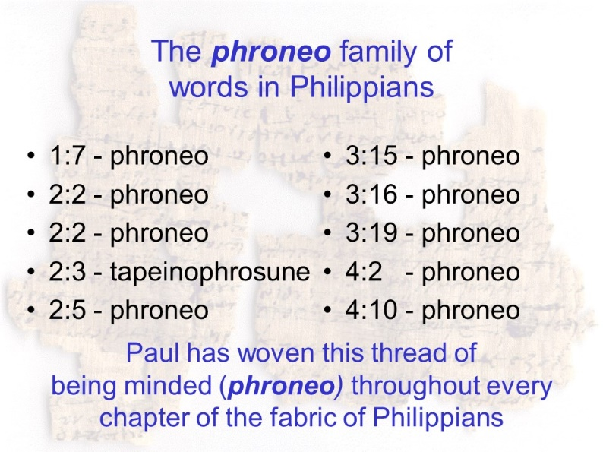
Therefore if there is any encouragement in Christ, if there is any consolation of love, if there is any fellowship of the Spirit, if any affection and compassion, 2 make my joy complete by being of the same mind (phroneo), maintaining the same love, united in spirit (sumpsuchos), intent on one purpose (phroneo). 3 Do nothing from selfishness or empty conceit, but with humility of mind (tapeinophrusone) regard one another as more important than yourselves; 4 do not merely look out for your own personal interests, but also for the interests of others. 5 Have this attitude (phroneo) in yourselves which was also in Christ Jesus, 6 who, although He existed in the form of God, did not regard equality with God a thing to be grasped, 7 but emptied Himself, taking the form of a bond-servant, and being made in the likeness of men. 8 Being found in appearance as a man, He humbled Himself by becoming obedient to the point of death, even death on a cross.

The Emotions of Man After The Image & Likeness Of God

Human beings, made in the image of God, obviously have emotions. Emotions, like the mind and will of man, have a physical component and a spiritual component. And we see emotions expressed in Christ during His time of earthly ministry, who was fully God and fully man. Scripture also expresses the emotions of God in anthropomorphic terms. Scripture can express the emotions of God truthfully in those anthropomorphisms, because we were made in the image and likeness of God. Included in or extending from this are pleasure, aesthetics in its various forms, enjoyment of the aspects of the image and likeness of God, as well as a sense of positive awe and amazement and wonder. In these things we can appreciate and experience and enjoy what God has done to make us in His image and likeness, and at the same time we recognize the ways in which God’s character and magnitude are massively and infinitely beyond us.

Genesis 1:31a, b
God saw all that He had made, and behold, it was very good.

Psalm 19:1
The heavens are telling of the glory of God;
And their expanse is declaring the work of His hands.

John 3:16-17
"For God so loved the world, that He gave His only begotten Son, that whoever believes in Him shall not perish, but have eternal life.”

1 John 4:19
We love, because He first loved us.

The Will of Man After The Image & Likeness Of God

The imperatives of the New Testament letters, from Romans on, generally appeal to the will of the believer (for example, 1 Corinthians 4:1). Likewise for those places where the authors of the New Testament urge their readers to do or not do something (for example, Romans 12:1, 15:30; 16:7).

