God’s Image and the Unfathomable Riches of Christ – Part II

Last Sunday we saw that our having been made in the image and likeness of God (Genesis 1:26, 27) means that when Christ was incarnated also in the image and likeness of God He was uniquely qualified to be a sacrifice on our behalf. Now we turn to another momentous insight: our having been made in the image and likeness of God, and Christ, having been born as a man made in the image and likeness of God, is the essential foundation for the individual believer’s identification with Christ, and our joint identification with Christ.
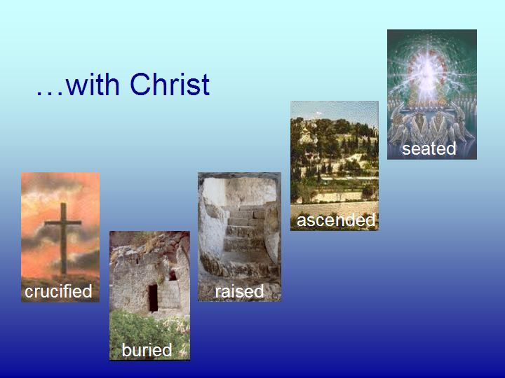
The five ways in which each one who comes to believe and all of us together were identified with Christ was when He was:

- Crucified (& died)
- Buried
- Raised
- Ascended
- Seated

Identification synonyms

We have used the word ‘identification’ so far, since that is a convenient ‘handle’ for what Scripture teaches. But the actual words used in Scripture that convey this intimately related family of biblical truths include:

- In - being placed entirely in, so as to share an identity
- With or joined - intimately joined in action and consequence
- Together with – as above, with ‘together’ underscoring the same identity & action
- United with – ‘united’ implies a oneness, so a spiritual oneness is communicated
- Baptized into – ‘baptized’ means to be immersed or entirely placed into, so as to be permanently changed by that immersion or entire placement

Meaning and significance

The meaning and significance of our identification with Christ in these five things is HUGE! It is HUGE enough that we took four lessons earlier in this elective just to introduce what the Bible says about identification. What the Bible says about identification goes from doctrine, to position, to condition – how life is intended by God to be lived out. We can only touch on those marvelous principles briefly here.

Galatians 2:19-21
For through the Law I died to the Law, so that I might live to God. 20 I have been crucified with Christ; and it is no longer I who live, but Christ lives in me; and the life which I now live in the flesh I live by faith in the Son of God, who loved me and gave Himself up for me.

Ephesians 1:3-4
Blessed be the God and Father of our Lord Jesus Christ, who has blessed us with every spiritual blessing in the heavenly places in Christ, 4 just as He chose us in Him before the foundation of the world, that we would be holy and blameless before Him.

Philippians 3:20-21
For our citizenship is in heaven, from which also we eagerly wait for a Savior, the Lord Jesus Christ; 21 who will transform the body of our humble state into conformity with the body of His glory, by the exertion of the power that He has even to subject all things to Himself.

Colossians 3:1-4
Therefore if you have been raised up with Christ [and this is assumed to be true to follow the logic], [then] keep seeking the things above, where Christ is, seated at the right hand of God. 2 Set your mind on the things above, not on the things that are on earth. 3 For you have died [with Him] and your life is hidden with Christ in God. 4 When Christ, who is our life, is revealed, then you also will be revealed with Him in glory.

A conclusion that has no end

Each believer’s identification with Christ in these things, and our joint identification with Him only make sense because we all were made in the image and likeness of God, though fallen. It also only makes sense that Christ was born as a man, also made in the image and likeness of God, wholly righteous. We could not have been identified with an angel or any other earthly creature of any other kind and have the same spiritual effect.

These truths and principles will have eternal outcomes. Our identification with Christ, individually and together, will continue to have marvelous impacts, on into the rolling ages to come. And it all began when God created mankind in His own image and likeness.

Ephesians 2:4-7
But God, being rich in mercy, because of His great love with which He loved us, 5 even when we were dead in our transgressions, made us alive together with Christ (by grace you have been saved), 6 and raised us up with Him, and seated us with Him in the heavenly places in Christ Jesus, 7 so that in the ages to come He might show the surpassing riches of His grace in kindness toward us in Christ Jesus.

Or, in the Darby and Lexham translations, ‘identified’.

