The Church as the Bride of Christ

We are continuing with the theme of our unfathomable riches for the church as one, as a body, together in position as one. We began by observing this set of truths in Ephesians 2:11-22. One of the ways that the New Testament presents that set of truths is through the set of apostolic teachings which proclaim the Church as the bride of Christ. Some of the passages which portray this are explicit, and others present that set of teachings by employing the Jewish wedding traditions. In keeping with that, we will go through the Jewish wedding traditions of New Testament times sequentially, from the establishment of the marriage relationship, known as betrothal, to the marriage ceremony. At the outset, the father of the bridegroom would select the bride. The wedding ceremony of the chosen bride would be a presenting of the bride to the bridegroom by the family, the friends, and even the bridegroom to himself. That is what we see being done in the choosing of the bride for the bridegroom, for the intended presentation in the ceremony to come.

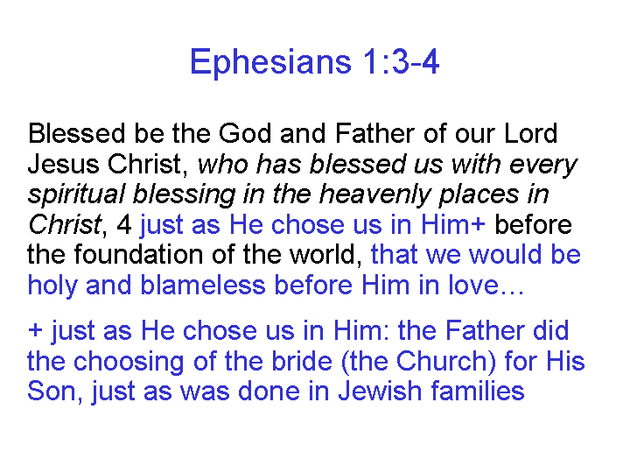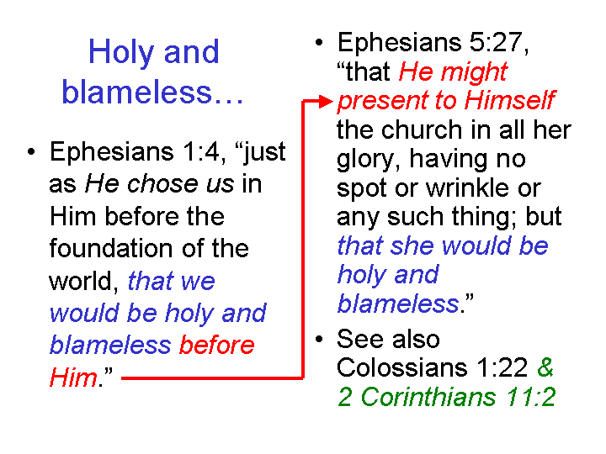

2 Corinthians 11:2 (NASU throughout)
For I am jealous for you with a godly jealousy; for I betrothed you to one husband, so that to Christ I might present you as a pure virgin.

Colossians 1:21-23
…yet He has now reconciled you in His fleshly body through death, in order to present you before Him holy and blameless and beyond reproach—

The betrothal tradition continued in this way:

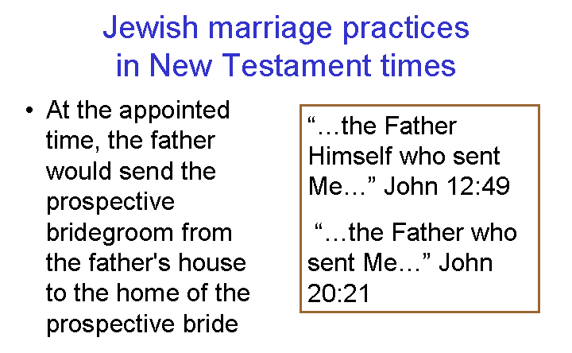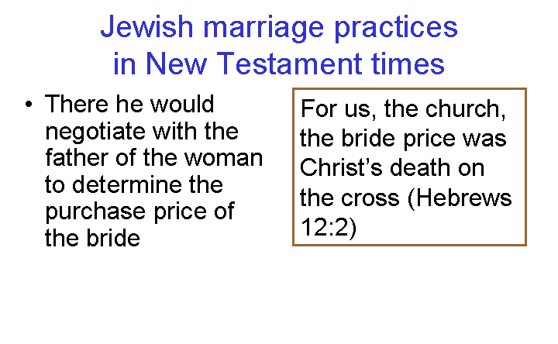
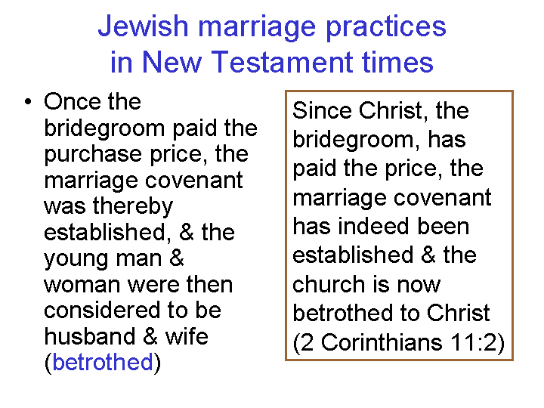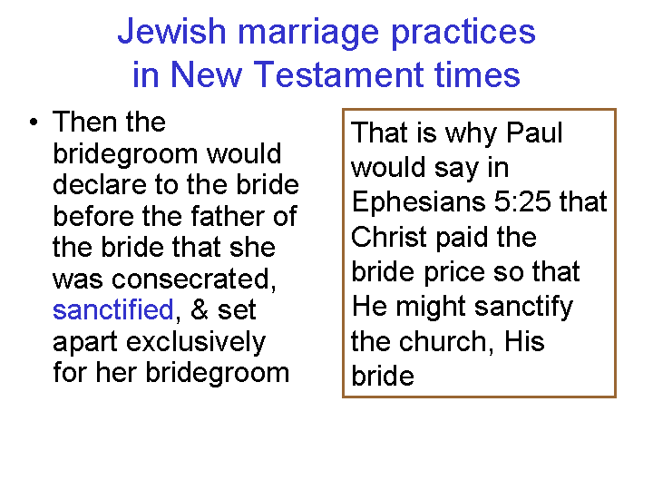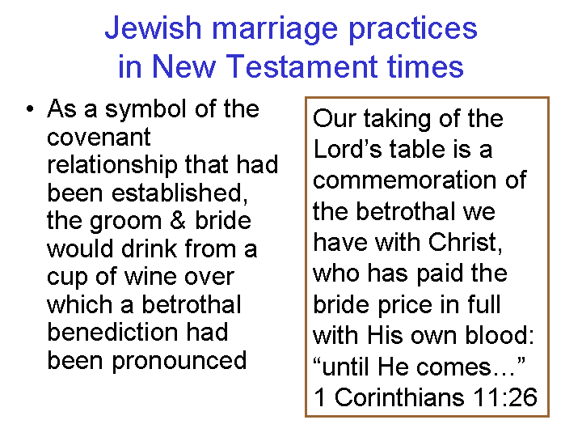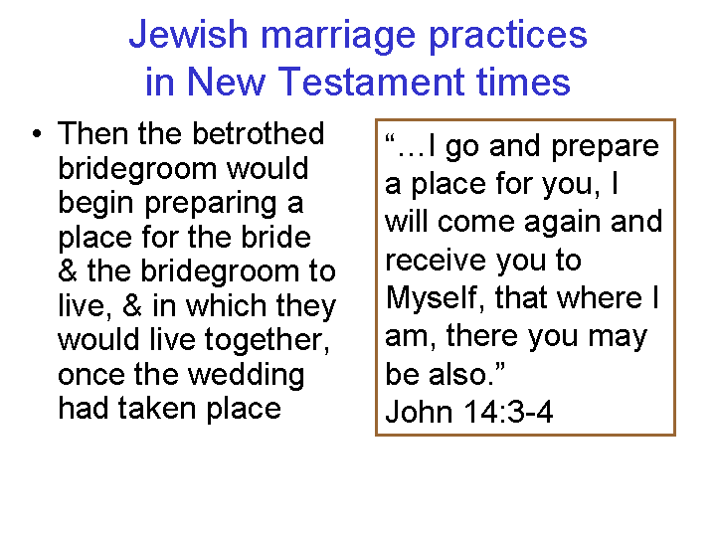

These things were said in anticipation of the coming of the bridegroom for the bride. The preparation for the wedding day, and the anticipation of the wedding day were central in the mind of the bridegroom, the bride, and the family and friends.

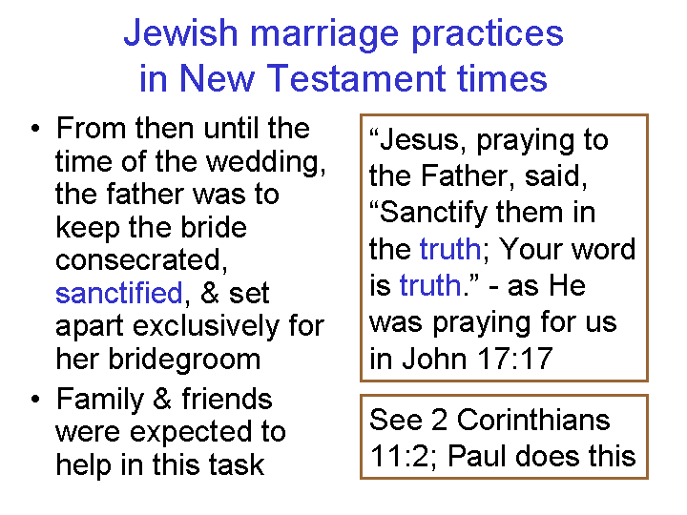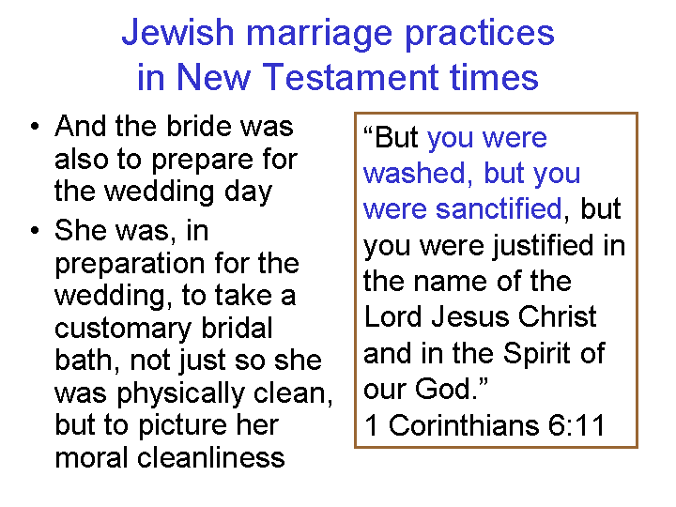

And on the wedding day, there was a set of customs applying to everybody involved in the wedding: The bridegroom, the bride, the father of the bride, and all family and friends.
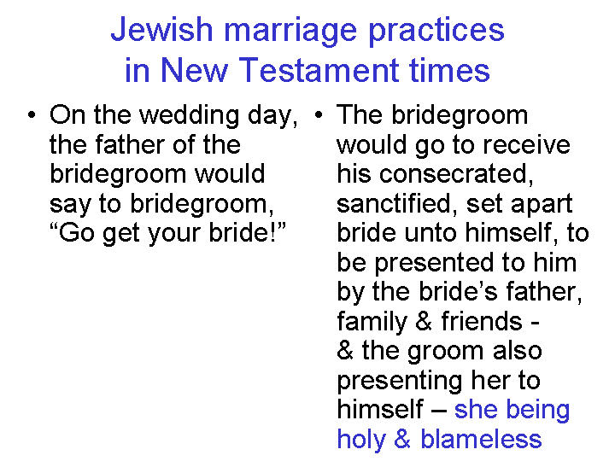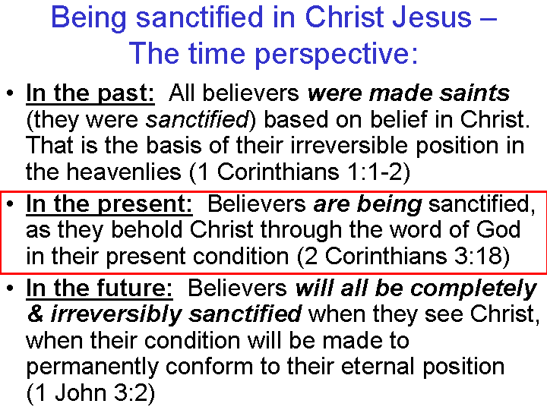

Revelation 19:7-9 (NASU)
"Let us rejoice and be glad and give the glory to Him, for the marriage of the Lamb has come and His bride has made herself ready." 8 It was given to her to clothe herself in fine linen, bright and clean; for the fine linen is the righteous acts of the saints.

Then he said to me, "Write, 'Blessed are those who are invited to the marriage supper of the Lamb.'" And he said to me, " These are true words of God."

An important distinction should be made between Israel as the wife of God (Yahweh), as portrayed in the Old Testament, and the Church as the bride of Christ, as portrayed in the New Testament. One reason for pointing out the distinction is that Israel was viewed as horribly unfaithful (see Hosea, as an example), and God even divorced Israel (Jeremiah 3:8). But with the church, the marriage is forward-looking, in the heavenlies, with the Church intended to be holy and blameless. And the marriage is Christ to the Church, an eternal romance in the heavenlies, not to be confused with God (Yahweh) and Israel, centered in the land of Israel.
_________________________________________

