The Church as a Temple

We are continuing with the theme of our unfathomable riches for the church as one, as a body, together in position as one. We began by observing this set of truths in Ephesians 2:11-22. Last Sunday, we looked at another New Testament teaching which proclaims the Church as the bride of Christ. This morning we will be turning our attention to the New Testament teaching that the Church is a temple – the dwelling place of God, sometimes expressed as a specific Person of the Trinity, such as the Holy Spirit or Christ (see footnote 2). This teaching is found in passages such as:

1 Corinthians 3:16-17 (NASU)
Do you not know that you are a temple [naós] of God and that the Spirit of God dwells in you? 17 If any man destroys the temple [naós] of God, God will destroy him, for the temple [naós] of God is holy, and that is what you are.

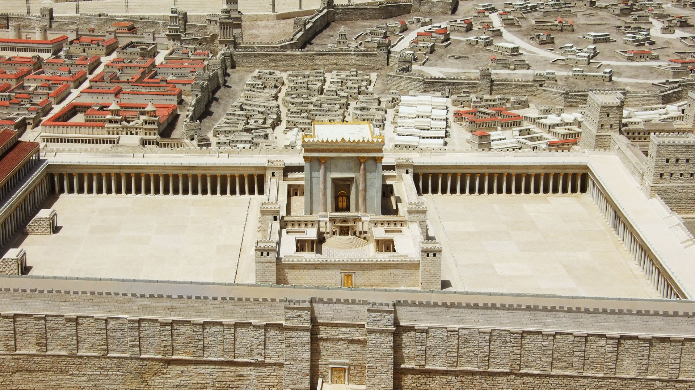
The inner temple, the sanctuary, was the naós. The outer temple courtyard was the hierón.
2 Corinthians 6:14-16 (NASU)
Do not be bound together with unbelievers; for what partnership have righteousness and lawlessness, or what fellowship has light with darkness? 15 Or what harmony has Christ with Belial, or what has a believer in common with an unbeliever? 16 Or what agreement has the temple [naós] of God with idols? For we are the temple [naós] of the living God; just as God said, "I will dwell in them and walk among them; and I will be their God, and they shall be My people."

Ephesians 2:11-22, especially 21-22 [NASU, bolding and [words in brackets] added]
Therefore remember that formerly you, the Gentiles in the flesh, who are called "Uncircumcision" by the so-called " Circumcision," which is performed in the flesh by human hands-- 12 remember that you were at that time separate from Christ, excluded from the commonwealth of Israel, and strangers to the covenants of promise, having no hope and without God in the world. 13 But now in Christ Jesus you [believers] who formerly were far off [Gentiles] have been brought near by the blood of Christ. 14 For He Himself is our peace, who made both groups [Gentile and Jew] into one and broke down the barrier of the dividing wall, 15 by abolishing in His flesh the enmity, which is the Law of commandments contained in ordinances, so that in Himself He might make the two into one new man, thus establishing peace, 16 and might reconcile them both in one body to God through the cross, by it having put to death the enmity. 17 and He came and preached peace to you who were far away, and peace to those who were near; 18 for through Him we both have our access in one Spirit to the Father. 19 So then you are no longer strangers and aliens, but you are fellow citizens with the saints, and are of God's household, 20 having been built on the foundation of the apostles and prophets, Christ Jesus Himself being the corner stone, 21 in whom the whole building, being fitted together, is growing into a holy temple [naós] in the Lord, 22 in whom you also are being built together into a [long-term, settled down deep] dwelling of God in the Spirit.

Gk: naós = the inner temple, the sanctuary; the outer courtyard is the Gk: hierón
Romans 8:9-11 (NASU) see also Galatians 2:20, “Christ who lives in me”. However, you are not in the flesh but in the Spirit, if indeed the Spirit of God dwells in you. But if anyone does not have the Spirit of Christ, he does not belong to Him. 10 If Christ is in you, though the body is dead because of sin, yet the spirit is alive because of righteousness. 11 But if the Spirit of Him who raised Jesus from the dead dwells in you, He who raised Christ Jesus from the dead will also give life to your mortal bodies through His Spirit who dwells in you. 2 Timothy 1:14 (NASU) Guard, through the Holy Spirit who dwells in us, the treasure which has been entrusted to you.

