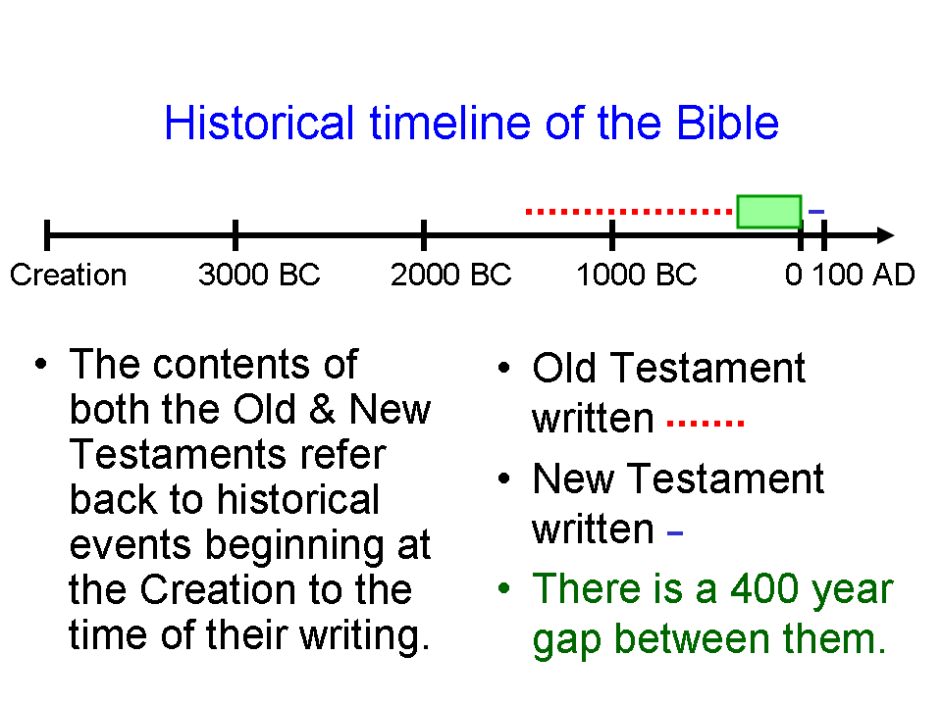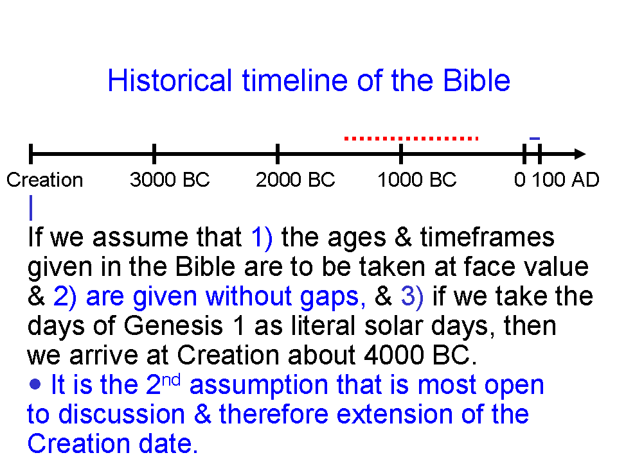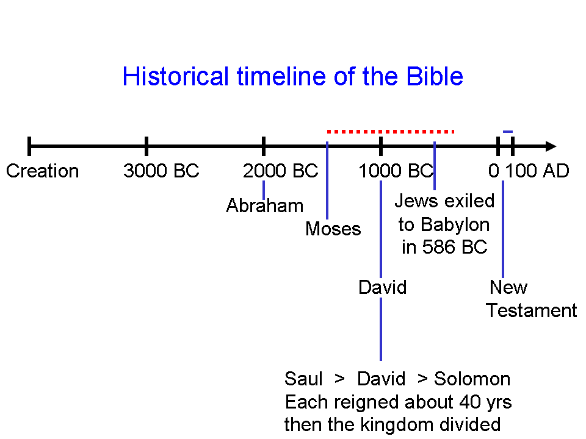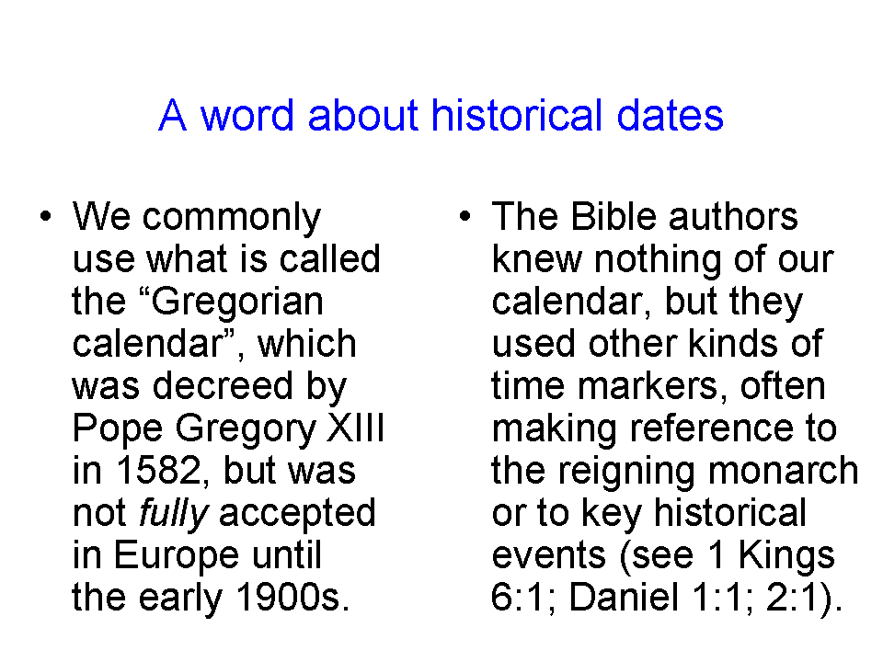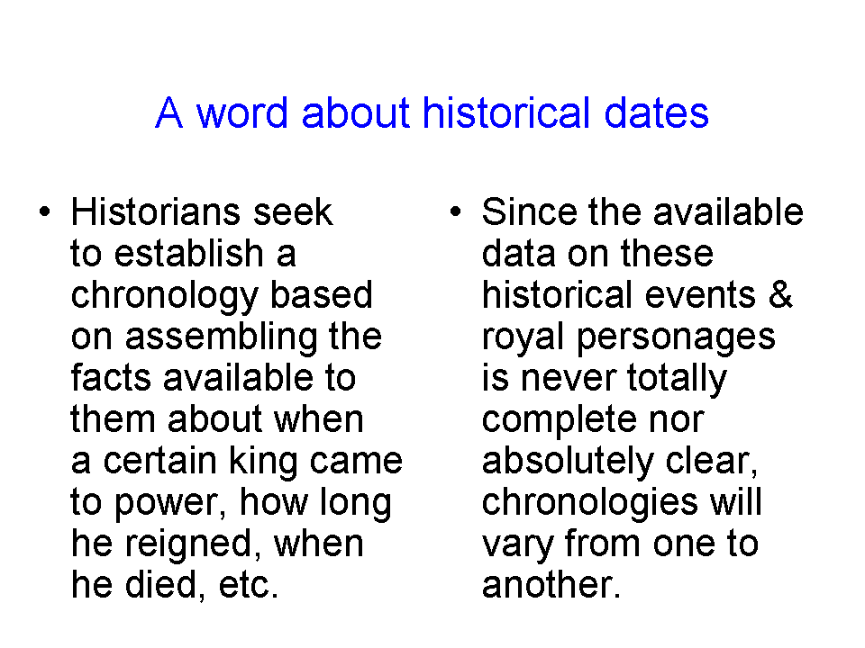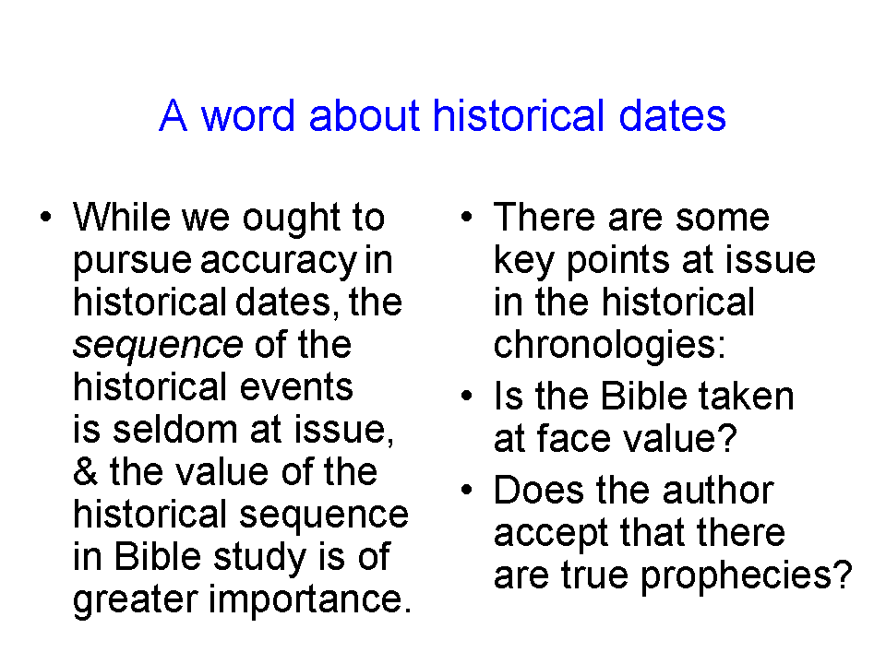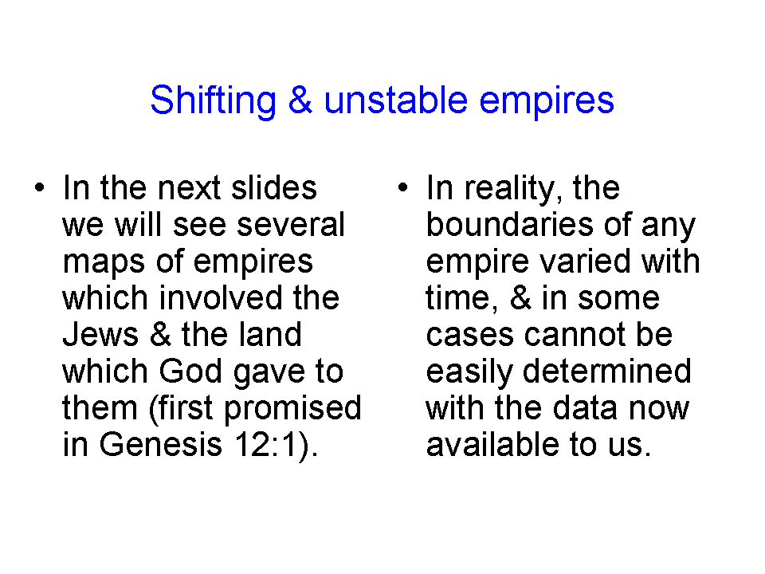
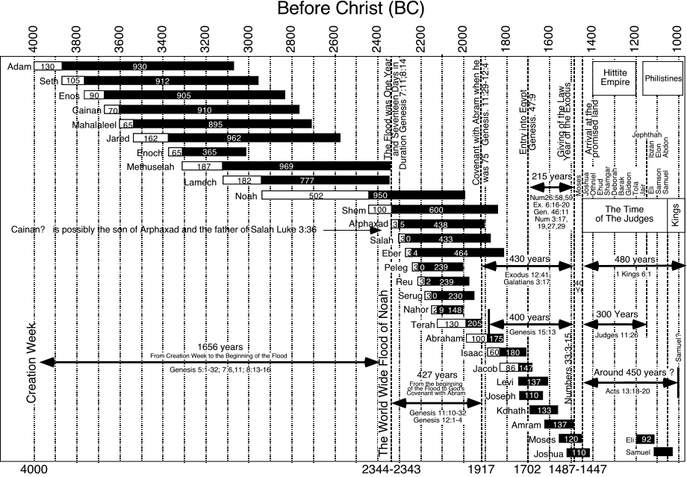
Old Testament to New Testament timeline adapted from www.creation-science-prophecy.com. Used by permission of the author. The contents of the website are not generally recommended without discernment.




