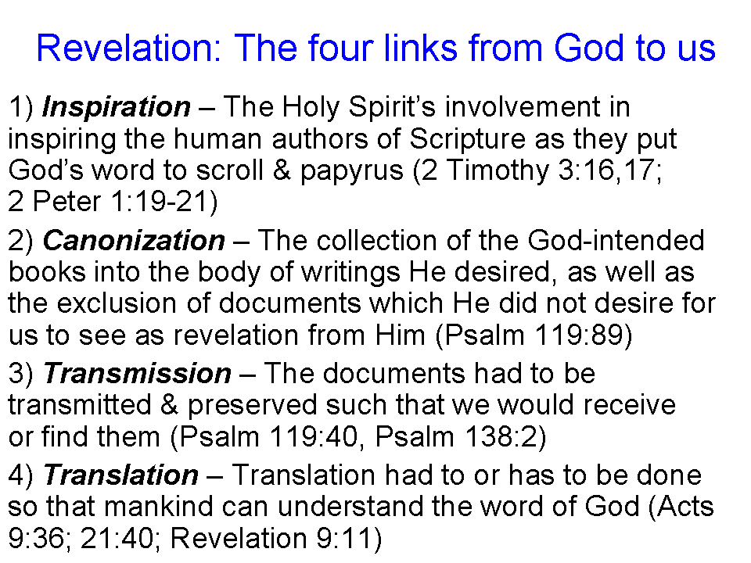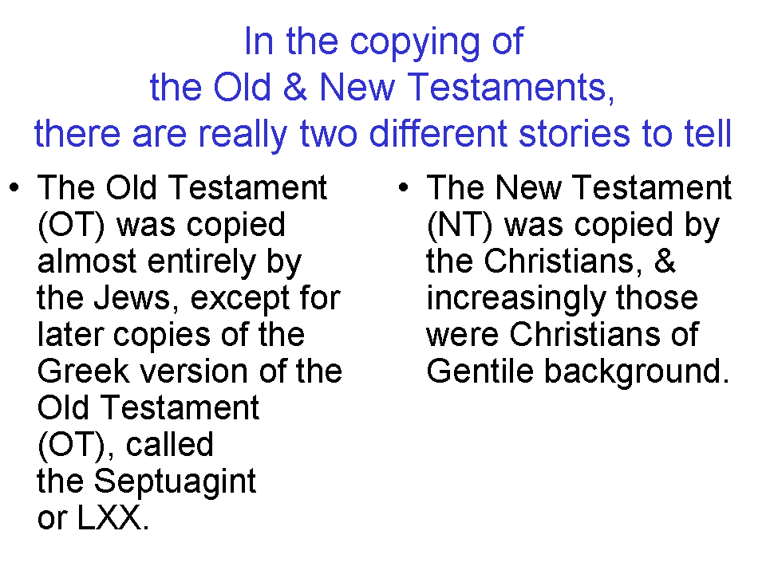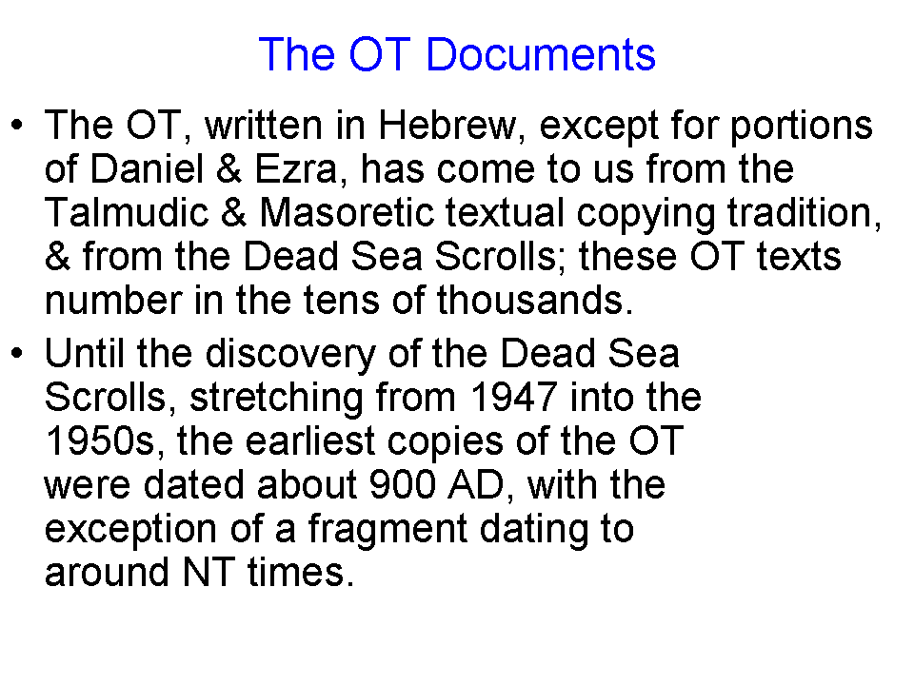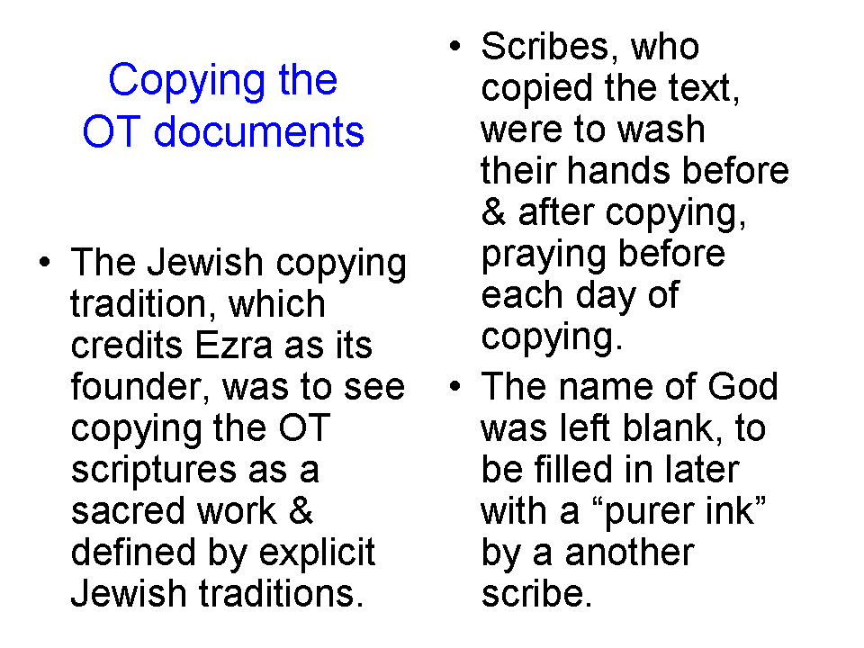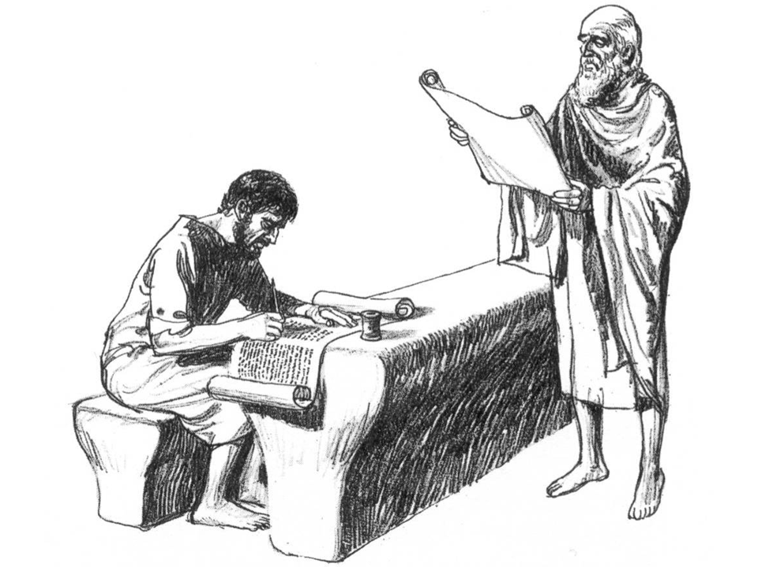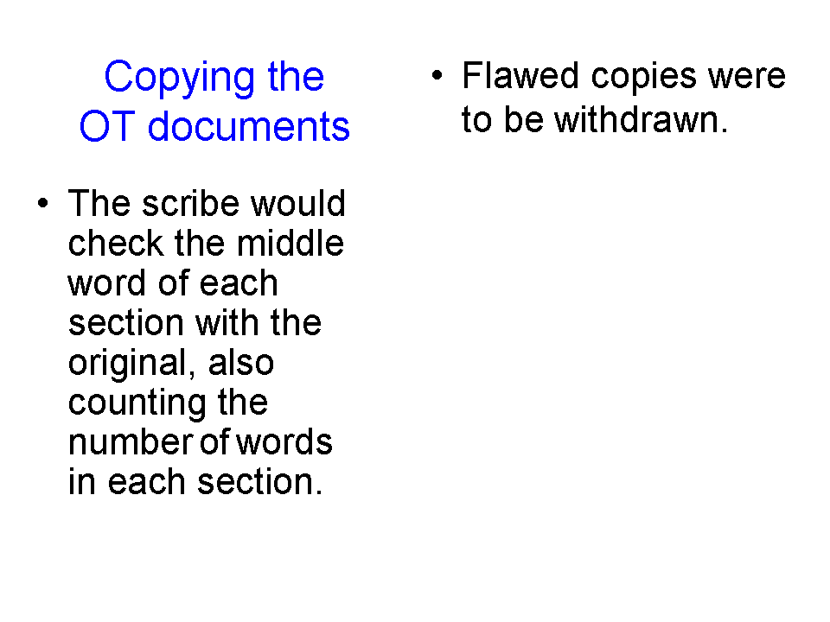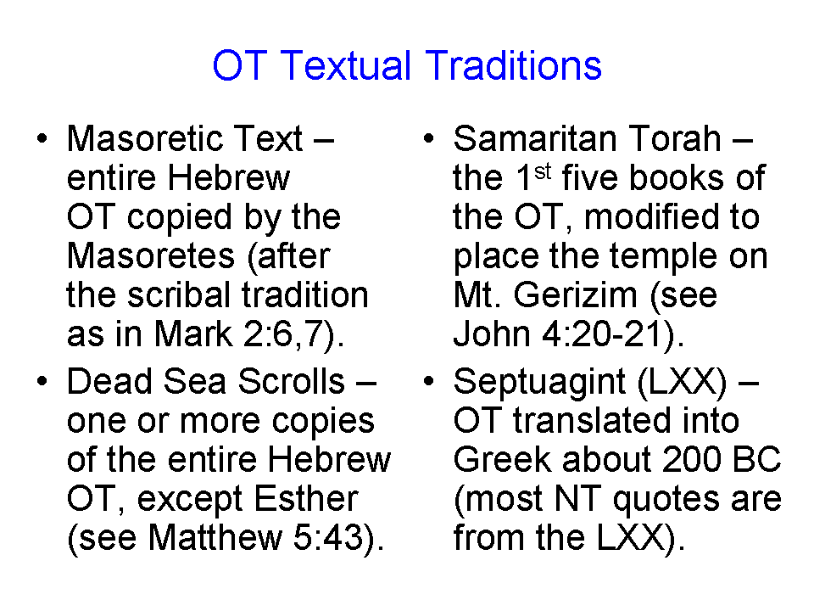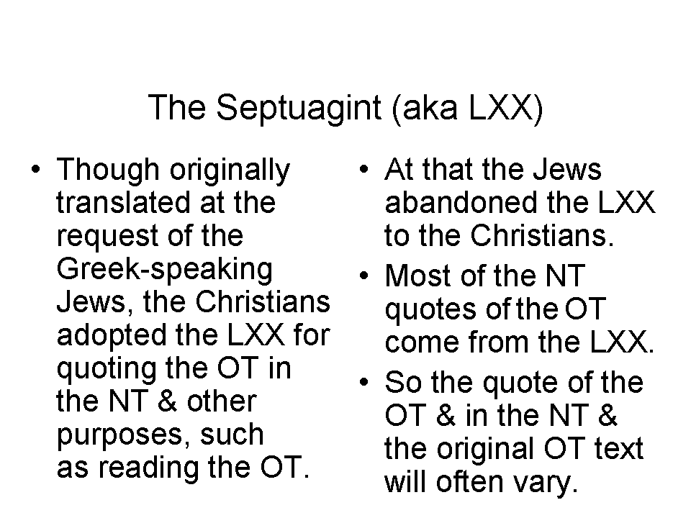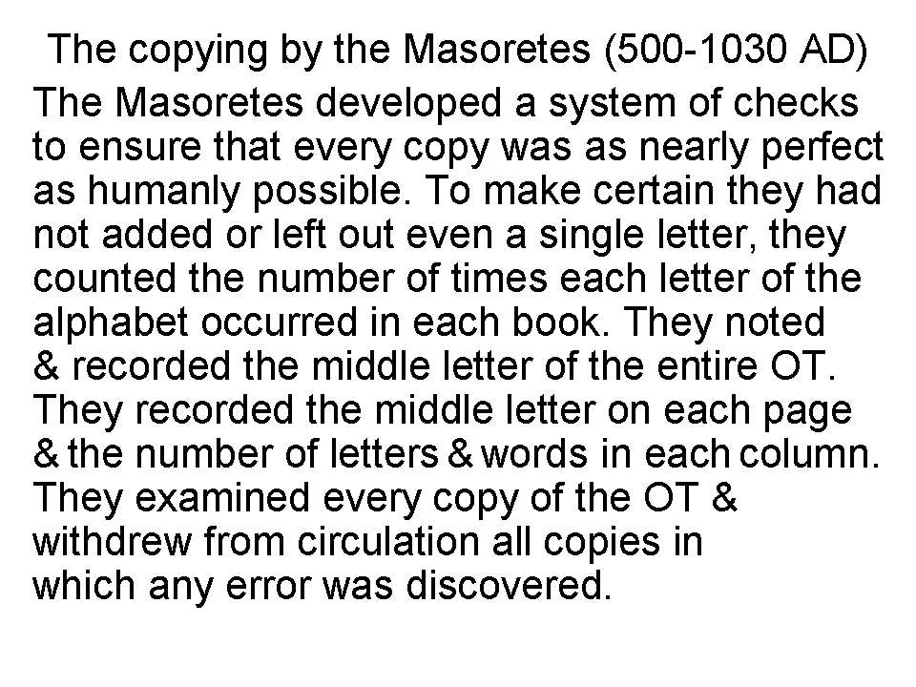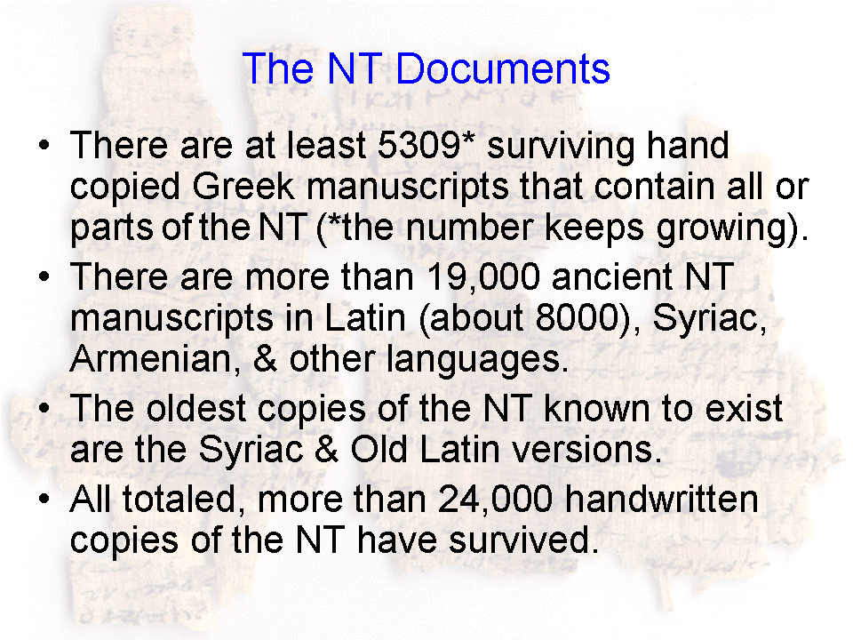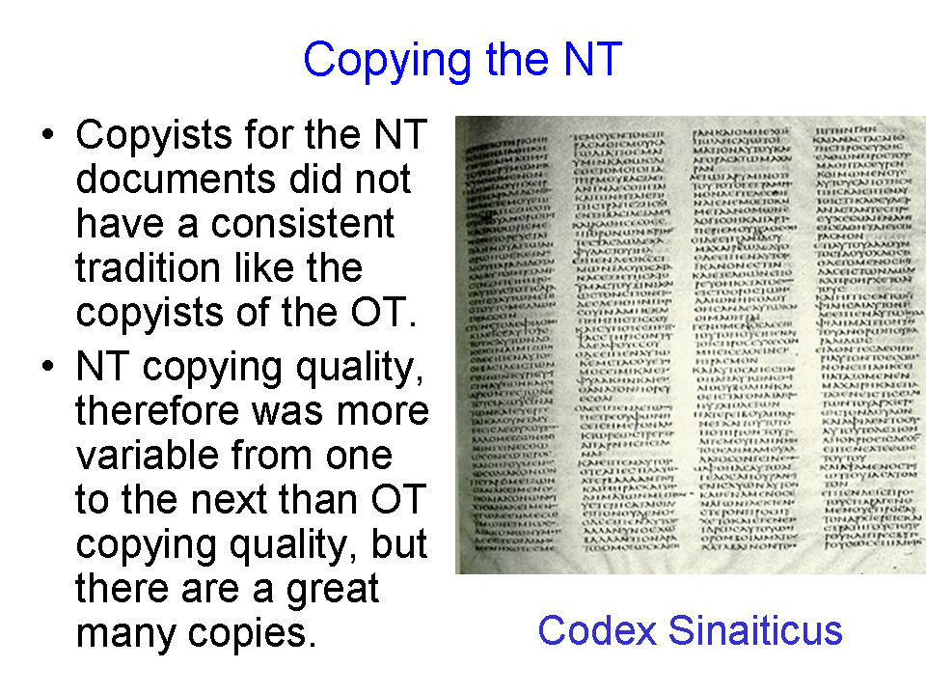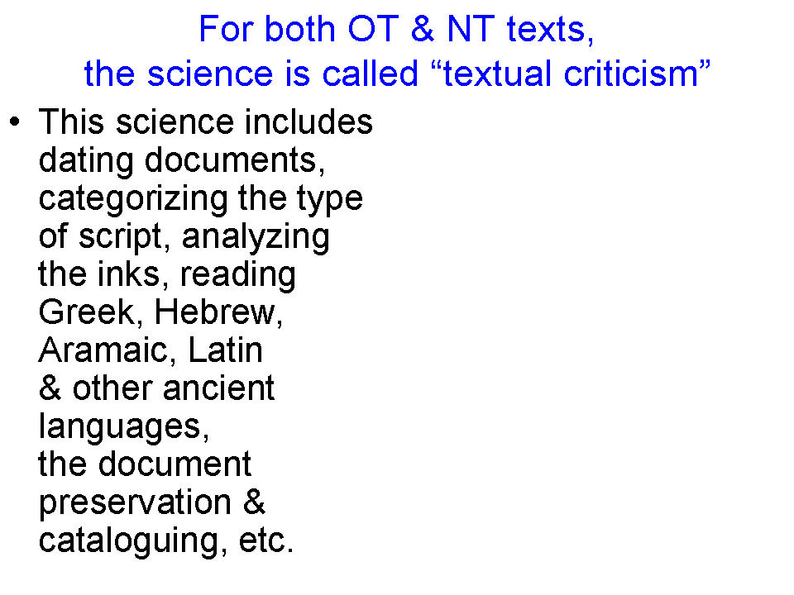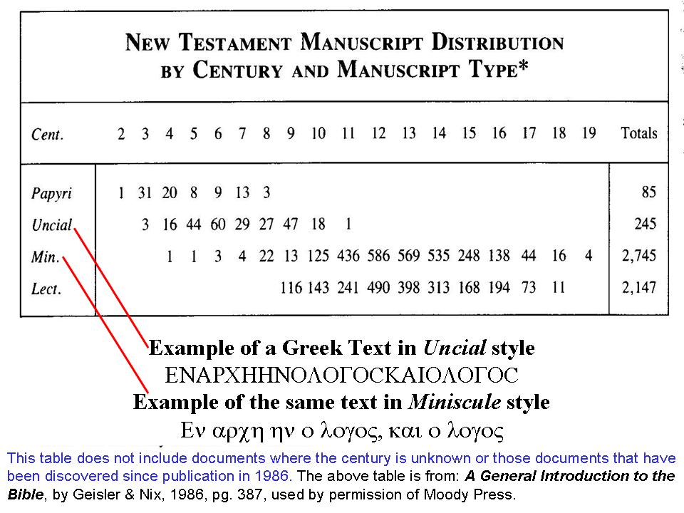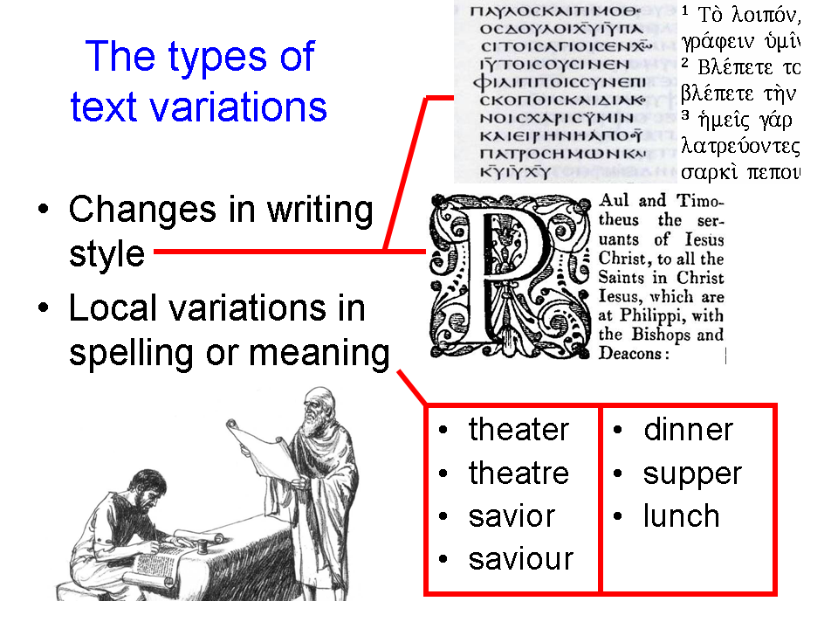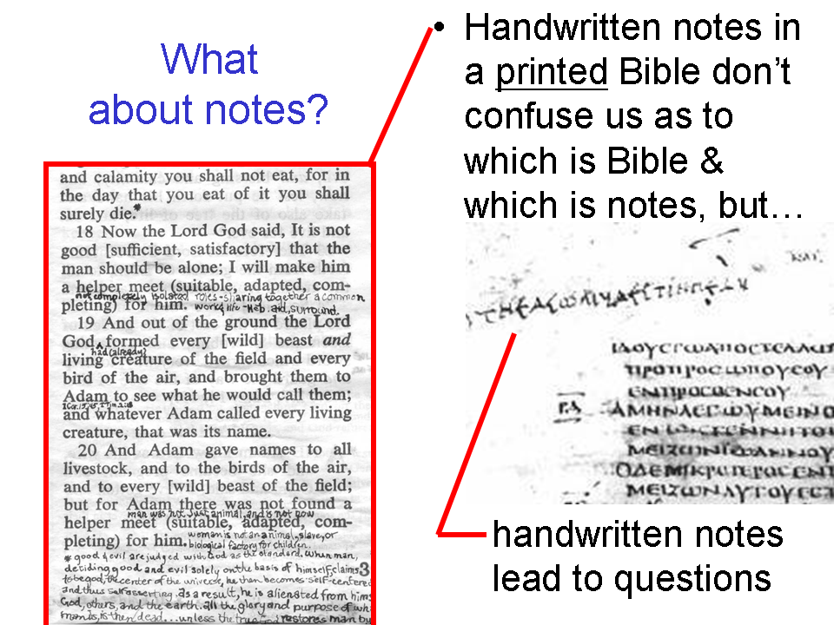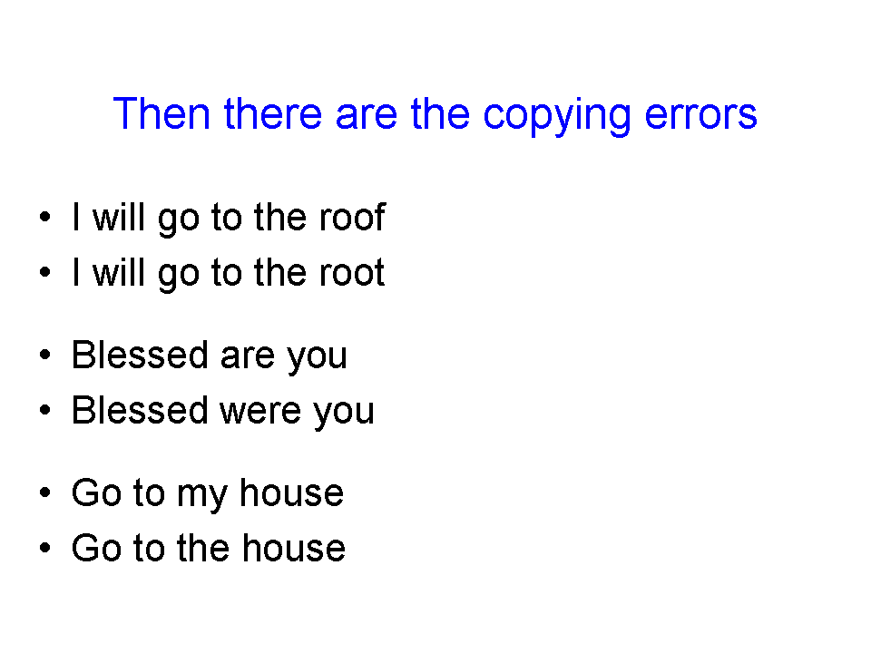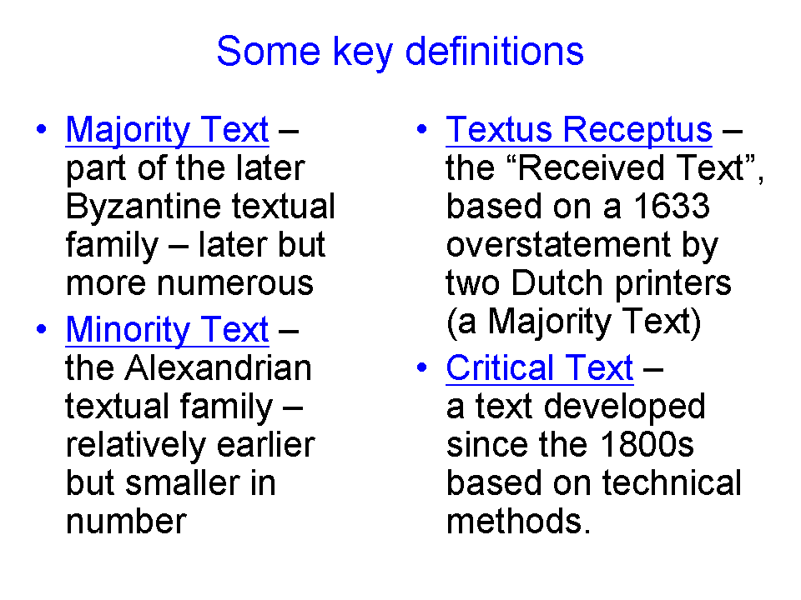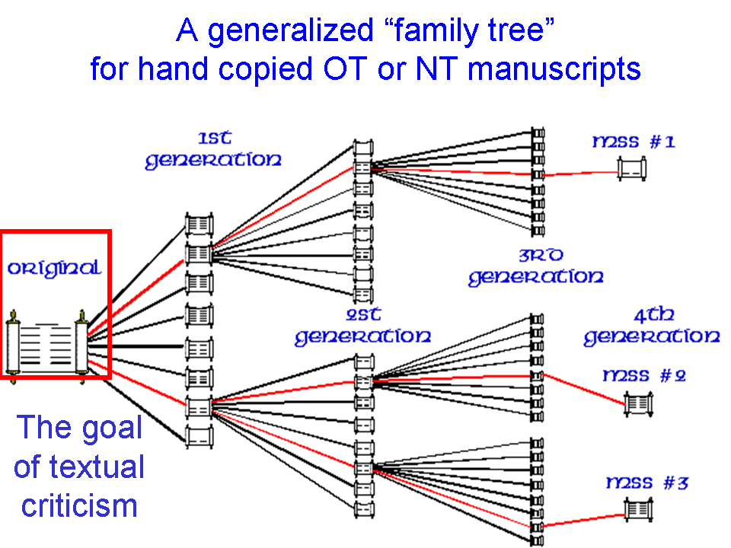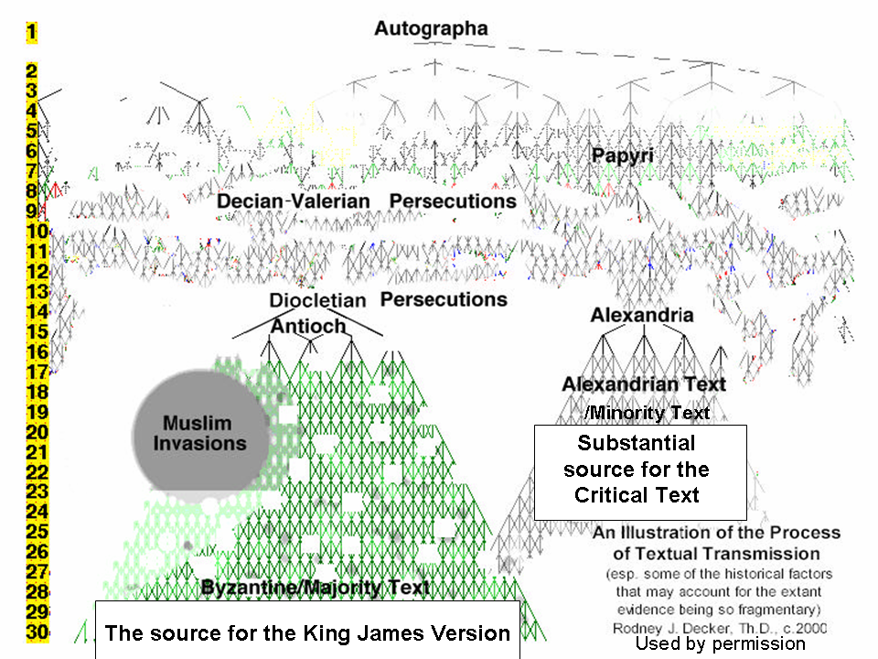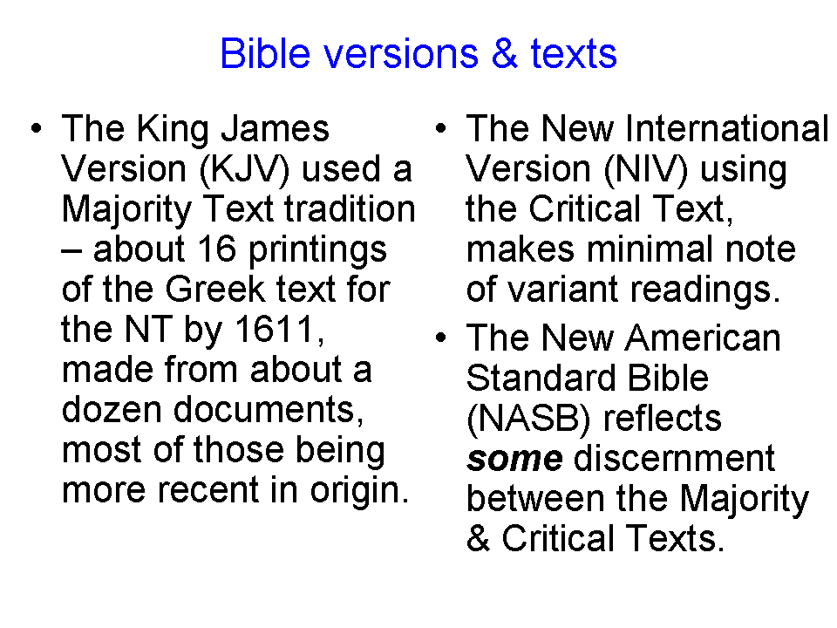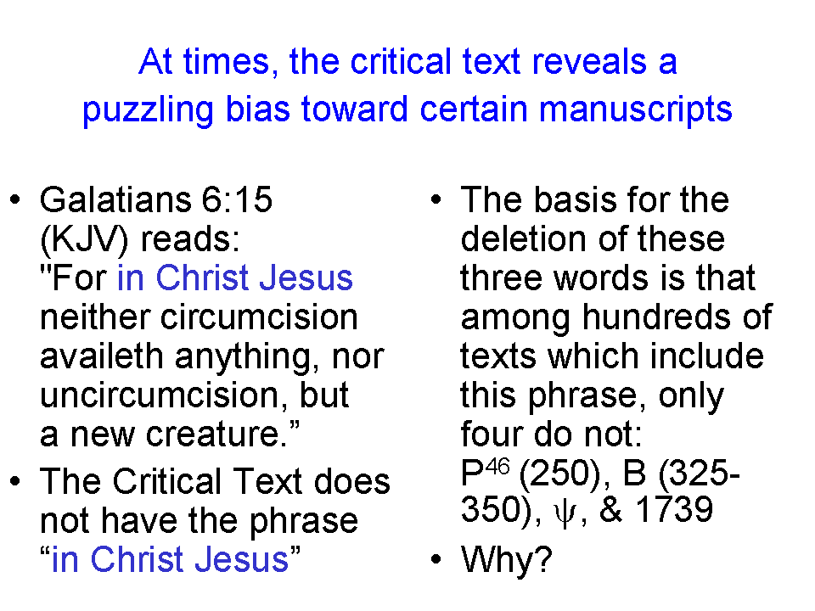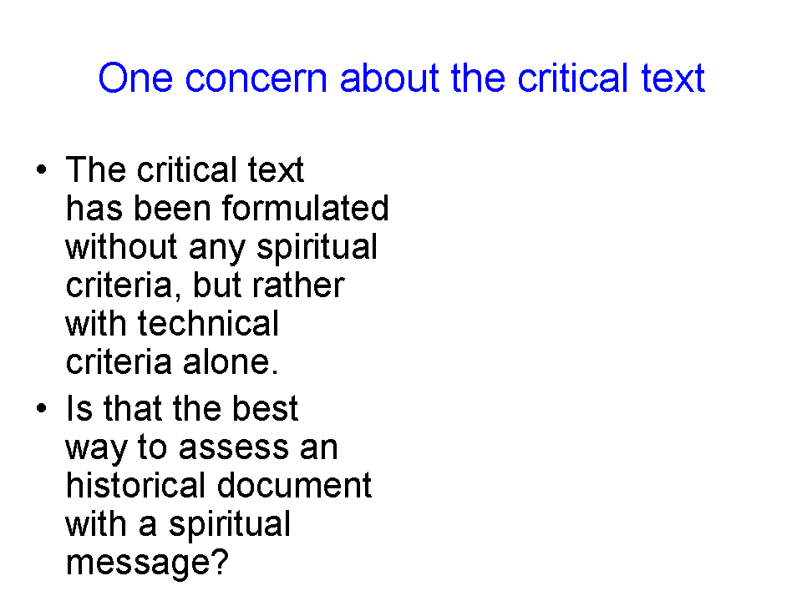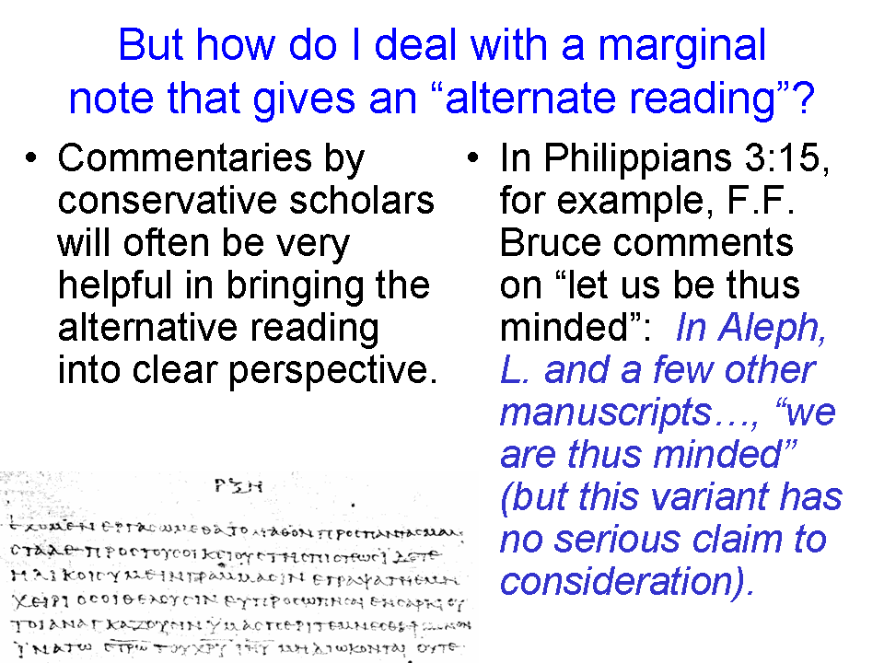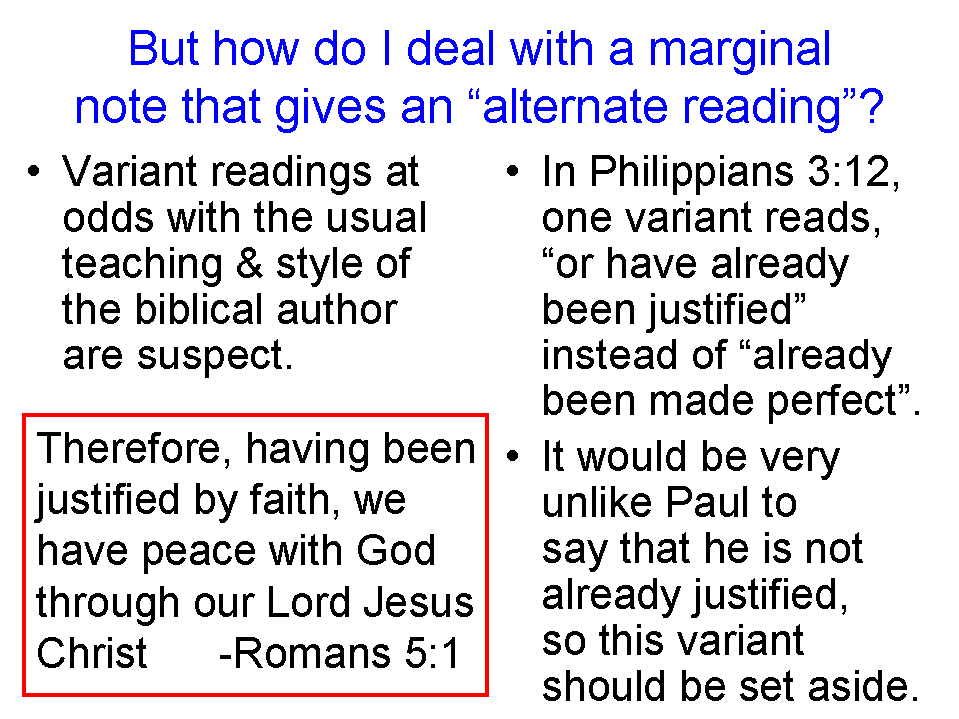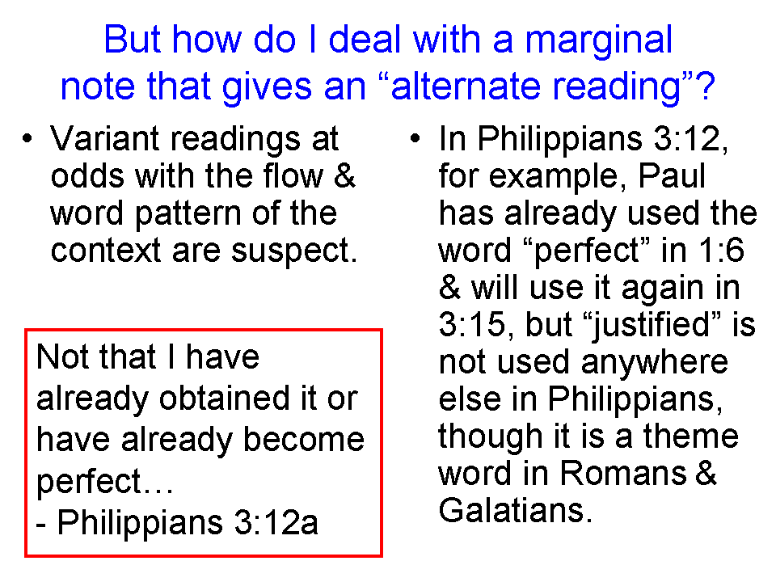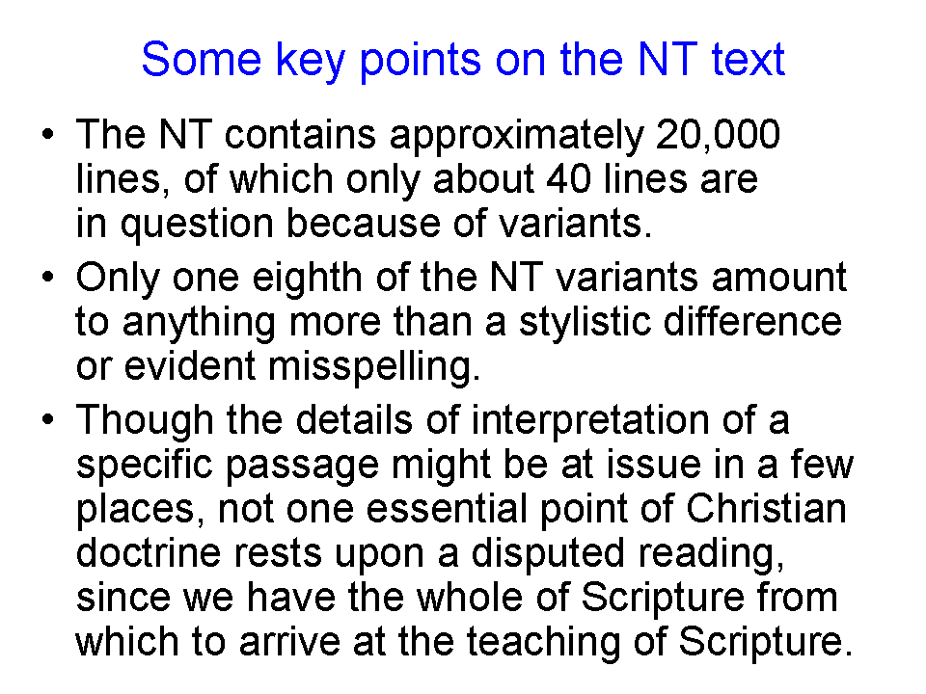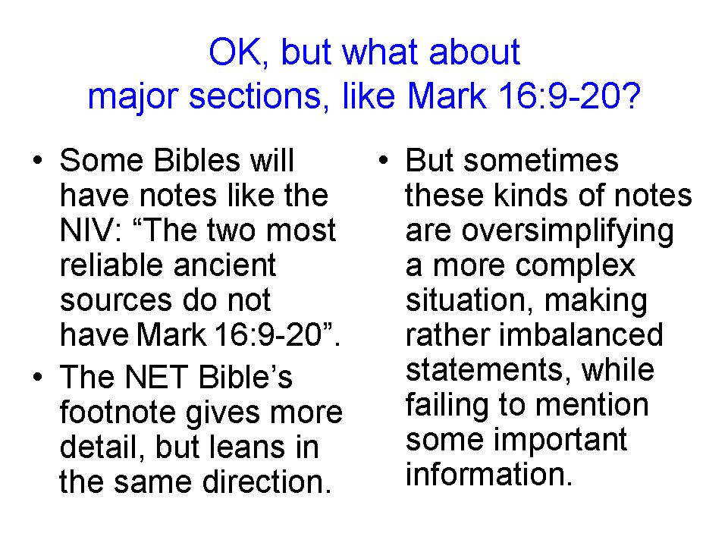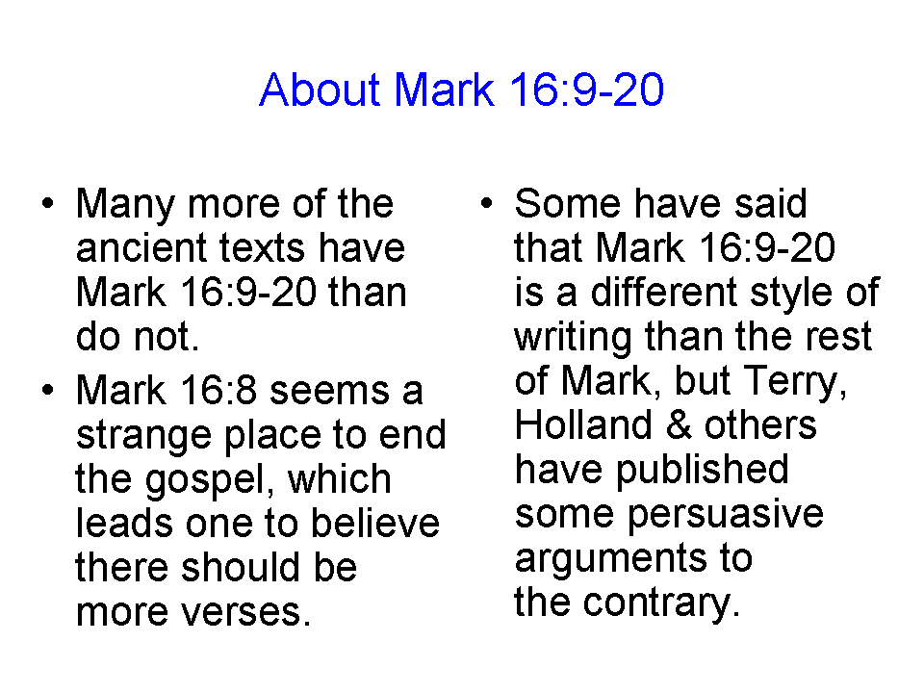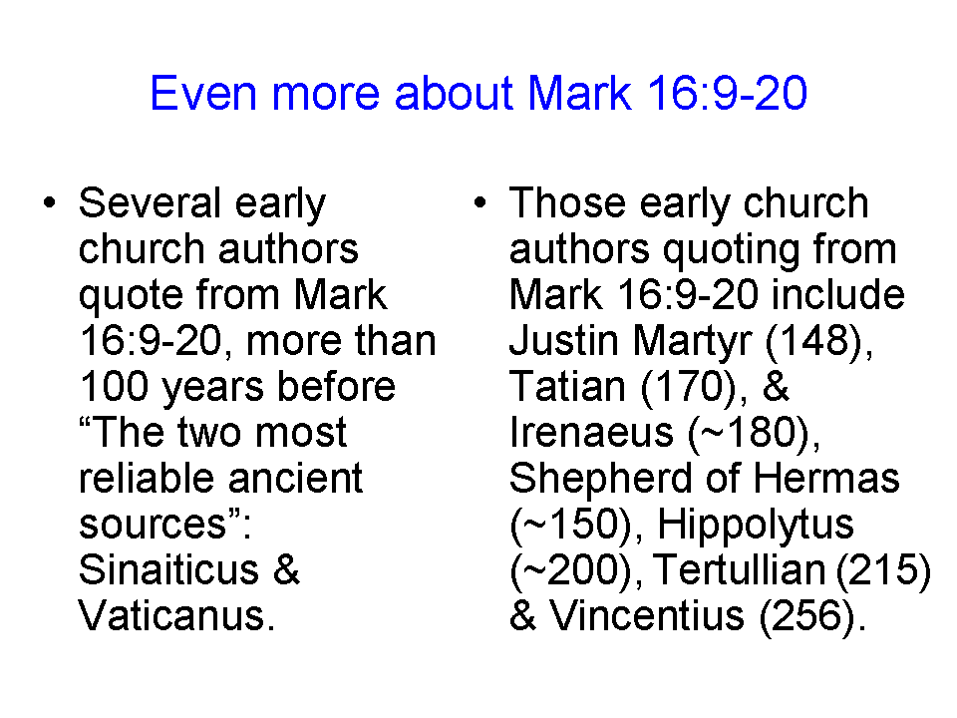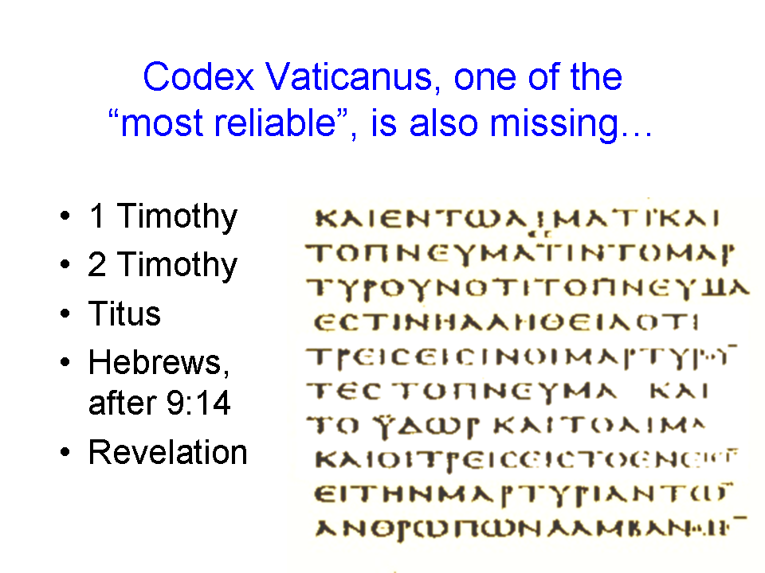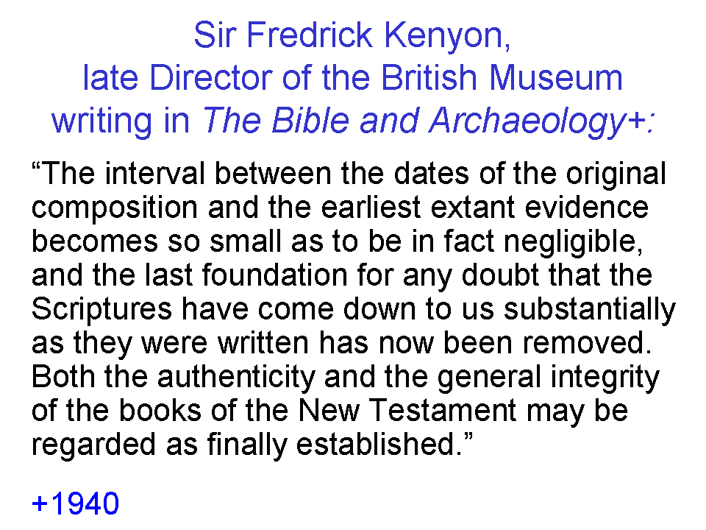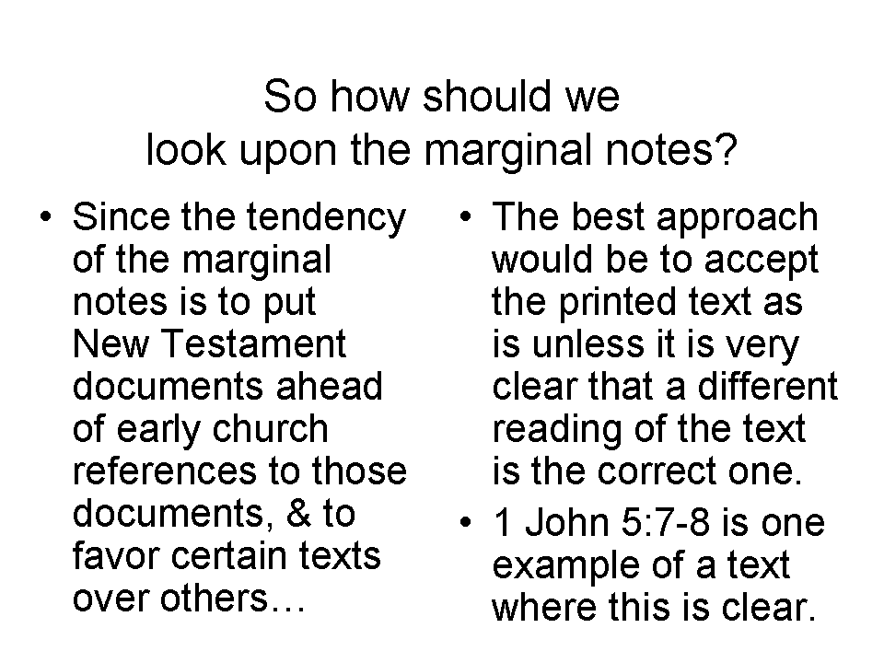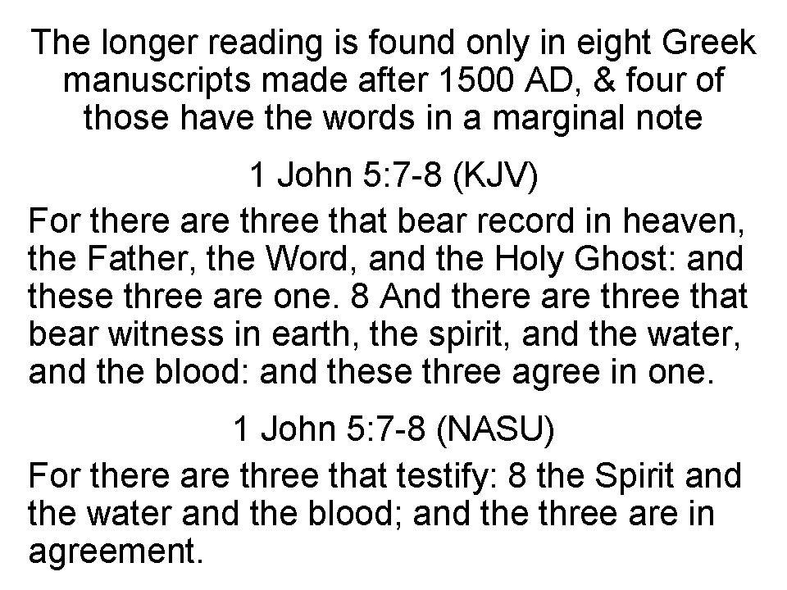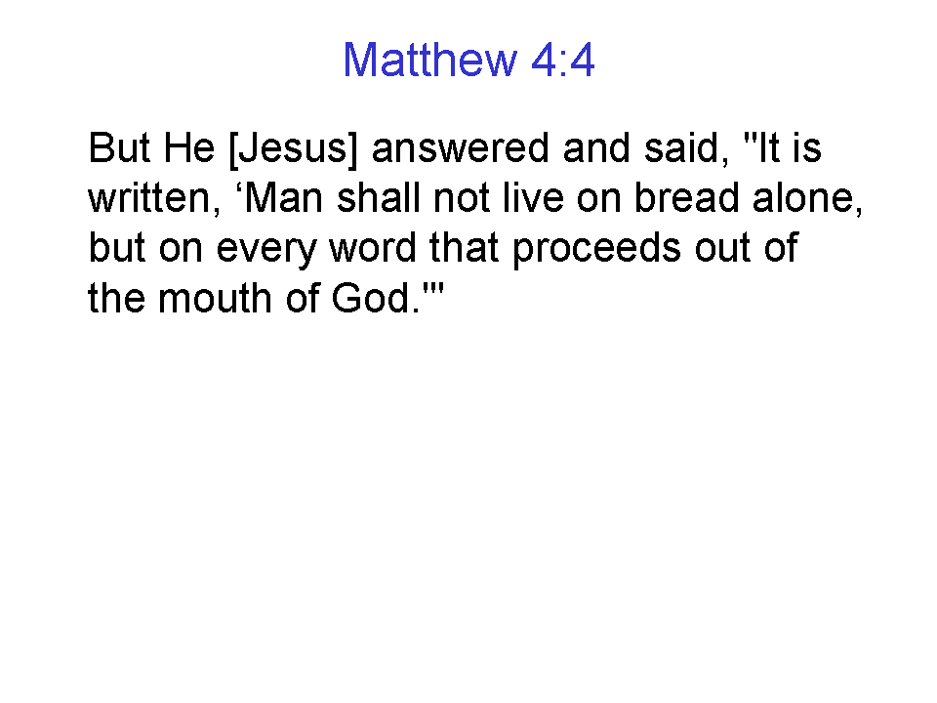

Textual & historical evidence regarding John 7:53-8:11

Textual Evidence:
The passage is missing from Vaticanus and Sinaiticus, as well as L, N, T, W, X, Y DELTA, THETA, PSI, 053, and 0141 among the uncial manuscripts. It is also missing from several of the minuscules manuscripts; 22, 33, 157, 209, 565, 1230, 1241, 1242, 1253, and 2193.
However, the passage is in numerous uncials, including Codex D (Bazae Cantabrigiensis), G, H, K, M, U, and GAMMA. Among the minuscule/cursive manuscripts it is in 28, 700, 892, 1009, 1010, 1071, 1079, 1195, 1216, 1344, 1365, 1546, 1646, 2148, and 2174. It also is in early translations such as the Bohairic Coptic Version, the Syriac Palestinian Version and the Ethiopic Version, all of which date from the second to the sixth centuries, as well as in the majority of the Old Latin manuscripts and the Latin Vulgate by Jerome.
The implication of some critics that 7:53-8:11 may as suitably be placed somewhere else--by noting that some few MSS. place the passage after John 7:36 (ms. 225), John 21:25 (ms. 1), or Luke 21:38 (family-13 mss.)--loses force when we see that placing John 7:53-8:11 after any of these verses is far from satisfactory compared to where the Received Text places it.
Historical Evidence:

Papias, who was a disciple of John, seems to have known this story and to have expounded on it. Eusebius, an early church commentator expounds on Papias story.

Jerome (A.D. 346-420) says that in his time it was contained in "many Greek and Latin manuscripts", and these must have been as good or better than the best manuscripts we now possess..

The passage is cited by a number of Church Fathers. Among them are Didascalia (third century), Ambrosiaster (fourth century), Ambrose (fourth century), and is in the Apostolic Constitutions, which are the largest liturgical collections of writings from Antioch Syria in about 380 AD.

After citing the forgiving phrase from Christ, "Neither do I condemn thee: go, and sin no more," Augustine (354-430) writes: 'This proceeding, however, shocks the minds of some weak believers, or rather unbelievers and enemies of the Christian faith: inasmuch that, after (I suppose) of its giving their wives impunity of sinning, they struck out from their copies of the Gospel this that our Lord did in pardoning the woman taken in adultery: as if He granted leave of sinning, Who said, Go and sin no more!'

The testimony of ancient lectionaries, which gave careful directions for the omission of these verses in the lection read in the church at Pentecost, shows that the verses were an honored portion of scripture in the church in ancient times.

http://www.revelationwebsite.co.uk/index1/lessons/John7_8.htm
ibid
http://members.aol.com/basfawlty/pericope.htm
http://www.kaleo.us/John/THE%20ROCK%20AND%20A%20HARD%20PLACE.doc
http://www.gospelcom.net/eword/comments/john/four/john7.htm
http://www.revelationwebsite.co.uk/index1/lessons/John7_8.htm
(St. Augustine, De Conjug. Adult., II:6.).
Burgon, "Appendix I: Pericope de Adultera," in Causes of the Corruption of the Traditional Text of the Holy Gospels, ed. Edward Miller, 1896 [reprint: Dean Burgon Society], p. 253-259.

