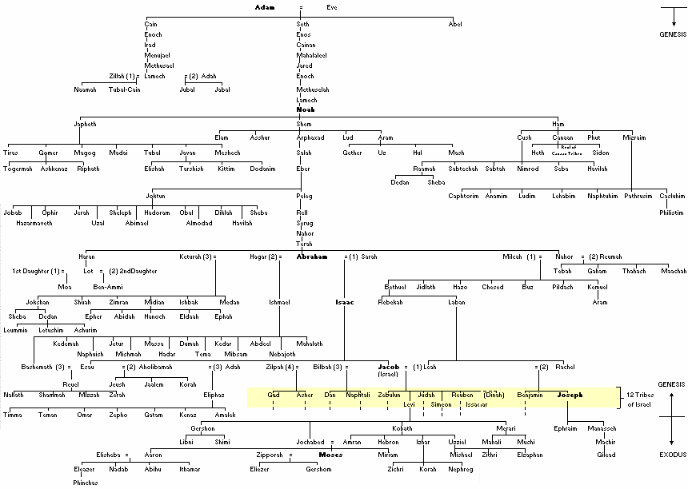
http://www.lukemastin.com/diary/bible_family_tree.gif
Used by permission of the author granted February 15, 2008
The post-Babel generations

