Introduction: Why Study This Stuff? Uh, What Stuff?

What is Biblical Anthropology?

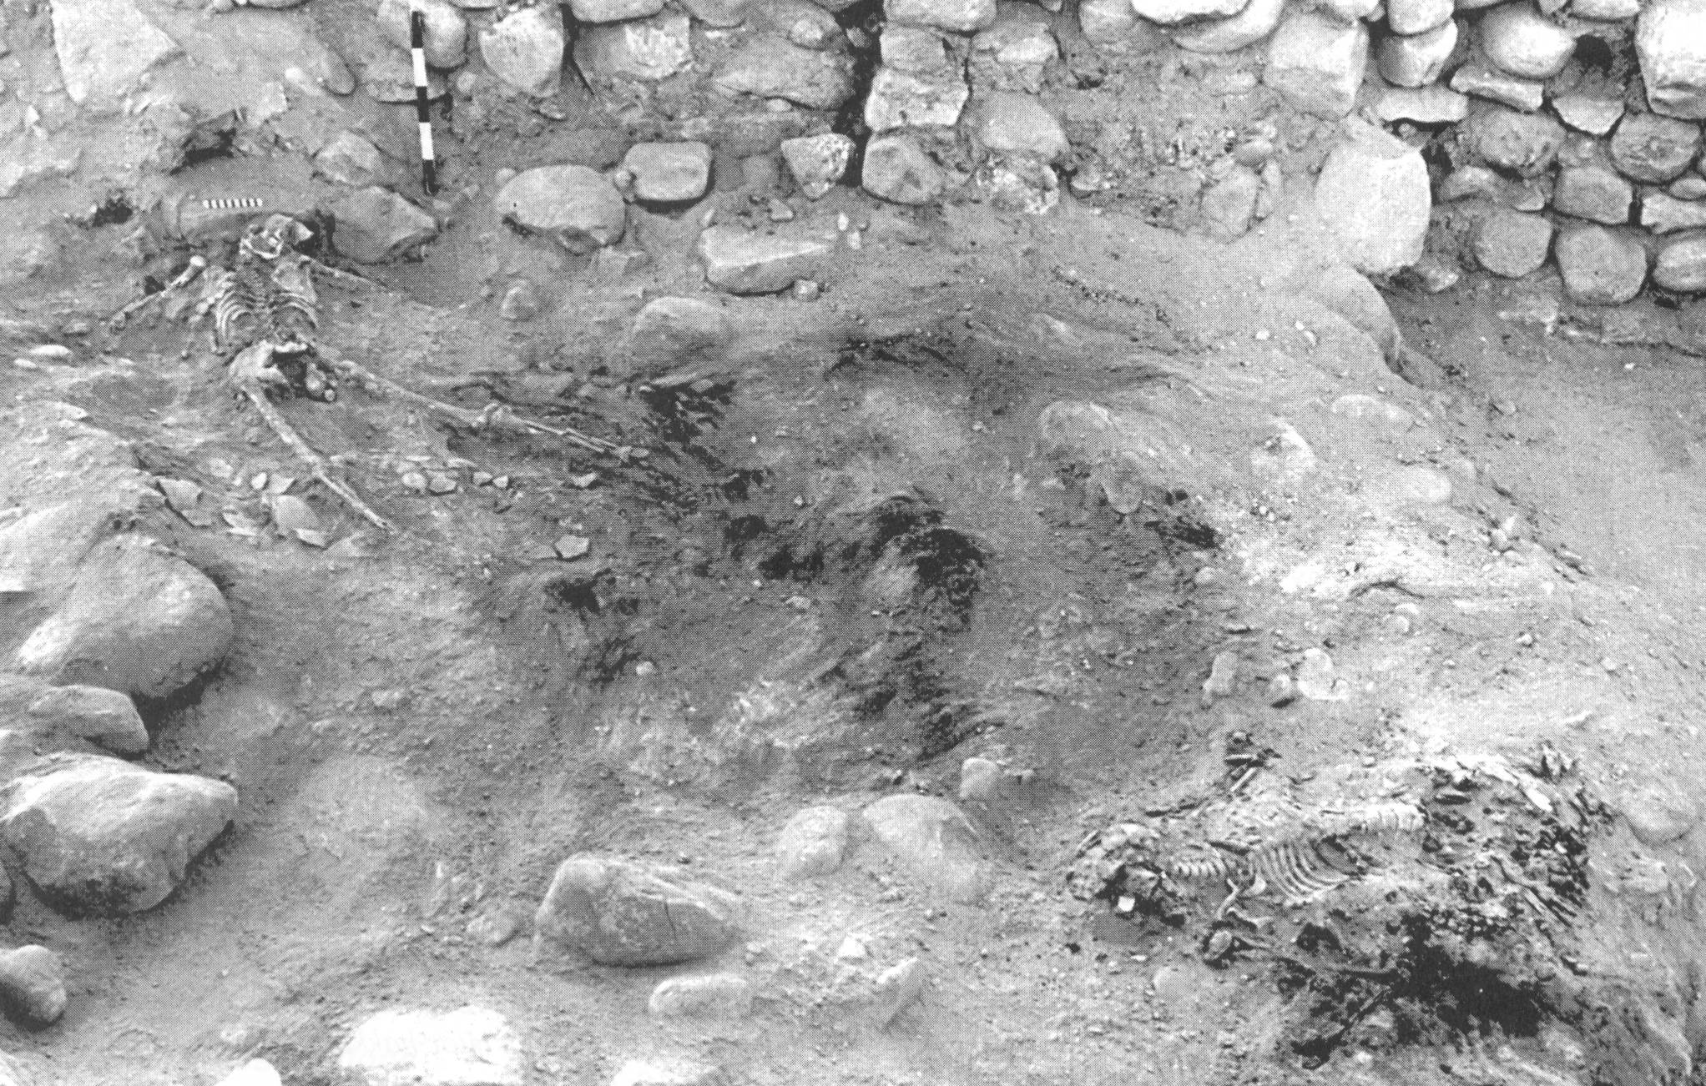
Anthropology is the study of man, as in ‘mankind’, taken from the Greek word anthropos. The study of mankind from the human and secular viewpoint includes cultural and physical anthropology, which, while quite fascinating, and useful in several respects, is the human viewpoint of mankind. Anthropology from a purely human viewpoint, even though it has a realm of validity and usefulness, is not explicitly inspired by God, does not have the Creator’s insights into mankind, nor can it address God’s eternal purpose in His creation of mankind.
Numeira archaeological site, 1977 Associates for Biblical Research

But biblical anthropology is the study of what the Bible says about mankind. Since all of God’s word is God’s uniquely inspired message to human beings, what the Bible has to say about human beings is a very special message. God’s word provides insights into mankind from God’s perspective that secular anthropology, however interesting and fascinating, cannot hope to provide. And God’s word provides truth that comes with a certainty and personal impact for the believer that makes it unique.

Since the Bible has a very great deal to say about mankind, biblical anthropology is potentially a very large topic. But our purpose in this study has a very specific direction:

We are examining what the Bible says about mankind in order to build up the body of Christ, and as a key part of our foundation for learning about biblical counseling.

For this reason, the focus of our study will include topics and have an emphasis that will provide an understanding of what God’s word says about mankind for the purpose of biblical counseling within the body of Christ. Let’s briefly examine the topics we will cover in this elective…

Made in God’s Image, Male & Female

The primary insights for this part of our study will be from Genesis chapters 1 and 2. The specific passages within Genesis 1 and 2 will be: 1:26-31; 2:4-25. These passages will tell us a number of important truths, including that:

- God had a specific design and intent for mankind
- God made mankind in His image and likeness, male & female
- God directly gave Adam life in a separate action from the animals
- God made male and female separately, and each was made in a different way
- God had a specific intent for the relationship between the man and the woman

The term ‘image and likeness’ has a particular pattern as we trace it through Scripture.

The Fall: Separation & Everything That Goes With It

In the events recorded in Genesis chapter 3, and expressly with the sin of Adam, mankind fell from a place of moral and spiritual innocence to a place of separation from God which Scripture calls ‘death’. That death of separation had within it a number of consequences for Adam (who was named in Genesis 2:20), for Eve (who was named in Genesis 3:20), and for the earth and all its creatures. The importance of understanding death as defined by separation will become apparent as we proceed through the relevant passages of Scripture – especially when we examine the identification truths. As we will see, what a person is joined to and separated from makes all the spiritual difference!

How is a Person Saved & What is Salvation?

What we find as we examine both the Old Testament and the New Testament is that since Adam sinned in the Garden of Eden, salvation has always been and always will be by faith in God’s provision (Genesis 15:6; Isaiah 12:2; 53:1; Habakkuk 2:4; Acts 16:31; Romans 4:1-25; Galatians 3:6-9). Though salvation has had a different expression and character among varying times and people groups, we will be focusing on the expression and character of salvation in regards to the Church. This is given for us primarily in the book of Acts and the New Testament epistles. Salvation as described in God’s word has an impact on a believer’s past, present and future.

What Makes Up a Human Being? Saved or Unsaved?

There is an abundance of relevant vocabulary in the Bible that it will be well for us to understand, such as:

- Body, flesh
- Mind. Intellect, emotions, heart, will, heart, soul
- Spirit, spiritual

We will be taking a look at how these aspects of a person differ in character between an unbeliever and a believer.

How Many Different Kinds of People Are There?

Though all human beings are of one original source (Adam and Eve, as created by God), there are many human ways of differentiating between them (race, income level, educational level, political affiliation, etc.). But the New Testament letters, especially those of Paul, make a spiritual distinction among people that places them in three basic spiritual categories:

- unsaved or natural
- saved but fleshly and unspiritual
- saved and spiritual

We will examine passages in 1 Corinthians and Galatians to clarify the spiritual distinction between these three types of people.

Identification Truths

The identification truths, explained principally in Paul’s letters to the Romans, Galatians, Ephesians and Colossians, state that believers in the body of Christ have been identified with Christ in His:

- Death
- Burial
- Resurrection
- Ascension
- Seating in the heavenlies

Scripture spells out the consequences of our identification with Christ in these things, impacting the believer’s past, present and future. The identification truths create a pivotal difference between the secular view of a person’s past and the believer’s view of his or her past, since a believer’s identification with Christ exchanges his or her personal history for Christ’s history. The identification truths also make a momentous difference in the present, since we find that we have ‘alive to’ and ‘dead to’ relationships that radically impact how we live – and who does the living.

Old Man, New Man, Old Nature, New Nature, Will

With these insights, we begin to understand our spiritual anatomy much more clearly. The letters of Paul, particularly, use terms like Old Man and New Man, Old Nature and New Nature, with consistency. But believers often do not understand these truths with consistency, nor do they commonly grasp their importance. Our examination of the relevant passages that explain these terms will give us insight into how the Christian’s life is intended to be lived. Our study of those passages will also give us an understanding of the place of the human will alongside God’s will.
Made in God’s Image, Male & Female

Created in His image begins with ‘Us’ & ‘Our’

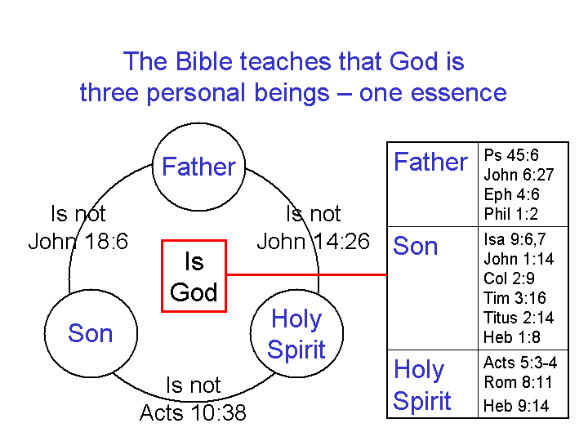
Aside from Genesis 1:26, the use of ‘Us’, ‘Our’ or ‘We’ in reference to conversation or interaction between the persons of the Trinity also occurs in Genesis 3:22; 11:7; Isaiah 1:18; 6:8; John 14:23; 17:21.
The use of ‘Us’ and ‘Our’ in Genesis 1:26, reveals a conversation and agreement to the point of action involving the persons of the Godhead alone (The Father, the Son & the Holy Spirit). This is important, not only for what it reveals about the nature of God, but because of what it reveals about image in which mankind was created, since the image was His.

Image & likeness: What’s the difference?
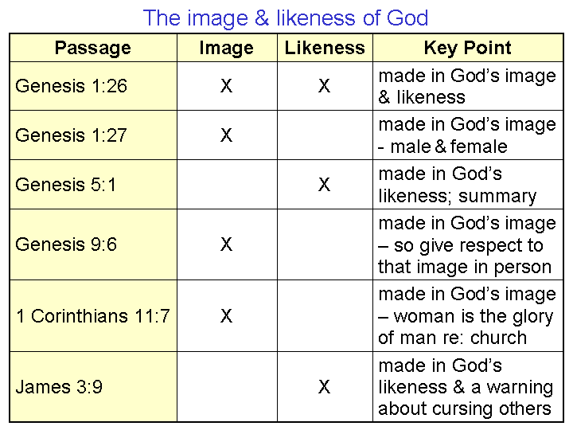
Though it is possible through word studies to arrive at a slight difference of definition for ‘image’ and ‘likeness’, a comparison of the use of the two words in Old and New Testaments seems to indicate that the words were, in this instance, intended to be virtual synonyms, as the chart to the left indicates.

What is the image & likeness of God in mankind?

Though there have been many pages written in an attempt to explain what it meant for mankind to be created in the image and likeness of God, the simplest and best answer seems to be:

What is similar in character to God in mankind is ‘the image and likeness of God’.

That creation in ‘the image and likeness of God’ in Genesis 1 refers to the original state of creation. After the fall, which is recorded for us in Genesis 3, the image and likeness of God remains, but is marred. In the next chapter we will examine in more detail what that ‘marring’ means for mankind born since the fall. Here are some key aspects in which mankind was created in God’s image:

• It is a personal image and likeness (Genesis 2:19-23).

• It is a spiritual image and likeness (1 Corinthians 15:45).

• It is a moral image and likeness (Ephesians 4:22-24; Colossians 3:9-10).

• It is an interpersonal image and likeness (Genesis 1:26; 1 John 1:3)

• It is an authority image and likeness (Genesis 1:26, 28)

• It is a creative image and likeness (Exodus 25:8,9)

Well, then, in what ways do humans differ from God?

The simple definition for the image and likeness of God that was used above also tells us what is of God’s nature or character that is not in man, including:

• God is not physical (John 4:24), except as Jesus Christ later was born as a human (Luke 1:26-38), but remained deity (Philippians 2:5-8).

• God is eternally righteous by His very character (Psalm 145:17; 1 John 2:29; 3:7), but man was initially created innocent (Genesis 1, 2).

• Mankind was created in the context of a time based universe, but God is not subject to time (Psalm 106:48; John 8:58), which is basic to this creation.

• God is infinite in His character (1 Chron. 16:34), but mankind is finite (Psalm 55:9).

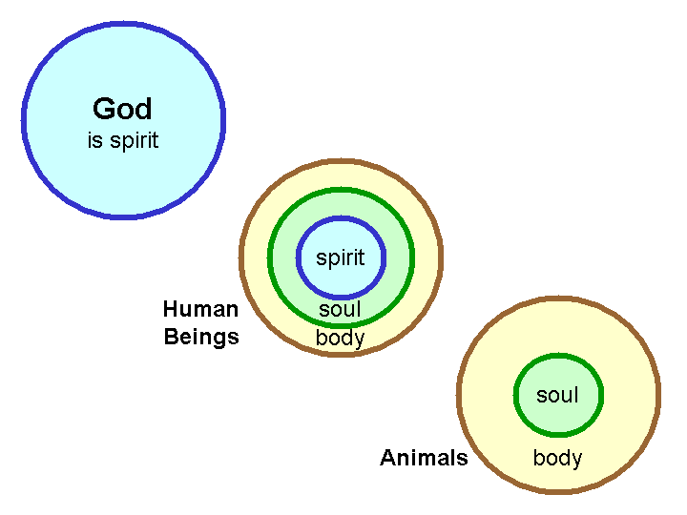

Male & Female He created them

There have been those who said that it takes both male and female to express the image of God. But maleness and femaleness seem to be distinctions set for this present earth and a time-based mode of existence (Matthew 22:30). Additionally, if we look at the list of ways in which mankind was created in His image and likeness, we find that neither maleness nor femaleness exclude any of those basic attributes. So it seems better to understand maleness and femaleness as distinctions of a lower order than being “created in the image and likeness of God”. Maleness and femaleness, biblically speaking, have at least these distinctions:

- Distinctions for reproductive purposes (“be fruitful and multiply).

- Distinctions for marriage relationship and family role purposes (Genesis 2:24).

- Distinctions later set out in the Law of Moses in great number, and within the Church.

- Distinctions within a culture as set out later so as to keep maleness and femaleness clearly defined.

As we will see later, the fall (Genesis 3) also had some impacts upon the above-listed distinctions and how those are carried out.
The Fall: Separation & Everything That Goes With It

The Genesis 3 pivot point

The event that is narrated for us in Genesis 3 provides some historical detail of the event typically called “The Fall” or “The Fall of Mankind”. The consequences of that event are given briefly in Genesis 3, with further explanation of that event and God’s manner of dealing with it in the rest of Scripture - all the way to the last chapters of Revelation. Though there are quite a number of things that we could see in Genesis 3, for our purposes here (What does God’s word say about mankind?) we will want to focus upon the character of fallen human beings as God has revealed through Scripture.

What God’s warning tells us

God said several things to Adam in the 6th day, but the critical one for our study today is found in Genesis 2:17:

Genesis 2:15-17
Then the LORD God took the man and put him into the garden of Eden to cultivate it and keep it. 16 The LORD God commanded the man, saying, "From any tree of the garden you may eat freely; 17 but from the tree of the knowledge of good and evil you shall not eat, for in the day that you eat from it you will surely die."

It was this last line that was the subject of the serpent’s deception of Eve (Genesis 3:1-4). First the serpent questioned what God said, then denied what God said, and finally the serpent couched the ultimate human tragedy as some sort of a benefit or advantage that God was denying them.

“…in the day that you eat from it you will surely die."

The big question is, “What did God mean by ‘die’, and how does that definition of ‘die’ fit with the death that happened on the day that Adam ate?” The assumption of classical Calvinism is that the death God warned about meant that Adam and all mankind would be the spiritual equivalent of being ‘out on a slab, cold, dead as a corpse, unable to respond’. From that assumption the classical Calvinist develops a logical sequence regarding the person who is saved that goes like this:

elected by God > regeneration > gift of faith > belief > salvation

We will not directly pursue the flaw in that assumption and its consequences, except to say that what Scripture does teach is that death is not ‘out on a slab, cold, dead as a corpse, and unable to respond’ but rather that death is separation. Mankind is spiritually separated from God by sin, and that death has a variety of different expressions and consequences.

Death is separation

The insight that death is separation would mean that God was telling Adam, “…in the day that you eat from the tree of the knowledge of good and evil you will be spiritually separated from Me, your Creator”.

That separation because of sin was expressed to Israel by the prophet Isaiah:

Isaiah 59:2
But your iniquities have made a separation between you and your God,
And your sins have hidden His face from you so that He does not hear.

The above passage, as part of the Isaiah 59:1-15 content, expressed separation between God and the people of Israel because of sin. But most of the passages that clearly reveal that death is separation come from the letters of the apostle Paul. Here are a couple of clear instances of where Paul says that death is separation:

Ephesians 2:1-3
And you were dead [there’s that word] in your trespasses and sins, 2 in which you formerly walked according to the course of this world, according to the prince of the power of the air, of the spirit that is now working in the sons of disobedience. 3 Among them we too all formerly lived in the lusts of our flesh, indulging the desires of the flesh and of the mind, and were by nature children of wrath, even as the rest.

Ephesians 2:12
…you were at that time separate [chōris] from Christ, being aliens [apallotrioō] …without God [atheos] in the world.

Ephesians 4:18
“…excluded [apallotrioō] from the life of God…”

Colossians 1:21
“…you were formerly alienated [apallotrioō] and hostile in mind …”

The word chōris means to be separate from or apart from, and apallotrioō means to be separate or alienated.

Death as separation, as being ‘dead in relationship to and alive in relationship to’ is also taught in these other passages in the apostle Paul’s letters:

- Romans 6:1-11 – dead to sin, alive to Christ
- Romans 7:1-6 – death releases from marriage; died to the Law, joined to Christ
- 2 Corinthians 5:14,15 – dead to ourselves, alive to Christ
- Galatians 2:19, 20 – died to the Law, to live to God; dead to ourselves, alive to Christ
- Colossians 2:20 – died with Christ to the elementary principles of the world
- Colossians 3:5, 20 – dead to sin, died with Christ to the world
And in 1 Peter 2:24 we read:

and He Himself bore our sins in His body on the cross, so that we might die to sin and live to righteousness; for by His wounds you were healed.

The Genesis 3 chiasm

When God came to walk with Adam and Eve, they attempted to cover themselves and to hide themselves from God (now there’s new evidence of separation). God began with questions, and in summary, the interactions went as follows:

God to Adam - questions

God to Eve – a question
God to the serpent – no questions, but consequences & the promise of a Savior

God to Eve - consequences

God to Adam – consequences

God prepares a covering for them (the ones that they made would not do), and an animal was sacrificed to do so – God’s sacrifice. Regarding the consequences of the fall for mankind and it’s personal impacts, Eve’s consequences would be in childbearing and in relationship to her husband (“…your desire will be for your husband, and he will rule over you”). Adam’s consequences would be to this earth, his toil in gaining a yield from it, and in returning to the dust from which he was created.

Notice that while the passage lays out consequences for Eve and for Adam, they are consequences of the separation from God that has already taken place because of Adam’s sin. And the consequences are not yet complete at this point. Adam and Eve will be driven from (from = separation) the Garden of Eden in order to keep them from (from = separation) the tree of life. The separation from God because of Adam’s sin has resulted not only in a change in mankind’s relationship with God, a change in mankind’s relationship with everything that God had made, a change within human beings and their bodies, and ultimately a change in every human being’s future from that time forward.

What we haven’t covered – yet

Every topic yet on our schedule for the weeks ahead has not been addressed here:

- How is a Person Saved & What is Salvation?
- What Makes Up a Human Being? Saved or Unsaved?
- How Many Different Kinds of People Are There?
- Identification
- Old Man, New Man, Old Nature, New Nature
- The Will of The Believer

The impacts of the fall of mankind were immense... so immense that we will not have time to touch upon all of the many devastating consequences of Adam’s sin.

But we will take a deeper look at the character of fallen mankind and of the ones who are saved.
How is a Person Saved & What is Salvation?

Salvation...so what?

The Salvation that Christ has won for us is a truly amazing thing. It is simple enough that a child can understand it, yet it is so unfathomable that in 2000 years believers have still not exhausted the subject in song, poetry, writing, or study. But why is it so very important that we continue to study this salvation that we have if we know that we are saved? Obviously we must know the gospel in order to be saved. Furthermore, if we don’t understand the gospel we will not understand our relationship to God after we have been saved. Finally, if we don’t understand our salvation how can we share the gospel with others as the Lord absolutely intends for us to? This teaching that seems so simple, so clear and almost remedial, but is of immense importance for us to understand fully and clearly. If we don’t understand the gospel we will never reach spiritual maturity, or fulfill God’s purposes that He wants to work through us in our lives. The stakes are very high!

The Need

Last week we talked about the Fall and how the need for salvation was established. When Adam ate the fruit and disobeyed God he fell from his state of innocence and immediately died (Genesis 2:16-17). The chasm was so great that man would never be able to bridge it. God told Adam that on the day he ate the fruit from the tree of the knowledge of good and evil he would die, and die he did. Adam did not die physically, however the death he died was a much deeper and more horrible death, the death he died was a spiritual death: Adam was separated from the God who made him. Included in Adam, as the corporate head of humanity, we all died with Him (Romans 5:15-21). We were all separated from God with no hope of doing anything on our own to merit a return to relationship and fellowship with Him.

Throughout the Old Testament the need for a savior was highlighted, reiterated and alluded to. Noah must have sat aboard the ark, tossed by waves, with the countless people outside having just perished, thinking about man’s need for a savior. Moses knew his uncleanness very clearly as he talked with God and was unable to behold God’s glory. As the Israelites celebrated the Passover, the Passover itself pointed to the Savior. Surely all of the saints of the Old Testament saw very clearly: I have no righteousness of my own, I can’t do this by myself, the only way I can have fellowship with God is by His grace and mercy (Psalms 51:4; 14:1-3; Isaiah 6:5).

How to be Saved

God in his mercy and grace has given us a number of verses that explain the gospel so clearly and so simply that it is not beyond the understanding of a child:

John 3:16
For God so loved the world, that He gave his only begotten Son, that whoever believes in Him shall not perish but have eternal life.

Romans 5:8
But God demonstrates His own love toward us, in that while we were yet sinners, Christ died for us.

1 Corinthians 15:3-4
For I delivered to you as of first importance what I also received, that Christ died for our sins according to the Scriptures, and that he was buried, and that he was raised on the third day according to the Scriptures.

Even though these verses (and a number of others) make the concept of salvation incredibly clear it is shocking to find out that it wasn’t until about 1100 AD that someone (Anselm by name) finally put in writing that Scripture taught that Christ in his death on the cross was taking our place as a substitution for the penalty that was due to us. Prior to this the idea that Christ’s death was somehow paying off the Devil for our souls, as if God owed Satan something to ransom us from Him. It becomes very clear that Salvation is not something that we can do for ourselves (Ephesians 2:8,9; the entire book of Galatians). Salvation can never be attained by works, it is only by faith in Christ, as the above verses explain, that a person can be saved, and by no other means.

Faith plus what?

It has been the mission of heretics since the dawn of Christianity to add something to faith in Christ to get to salvation. The Gnostics may have said faith, but they would have quickly added: “Plus this other secret knowledge I have for you.” Satan has been able to fuddle the world very easily by trying to give the impression that Christ’s sacrifice gave us the ability to start earning our salvation. The most seductive traps of these kinds are those that want to add some religious duty to what in the Bible. In order to be saved we must add to faith: baptism, the sacraments, communion, confirmation, giving a certain amount of money, and the list goes on and on and on. However if we look at what the Bible says we find quite a different story. When The Philippian jailor asked Paul what he must do to be saved Paul did not answer: “Well first you have to give me twenty bucks, then we’ll get you baptized, then you can come to the introductory meetings, and after that…we’ll see!” No, Paul was very clear with him: “Believe in the Lord Jesus, and you will be saved, you and your household.” (Acts 16:31) That’s pretty clear! Even more shocking in 1 Corinthians 1:14 we find Paul thanking God for his NOT baptizing people! How shocking and morbid this would be if baptism were some sort of prerequisite to salvation.

However, more than anything else it must be understood that if anything could be added to our salvation by faith as the free gift of God it would no longer qualify to be called grace. If there were one penny to repay, it would not be grace. If there were one work to do, it would not be grace. If there were one thing that was expected, it would not be grace. In order for this salvation to be by “grace” there can be nothing else attached to it. It would be like those advertisements that offer something for free, but once you walk in the door you find out that you actually have to spend a certain amount to get the free gift! THAT IS NOT A GIFT!

A Word on Security
This is another misunderstanding that comes from not understanding the gospel properly. Many people think they can lose their salvation because they simply don’t understand what salvation is! If someone gives you a car and then sends you an invoice for monthly payments that car is not a gift. Therefore, anyone operating under the fantasy that we would even be able to KEEP our salvation if we had the ability to lose it has no real understanding of the Gospel, of the Cross or of the God who gave us both! A literal translation of John 10:28 would be translated: “And I am constantly giving the life eternal, and it is not even remotely possible for them to destroy themselves into eternity nor for any to steal them by force out of the hand of me.” The Greek text of this verse makes it even more clear than most English translations (which also make it quite clear) our salvation is about God’s competence and not ours. If our salvation were to fail it would be because Jesus, who is the author and perfecter of our faith (Hebrews 12:1-2), failed in saving us: the absurdity of the very idea is beyond belief!

Conclusion
Often times we are tempted to overcomplicate the Gospel by our intellectual machinations. It gets complicated by the world, the flesh and the devil. The threefold enemy of the believer (and more to the point the threefold enemy of God) will do anything in their power to cloud, confuse, erase, cover or fuddle the gospel in the minds of both believers and unbelievers if they can. We must stand by faith on the word of God in the ever darkening world (Ephesians 6:10-17).
What Makes Up a Human Being? Saved or Unsaved?

Two key issues

When we talk about what makes up a human being, there at least are a couple of principle issues that are debated, and which we must sort out using God’s revelation through Scripture as our ultimate guide:

- Is mankind only material – or is mankind material and spiritual?
- Is mankind composed of two parts (body & soul, in which the soul is exactly the same as the spirit) or three parts (body, soul & spirit)?

One lump, or two?

As to the first issue, secular sciences that seek to study human individuals and their groups (psychology, sociology, anthropology) typically have a non-spiritual assumption. It is not that these sciences prove that man has no spiritual aspect based on the facts, but rather that among the common unverifiable assumptions that are basic to the secular pursuit of these sciences, only discoveries from the physical side of reality are allowed within the realm of science. Scripture, however, reveals truths that cannot be known by mankind apart from God’s deliberate revelation, including truths regarding the physical realm (God created the entire world, and created Adam from the dust of the ground and Eve from him).

Two lumps, or three?

Among those who study Scripture, there has been an ongoing debate as to whether a person is composed of two parts (body & soul, where soul = spirit) or three parts (body, soul & spirit). At times, the
debate has been elevated (?) to high decibels and low name-calling. When the dust clears, however, Scripture says consistently that a person is both a physical being and a spiritual being (two parts of reality and of mankind, mankind being in each part of reality). The various words that refer to the spiritual side of a person, in whole or in part, often refer to distinctions within the spiritual side of man, and are not really in conflict with the two part view of a person, but only look at particular subdivisions of those two parts (i.e., soul, spirit, heart, mind, etc.). Two passages that seem to make a clear and particular division between soul and spirit are:

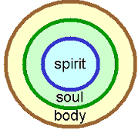1 Thessalonians 5:23
Now may the God of peace Himself sanctify you entirely; and may your spirit and soul and body be preserved complete, without blame at the coming of our Lord Jesus Christ.

Hebrews 4:12
For the word of God is living and active and sharper than any two-edged sword, and piercing as far as the division of soul and spirit, of both joints and marrow, and able to judge the thoughts and intentions of the heart.
OK - Three lumps

Scripture uses a number of words to describe or refer to different parts or aspects of a person, but the three part understanding (body, soul and spirit), is a good and biblical foundation for looking at the composition of a person, whether an unbeliever or a believer (see Appendix Item 3 by Hal Molloy). Though what God has revealed about human beings is not an analytical model with tight definitions, these distinctions can be made and are helpful to our understanding of what God reveals about the composition of a person.

Body: The body of a person (believer or unbeliever) is what exists in, and interacts with this present physical world. A living person is one whose soul and spirit are still joined to the body in this present world, but when a person dies physically, that is when the soul and spirit have left the physical body (since death is separation).

Soul: The immaterial and eternal part of a person that is the interface between a person’s physical being and one’s spiritual being. The soul is the center of consciousness of self, and has the aspects of mind, emotions, and will.

Spirit: The immaterial and eternal part of a person that is the point of interaction with God, for those who believe, and the point of spiritual separation from God, for those who do not believe.

Five senses both ways

Human beings have five senses in the physical realm, whether an unbeliever or a believer: touch, hearing, smell, sight and taste. Depending upon the individual, one or more of those physical senses may be limited or nonfunctional. But an examination of Scripture indicates that there is a spiritual analog for each one of these five senses (see also Ephesians 4:19, next page: “and having become callous” KJV: being past feeling):

Ephesians 1:18-19a
I pray that the eyes of your heart may be enlightened, so that you will know what is the hope of His calling, what are the riches of the glory of His inheritance in the saints, 19 and what is the surpassing greatness of His power toward us who believe.

1 Peter 2:1-3
Therefore, putting aside all malice and all deceit and hypocrisy and envy and all slander, 2 like newborn babies, long for the pure milk of the word, so that by it you may grow in respect to salvation, 3 if you have tasted the kindness of the Lord.

Hebrews 5:11-14
Concerning him we have much to say, and it is hard to explain, since you have become dull of hearing. 12 For though by this time you ought to be teachers, you have need again for someone to teach you the elementary principles of the oracles of God, and you have come to need milk and not solid food. 13 For everyone who partakes only of milk is not accustomed to the word of righteousness, for he is an infant. 14 But solid food is for the mature, who because of practice have their senses trained to discern good and evil.
2 Corinthians 2:14-16
But thanks be to God, who always leads us in triumph in Christ, and manifests through us the sweet aroma of the knowledge of Him in every place. 15 For we are a fragrance of Christ to God among those who are being saved and among those who are perishing; 16 to the one an aroma from death to death, to the other an aroma from life to life. And who is adequate for these things?

These spiritual senses are present in every believer, but have varying degrees of functionality, as some of the passages above reveal. These same spiritual senses in the unbeliever are naturally either non-functional or are with distorted perception (2 Corinthians 2:15-16 above; also 2 Corinthians 4:4). The ministry of the Holy Spirit in unbelievers is to shed light on their personal need for the Savior, Jesus Christ (John 16:5-10). Without the ministry of the Holy Spirit, any spiritual sensibility in the unbeliever would be nonfunctional or severely distorted.

A spiritual summary of the unbeliever
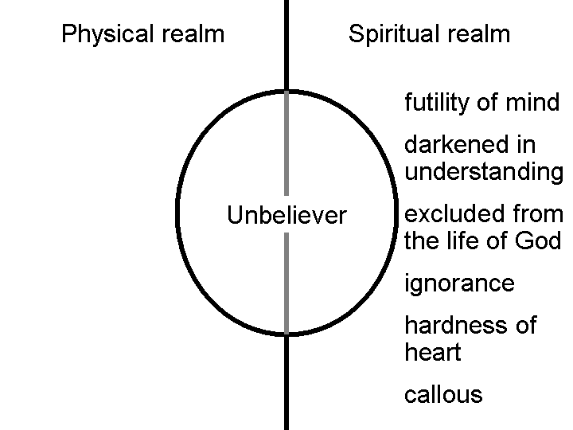
Ephesians 4:17-19
So this I say, and affirm together with the Lord, that you walk no longer just as the Gentiles also walk, in the futility of their mind, 18 being darkened in their understanding, excluded from the life of God because of the ignorance that is in them, because of the hardness of their heart; 19 and they, having become callous, have given themselves over to sensuality for the practice of every kind of impurity with greediness.

A spiritual summary of the believer
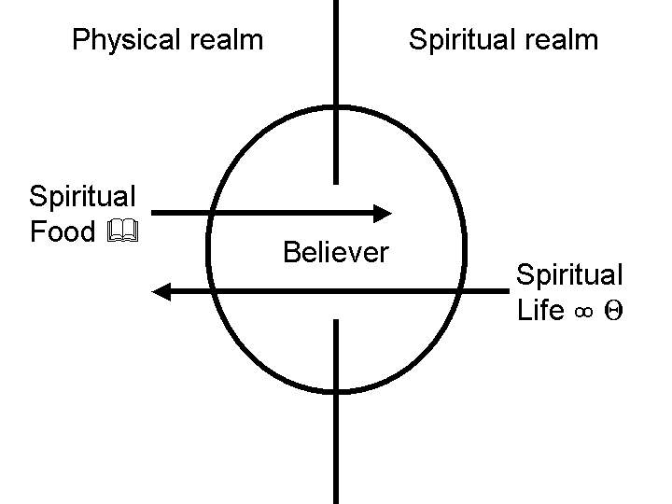
We will continue to examine what God’s word says about the character of the believer in the weeks ahead, but here are two aspects worth highlighting for now:

1) The believer receives spiritual food from God’s word, which is often presented by and through other believers. It reaches the deepest part of the believer (1 Peter 2:2; 1 Corinthians 3:1,2; Hebrews 4:12).

2) The very life of Christ is expressed through the believer to others, whether believers or unbelievers (Galatians 2:20).
How Many Different Kinds of People Are There?

The three types of people (under the Grace Stewardship) are the Natural Man, the Carnal Saint, and the Spiritual Saint. In the Age of Grace, there exist only two reigning principles: the flesh (law) and the Spirit (Grace). Broadly speaking, the first two types of people have in common that they live by the flesh. The second two have in common that they are eternally identified with Christ. The Carnal Saint is the anomaly, for he is walking contrary to his nature. The other two, the Natural Man and the Spiritual Saint, are walking according to their nature.
Flesh
Spirit
Natural Man
Carnal Saint
Spiritual Saint
Three types of People; Two Reigning Principles

The Natural Man

Regarding 1 Corinthians 2:10-16

The Greek for “Natural Man” is “psuchikos,” which means: "belonging to the psuche, soul" (as the lower part of the immaterial in man), "natural, physical," describes the man in Adam and what pertains to him (set in contrast to pneumatikos, "spiritual") (Vines).

The Natural Man, or non-saint, is unable to understand Biblical principles. He is separated from God. He is spiritually in the dark, i.e. lacking spiritual perception. He (the Natural Man) is centered in his Adamic nature, which is eternally condemned before God.

Regarding 1 Corinthians 15:45-50

The Natural Man is earthly, and forever connected to the dust. It is impossible that that which is earthly can have any part with that which is heavenly. The Natural Man can have no connection with Christ.

Regarding Romans 1:18-32

Paul gives a rather unbecoming description of the Natural Man. He is rebellious towards God. He refuses to acknowledge God’s sovereignty. Romans 5:8 describes him as the enemy of God, antagonistically opposed to God. His (the Natural Man’s) mind and reason are darkened. Thus, all his thinking is futile. Because this is true, Natural Man will not voluntarily approach God. God has given the Natural Man over to his rebellious and sensual passions. He perverts and contorts every desire that God has given him. He is in a state of continual sinfulness.

Other passages: Philippians 3:17-21; Ephesians 2:1-3

The Carnal Saint

Regarding 1 Corinthians 3:1-3

The Greek word for “carnal (KJV)” or “people of the flesh (ESV)” is “sarkinos,” which means: having the nature of flesh, i.e., sensual, controlled by animal appetites, governed by human nature, instead of by the Spirit of God (Vines).

The Greek word for “infants (ESV)” is “nepios,” which means: [literally], without the power of speech, denotes "a little child” (Vines). In this context, it refers to “those who are carnal, and have not grown, as they should have done, in spiritual understanding and power, the spiritually immature” (Vines).

The Carnal Saint is one who submits to the control of the flesh instead of walking by means of Spirit. He has not the knowledge, and the faith, to live by the principles of Grace. He is living contrary to his new nature in Christ. He is spiritually weak, so he must eat the “milk”, as opposed to the “meat.” See also Hebrews 5:11-14

Regarding Romans 6:12-14

Even though the flesh is the “deposed dictator,” Paul clearly states that Saints can choose to yield control of their lives to it. They can walk in a manner that is not worthy of their position in Christ. This will result sometimes in immediate sin and sinfulness. It can also mean placing themselves under a law, for to live by a law is to live under the dominion of sin. The Carnal Saint will live in either legalism, or liberality.

Regarding Galatians 3:1-4

The Carnal Saint overlooks the fact that, just as his justification was by Grace through faith alone, so is his sanctification. He continues to live by the flesh. He places himself under a law to make “Old Adam” more acceptable to God. In doing so, he shuns the Grace that has identified him in Christ. He is not walking by faith, but by sight.

Other passages: 2 Corinthians 12:20-21; Galatians 5:15, 26; James 3:14-16; James 4:1-4

The Spiritual Saint

Regarding Galatians 5:16-26

The difference between the Carnal Saint and the Spiritual Saint is wherein lies their faith. The faith of the Carnal Saint is in the flesh. Therefore, the works of the flesh will be evident in their life. The confidence of the Spiritual Saint is in the Spirit, therefore the fruit of the Spirit will be evident in their life.

Regarding 2 Corinthians 3:12-18

A maturing, or growing, saint is not one who learns how to overcome the flesh, or how to live the “proper Christian life.” A maturing saint is one who beholds the glory of Christ and grows in his knowledge of Grace. It is in this person that the Spirit of God reproduces the very virtues of God.

Summary

The Natural Man is eternally identified with Adam. Though his condition may appear similar to that of Christ, he is eternally condemned, for Adam is eternally condemned. The Saint is eternally identified with Christ. Though his condition may appear similar to that of Adam (the Carnal Saint), he is eternally secure, for he is in Christ, forever seated in the heavenlies.

Identification – Part I

Who gets credit for letting us know about identification & how it was accomplished?

Identification is a principle taught in Scripture, principally to believers in the body of Christ. Identification is explained most fully by the apostle Paul, but evidenced in the writings of John and Peter, as well as other authors of Scripture. We can take no credit for either knowing these truths or in what God has accomplished by our identification with Christ. These truths of identification are revealed entirely by the will and actions of God, and the blessings of our identification with Christ are accomplished entirely by God’s infinite, eternal and amazing grace. “Blessed be the God and Father of our Lord Jesus Christ, who has blessed us with every spiritual blessing in the heavenly places in Christ, 4 just as He chose us in Him…” Ephesians 1:3-4a. . While we can find examples of this identification principle applying to other people groups, the teachings that we will focus on here are the identification truths that apply to believers who are in the body of Christ, from Acts 2 to the Rapture, when Christ comes for His bride, the Church.

Identification synonyms

We have used the word ‘identification’ so far, since that is a convenient ‘handle’ for what Scripture teaches. But the actual words used in Scripture that convey this intimately related family of biblical truths include:

- In - being placed entirely in, so as to share an identity
- With - intimately joined in action and consequence
- Together with – as above, with ‘together’ underscoring the same identity & action
- United with – ‘united’ implies a oneness, so a spiritual oneness is communicated
- Baptized into – ‘baptized’ means to be immersed or entirely placed into, so as to be permanently changed by that immersion or entire placement

Later we will address the words and terms that God’s word uses to describe the multiple spiritual outcomes from identification.

First, the bad news

God’s word says that when Adam sinned, we were in Adam in that sin, so were identified with fallen Adam, including the consequences that God said would result from that sin (death – see below):

1 Corinthians 15:22a
“For as in Adam all die…”

As was explained on pages 7 and 8 of this document, death means spiritual separation. Being ‘in Adam’ means spiritual separation from God, and all the ghastly earthly and eternal consequences that go with it. That’s the bad news, and if God had left things there, it would be nothing but totally hopeless, really depressing, eternally bad news.

At first the news only gets worse – much worse:

John 8:24
"Therefore I said to you that you will die in your sins; for unless you believe that I am He, you will die in your sins."

Ephesians 2:1-2, 5a
And you were dead in your trespasses and sins, 2 in which you formerly walked according to the course of this world, according to the prince of the power of the air, of the spirit that is now working in the sons of disobedience….even when we were dead in our transgressions…

Colossians 2:13a
When you were dead in your transgressions and the uncircumcision of your flesh…

But to God’s eternal praise and glory and honor, He did not leave us there in Adam and dead in our trespasses and sins and transgressions.

And now… the really, really good news

Our identification with Christ, mentioned before, is expressed in several different ways, as listed in the ‘bullets’ on the prior page. One of the frequent ways in which that truth is conveyed is that the believer is “in Christ’ as opposed to remaining “in Adam”. That truth is conveyed primarily in the letters of Paul, such as we find in his letter to the believers in Ephesus 36 times in six chapters, including these references:

- In Christ (1:3,7, 10)
- In Him (1:4, 9, 10, 13)
- In the Beloved (1:6)
- In Whom (2:21,22; 3:12)

So the one who has placed his or her faith in Christ for salvation is ‘in Christ’, meaning that the believer has been placed by God entirely in Christ, spiritually speaking, so as to share an identity with Him, and so as to share a history with Him in each of these aspects in which we have been identified. There is not the slightest indication from Scripture that this placement ‘in Christ’ is something that varies over time, or that it is ever undone or reversed or that such a reversal or undoing of the identification is even threatened. Every indication from Scripture is that once we have been made to be “in Christ” by God’s doing, that placement ‘in Christ’ is eternally fixed and unchanging and irreversible.

This truth is an important part of the answer to the question, “Can a believer’s salvation be lost?” This aspect of the truth revealed in God’s word fits with the rest of the answer to that pivotal question. No believer can be taken out of Christ or lose his or her salvation.
How in the heavenlies did we get here?

We who believe in Christ for salvation were placed ‘in Christ’ by being baptized, that is, immersed into Christ, with the consequence that we are permanently changed in fundamental character by the immersion into Christ that God alone accomplished. That baptism into Christ is taught in Romans 6:3,4 and Galatians 3:27. The multiple spiritual outcomes from our baptism into Christ are important, impacting our eternity and our present daily life, and will be discussed later (Identification – Part II, next page).

With, together with and united

These terms tell of how we were identified with Christ in His death, burial, resurrection, ascension and seating in the heavenlies, as a number of verses testify:

Romans 6:4-6ab
Therefore we have been buried with Him through baptism into death, so that as Christ was raised from the dead through the glory of the Father, so we too might walk in newness of life. 5 For if we have become united with Him in the likeness of His death, certainly we shall also be [united with Him] in the likeness of His resurrection, 6 knowing this, that our old self was crucified with Him…

Galatians 2:20
I have been crucified with Christ; and it is no longer I who live, but Christ lives in me; and the life which I now live in the flesh I live by faith in the Son of God, who loved me and gave Himself up for me.

Ephesians 2:4-6
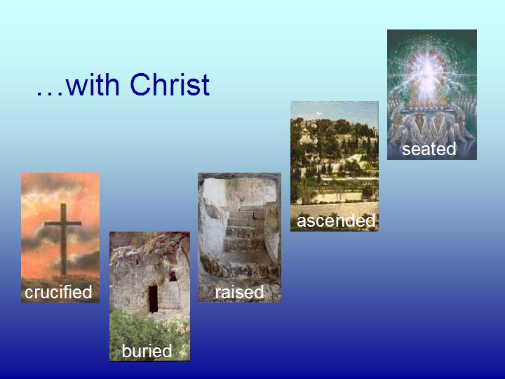
But God, being rich in mercy, because of His great love with which He loved us, 5 even when we were dead in our transgressions, made us alive together with Christ (by grace you have been saved), 6 and raised us up with Him, and seated us with Him in the heavenly places in Christ Jesus;

What’s next?

Next time we’ll look at the consequences of having been identified with Christ, which are many indeed, and of great importance as we continue to ‘set the stage’ for learning about biblical counseling.

Identification – Part II

The consequences of identification

In Identification – Part I we talked about the fact of identification with Christ, and how identification is referred to in the New Testament:

- In - being placed entirely in, so as to share an identity
- With - intimately joined in action and consequence
- Together with – as above, with ‘together’ underscoring the same identity & action
- United with – ‘united’ implies a oneness, so a spiritual oneness is communicated
- Baptized into – ‘baptized’ means to be immersed or entirely placed into, so as to be permanently changed by that immersion or entire placement

From there, we will address the consequences of our having been identified with Christ. All the facts of identification are known by revelation – not by personal memory or experience. Our faith, then, is in the revealed spiritual facts. These facts are absolutely true of us (our position), and totally practical, for now (our condition) until the day we walk through heaven’s gates.

Crucified

Several New Testament passages say that we were identified with Christ in His death (such as Romans 6:1-10; Galatians 2:20; Colossians 2:20). Though the Romans soldiers that drove the nails, and the crowd that surrounded Christ were not aware of it, the cross where Christ was crucified was ‘spiritually very, very crowded’:

- The sins of the entire world for all time – everyone on the planet - from Adam to the last one born on this present earth, were placed upon Christ (John 3:16; 1 John 2:2).

- Every person who has believed or will believe, from Acts 2 to the Rapture was there with Christ at His crucifixion, being crucified with Him. The Old Man of each one of us who believe was crucified there that day (Romans 6:1-10; Galatians 2:20).

- The Law was crucified there – nailed to the cross as well, along with the debt note that went with it (Ephesians 2:14-16; Colossians 2:14).

Yes, that hill called Golgotha was very, very crowded that day, but of all the people who were there, only Christ knew how very, very crowded that hill actually was.

There are three summary outcomes to the identification with Christ’s crucifixion that God caused to take place that day. They are all three in the form of ‘died to’, that is, died in relationship to, which expresses the spiritual separation that took place on the cross. These three summary outcomes are:
- The believer died in relationship to the sin nature, which does not mean the believer does not have a sin nature, but rather that the believer is no longer an absolute slave to the sin nature (Romans 6:1-10). See Appendix Item 5 for a diagram of the believer’s relationship to the sin nature while in this present earthly body. The flesh is the expression of the sin nature through the earthly body.

- The believer died in relationship to the Law of Moses, and any principle of law (Romans 7:4; Galatians 2:19). This means that no part of the Law of Moses is applicable as Law to the believer who is part of the body of Christ. See Appendix Item 6 for a comparison between the Principle of Law and the Principle of Grace.

- The believer died in relationship to the world and its basic principles (Galatians 6:14; Colossians 2:20). The world has its pressures (Romans 12:2), ways and systems (Ephesians 2:1-3), and these no longer have a claim on the believer.

In each case it is important to see that our death with Christ on the cross does not terminate or annihilate the sin nature, the Law or the world. Each of these are still present here on earth. Our death with Christ on the cross, however, causes us to have died in relationship to each of these. It is a death of separation, rather than annihilation, termination and cessation.

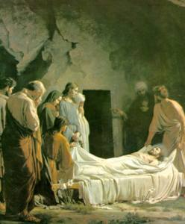
Buried

Being buried with Christ (Romans 6:14; Colossians 2:12) is the assurance that the death actually took place. This was no fainting, swooning or coma phenomenon. The body of Christ was wrapped in accordance with traditional Jewish practices on the same day in which He was crucified, placed in a tomb, with a stone over the opening of the tomb. The tomb was sealed with the seal of Rome, and a team of Roman guards set in place to prevent the breaking of the seal. But inside the tomb, it was spiritually very, very crowded, because we who believe, of the body of Christ, were there with Him as His wrapped body lay dead in the tomb. Being dead in relationship to the sin nature, the Law and the world are not hypothetical or nearly true. It is true.

Raised

Being raised with him (Ephesians 2:6; Colossians 2:12; 3:1) means that when Christ was raised to new life, that burial cloth and that tomb experienced a mass evacuation – even if the startled Romans soldiers guarding the tomb never saw the crowd! Being raised with Him has some momentous and critically important truths for us to live by.
Being raised with Him means that our new life is derived from His new life. We are not only dead in relationship to the sin nature, the Law and the world, but we are alive, in a new kind of life, to God and to righteousness (Romans 6:1-10; 1 Peter 2:24). And while being made alive was a one time occurrence, being alive is from then on until forever.

But there is also an important aspect of that new kind of life that we share with Christ that should not be overlooked – we need to be spiritually calibrated for the massive and unparalleled magnitude of that resurrection life:

Ephesians 1:18-23
I pray that the eyes of your heart may be enlightened, so that you will know what is the hope of His calling, what are the riches of the glory of His inheritance in the saints, 19 and what is the surpassing greatness of His power toward [Greek: eis = into] us who believe. These are in accordance with the working of the strength of His might 20 which He brought about in Christ, when He raised Him from the dead and seated Him at His right hand in the heavenly places, 21 far above all rule and authority and power and dominion, and every name that is named, not only in this age but also in the one to come. 22 And He put all things in subjection under His feet, and gave Him as head over all things to the church, 23 which is His body, the fullness of Him who fills all in all.

The surpassing greatness of the power of Christ’s resurrection is the measure of the magnitude of that new life that was not just enacted at that past point in time, but is being right now directed into the life of each believer – right now! Which is also a marvelous truth that is not at all just hypothetical, but intended to be real life now: We who believe are not intended to do the living here on this planet – He is! (Galatians 2:20).

Ascended & Seated

Acts 1 records historically that Christ ascended, right from the presence of the eleven disciples. And then we have it from the Ephesians passage above (also Ephesians 2:4-7; and elsewhere in Scripture) that Christ was seated in the heavenlies. As with any process or sequence, it’s where it ends that is what counts so greatly. We end up seated with Him in the heavenlies, not just when we die or are raptured, but spiritually speaking, right now. As we’ve seen before in this sequence, that seat where Christ is seated right now is very, very crowded, spiritually speaking! It is there where we have all of our spiritual blessings (Ephesians 1:3). It is there in the heavenlies where we have our citizenship, which is why our names are written in the book of life – the list of heavenly citizens. It is there where we have our fellowship with Him. We are to do the living there, seated in the heavenlies where we are blessed completely with Him, while He does the living here, since He is not limited by spatial constraints.

Let me tell you the story of my life

Each of us – saved and unsaved – has a life story that fits our past here on this planet. But for those who believe, their life story – their personal history – has been replaced. They now have Christ’s history, and it is that history that is so precious and valuable and a treasure to recite and to tell others who have come to know Him by faith in the facts.

Old Man, New Man, Old Nature, New Nature – Part I

Summary

These next two classes we will seek to graciously bring together the biblical teaching on the biblical terms old man, new man, old nature, and new nature in a manner that provides insight into the nature of biblical salvation and a believer’s walk by faith. We have addressed the believer’s heart, soul, mind, spirit, and emotions previously and will additionally define and explain those terms later in the Biblical Counseling portion of this elective. These aspects of human personality most certainly have a part of and an influence in the action of the will. Today’s class will explain the biblical teaching regarding the unbeliever as the “old man” to the point that a person becomes a believer, and the next class will address these terms for the person who has become a believer, that is, a “new man”. The most important point to be brought forward in these next two classes is faith in Christ for eternal salvation (included at the end of Part I) and daily fellowship with Him (the focus of Part II). Any details should be seen in that light.

The “old man” is not the same as the “old nature” or “sin nature”

The unbeliever, with all his components, is described in Scripture as “the old man” (NASU: “old self”; Romans 6:6; Ephesians 4:22; Colossians 3:9). The old man is “in Adam” which was explained on pages 18-20 in this study (Romans 5:12; 1 Corinthians 15:22). 1 Corinthians 15:22 presents a contrast between the unbeliever who is “in Adam” and the believer who is “in Christ” :

For since by a man came death, by a man also came the resurrection of the dead. 22 For as in Adam all die, so also in Christ all will be made alive.

A key point of discernment in the biblical teaching is that the “old man”, who is the unbeliever, with all his components, and who is “in Adam”, has a “sin nature”, but the “old man” is not the same as the “sin nature”. This point of discernment was expressed well by H.A. Ironside when he wrote in regards to Ephesians 4:22:

What do I mean when I speak of the old man? Some people confound the old man with the old nature. You see, the old man is more than the old nature. The old man is the man of old, what you once were before you were converted. Now you are through with the man of old. If you are a Christian, you are not to live like that any longer, but you are now to live in accordance with the truth of the new man. And who is the new man?… A man in Christ – that is the man that I now am through infinite grace.
These two terms, “old man” and “sin nature” are often mistakenly understood as synonyms. The common misunderstanding of these terms is likely due to a pattern of inconsistent translation of the three key passages on the “old man” (NASU: “old self”) in Romans 6:6, Ephesians 4:22 and Colossians 3:9). All three of these passages are a statement about what is already eternally true of the believer regarding our relationship to the “old man” (that is, our eternal position), and not an appeal for the believer to be continually doing something with the “old man” (in our daily condition). This point of distinction is far from hypothetical or just semantic, as we will see, because clarity of understanding will be valuable in the believer’s own spiritual walk and in biblical counsel with other believers. The “old man” is, or for the believer, was “in Adam”. The believer, however, is not now “in Adam” but is now “in Christ”. Using the term ‘old man” as a synonym for the “old nature” or the “sin nature” implies that the believer can still choose to go back or somehow slip back to being “in Adam”. The believer cannot in any way choose to reverse his eternal position back to that of being “in Adam” or being the “old man”. That confusion of the term “old man” with the “old nature” or “sin nature” does not clearly recognize the totally new-in-kind character of being “in Christ” in one’s eternal position.

The will of the “old man”

The unbeliever does indeed have a will (as shown by the use of the Greek word thelō , “to will” as exercised by Felix, the unbeliever: Acts 24:27), among other components of his spiritually fallen personality. The will of the “old man”, if left entirely under the influence of the “sin nature”, would be locked contrary to God’s provision for salvation in Jesus Christ (Isaiah 53:6; Romans 3:10-19). Isaiah expressed this truth using a ‘flock of sheep’ metaphor:

Isaiah 53:6ab
All of us like sheep have gone astray,
Each of us has turned to his own way;

Thankfully, God has not left the unbeliever exclusively to the will and inclination of the sin nature. God has not only provided a way of salvation through Christ, but has also provided the ministry of the Holy Spirit to the unbeliever, so that he or she might believe.

Why the old man doesn’t stay around or even return - ever

It is the ministry of the Holy Spirit to the unbeliever to convict so as to influence the will to act contrary to the dictates of the sin nature:

John 16:8-11 (NASU; quoting Christ as He spoke to the apostles)
"And He, when He comes, will convict the world concerning sin and righteousness and judgment; 9 concerning sin, because they do not believe in Me; 10 and concerning righteousness, because I go to the Father and you no longer see Me; 11 and concerning judgment, because the ruler of this world has been judged."

Based on the ministry of the Holy Spirit to the unbeliever, the unbeliever’s sin nature does not have total control, then, since the one way out of from slavery to the dictates of the sin nature is to believe the Gospel (John 14:6). The convincing and wooing ministry of the Holy Spirit is how God draws the heart of the unbeliever to come to believe (John 16:8; Romans 10:8,9).

When that unbeliever then comes to believe (“believe” in Acts 16:31 is an active imperative, appealing to the will), as an act of will contrary to the dictates of the “sin nature”, and with his heart under the influence of the Holy Spirit (John 16:8-11; Romans 10:10), the “old man” is crucified (Romans 6:6), and that person is made to be the “new man”, and that person is made to be “in Christ”, entirely by God’s doing (1 Corinthians 1:30). The believer is a new creation – a new creature:

2 Corinthians 5:17
Therefore if anyone is in Christ, he is a new creature; the old things passed away; behold, new things have come.

Believing in Christ, which takes place only by means of the convicting ministry of the Holy Spirit, takes that person entirely out of being “in Adam”. That person is no longer “in Adam”, nor is he or she the “old man” (NASU: old self), nor can that person who has come to believe in Christ ever go back to that person that he or she was (the “old man”), nor can the believer ever go back to the position that he or she once had “in Adam”. The believer is forevermore “in Christ”.

There is a continuity of person

The New Testament recognizes that there is a continuity of person that remains through the transition from “old man” to “new man” and is not identical to the “old man” or the “new man’. This is why Paul could tell about the things that he was before he believed, and still say it was him (Acts 22:28; 26:12; 1 Timothy 1:12-16; Philippians 3:4-11):

1 Tim 1:12-14
I thank Christ Jesus our Lord, who has strengthened me, because He considered me faithful, putting me into service, 13 even though I was formerly a blasphemer and a persecutor and a violent aggressor. Yet I was shown mercy because I acted ignorantly in unbelief; 14 and the grace of our Lord was more than abundant, with the faith and love which are found in Christ Jesus.

This biblical truth - the continuity of person - will be the point where we pick up in the next class: Old Man, New Man, Old Nature, New Nature – Part II.

Old Man, New Man, Old Nature, New Nature – Part II

What continues from the old man to the new man

The New Testament conveys that there is a continuity of person that continues through the transition from “old man” to “new man”. That continuity of person is not identical to either the “old man” or the “new man”, and spends no time as an independent entity between the “old man” and the “new man”. It is because of this continuity of person that Paul could tell about the things that he was before he believed, and still say it was him (Acts 22:28; 26:12-15; 1 Timothy 1:12-16; Philippians 3:4-11). As an example, here are the words of Paul, who was speaking of when he was an unbeliever, at the time just before he came to believe in Christ):

Acts 26:12-15
"While so engaged as I was journeying to Damascus with the authority and commission of the chief priests, 13 at midday, O King, I saw on the way a light from heaven, brighter than the sun, shining all around me and those who were journeying with me. 14 "And when we had all fallen to the ground, I heard a voice saying to me in the Hebrew dialect, 'Saul, Saul, why are you persecuting Me? It is hard for you to kick against the goads.' 15 "And I said, 'Who are You, Lord?' And the Lord said, 'I am Jesus whom you are persecuting.'"

The “new man” is spiritually new (kainos: new in kind), but the personhood continues and the identity of the physical body and the soul of the person is conveyed through the transition from being spiritually the “old man” (who is crucified) to being spiritually the “new man”, who is “in Christ”.

The physical body of the believer will be changed (1 Corinthians 15:51) when the Rapture occurs, and the new body will not have associated with it a “sin nature” to choose (1 John 3:2), so the will of the believer in eternity will be free to exercise itself only for God (stated negatively in Revelation 21:8; 22:15).

In what ways can we sum up the position of the believer?

The new believer, then, is in Christ (1 Corinthians 1:30), and is described as “the new man” (Ephesians 4:24; Colossians 3:10), who has a “new nature”, and is indwelt in his position by the Holy Spirit (Romans 8:11), Who has a lengthy list of ministries to the believer. While the “old man” who was “in Adam” was crucified and once for all put off, the “sin nature”, which pertained to the “old man”, remains (though rendered inoperative in His position in Christ: Romans 6:6) as long as the believer remains in the physical body. The believer, however, is not at all beholden to that “sin nature” (the “sin nature” is identified as “sin” in Romans 6 and 7, having a definite article in the Greek).

The battle begins… and continues

While the believer has two natures, they are clearly opposite but not by any means equal in power, character, authority, and relationship to God (Romans 6). The sin nature is a deposed monarch (Romans 6:12). The believer must operate at any time under either one nature or the other, but can will to change from abiding by faith in one to abiding by faith in the other:

Galatians 5:16
But I say, walk [active imperative, indicating an appeal to the will] by the Spirit, and you will not carry out the desire of the flesh.

See the diagram in Appendix Item 5 for a graphical presentation of the ‘spiritual anatomy’ of the believer. Once abiding in the “new nature”, which is from Christ, the believer’s will is influenced by the Holy Spirit’s ongoing ministries upon the heart so as to will within the character of that “new nature”, but has the latitude of will to trust in the “sin nature”, but not without spiritual consequences.

Once abiding in the “sin nature”, the believer also has the freedom and calling in Christ to stop trusting in the “sin nature” and so to abide by faith in the “new nature”. This, of course, is the urging of Scripture, and the singular direction of the ministries of the Holy Spirit, to abide in the “new nature”, which is from Christ.

The believer is never spiritually independent of a nature

There is no ability to remain in some hypothetical position apart from one nature or the other, so the apostle Paul clearly denies that the believer can expect to directly will the right behavior into action:

Galatians 5:17
For the flesh sets its desire against the Spirit, and the Spirit against the flesh; for these are in opposition to one another, so that you may not do the things that you please (thelō).

The believer may not simply will to have some specific attitude or behavioral outcome “on his own”, however desirable that might falsely appear – there is no such place of directly willing outcomes apart from one nature or the other. The believer wills in which nature to abide, but the choice is exclusive (entirely one or the other: Galatians 5:16), and all other choices are within the range of that chosen nature, for as long as the believer abides in that chosen nature.

Based on the believer’s eternal position in Christ, the only logical course of action is to abide in the “new nature”, which is from Christ. The motivation of the believer and the ministries of the Holy Spirit are all of grace (Romans 5:21), with God’s mercies being a motivator as well (Romans 12:1,2). Ephesians 2:4-7 says that God’s mercy and grace are both of such a magnitude that they are called “riches of mercy” and “riches of grace”.

What God has in mind

Paul will typically convey the believer’s position, then present the imperative(s) that are to convey the believer’s eternal position into daily condition. Romans 6:11-13, for example, conveys that though the believer could choose to allow the “sin nature” to reign, the only conclusion that makes any spiritual sense at all, in view of the revealed spiritual facts (verses 1-10), is to choose to reckon oneself dead to the “sin nature” and alive to God, which is actively placing faith in what God has accomplished in Christ.

The believer’s will is exercised biblically in his responding by faith to what God has done. Biblical faith is expressed as he reckons himself dead to the “sin nature” and alive to God (Romans 6:11), walks in Him (Colossians 2:6), walks in the Spirit (Galatians 5:16), and abides in Him (John 15:4).

Romans 6:1-11
What shall we say then? Are we to continue in [the] sin [nature] so that grace may increase? 2 May it never be! How shall we who died to [the] sin [nature] still live in it? 3 Or do you not know [and the context implies, “Of course you do!”; see Romans 7:1] that all of us who have been baptized into Christ Jesus have been baptized into His death? 4 Therefore we have been buried with Him through baptism into death, so that as Christ was raised from the dead through the glory of the Father, so we too might walk in newness of life. 5 For if we have become united with Him in the likeness of His death, certainly we shall also be in the likeness of His resurrection, 6 [because of your] knowing this, that our old self was crucified with Him, in order that our body of [the] sin [nature] might be done away with [not annihilated, but put offline], so that we would no longer be slaves to [the] sin [nature]; 7 for he who has died is freed from [the] sin [nature].

8 Now if we have died with Christ, we believe that we shall also live with Him, 9 [because of your] knowing that Christ, having been raised from the dead, is never to die again; death no longer is master over Him. 10 For the death that He died, He died to [the] sin [nature] once for all; but the life that He lives, He lives to God. 11 Even so [present middle imperative: you must right now continue to] consider yourselves to be dead [in relationship] to [the] sin [nature], but alive [in relationship] to God in Christ Jesus.
The Will of the Believer – Part I

Over the past two Sundays, we sought to graciously bring together the biblical teaching on the old man, new man, old nature, new nature, and will in a manner that provides insight into the character of biblical faith. With this lesson we seek to continue that process by bringing together some aspects of the biblical teaching on the exercise of the believer’s will.

The diagram below, initially prepared by Hal Molloy, shows the believer as having the capacity in this life to either abide in the sin nature or in the new nature, based on Galatians 5:16,17 and John 15:4. That capacity of abiding in either nature is shown with a switch (under the word “Walk”), set so as to show the believer abiding in the new nature.

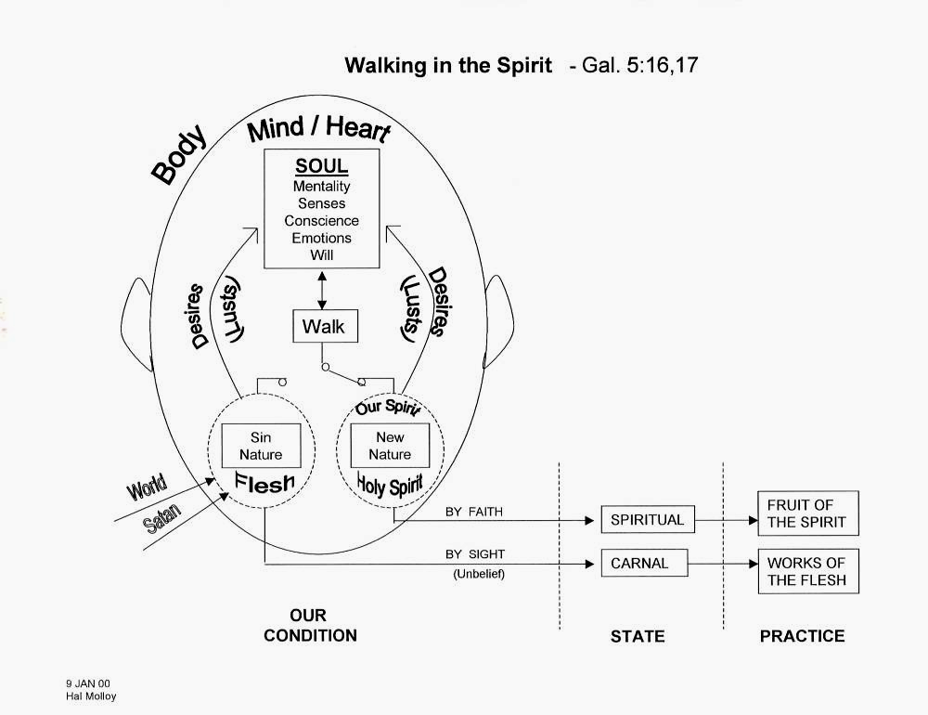

Notice the following points regarding the diagram:

1) The believer may only abide in the sin nature or in the new nature. At no time is there a neutral or ‘gray scale’ position for the believer (Galatians 5:16,17).

As we have previously noted, the Natural Man does not have a choice. He can abide only in his sinful, Adamic nature (Romans 1:18-32). Thus, everything he does condemns him, for he is in Adam, who is eternally condemned. The only choice he has is to believe in Christ when the Spirit beckons him (see Appendix 1). We have also discussed the fact that a Carnal Saint is abiding in the flesh, rather than abiding in the Spirit (1 Corinthians 3:1-3). This can manifest itself in legalism (Galatians 3) or license (Galatians 5).
As saints, we are to focus solely on Christ and our fellowship with Him (2 Corinthians 3:18). As brothers and sisters in Christ, we are all on equal footing. We will see in the counseling study that our relationship with each other centers on our relationship with God. We give one another mutual assistance so that we can behold Him clearly. This will have a direct affect on how we “judge” and “admonish” one another (Galatians 6:1-5).

2) While the diagram represents the truths of Scripture objectively, the believer is always viewing these truths subjectively in daily experience, that is, always viewing these truths from within abiding in either the sin nature or the new nature.

A difficulty for the saint is living objectively in a subjective environment. Key portions of our person that continue through regeneration are our body and our emotions. Both are constantly making demands of us. If we are not grounded in the facts about our position, these demands can confuse us, and cause us to take our faith off Christ. Thus, Christians can easily fall into walking by sight and not by faith. Walking by sight is a characteristic of our Adamic nature. Knowing the truth about Christ, and trusting in that truth, is essential for the saint (2 Corinthians 5:7; Philippians 4:8,9; 2 Thessalonians 2:13-15).

3) Though the believer has the capacity to abide in either of the two natures, whether the believer abides in the sin nature or the new nature is not a spiritually neutral matter (Romans 6:23; Galatians 5:18-24). Each place of abiding has a specific outcome.

Sanctification can be summarized as learning to walk in the Spirit in fellowship with God. Sanctification is primarily a matter of faith, and not of works. The priority choice for the believer is not: to be sinful or to be holy. It is to abide either in the Spirit, or in the flesh. The works are the result of the choice. If we focus on the works, we can easily fall into “striving” to be holy, and fail to allow the Spirit to reproduce God’s virtues in us. In seeking to be worthy, or to be holy, we often end up walking in flesh.

The crux of the choice before the believer is faith.

Hebrews 12:1-2
Therefore, since we have so great a cloud of witnesses surrounding us, let us also lay aside every encumbrance and the sin which so easily entangles us, and let us run with endurance the race that is set before us, 2 fixing our eyes on Jesus, the author and perfecter of faith, who for the joy set before Him endured the cross, despising the shame, and has sat down at the right hand of the throne of God.

Who are the witnesses in the passage? The Greek word is “martus,” from which we get the word martyr. According to Vines, it can refer to “those whose lives and actions testified to the worth and effect of faith, and whose faith received ‘witness’ in Scripture.” The witnesses testify that the only way to live in Christ is to walk by faith. Walking by faith is a walk that looks to Jesus.

Romans 10:17
So faith comes from hearing, and hearing by the word of Christ.
2 Corinthians 3:18
But we all, with unveiled face, beholding as in a mirror the glory of the Lord, are being transformed into the same image from glory to glory, just as from the Lord, the Spirit.

Our Willing And Awareness

Scripture reveals that, as saints, we ought to live in fellowship with Christ and not in dependence upon the sin nature. Certain passages, such as Romans 6:11-13; Romans 12:1, 2; Galatians 5:16, 17 discuss the role of the believer’s will. Scripture does not convey, alongside these passages, that the believer must be aware - or unaware - of the choice.

Regarding Romans 12:1, Thomas Constable has written:

Positively we should "present" or "offer" ourselves to God and ourselves as His tools to fulfill His will (cf. 12:1). The believer has a choice. We can present ourselves to sin or to God... [Chester McCalley: presenting ourselves should specifically be our bodies, since our bodies, being our members, are instruments – Romans 6:13; Romans 12:1].

Similar statements of the spiritual choice before believers have been expressed by others as they have sought to explain and expound upon the above passages. The primary reason for the similar use of words in their explanation (choice, choose, will, volition, etc.) is that the Greek imperative verbs translated as “consider” (KJV: reckon), “present” (KJV: yield), and “walk” in the above passages have a fundamental character of making an appeal to the will, calling upon the believer’s volition or willing.
The Will of the Believer - Part II

Last week, we discussed the priority choice before the believer, which is to behold Christ and thereby abide in Him. The alternative is to fail to behold Him, and thereby walk in the flesh. Rather than focus on the choice, or our sin and condition, we should be focusing on Christ. In doing so, we will be urged to present our bodies as His instruments. Many statements in Scripture make an appeal to the believer to choose to walk in the Spirit. This is indicated partially by the specific verb tense the Biblical authors use in making these invocations. God does not seek to commandeer our will. Rather, He desires that we willingly walk by means of the ministries of the Holy Spirit, which include beholding Christ and transforming us into His image.

Yet, there are other reasons for expressing these and similar biblical passages as a choice, exercise of the will, etc. These points of clarification are important to convey:

- Scripture presents these, and quite often, other imperatives in the present tense, with the idea of “right now continuing”. Scripture does not convey, alongside these passages, that the believer must be aware - or unaware - of the choice. Instead, the emphasis of Scripture is upon the singular outcome of the choice (“present”, “walk in the Spirit”, etc.). While Scripture presents a great number of imperatives directed towards a specific behavior pattern, the priority decision is always to abide in Christ. God never intends for believers to attempt godly behavior out of the sin nature or with the idea that we alone can simply will godly behavior (Romans 7:7-25, Galatians 5:17).

The key struggle for the saint is not our battling the sin nature directly. Those who attempt to fight the sin nature out of their own resources will always lose. If we could defeat it on our own, what need have we of Christ? We cannot and will not will ourselves to victory over sin, no matter how many “bullet verses” we have at our disposal. As Paul states in Romans 7, the only way to find victory over this “body of death” is Jesus Christ. The key point of decision for the saint is ever keeping his eyes on Jesus, and resting in Him. He will do this by beholding Christ in the Scriptures. The Scriptures do not function in isolation as a weapon against sin. It is through the Scriptures, though, that we draw closer to Christ, who is the only One who can defeat. Keep in mind, Christ has already defeated sin and the devil. It is a past act with continuing results.

- Scripture’s repeated message in the present tense verbs, of “right now continuing” does not mean that the believer is to step outside of walking (aka abiding) in the Spirit to continuously reassess one’s walk. If the believer is presently walking in the Spirit, the meaning of Galatians 5:16a is to continue walking in the Spirit. If the believer is walking (aka abiding) in the sin nature, then the exhortation of Scripture is to choose to walk right then in the Spirit, then to continue walking in the Spirit thereafter (We will discuss what it means to walk in the Spirit a bit later.).

Since we are always within one of two possible spheres (walking in the Spirit or walking in the flesh), we will never see them objectively. We can only objectively see Christ in the Scriptures. That is why we are to first and foremost keep our eyes on Him. To look elsewhere is to walk by sight, and not by faith. The only works that we can accomplish on our own are the works of the flesh. It is the Spirit that produces the fruit of the Spirit within us. When we take our eyes off Christ, and start looking at our works, it becomes easy for us to “work” to produce fruit by our own power. God does not expect us to be “good Christians.” He calls us to behold Him, so He can conform us to the image of His Son. We present ourselves (our bodies) so He can conform us. We do not (and cannot) conform ourselves.

- Scripture does not simply present to us “the choice” without also presenting to us the spiritual standing (aka eternal position) that we have as believers, with a principal emphasis on the person of Christ and our being “in Him”. The urging to make a choice to walk in the Spirit is on the basis of the revealed spiritual facts. By God’s inspiration the authors of Scripture have ‘painted a picture with words’ that portrays the ‘spiritual landscape’ before the believer that calls us to behold Christ (2 Corinthians 3:18).

Outside of Christ, all life is subjective. Is it any wonder the non-believer has difficulty finding absolutes in this world? The Gospel is foolish to him, not possessing the spiritual insight to see the objective facts about Christ (1 Corinthians 2:14-16). Every aspect of the saint’s life centers on his position in Christ. He always is who he is in Christ. Stability for him, then, comes from Christ. The saint is unable to escape his position in Christ. He may think as the natural man, who does not posses the life of Christ. This, however, will cause a loss of fellowship.

- Scripture presents the ‘spiritual atmosphere’ of the believer as always and ever grace. Grace, a fundamental and eternal characteristic of God Himself, is the ‘breath we breathe’ and the motivator of the believer, who, by God’s gracious accomplishment, is “in Christ” (1 Corinthians 1:30). Though the imperatives of the New Testament are not spiritually and morally neutral options, they do convey the singular choice that the believer is to make, in view of the eternal position God has graciously provided and the power and life that God is providing through the Holy Spirit (Ephesians 3:20, 21).

Grace is the greatest motivator. Every aspect of a believer’s position in Christ is gracious. Grace, unlike law, functions from blessings already obtained. Since the saint possesses every spiritual blessing, he is free to fellowship with God without restriction. Grace has done for the saint everything he could possibly desire to do for himself in his relationship to God. The only “task” left for him is to say, “Thank you,” and continue to walk by faith. Can a believer function properly with an improper understanding of grace?

- The Holy Spirit is always present with us, carrying on a ministry that is ever in the direction of our continuing to walk in fellowship with Christ. The Holy Spirit will minister to us so as to behold Christ, to abide in Him, to fellowship with Him, for His life to be lived in and through us, and for us to stand in our position, which is in Christ. In any moment when we abide in the sin nature, the Holy Spirit will be grieved (Ephesians 4:30) and quenched (1 Thessalonians 5:19). In any moment when we abide in Christ according to the continuing ministry of the Holy Spirit, we will live out, by the work of the Spirit, the fruit of the Spirit (Galatians 5:22-23).

A primary ministry of the Spirit is to reproduce the very virtues of the risen Christ in us, who is our life. As we abide in Christ and rest in Him, we are allowing the Spirit to fulfill this ministry. If we attempt this work on our own, we not only fail, but we deprive the Spirit of this essential ministry. We do not allow grace to function as it ought. Along with this ministry of conforming us, He always seeks to draw attention to Christ. According to Chafer:

Experimentally [meaning ‘experientially’], the believer, when empowered by the Spirit, will be conscious only of the exercise of his own faculties. The Spirit does not disclose His presence directly; His ministry is to reveal and glorify Christ. His presence will be evidenced, however, by the victory that is wrought, which victory could be wrought only by the Sprint.

- The working of God will always be in the direction of our willing and doing in a manner consistent with the will and character of God (Philippians 2:12,13; 4:8,9). As believers we can, by faith, count upon who we have graciously been made to be “in Christ” and His continuing gracious provision for us.

According to Romans 8:28-29, God has predetermined that we as saints will be conformed to the image of His Son. That is the “good and acceptable and perfect” will of God that Romans 12:2 discusses. God’s plan for us far exceeds any earthly success. Only by keeping our eyes on Christ, and allowing the Spirit do His work can this plan come to fruition while we are here on this earth.
Where Have We Been & Where Are We Going?

From Looking at All Humans to Helping Saved Humans

We are just now finishing a three month series on Biblical Anthropology. This series has not covered old bones, nor has it covered ancient cultures, but rather has been concerned with the issue: What does the Bible tell us makes up a human being, both saved and unsaved, but particularly the saved person. In this series we have not been so concerned about the things that might be viewed as academic but we have been more mindful of what actually makes a person up with a view to Biblical Counseling which we will be spending the next six months studying. Today’s class will be concerning what we have looked back at and why it will be so valuable for our study of Biblical Counseling. It will be very important before we go a step further to look at some of the assumptions that we will be making right at the start:

- The Bible is God’s Message to Man – As such, God is able to communicate to us what we need to know about ourselves, our relationship to Him, our perspective regarding our trials, and our relationships with each other. (Deuteronomy 6:1; Psalms 19:7-11; Isaiah 52:4a; 2 Timothy 3:16-17).

- The Bible is Relevant – We find that the Bible was not written in a vacuum, nor was it written by people who were totally aloof from the trials, tribulations and difficulties in the world. The ancient world was rife with physical abuse, sexual abuse, addiction, slavery, false religion and every kind of expression of the sin nature. What the biblical authors wrote was God’s response to all of the horrid effects of sin in the world. (Psalm 119:9-11; Ephesians 2:1-2; James 1:2-3). God’s word is the most relevant document in print!

- The Bible has the Answers – The biblical authors did not write in ignorance of these difficulties but claimed that the word of God was still the soul care tool for addressing these trials, difficulties and tribulations. Further, the word of God provides guidance for the believer from the small details on into eternity (Hebrews 4:12; 2 Timothy 3:16-17).

- Biblical Counseling is for EVERYBODY in the body of Christ – As we study the words associated with Biblical Counseling we will be confronted with the startling truth that Biblical Counseling is for everybody in the body of Christ to be involved in; both giving and receiving! We will see increasingly that there is a call on every believer to counsel, encourage, urge, admonish and show God’s mercy and grace to his brethren in Christ. There is also a need for us to be able to rely on the body to give us biblical counsel as well! This is not something to be relegated to a special class of people with degrees and / or certifications: this is something that the whole body of Christ should be involved in!

With those few assumptions in mind we will look at each major topic that we have studied this past few months and assess why it is of the utmost importance to have this knowledge, both in terms of our personal faith, as well as in terms of our being counselors as God has ordained each one of us to be.
Made in God’s Image

In this study we went to the early chapters of Genesis as our chief texts. As we looked at these texts we were able to see very clearly:

- God had a specific design and intent for mankind
- God made mankind in His image and likeness, male & female
- God directly gave Adam life in a separate action from the animals
- God made male and female separately, and each was made in a different way
- God had a specific intent for the relationship between the man and the woman

Obviously, this has massive importance to us as we consider our own faith. If we know why God designed us then we will be able to grasp what His purpose is for us. Under-standing the beginning is essential to getting everything else right. As we move into Biblical Counseling we will see that who God made human beings to be and God’s intended distinctions between male and female provide wonderful insights that apply to all believers and their relationships.

The Fall: Separation and Everything that Goes With It

An important truth that we learned in studying ‘the fall’ was the reality that the word “death” in the Bible is talking about separation not elimination or annihilation. This distinction is critical in understanding Genesis 3:17 (“…on the day that you eat of it you shall surely die”) and even more so as we look at death in relation to the sin nature. This is yet more important as we move on to counseling, since we will then be able to better convey the truth from God’s word about why people struggle as they do, and what God did to deal with that separation.

How is a Person Saved & What is Salvation?

In this study we saw that salvation always was, is, and always will be God’s provision (Genesis 15:6; Isaiah 12:2; 53:1; Habakkuk 2:4; Acts 16:31; Romans 4:1-25; Galatians 3:6-9). Realizing that salvation is not something that we do, but a work of God, is something essential to our spiritual health. As we consider counseling others we must be able to ascertain whether or not that person understands how we are saved, and what that salvation looks like. Our ability to give biblical counsel rests on this understanding.
One point of special importance is our eternal security. If a person could lose their salvation (which is biblically impossible) then good counsel would be totally different. Likewise, knowing that we cannot lose our salvation means that any advice towards “earning your salvation” or “keeping your salvation” will give the person who is receiving the counsel a false view of God’s character, God’s purpose, as well as God’s power.

What Makes Up a Human Being? Saved or Unsaved?

We have seen that Scripture conveys the makeup of a human being as having these aspects:

- Body, flesh
- Mind, intellect, emotions, will, heart, soul
- Spirit, spiritual

We have taken a look at how these aspects of a person differ in character between an unbeliever and a believer. For Biblical Counseling we have will be using our understanding of these aspects of a believer, and the depth to which God’s word touches the heart of a believer (Hebrews 4:12) to provide genuine and precious spiritual care for the souls of our fellow believers.

How Many Different Kinds of People Are There?

In this study we used 1 Corinthians and Galatians to look closely at how the Bible divides up the human race in contrast to the different ways that we may divide humanity. The main divisions that we saw and defined were:

- unsaved or natural
- saved but fleshly and unspiritual
- saved and spiritual

These distinctions are very helpful to us as we consider giving biblical advice to others because what the Bible has to say to an individual is going to be affected by what kind of person they are. Our focus will be upon helping believers to understand the critical difference between being fleshly and unspiritual and being spiritual

Identification Truths

In these two sessions we studied what other classes have taken months to study. That being said, our summary of the identification truths (primarily from the books of Romans, Galatians, Ephesians, and Colossians) showed us how we who believe are identified with Christ in His:

- Death
- Burial
- Resurrection
- Ascension
- Seating in the heavenlies
This is of great value to us in our own walk with Christ. Accordingly, if we attempted to give people biblical counsel and missed these great truths we would find ourselves treading water for a number of reasons - mostly because a misunderstanding or ignorance of our eternal position makes many of the most applicable biblical passages completely unintelligible, and impossible to match up to our experience in our daily condition. Each believer needs to know who he or she is and where he or she is going, based on God’s word.

Old Man, New Man, Old Nature, New Nature

Drawing primarily upon the sixth chapter of Romans (with the assistance of Ephesians and Colossians) we saw that there is a very concrete and intentional way in which each of these terms is used. It became quite clear that the old man is not a synonym for the old nature. Likewise, we found that there is a difference between our new man and our new nature. Another important point of this study is the fact that the believer now exists with both the old sin nature, as well as the new nature. This accounts for the great conflict that goes on inside us as believers. If we were to submit to one naturist teachings (the idea the believer now only has the new nature and that the old nature is annihilated) then we would probably wind up thinking that we must not have been saved properly because we still have struggles with sin!

The Will of the Believer

In this section we studied the nature of the will in great detail. We found that the will of the believer is truly free to trust in Christ (abide in Christ, walk in the Spirit, walk in the light, etc.) or trust in our sin nature (walk in the flesh, have broken fellowship with God). This study was incredibly important because we saw that our day to day task should not be fretting over trying of our own selves and willing not to do the ‘little sins’ that aggravate us so much, but focus on beholding the Lord Jesus Christ and trusting (reckoning) on what He has done.

This will also be of vast importance in our counseling because we see that we do not need to be running around trying to will against individual sins or trying to manage the sin nature or any of its expressions. That would be like putting band-aids on cancer – or worse! This study showed us that we must go to the root of the problem and encourage believers to choose to trust in Him and walk in the Spirit.

Onward Christian Counselors!

As we move forward in this exciting study we will continue to behold the Lord through his Word. We will see another exciting part of God’s plan for us as individual believers to build up the body of Christ both locally and throughout the world! We will see the great need for followers of Christ today to be biblically informed and lovingly offering that counsel to other believers. The basis for understanding what it is that goes into a person, and how the Bible describes what goes on inside both believers and unbelievers will be our basis for offering godly counsel and encouragement to others in the body of Christ. We must know what God has revealed about who and what we are before we can point people to the parts of the word that are most applicable to their current situations, problems, trials and tribulations. It is as we behold Christ that were are transformed from glory to glory (2 Corinthians 3:18) and as we help and encourage others to behold Him that they are transformed from glory to glory.

Some would divide secular anthropology differently, but that has no impact on our study of biblical anthropology. For instance, some would divide the fields of anthropology as: Cultural Anthropology, Archaeology, Biological Anthropology, and Linguistics. One could also contend for areas of overlap of anthropology with other scientific and applied fields of study and practice, and for other systems of subdivision of anthropology.
The Biblical Counseling elective will be taught from April to September, 2008. Similar to the distinctions presented above for secular anthropology and biblical anthropology, the perspective of biblical counseling is distinctly different from that of secular counseling.
Scripture quotes are from the New American Standard Updated, unless noted otherwise.
See Appendix Item 1 - Must One First Be Regenerated In Order To Believe?
See also 1 Peter 5:14.
More on ‘the Old Man’ later in this study.
More focus and explanation on the will and abiding will be given in the two classes to follow: The Will of The Believer – Part I & Part II.
Distinguishing The "Man" And The "Nature" Pt. 1 and Distinguishing The "Man" And The "Nature" Pt. 2 by Tom Stegall: http://www.duluthbible.org/page_2.aspx?id=163357.
H.A. Ironside, Ephesians: In the Heavenlies (Neptune, NJ: Loizeaux, 1937) page 217.
Lewis Sperry Chafer, The Epistle to the Ephesians (Grand Rapids: Kregel, 1991), pages 121-123; Harold W. Hoehner, Ephesians: An Exegetical Commentary (Grand Rapids: Baker, 2002), pages 598-615; H.A. Ironside, Ephesians: In the Heavenlies (Neptune, NJ: Loizeaux, 1937) page 217; Daniel B. Wallace, Greek Grammar Beyond the Basics (Grand Rapids: Zondervan, 1996), page 605; Warren W. Weirsbe, The Bible Exposition Commentary, Vol. 2 (Wheaton, IL: Victor, 1989) page 40.
See the list of ministries of the Holy Spirit in the believer in Appendix Item 8.
? The general character of the imperatives of the New Testament epistles is to address the will of the believer. Other words or combinations of words, which are not strictly imperatives, have the capacity to address the will as well (e.g., “ought” in Ephesians 5:28; “must” in 1 Timothy 3:2). See Greek Grammar Beyond The Basics, Daniel B. Wallace, page 486, footnote, “The Greek is stronger than mere option, engaging the volition and placing a requirement on the individual.” Romans 6:13 is specifically noted as being under this kind of use. A Manual Grammar of the Greek New Testament, Dana & Mantey, page 174, paragraph 165 says, “The imperative is the mood of volition, so that the imperatives are calling upon the will of the believer: “The imperative is the mood of command or entreaty – the mood of volition. It is the genius of the imperative to express the appeal of will to will. In ordinary linguistic communication the primary appeal is from intellect to intellect, but in the imperative one will addresses another.”.
Notes on Romans (2006 Ed.), Thomas Constable, pg 67. See also Treasures from the Greek New Testament, Kenneth Wuest, pg 99, on Romans 6:11-13; Major Bible Themes, Lewis Sperry Chafer & John Walvoord. Pgs 208, 216; The Three Operative Words, Chester McCalley, on Romans 6:11-19 (www.wordoftruth.net); Romans, Verse by Verse, William Newell, pg 229, on Romans 6:13; Galatians: God’s Antidote to Legalism, Ron Merryman, pg 96, on Galatians 5:16.
? “Imperative mood:… The mood expresses action which is volitionally possible and involves the exercise of the will.”, Essentials of New Testament Greek, Summers & Sawyer, pg 118; see also A Manual Grammar of the Greek New Testament, Dana & Mantey, pg 174, ¶ 165; Greek Grammar Beyond The Basics, Daniel B. Wallace, pgs 485, 486; A Classification Of Imperatives, James L. Boyer, pg 1; New Observations on Voice in the Ancient Greek Verb, Carl W. Conrad; Rethinking Greek Verb Tenses…, Dave Mathewson, pgs 29, 30.
The middle voice of some verbs carries the additional meaning of an appeal to the human will. Scripture also uses words that mean “to will” (i.e., thelō), and ‘the will” (thelema).
L.S. Chafer, Systematic Theology, Vol. 4, 1948, p. 191 or Grace: An Exposition of God's Marvelous Gift (Kregel Publications: Grand Rapids, MI), 1922, p. 158.
Pages 4-6 of the Biblical Anthropology Material.
Pages 7-9 of the Biblical Anthropology Material.
Pages 10-12 of the Biblical Anthropology Material.
Pages 13-15 of the Biblical Anthropology Material.
Pages 16-18 of the Biblical Anthropology Material.
Pages 19-24 of the Biblical Anthropology Material.
Pages 25-30 of the Biblical Anthropology Material.
Pages 31-36 of the Biblical Anthropology Material.

