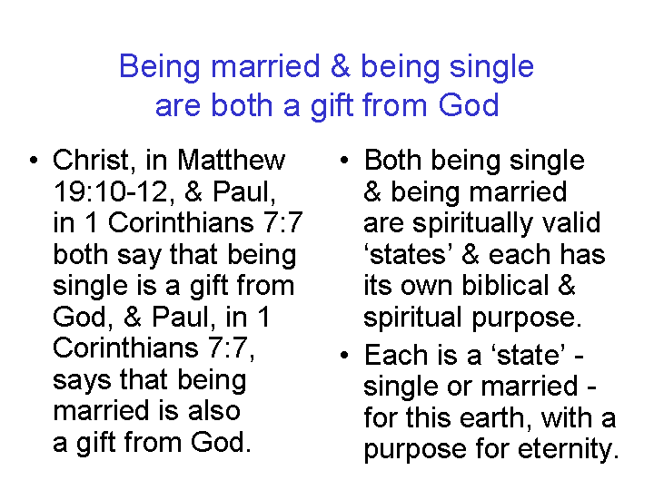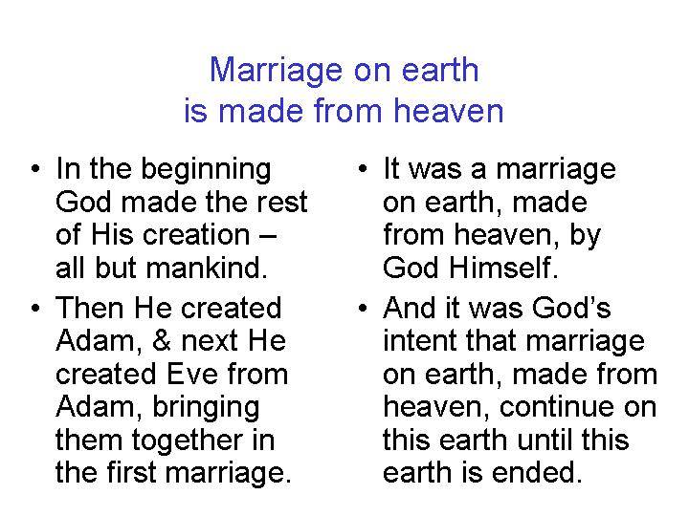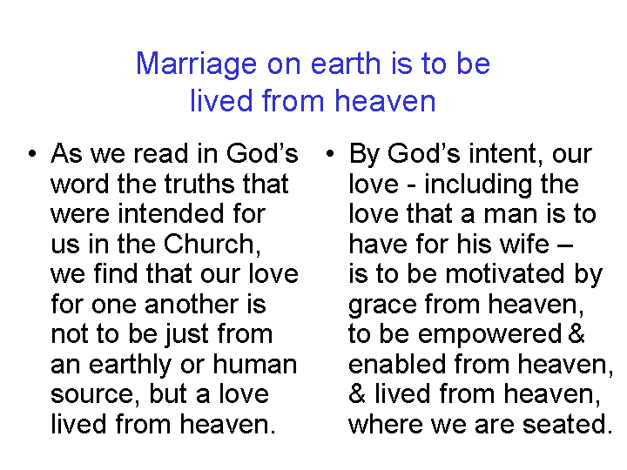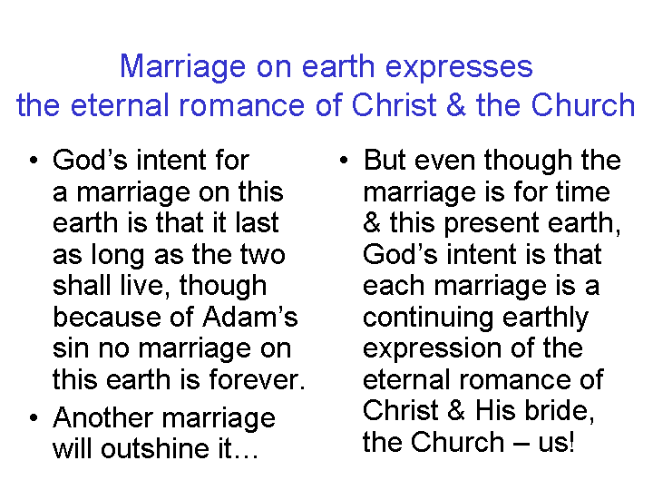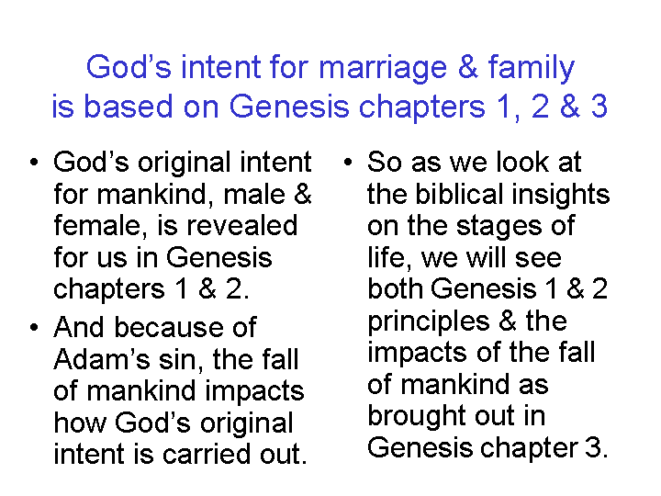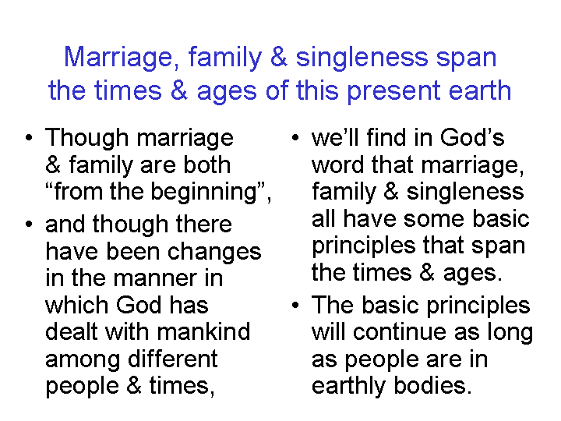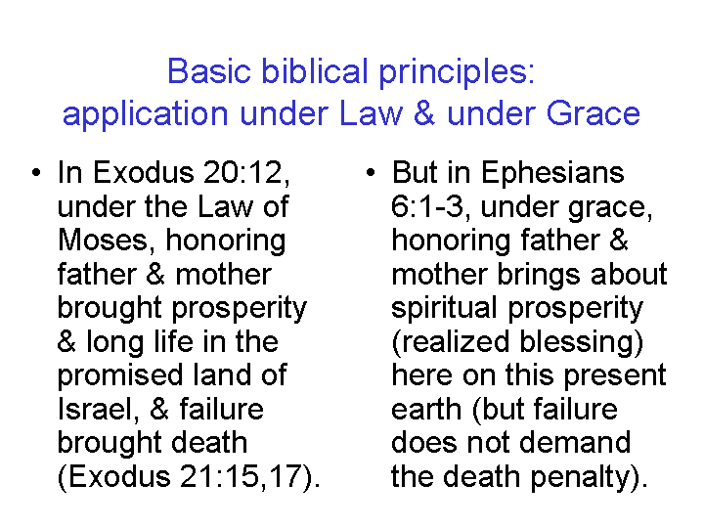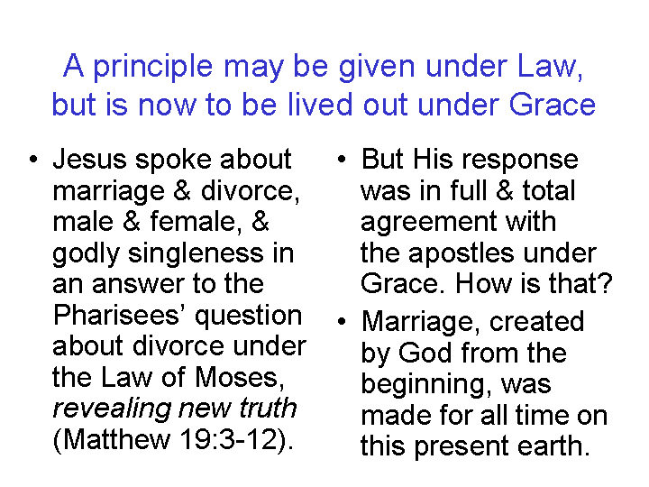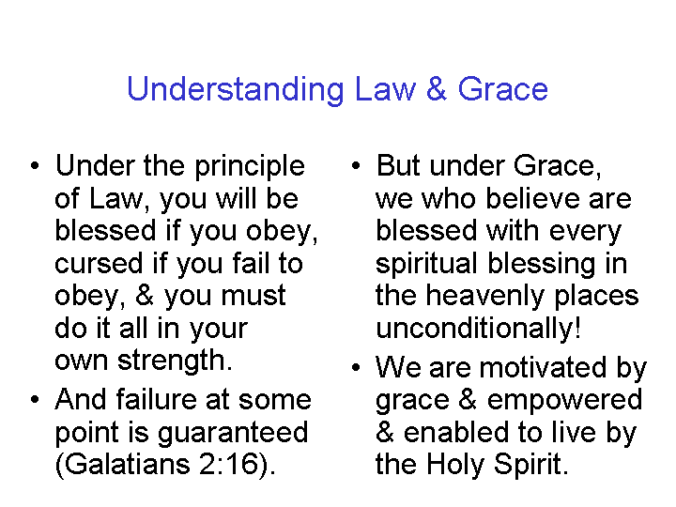
Biblical Guidance on Life Stages

Marriage Children Children marry Assistance

Birth Leave home Born / raised Leave home From children Death

Psalm 139:13-16 Genesis 2:24 Psalm 139:13 Genesis 2:24 1 Timothy 5:4,8,16 1 Thessalonians 4:13-18
Jeremiah 1:5 Ephesians 5:22-33 Ephesians 6:1-4 Matthew 19:5 Philippians 1:19-26
John 9:1-3 1 Corinthians 7 1 Thessalonians 2:1-12 Mark 10:7-8
1 Peter 3:1-7 1 Timothy 3:4,5 Ephesians 5:31 John 14:1-6 2 Corinthians 12:14 Colossians 3:20,21

Honoring parents means:

Obedience……… Respect…………………………………………………………….…… Responsibility………………………………

Exodus 20:12 Exodus 21:15,17 1 Timothy 5:4,8,16 Ezekiel 44:25
Deuteronomy 5:15 Proverbs 23:22-25
Ephesians 6:1-3 Micah 7:6

Headship in Home:

Husband…Father… (transfer)
Husband……………..Father…………………… (transfer)
Husband……………..Father………………………

For headship in the home, see passages under the column ‘Children marry / Leave home’ above.

Priority of Responsibility:

1) Own household (1 Timothy 5:8)
2) Parents, children (direct lineage: 1 Timothy 5:4)
3) Grandchildren (next in lineage: 1 Timothy 5:4)
4) Uncles, aunts, cousins, etc. (Acts 15:39; 23:12-22; Colossians 4:10)
5) Church (Acts 6:1-6; Galatians 6:10; 1 Timothy 5:1-16)
