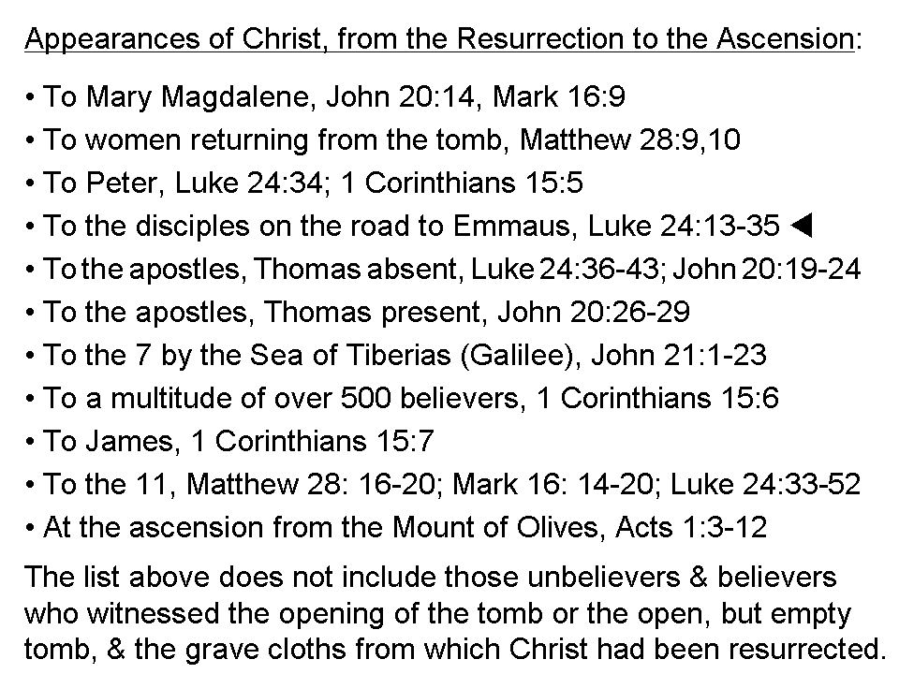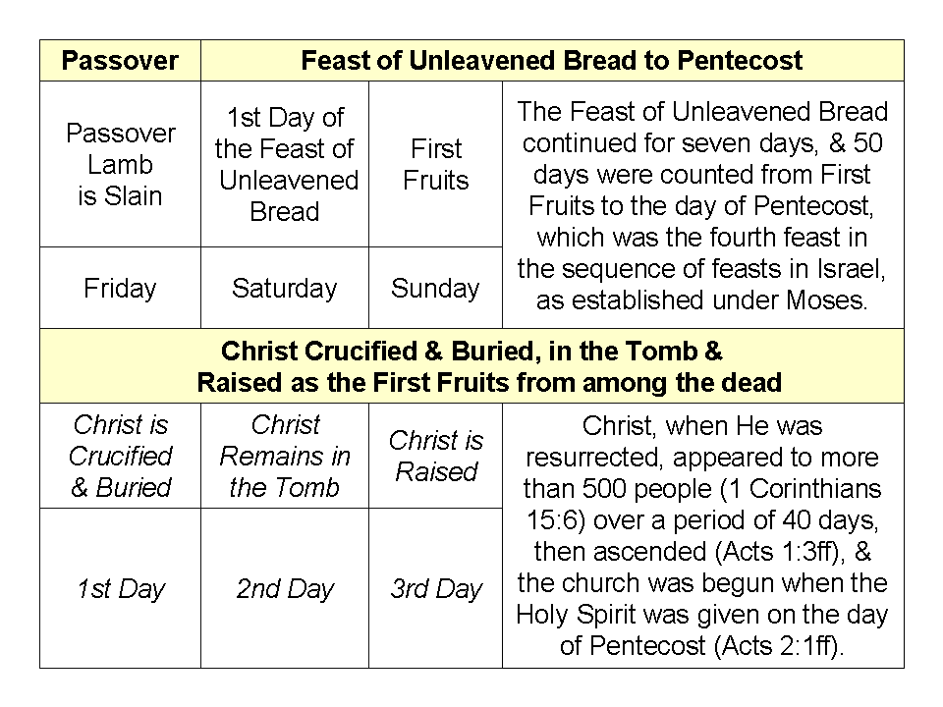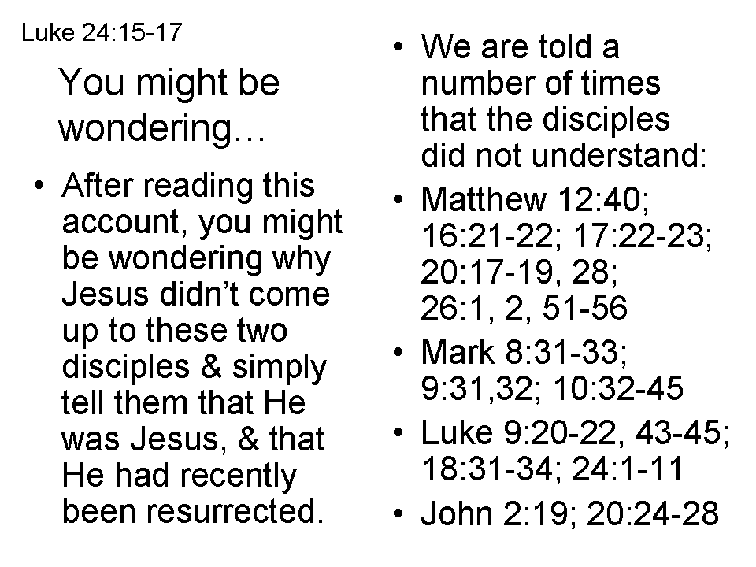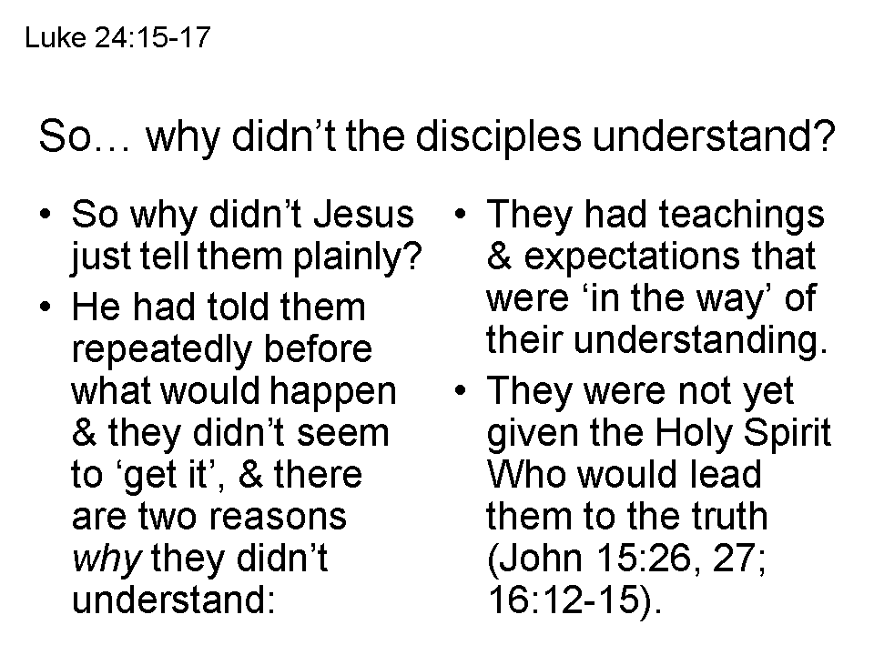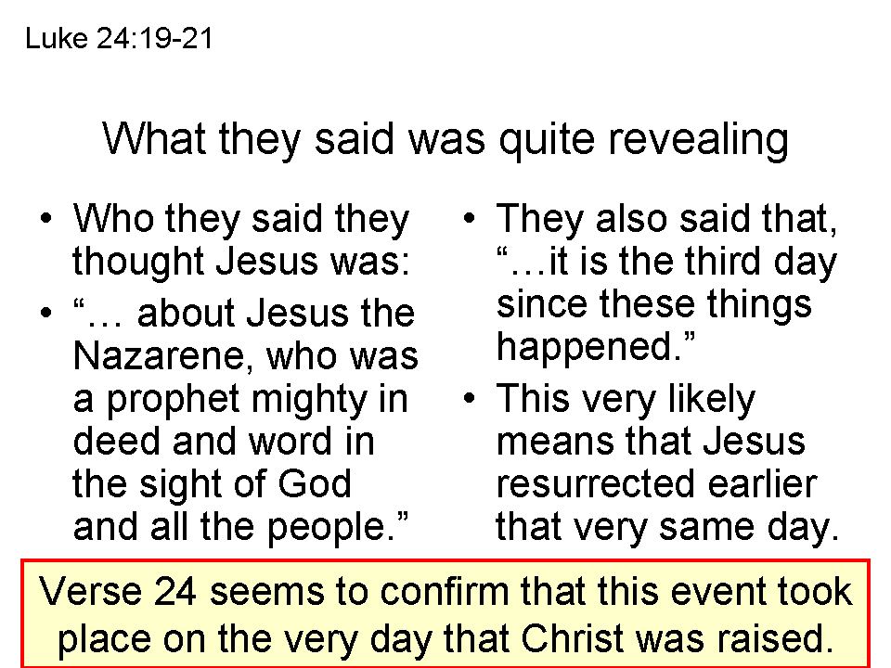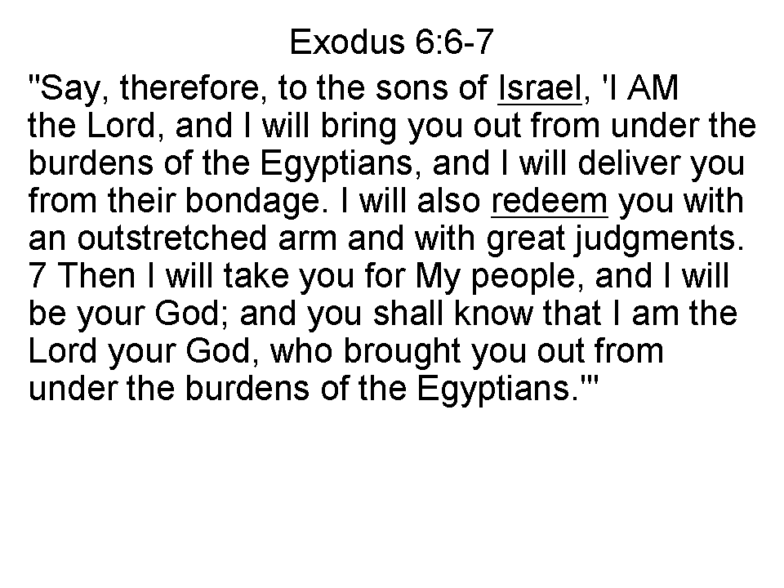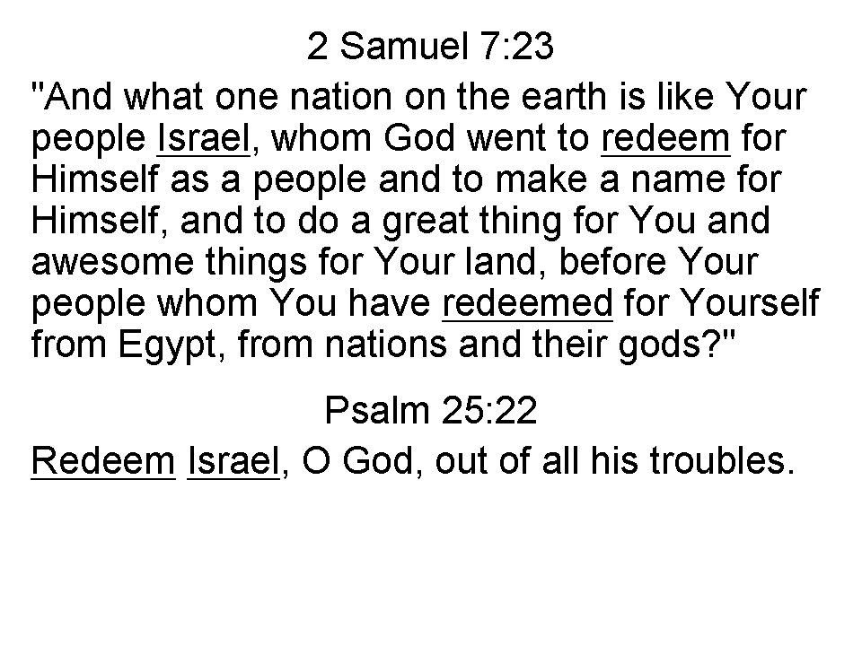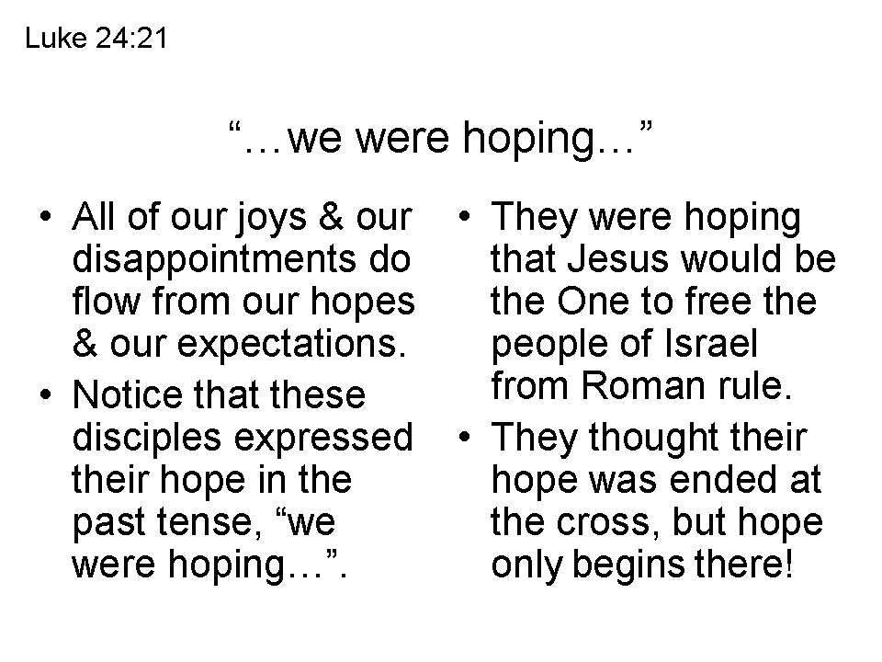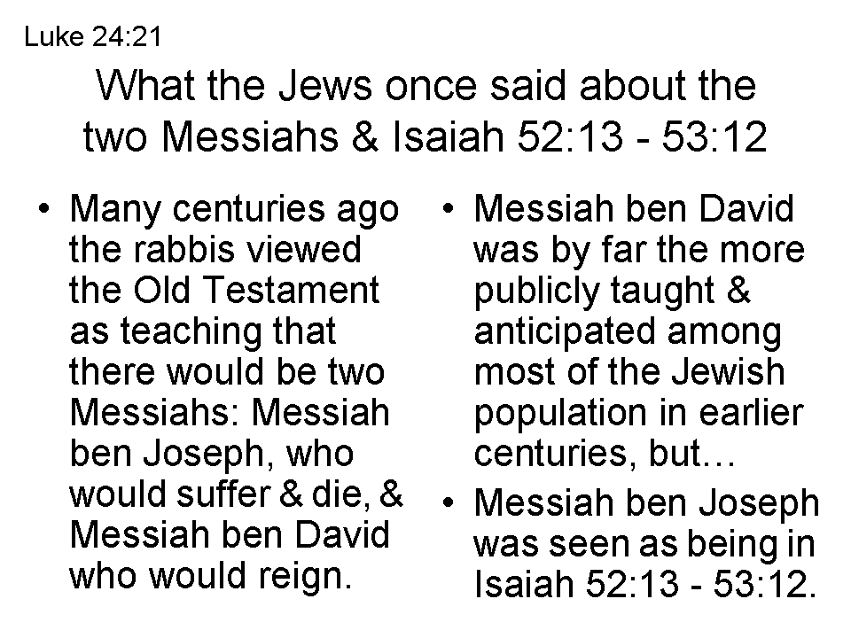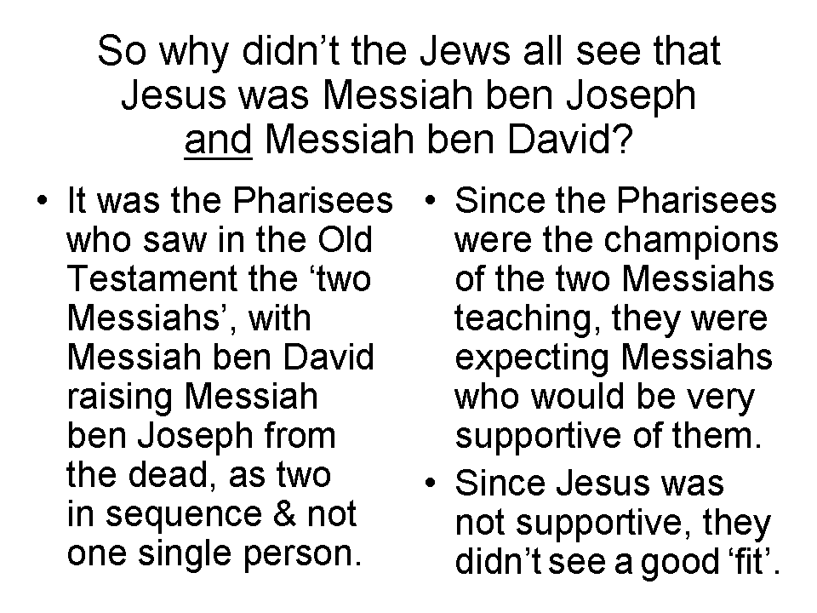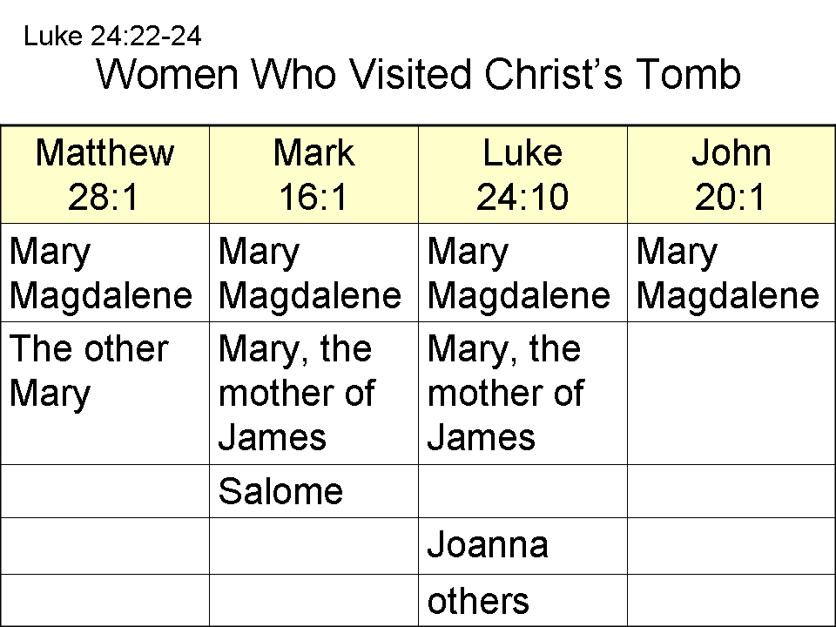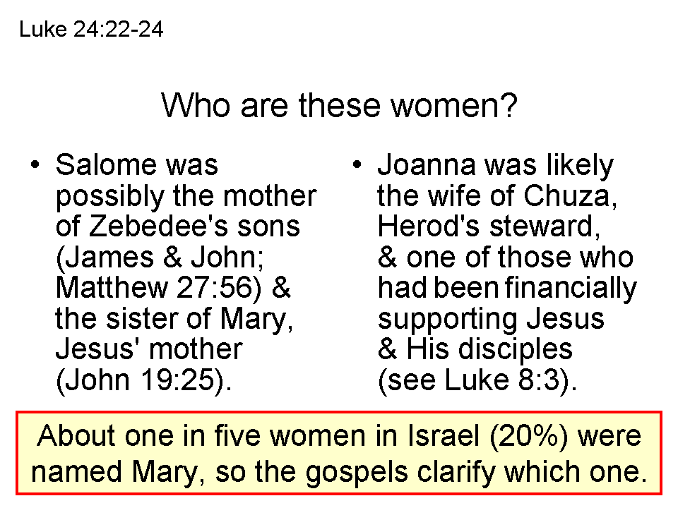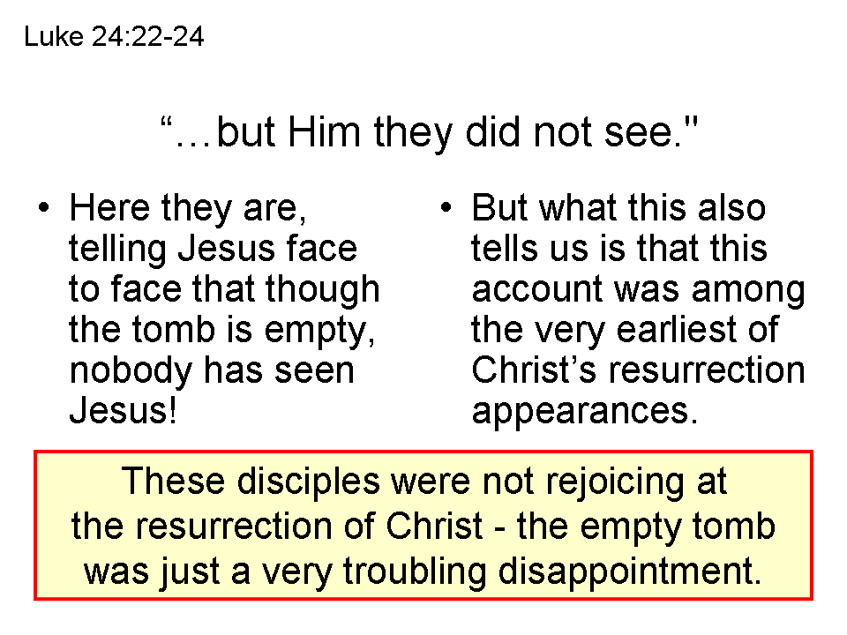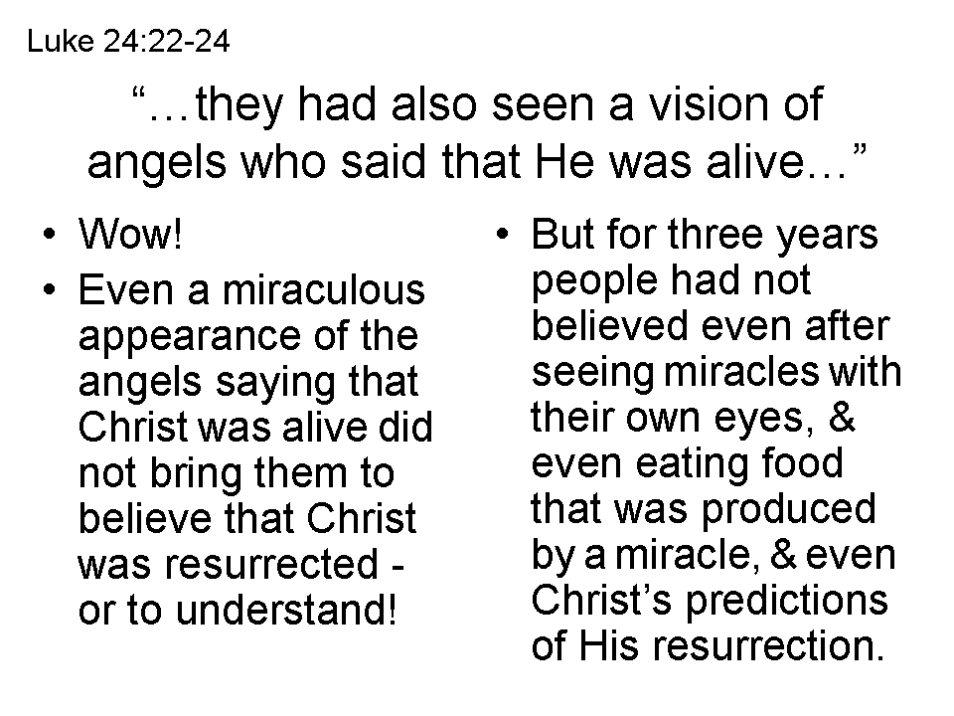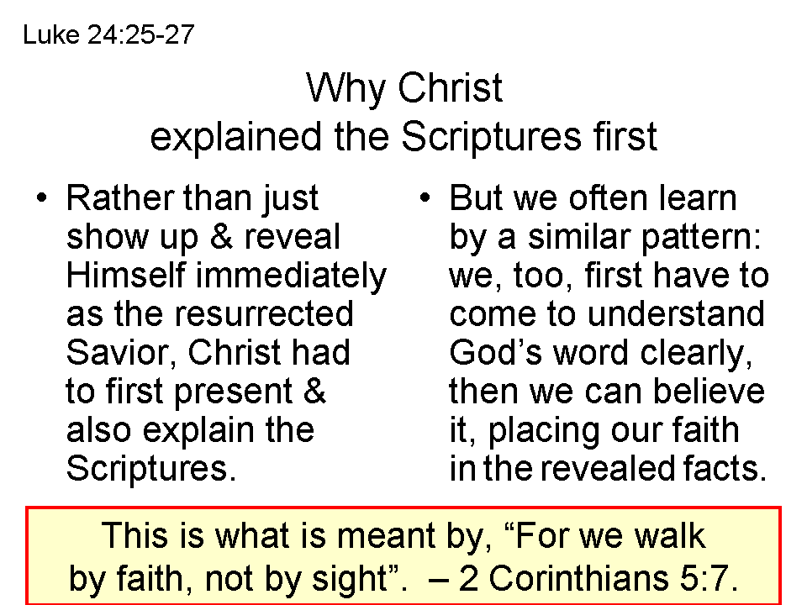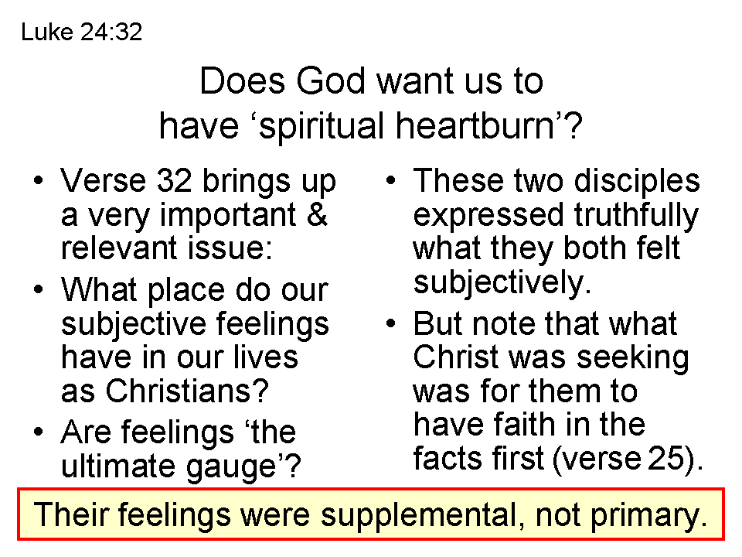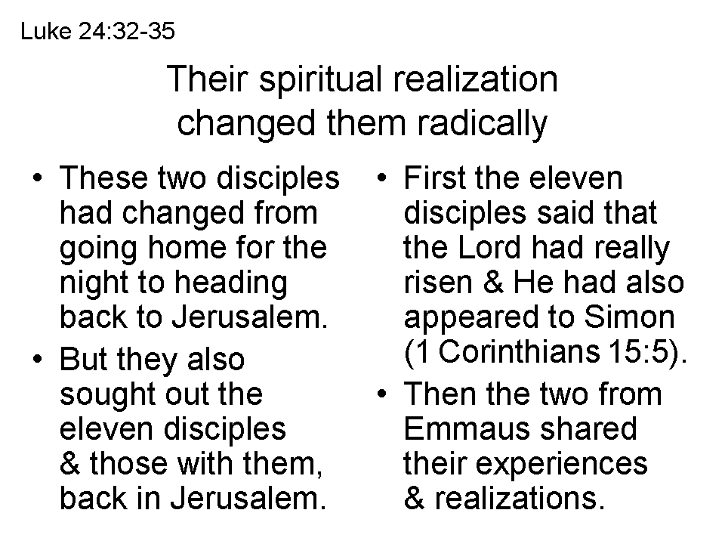
Old Testament Prophecy | Subject Prophesied / Fulfilled | New Testament Fulfillment
Isaiah 53:1 | not believed | John 12:37-38
Zechariah 13:7 | sheep of the Shepherd scattered | Matthew 26:31
Psalm 41:9, 55:12-13; Zechariah 13:6 | betrayed by a close friend | Luke 22:47-48; Matthew 26:49-50
Zechariah 11:12 | betrayed for thirty pieces of silver | Matthew 26:14-15
Zechariah 11:13 | betrayal money used to buy Potter's field | Matthew 27:6-7
Psalm 35:11 | accused by false witnesses | Mark 14:57-58
Isaiah 53:7 | silent to accusations | Mark 15:4-5
Isaiah 50:6 | spat on and struck | Matthew 26:67, 27:30
Isaiah 53:5 | scourged | Matthew 27:26
Psalm 35:19 | hated without reason | John 15:24-25
Isaiah 53:5 | vicarious sacrifice | Romans 5:6, 8
Isaiah 53:12 | crucified with malefactors | Mark 15:27-28
Zechariah 12:10; Psalm 22:16 | pierced through hands and feet | John 20:25-27
Psalm 22:7-8 | sneered and mocked | Luke 23:35
Psalm 69:9 | was reproached | Romans 15:3
Psalm 109:25 | people shook their heads | Matthew 27:39
Psalm 69:21 | given vinegar for His thirst | John 19:28-29
Psalm 109:4; Isaiah 53:12 | prayer for His enemies | Luke 23:34
Psalm 22:17-18 | soldiers gambled for His clothing | Matthew 27:35-36
Psalm 22:1 | forsaken by God | Matthew 27:46
Psalm 31:5 | committed His Spirit to God | Luke 23:46
Psalm 38:11 | friends stood afar off | Luke 23:49
Psalm 34:20 | no bones broken | John 19:32, 33, 36
Zechariah 12:10 | His side pierced | John 19:34
Amos 8:9 | Darkness over the Land | Matthew 27:45
Isaiah 53:9 | buried with the rich | Matthew 27:57-60
Psalm 16:10, 30:3, 49:15, 118:17 | to be resurrected | Mark 16:6-7
Isaiah 44:3, Joel 2:28 | sent the Holy Spirit | John 20:22; Acts 2:16-17
Psalm 68:18, 110:1 | His ascension to God's right hand | Mark 16:19; Corinthians 15:4; Ephesians 4:8
Prophecy Fulfilled by Christ: His Sufferings to His Ascension

