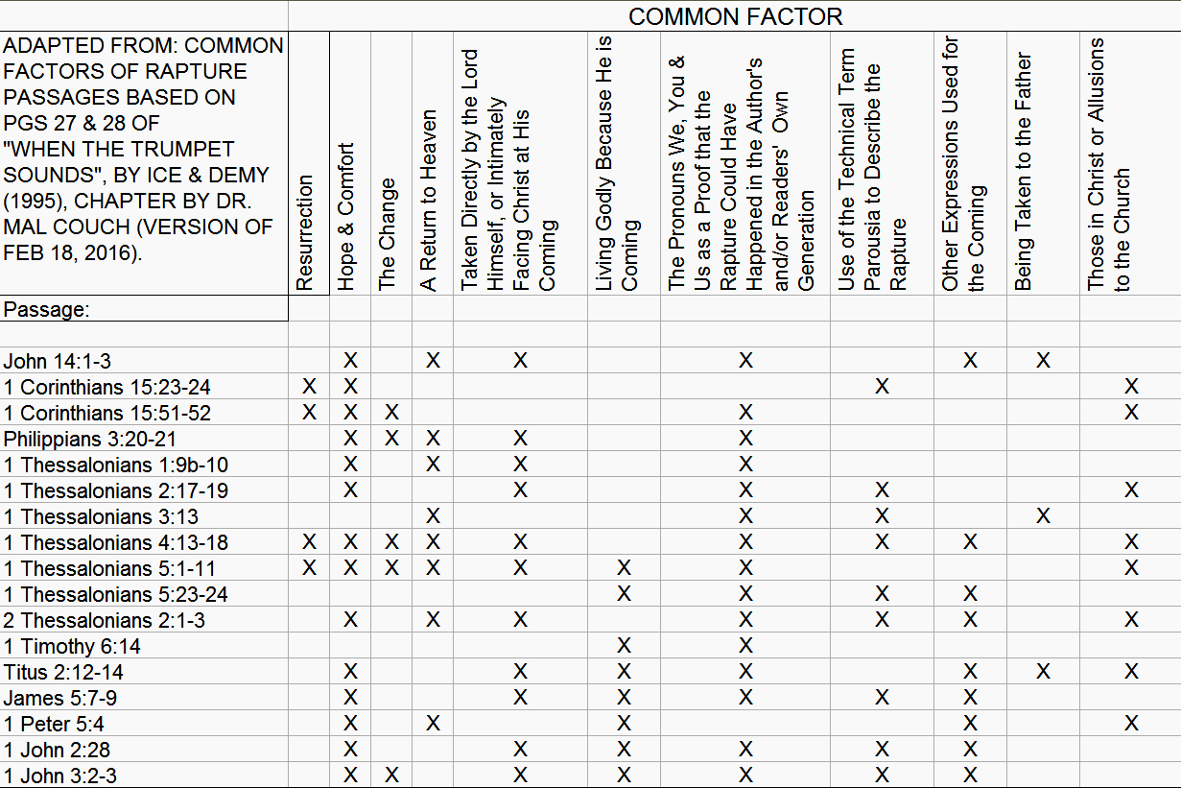
Other passages being considered: Colossians 3:4; 2 Thessalonians 2:3; Hebrews 9:28; 1 Peter 5:4

