2005 Identification Truths Series # 1 …
by Mike Doyle or Courtney Hemenway

Text Field / ID3 info format

Title: # Identification Truths

Artist: Mike Doyle or Courtney Hemenway
Name: Identification Truths Series
Genre: Speech
Copyright: Holly Hills Bible Church Denver, CO
Date: 2006
Comments: mmm dd, yyyy 10 AM

Text Field / ID3 info format

Title: # Identification Truths

Artist: Mike Doyle or Courtney Hemenway
Name: Identification Truths Series
Genre: Speech
Copyright: Holly Hills Bible Church Denver, CO
Date: 2006
Comments: mmm dd, yyyy 10 AM

- use Windows Explorer to Rename file with only one Teacher
last name, first name initials and his # in the file name like:
TT# = DM1 for Mike Doyle or HC1 for Courtney Hemenway
Series and ## of the series info:
SS = IT for name of Identification Truths Series
File+Save as filename like yyyymmddhhTT#SS##.wav
2) right click on the renamed filename and use wTouch option to set correct date time as 10:05:00 AM
3) Double click on the icon of the filename to Load file into Audio Audition program
File+Save as filename with a on end like yyyymmddhhTT#SS##a.wav
4) Use View+WaveProperties+TextFields to add the ID3/Text info per above as show in example below
File+Save
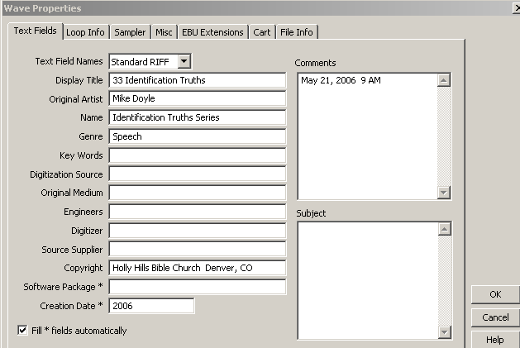
For this Identification Truths Series use:
Lesson # Then Identification Truths, in the Display Title field
And mmm dd, yyyy hh AM in Comments
5) Use Generate+Silence to add 1 sec silence to begin and end, trim a bit if nec to eliminate prayers at beg
File+Save
6) Use Effects+Hard limit so has a level of peaks is above 0db so can be limited up to the -0.2 db point..
File+Save as yyyymmddhhTT#SS##aHL#.wav HL# # = hard limit # of db gain used to get peaks above 0db
7) finally, make the mp3 audio file by using File and :
Save copy as for the mp3 formatted file, with file name truncated to yyyymmddhhTT#SS##.mp3

