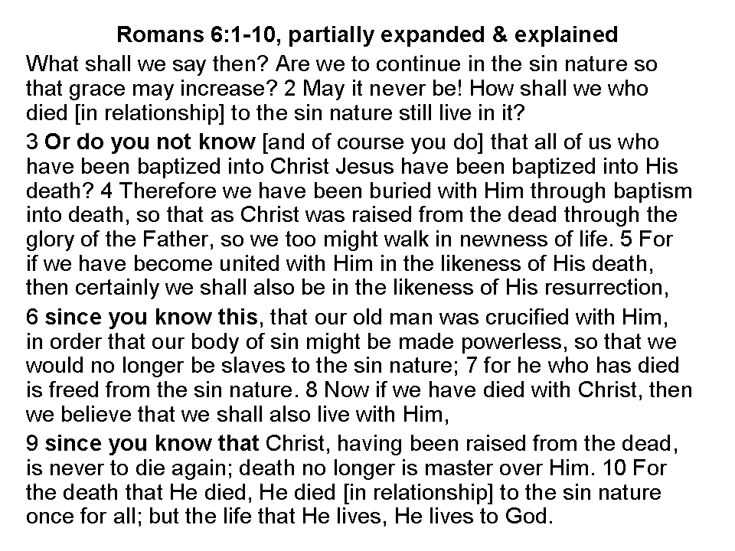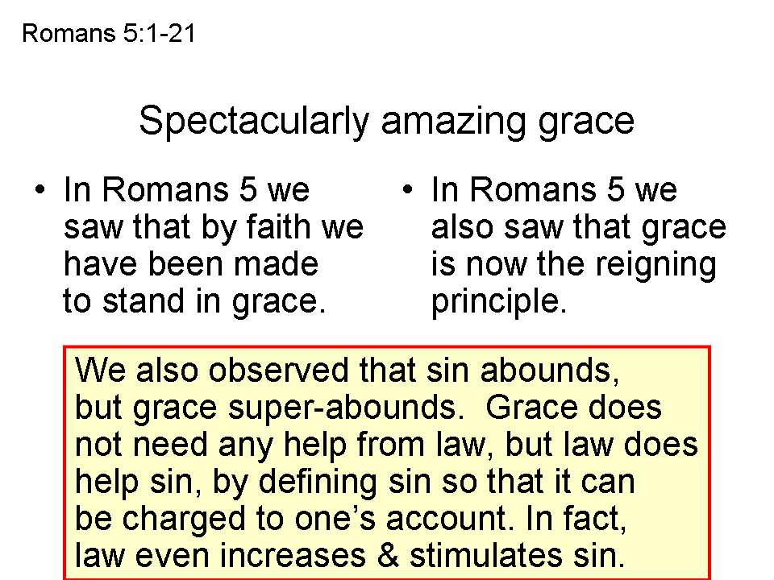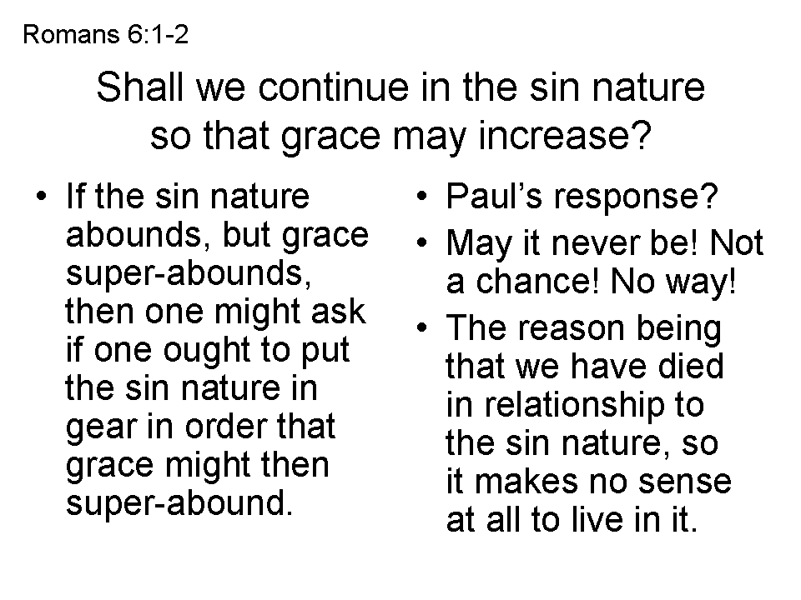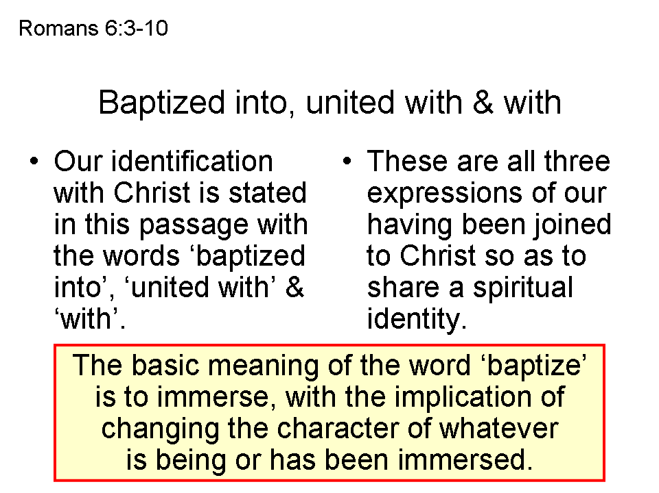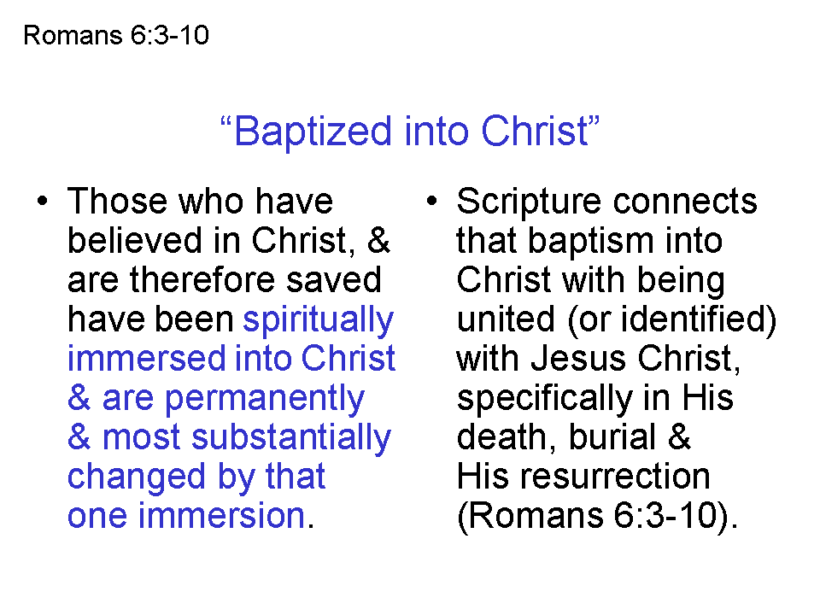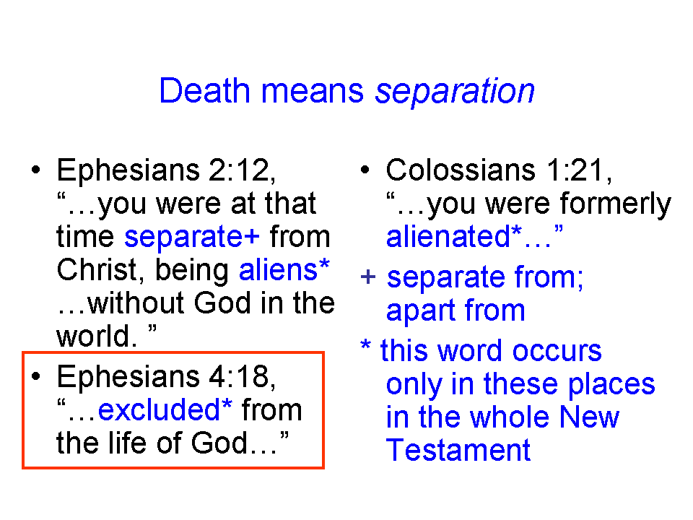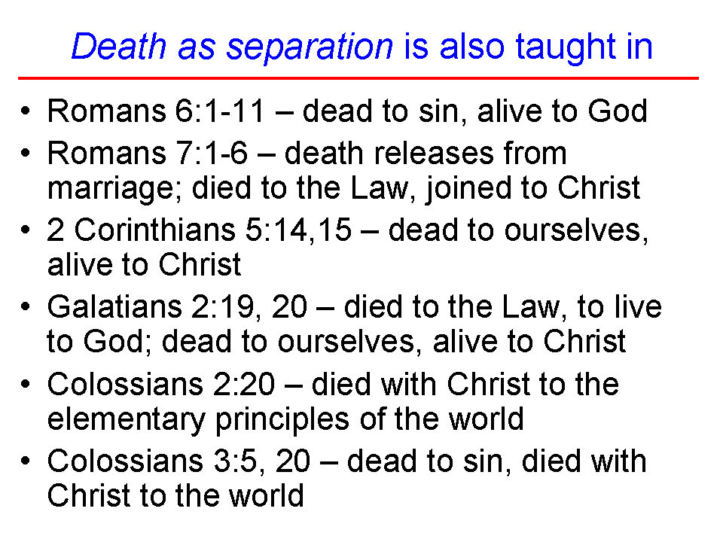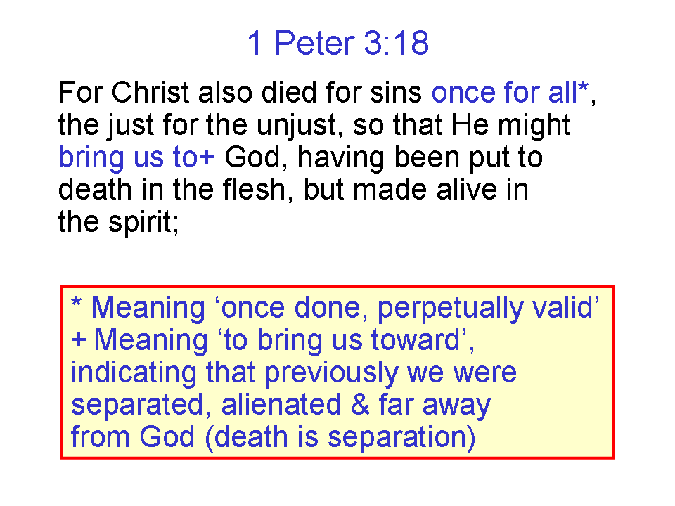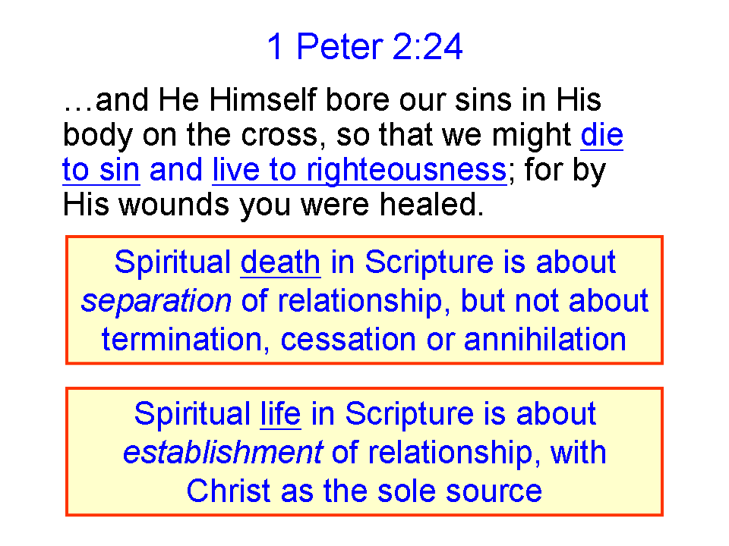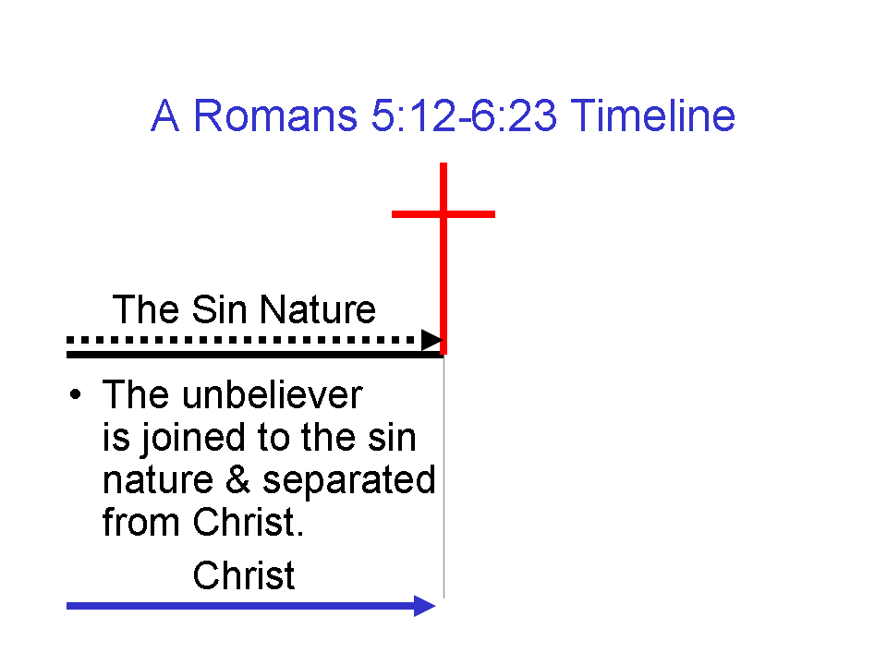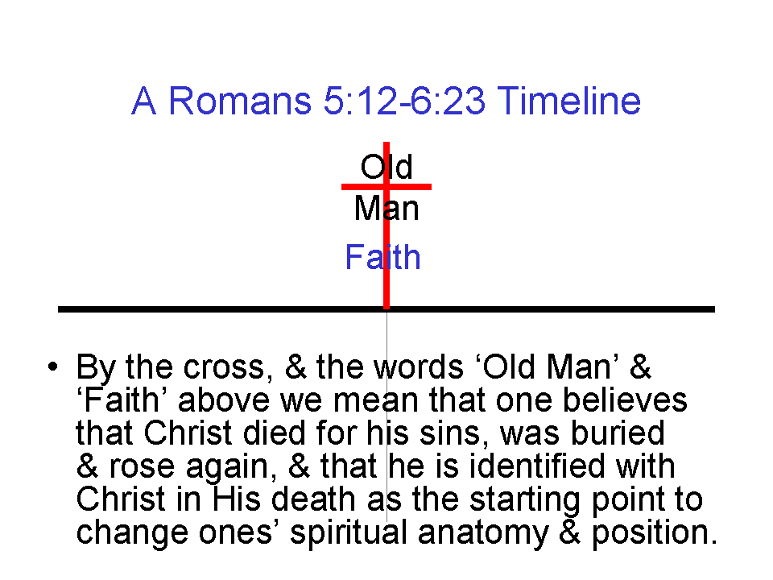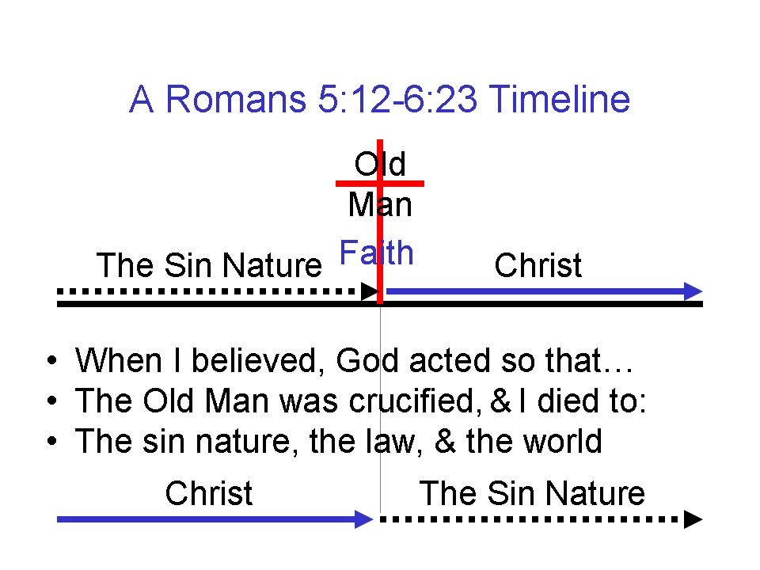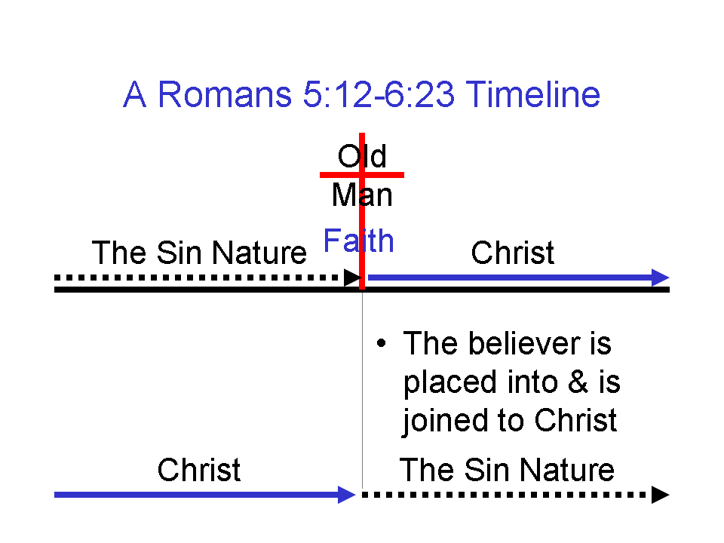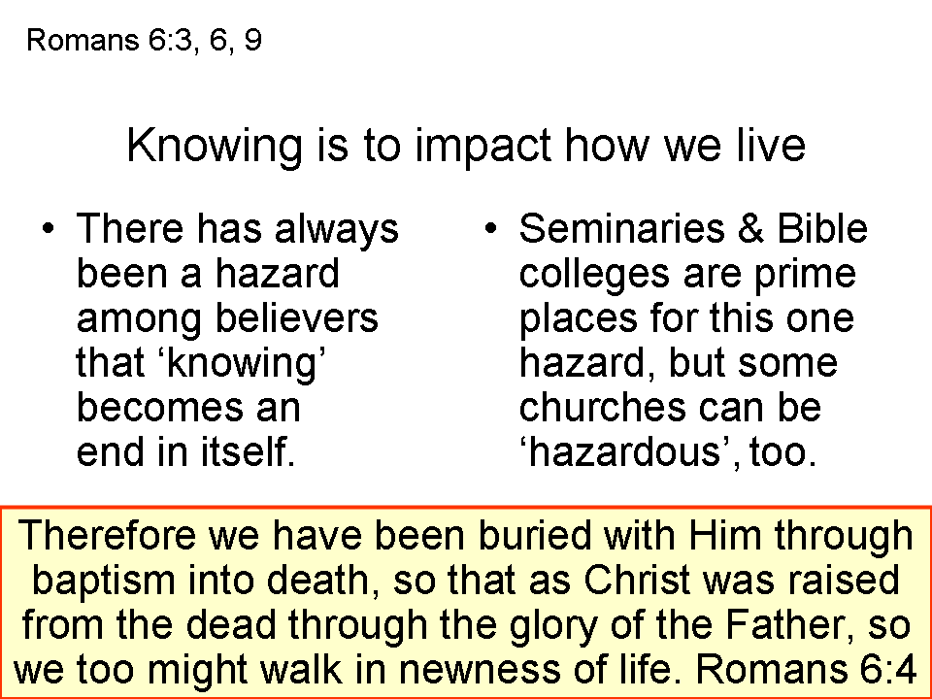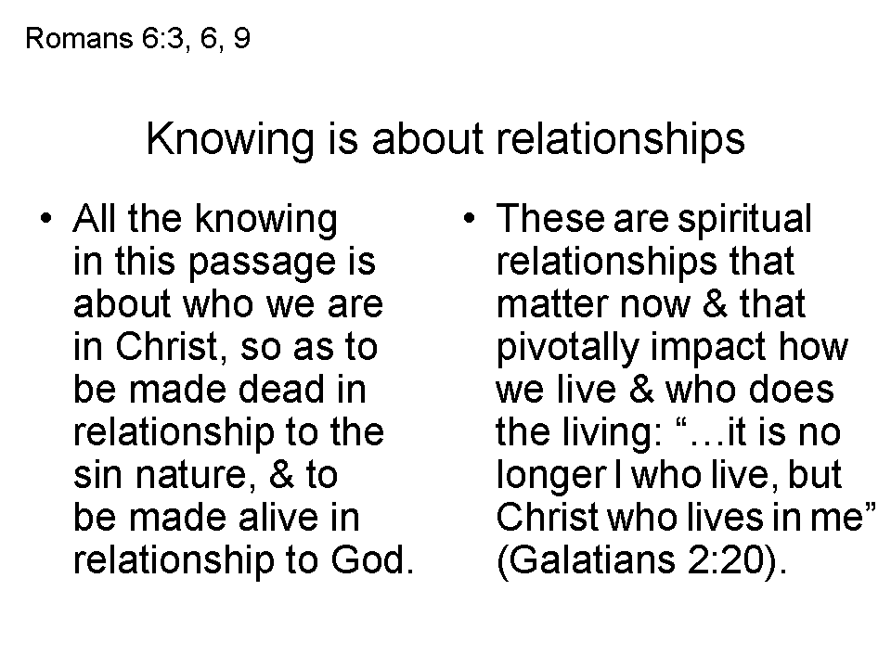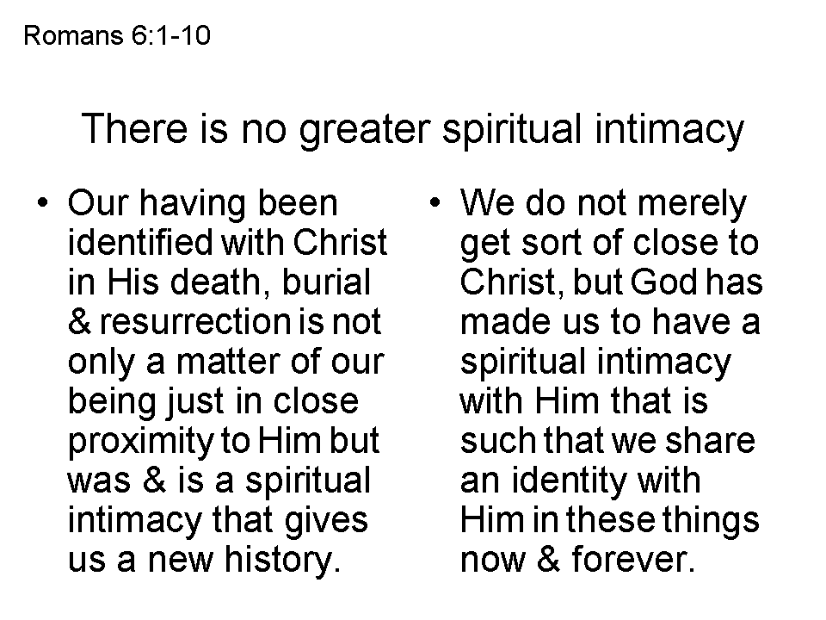
What Is The Basis For Using The Term ‘The Sin Nature’?

Looking into the source of the term "the sin nature" brings up a larger issue in understanding Scripture: some meanings are conveyed by specific words, while others are conveyed mostly or entirely by grammar and context.

Now for the term "the sin nature", the word 'nature' is not taken from a separate Greek word that means 'nature'. That Greek word with that meaning is actually relatively uncommon in the New Testament. But the term "the sin nature" is not derived principally by Greek word meaning, and most certainly not by explicit use of a word meaning 'nature'. The term "the sin nature" is instead derived by grammar and context. So there are three main points to make about the term:

1) Some have objected to the term 'nature', saying that we should instead use the term 'disposition' or 'principle'. But staying with the term 'nature' makes it easier for us to communicate with one another more clearly, rather than using varying terms. 'Nature', 'disposition' and 'principle' are indeed synonyms. One could also use "Godless spiritual and moral inclination to think and to act" although that starts to get more 'wordy'.

2) Paul's repeated and deliberate use of the Greek noun that is translated "sin", preceded by the definite article, indicates specificity. Paul is not using the term for 'sin' in general - it is specific. Paul is not using the verb 'to sin' as an action - it is an abstract noun. Paul is also not using the term for a 'man', as in Old Man or New Man, as these are used of the person who has an identity because of identification (either "In Adam" or "in Christ"). Paul does repeatedly talk about the spiritual and moral inclination to action or natural disposition of "the sin" - it's nature. Paul's use of the term "the flesh" is viewed as the sin nature as expressed through the fallen human body with which that sin nature is associated.

3) Translators and expositors from the Greek text have used "the sin nature" or similar terms as they have sought to bring across what Paul meant by the sin or the flesh. So they have used:
- sinful nature (NIV; NOTE: the suffix "-ful" can have the meaning 'characterized by', which can redundantly communicate the idea of 'nature', so likely the intent is to convey 'full of' sin, that is, "the nature that is full of sin") See the use of sinful nature in Romans 7:5, et al.
- evil nature (Wuest)
- Old Sin Nature (OSN: James Allen, Tod Kennedy, Grace Notes, et al - this term was common for those at or from "Old" Dallas Seminary, in the Walvoord era, and presently at Chafer Theological Seminary)
- sin nature (Hampton Keathley III, Ron Merryman, et al)
So in the end we could allow that someone might use a variant expression for "the sin nature" as long as they don't deny its presence in the believer in this present body. It is a mistake, however, to deny its presence, though that is common among some groups. Using the term "the sin nature" makes for simple and clear communication. Like the word "Trinity" it is a helpful 'handle", but it still needs to be explained so that it is not just 'Christian code'.

