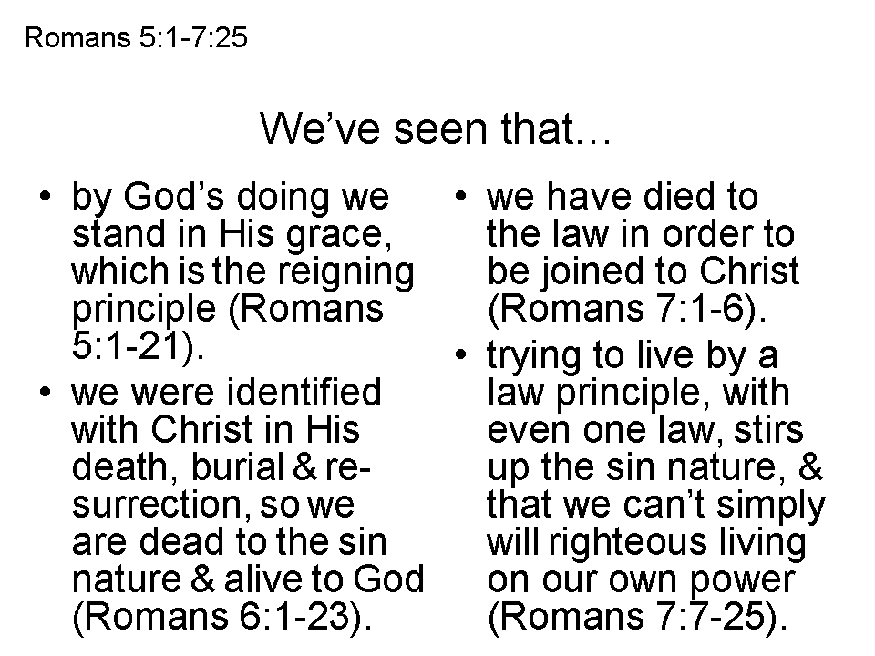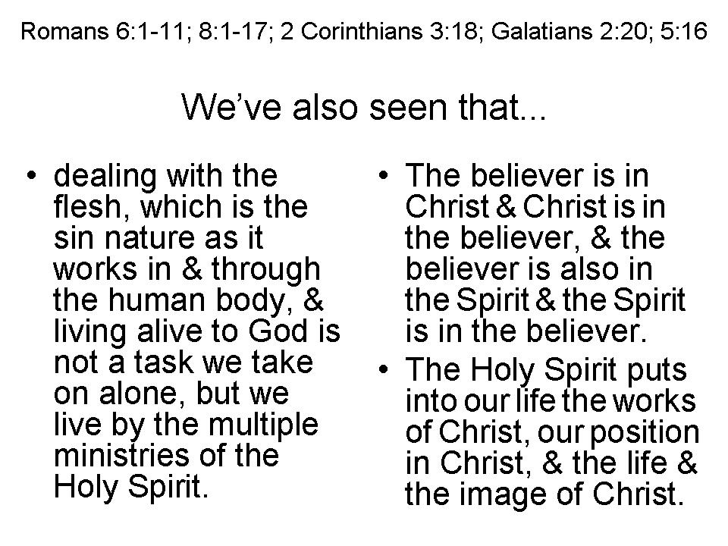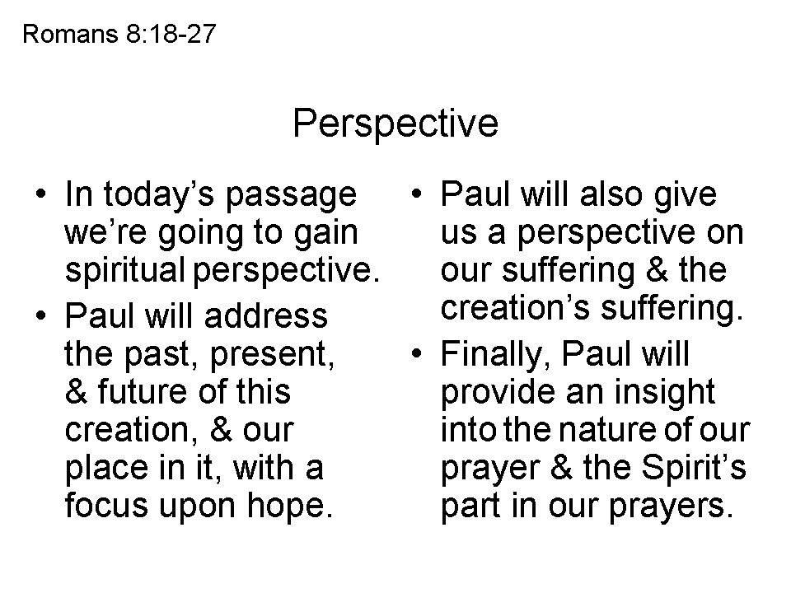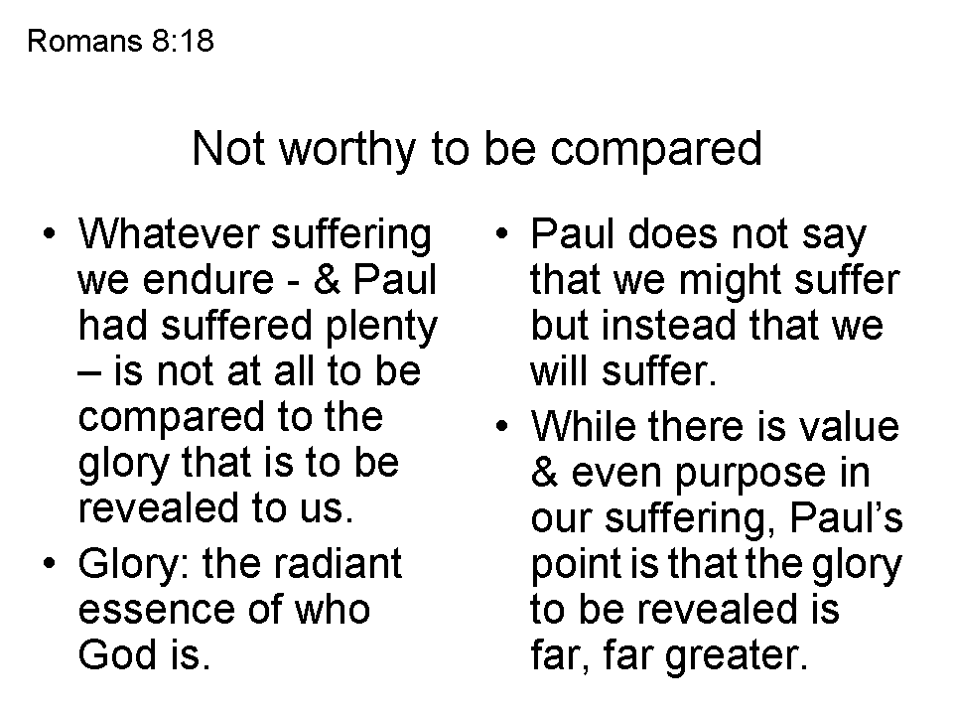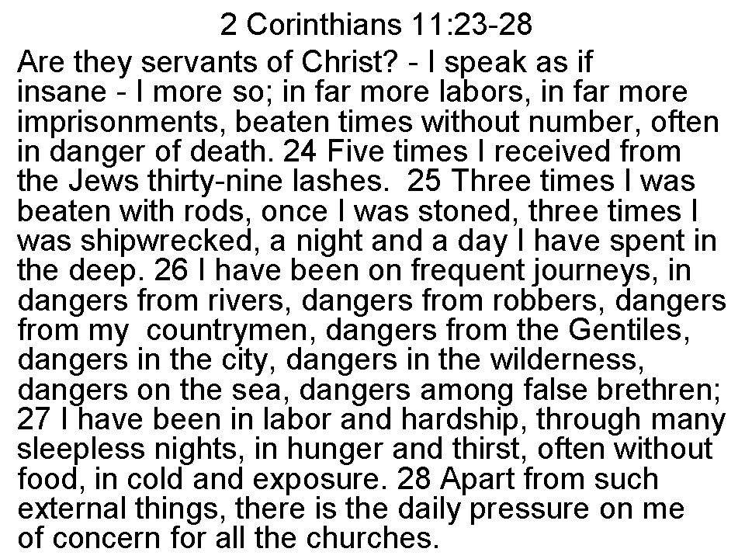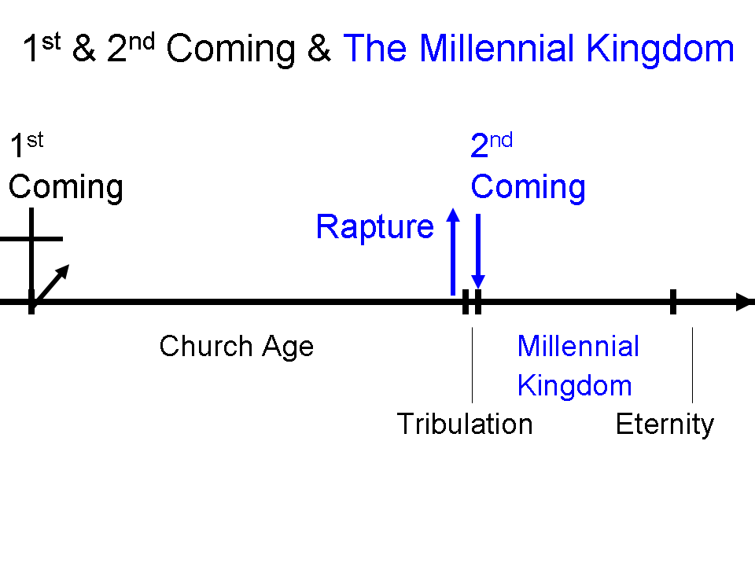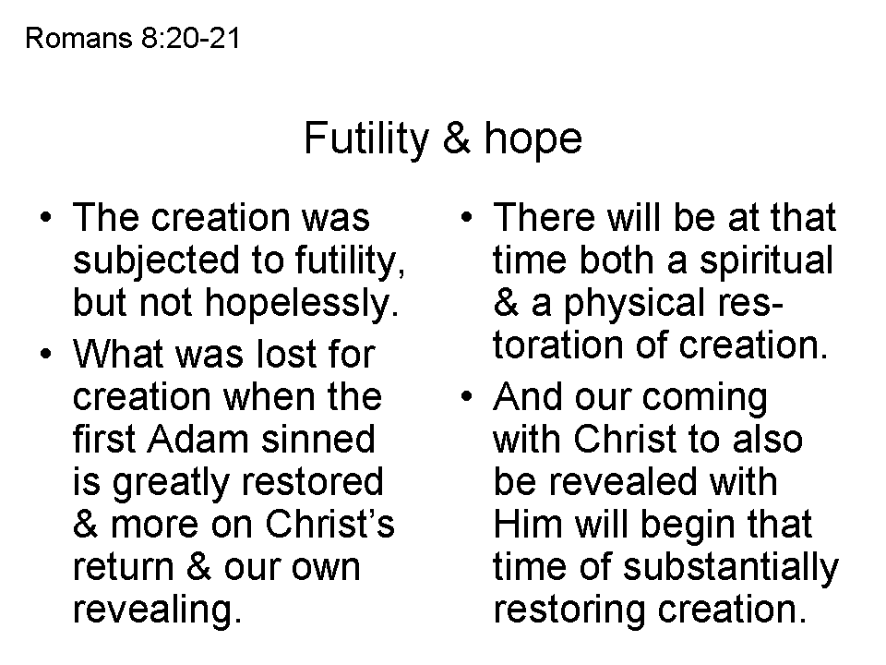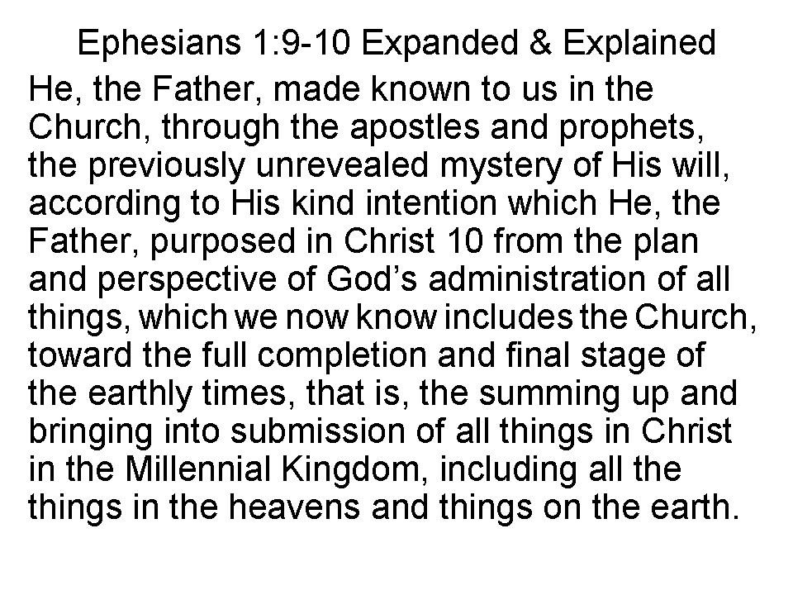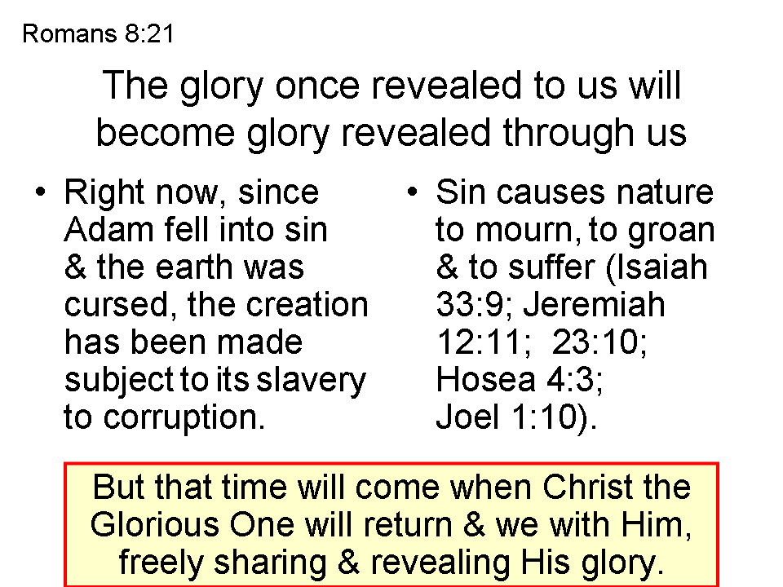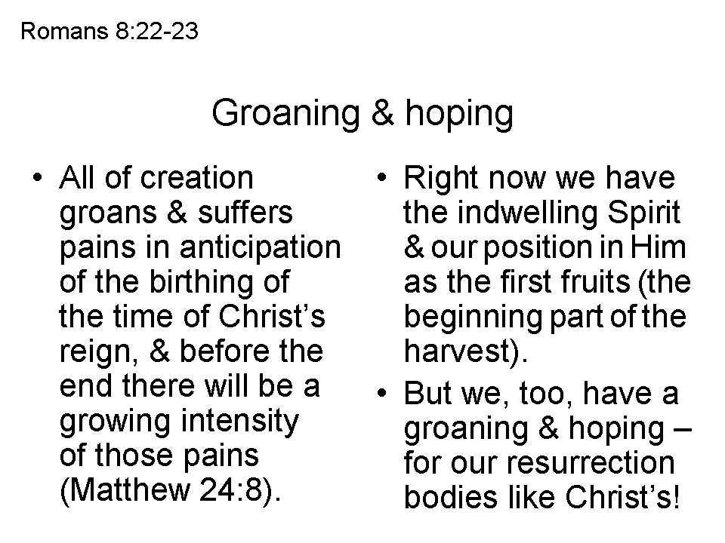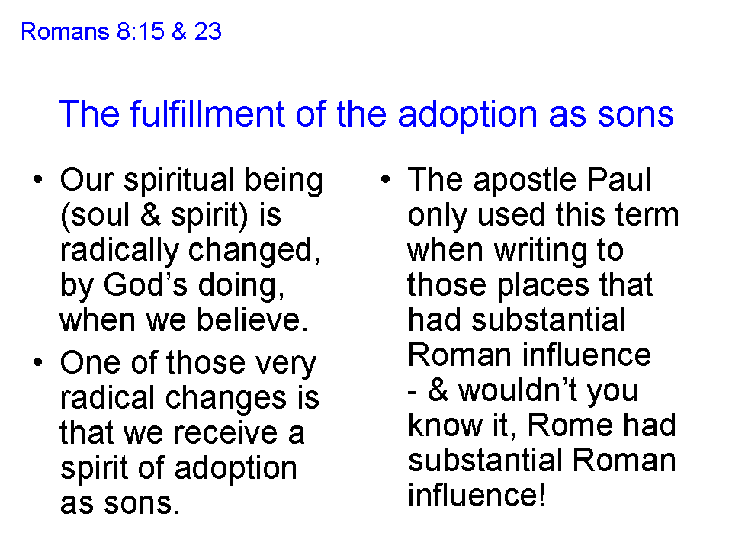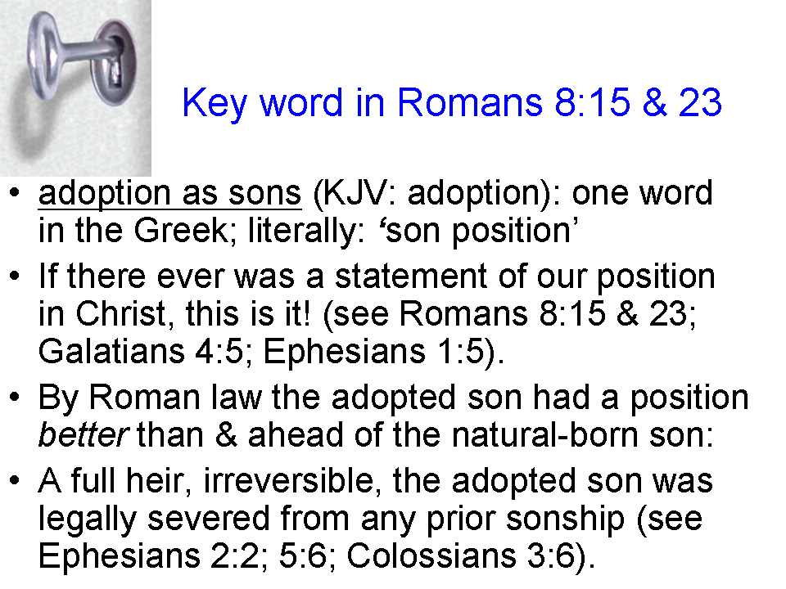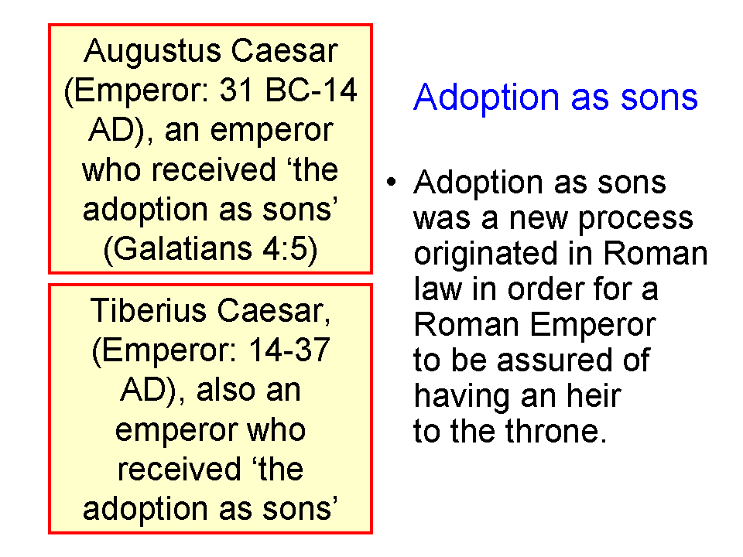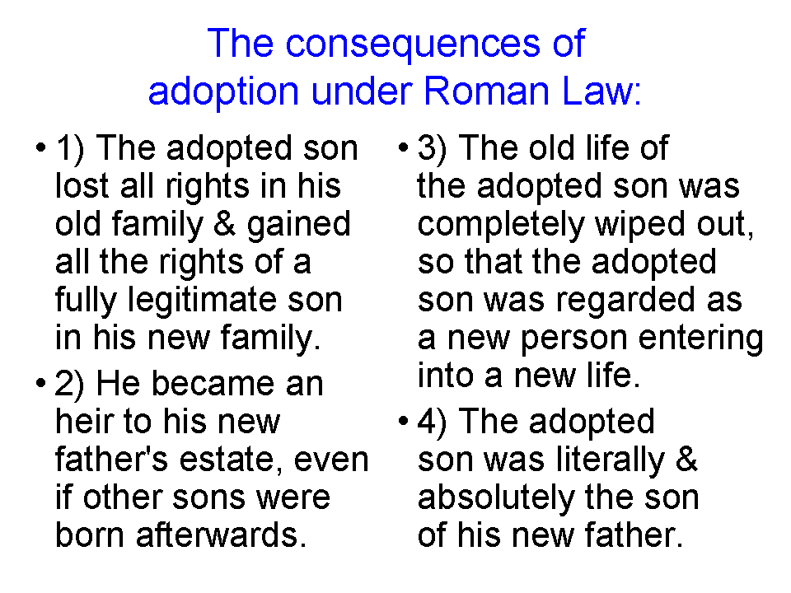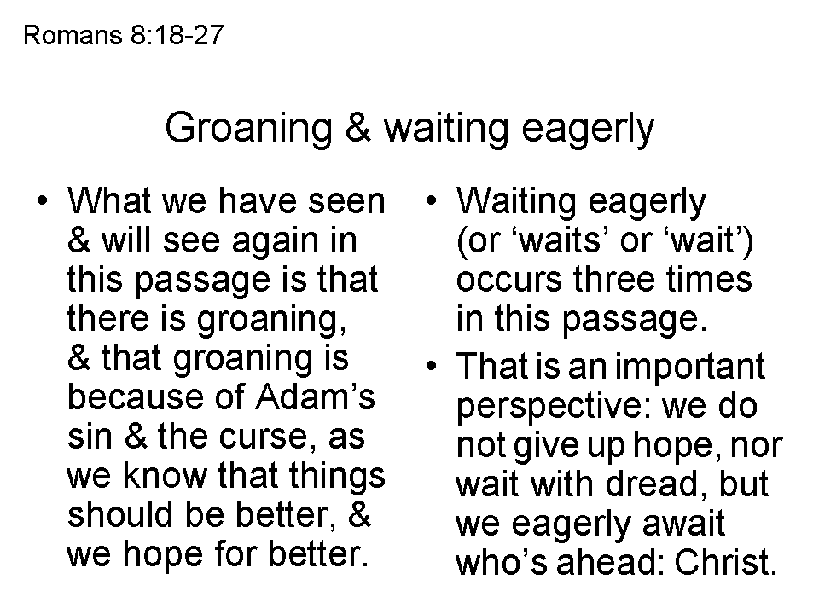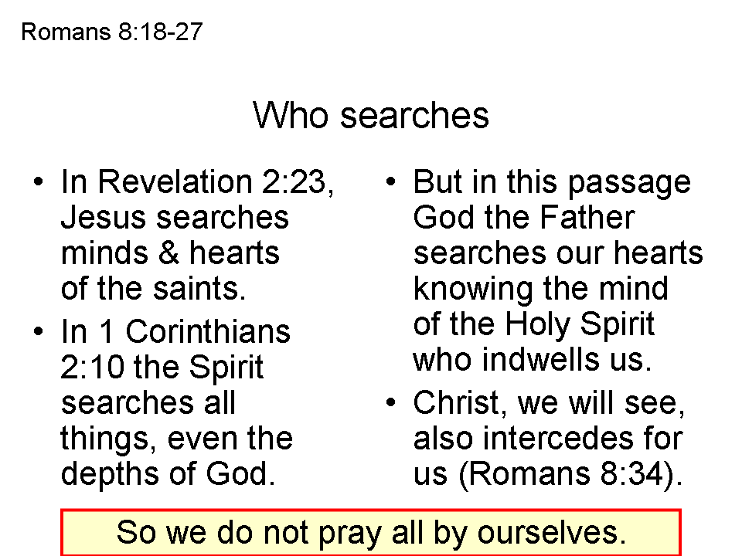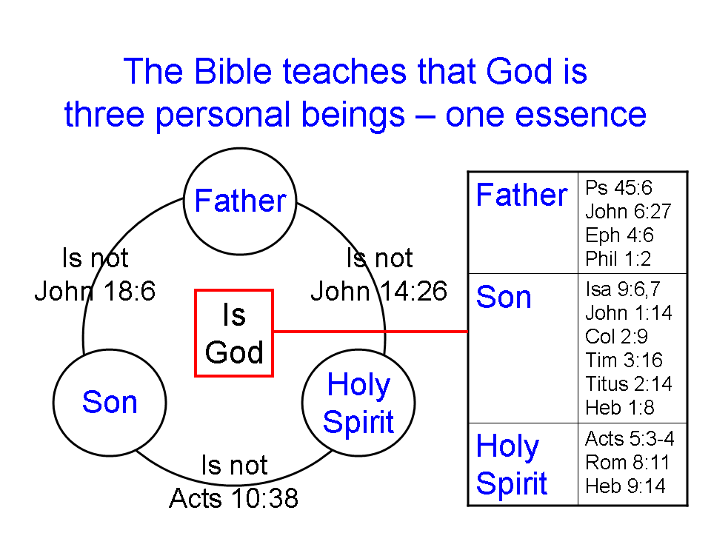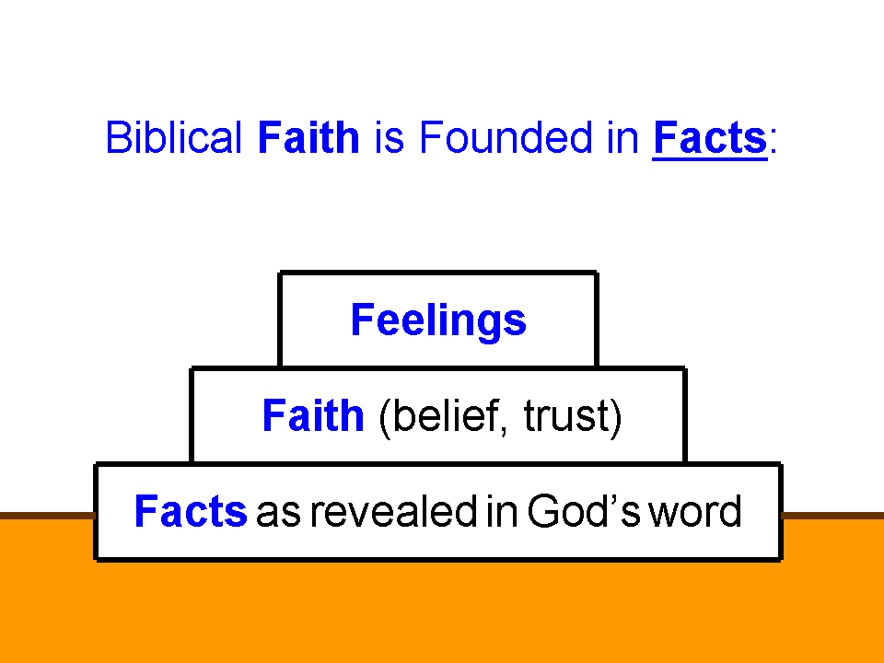
Some Of The Various Aspects Of The Ministry Of The Holy Spirit In The Believers Life

1. The Spirit dwells in believers. Jn 14:6; Romans 5:5; 8:9; 1 Cor 3:16

2. The Spirit gives believers access to the Father. Ephesians 2:18

3. The Spirit has fellowship with believers. 2 Cor. 13:14; Phil. 2:1; 1 John 4:13

4. The Spirit teaches believers. 1 John 2:20, 27; 1 Cor. 2:13

- The Spirit reveals the glory of Christ to believers. 1 Cor. 2:9-13; John 16:13-15
6. The Spirit transforms believers. 2 Cor 3:18; John 17:24; Eph. 2:6, 7
7. The Spirit manifests his fruit through believers. Galatians 5:22, 23; John 15:5

8. The Spirit gifts every believer for ministry. 1 Cor. 12:7,11,27; Eph. 4:7,8,11,12

9. The Spirit empowers believers. Acts 1:8; Ephesians 3:18

10. The Spirit fills believers. Acts 2:4; Ephesians 5:18

11. The Spirit desires against believers' sin nature. Romans 8:13; Galatians 5:17;

12. The Spirit controls the mind of the new man. Romans 8:5, 6; Phil. 2:5

13. The Spirit frees believers. Romans 8:2; 2 Cor. 3:17

14. The Spirit guides believers. Romans 8:14; Galatians 5:18, 25

15. The Spirit intercedes in prayer for the believer. Romans 8:26, 27; Eph 6:18; Phil 3:3

16. The Spirit is God's guarantee of his promises to the believer. 2 Corinthians 5:5; Eph. 1:13,14

17. The Spirit is the agent in the believer's sanctification. 2 Thess. 2:13,14; Romans 15:16

18. The Spirit assures believers. Romans 8:16; 1 John 4:13

19. The Spirit glorifies Christ through believers. John 16:13,14; 1 Cor. 12:3

20. The Spirit can be grieved & quenched by the believer. Eph. 4:30; 1 Thess. 5:19

21. The Spirit is the means by which a believer walks. Galatians 3:2,3; 5:16

- The Spirit perfects the believer. Galatians 3:3
Supplement: Ministries of the Holy Spirit by Hal Molloy

