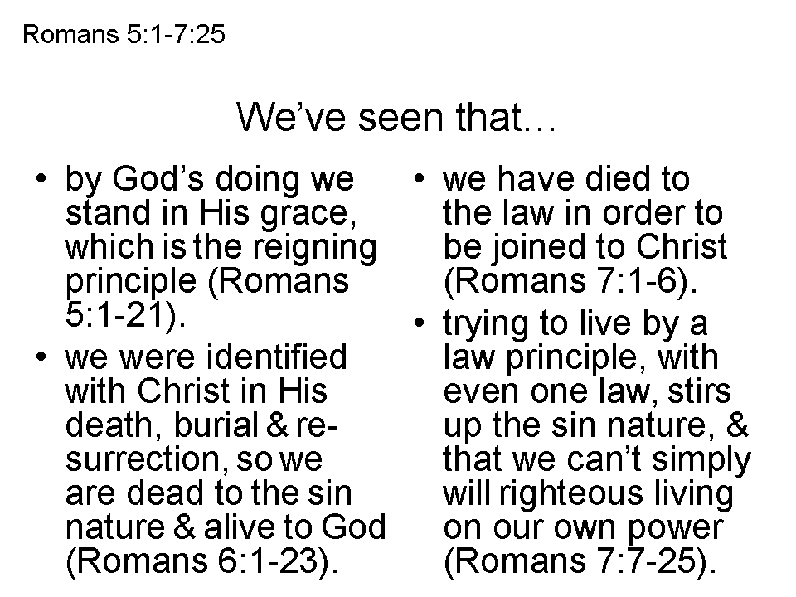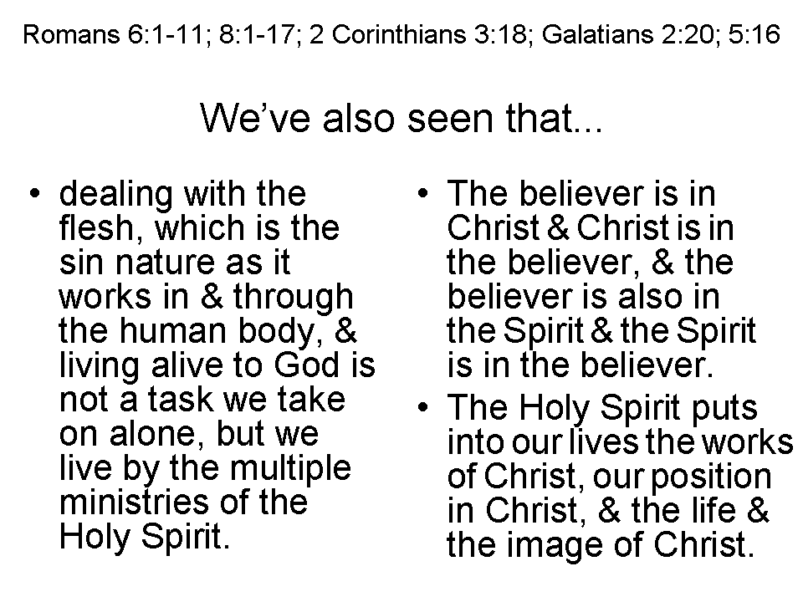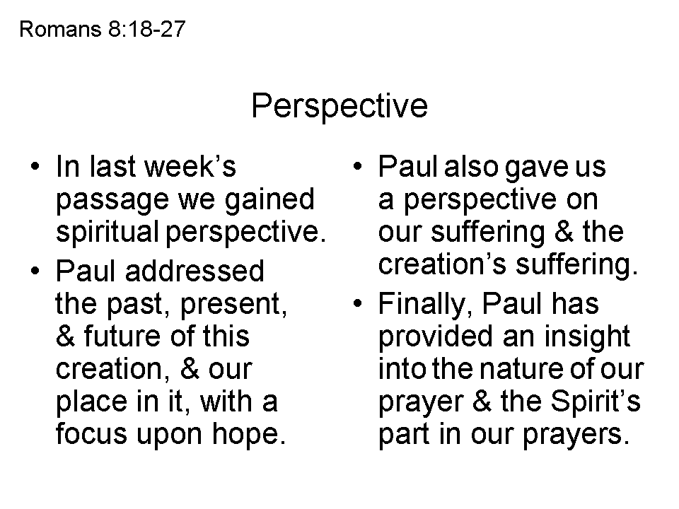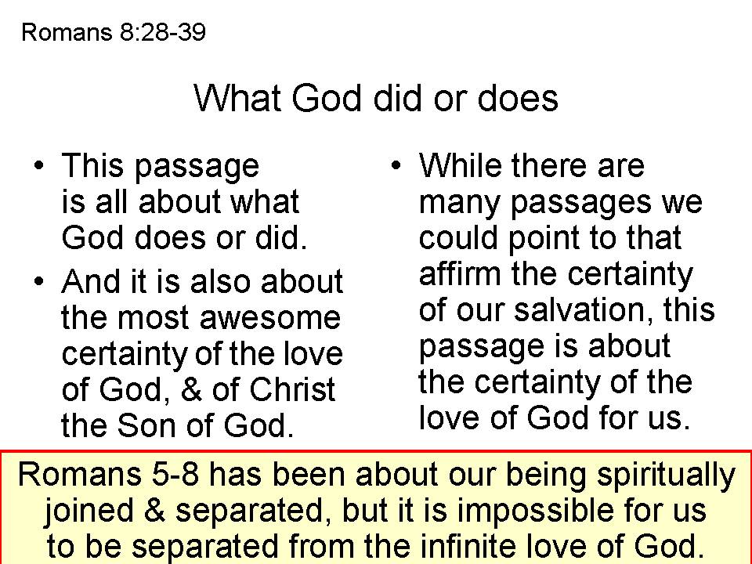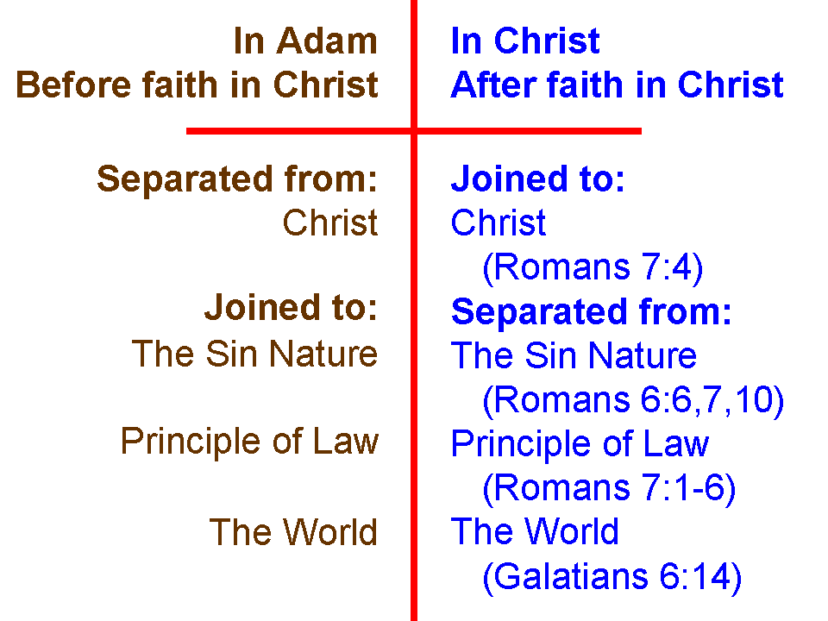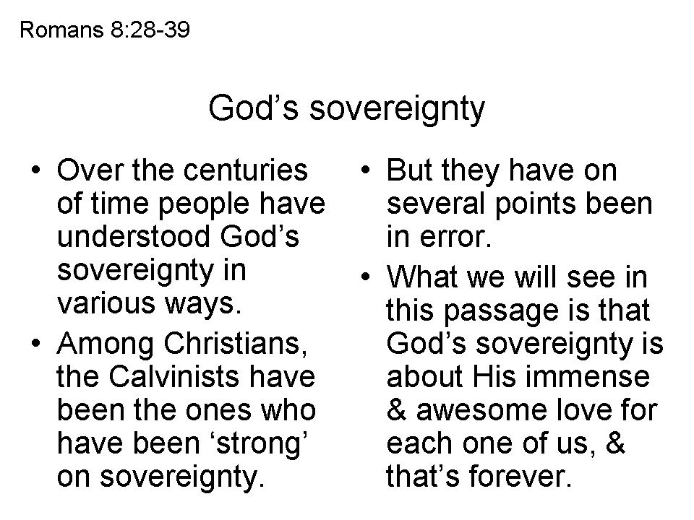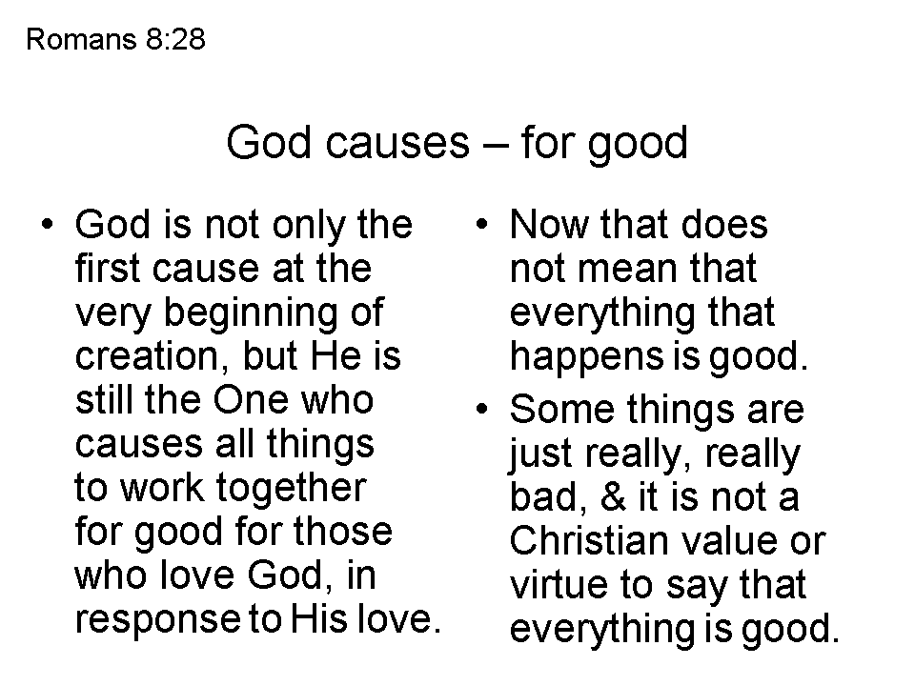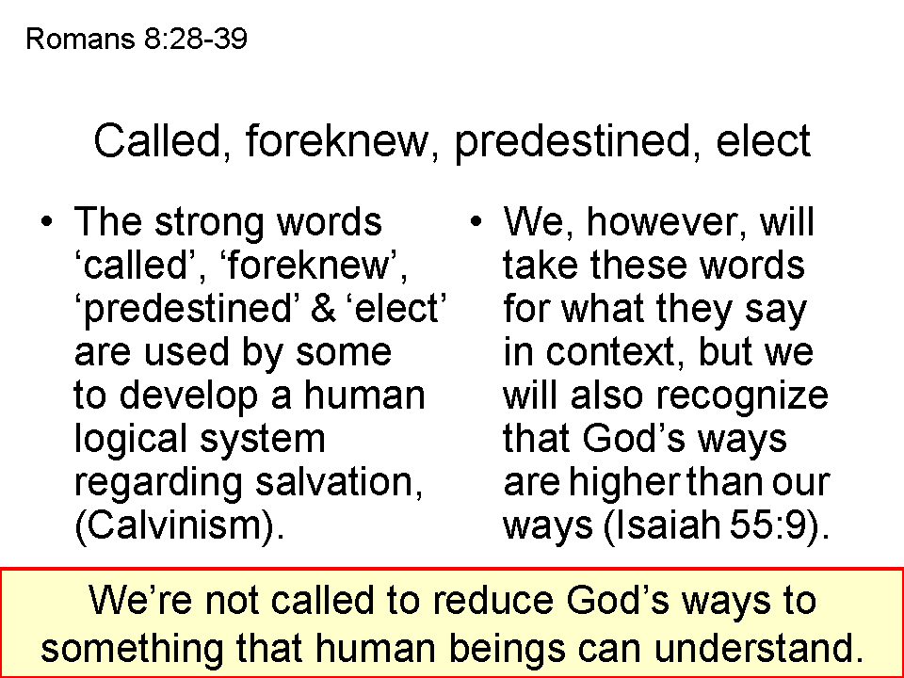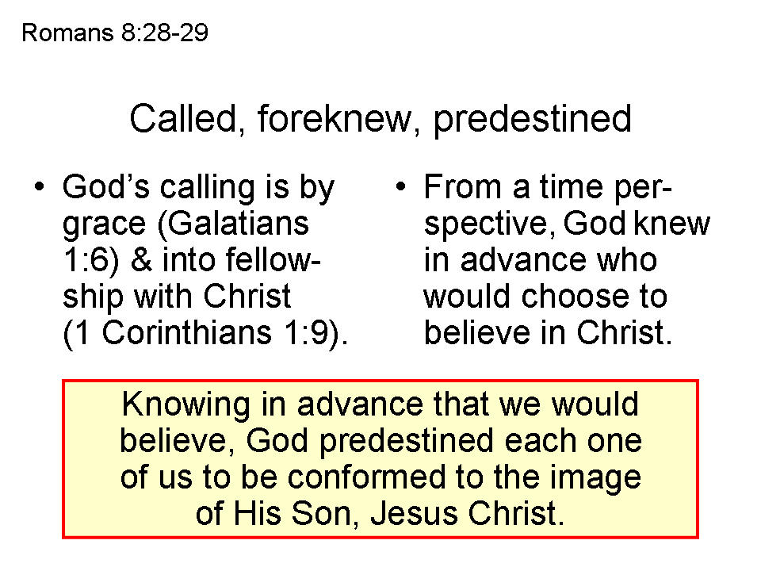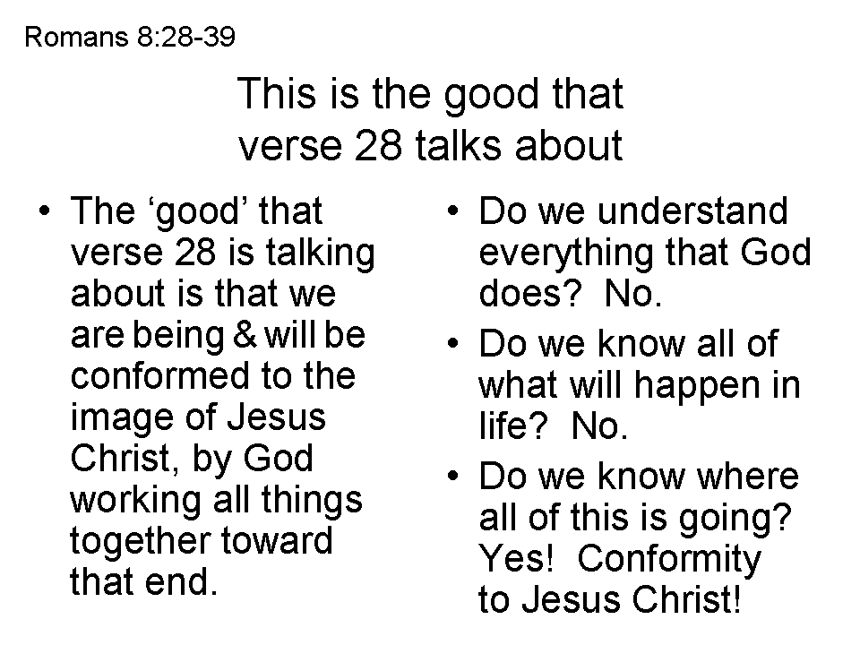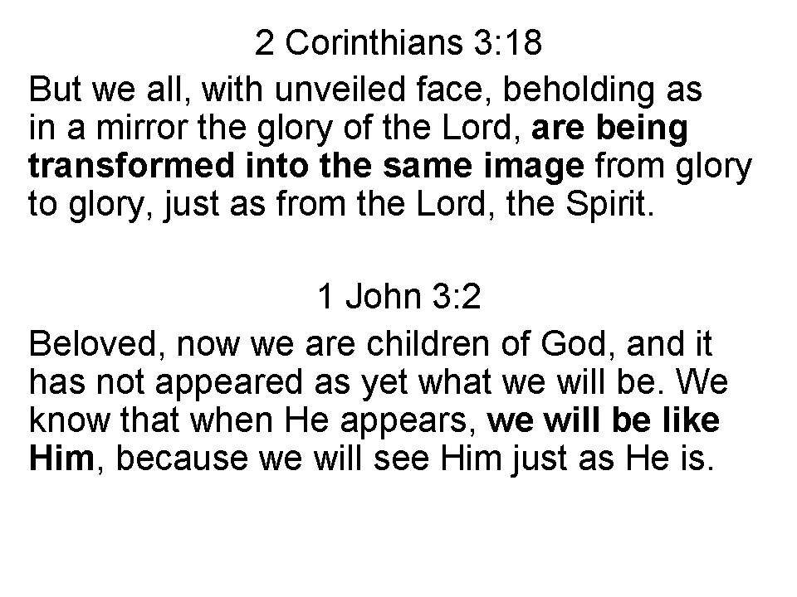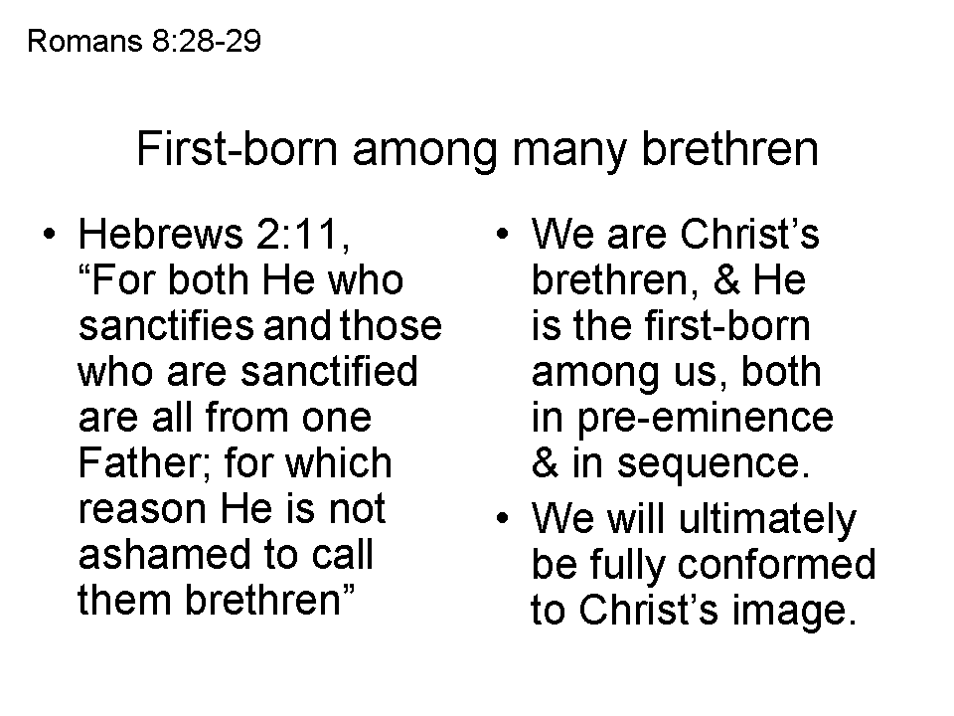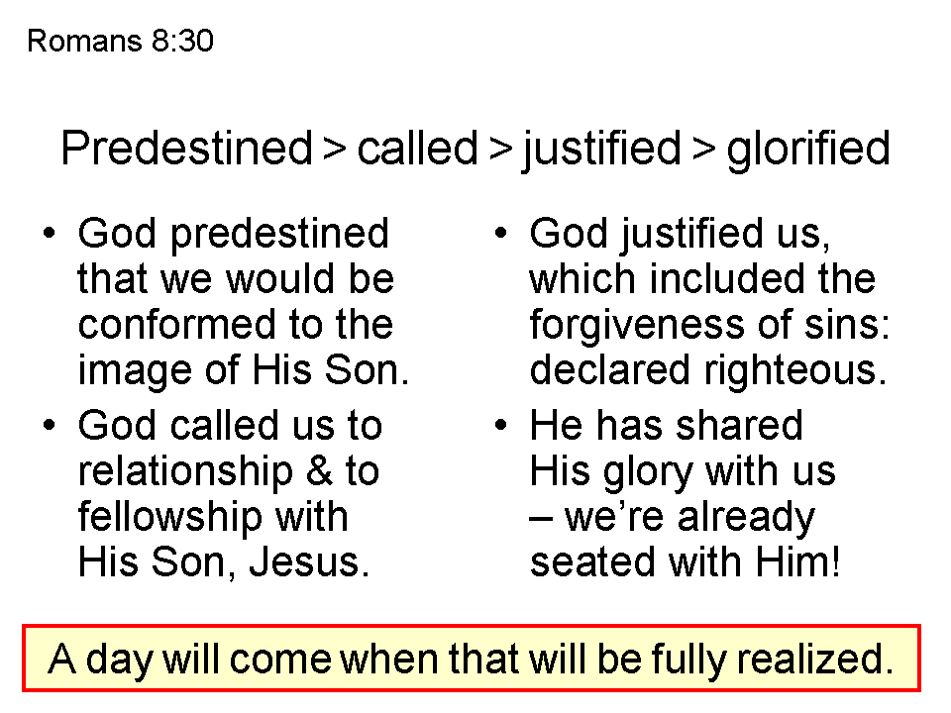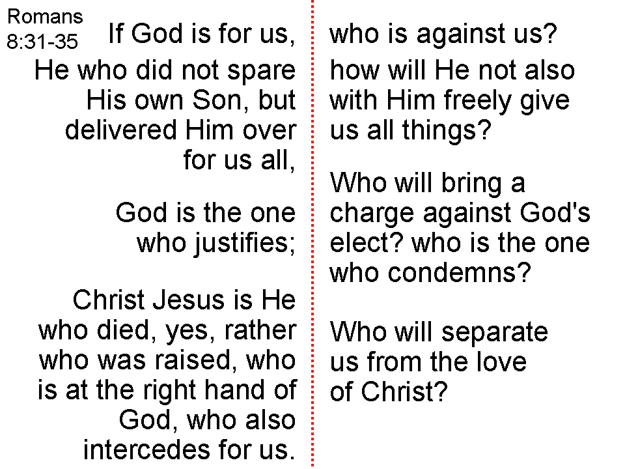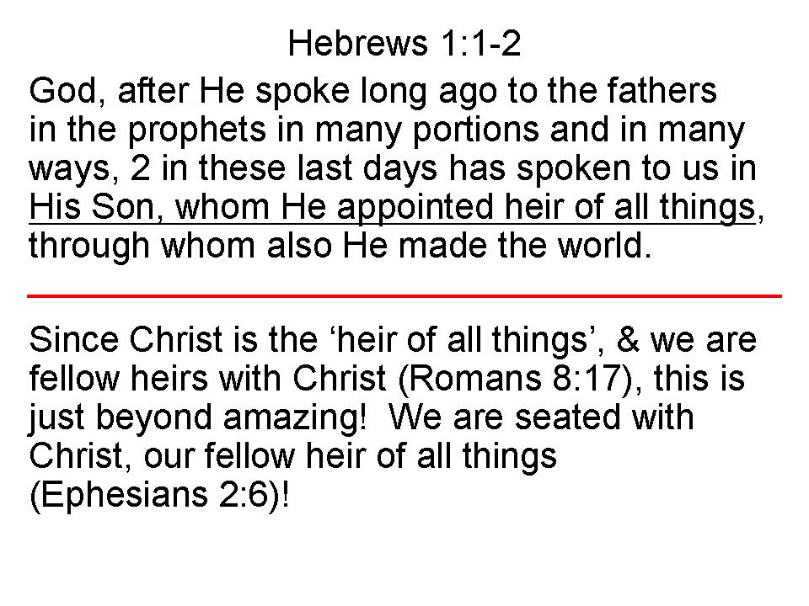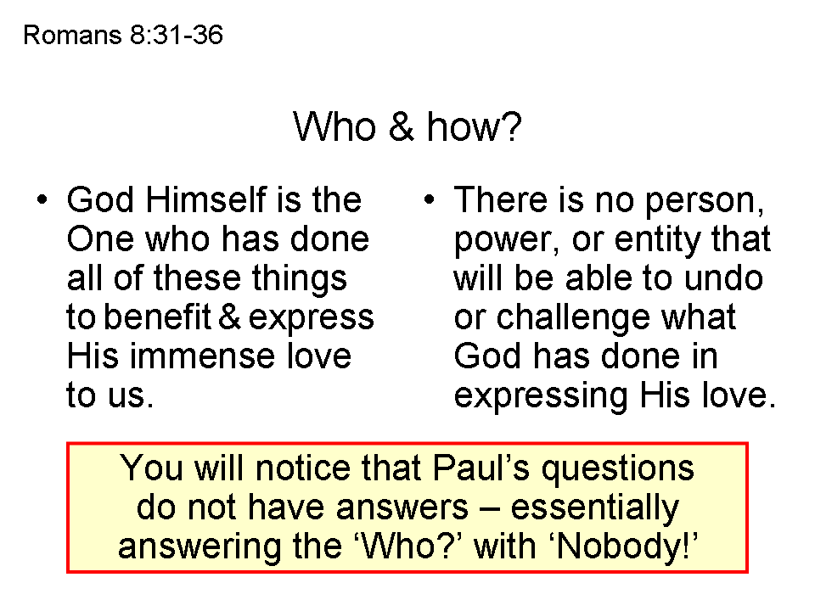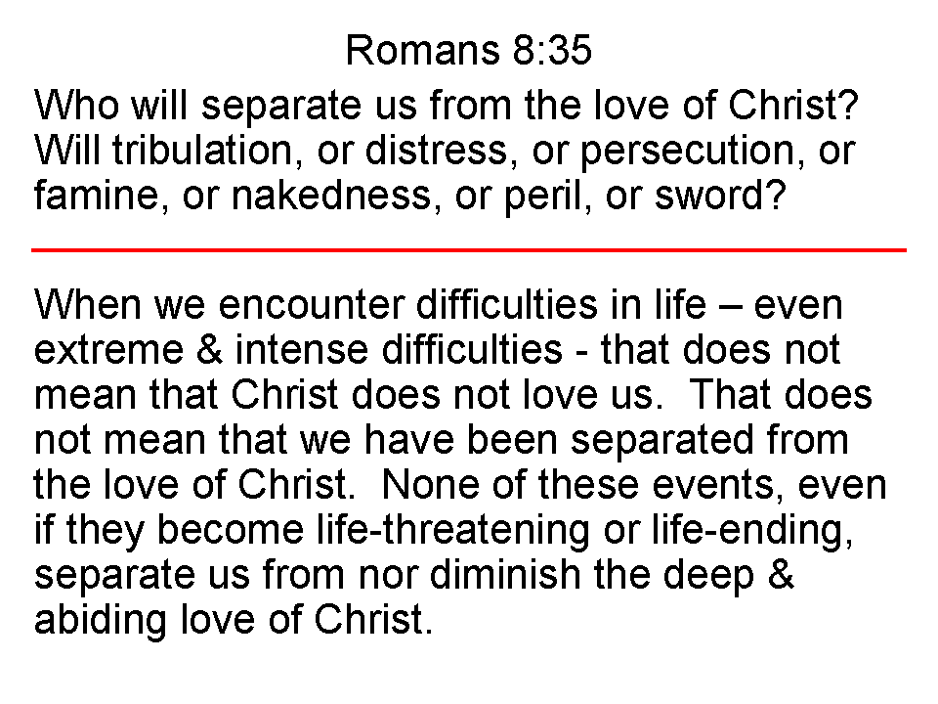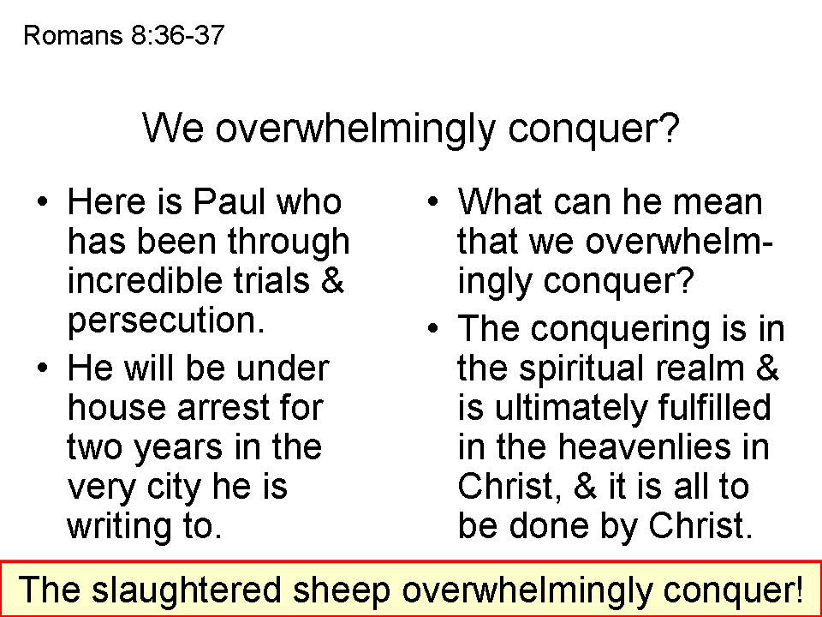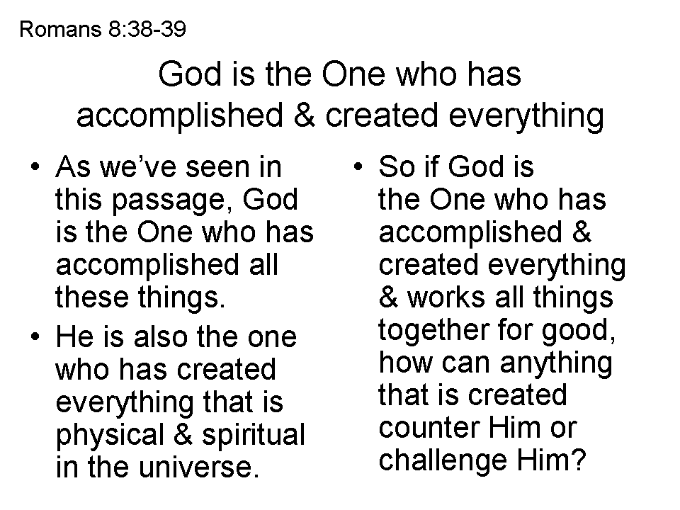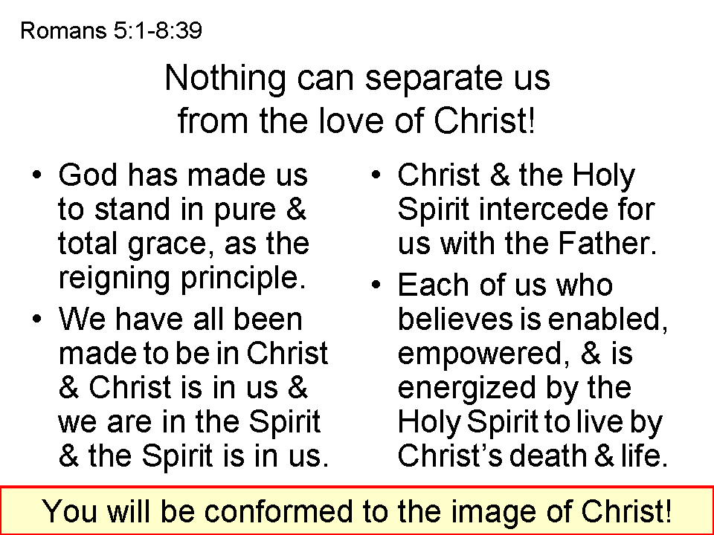
Is this what John Calvin had in mind?
Basically, Calvinism is known by an acronym: T.U.L.I.P.
T otal Depravity (also known as Total Inability and Original Sin)
U nconditional Election
L imited Atonement (also known as Particular Atonement)
I rresistible Grace
P erseverance of the Saints (also known as Once Saved Always Saved)
From the assumption that the spiritually dead person has a Total Inability to respond spiritually, the elect person who is chosen is made alive by God, given the gift of faith, believes, and then is saved because He believes. This would be the sequence:

Chosen > Regenerated > Given the gift of faith > Believes > Saved

Here is a brief summary of the problems with the above assumptions and conclusion:

- Man does have a Total Inability to believe, were it not for the ministry of the Holy Spirit upon the wills of the unbelieving, which can change a man from unable to enabled to believe: John 16:8-11. The Holy Spirit regenerates those who believe (Titus 3:5).
- Death in Scripture is primarily defined as spiritual separation: Ephesians 2:12; 4:17-19 (separate, excluded, without God); Romans 6:1-11 – dead to sin, alive to Christ; Romans 7:1-6 – death releases from marriage; 2 Corinthians 5:14,15 – dead to ourselves, alive to Christ; Galatians 2:19, 20 – dead to the Law, alive to Christ; Colossians 2:20 – died with Christ to the elementary principles of the world; Colossians 3:5, 20 – dead to sin, died with Christ to the world; 1 Peter 2:24 - die to sin and live to righteousness.
- The clear sequence in Scripture is not ‘be given life, then believe’, but rather ‘believe, then be given life’: John 3:16; 5:24; 11:25; 20:31.
- In the many passages that teach that we have been identified with Christ in his death, burial, resurrection, ascension, and seating in the heavenlies (Romans 6:11; Galatians 2:20; Ephesians 2:4-7; Colossians 2:12, 9-15, 20; 3:1-4, et al), the third part of this sequence is resurrection, in which the believer is given Christ’s life, and that is the third in the sequence, not the first. There is no evidence that an unbeliever is now identified with Christ. Colossians 2:12 (NASU) speaks of the ones who have been raised up with Him through faith – not raised up in order to be given the gift of faith.
- The appeal of the apostles and their co-sponsored authors of the New Testament, again and again, was to actively believe in Christ (the saving gospel), as an appeal to the will of the hearer, in order to be saved. What we do not find at all is the Greek grammar that one would expect if Calvinism were true that says: “You will be made to believe”, “You will be regenerated first, then you will be given the gift of faith, and then you will be made to believe” or anything like that.
- Calvinism requires that a great many passages, especially those in the New Testament, have multiple meanings inserted into the text which are simply not there. For example:

John 3:16
"For God so loved the world [of the elect], that He gave His only begotten Son [only for the elect], that whoever believes in Him [which will only be the elect] shall not perish, but have eternal life.

1 John 2:1-2
Jesus Christ the righteous; 2 and He Himself is the propitiation for our sins [those of the apostles or those who have believed so far]; and not for ours only, but also for those of the whole world [of the elect only].

