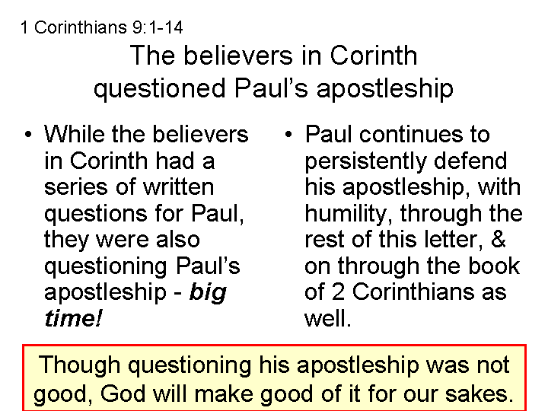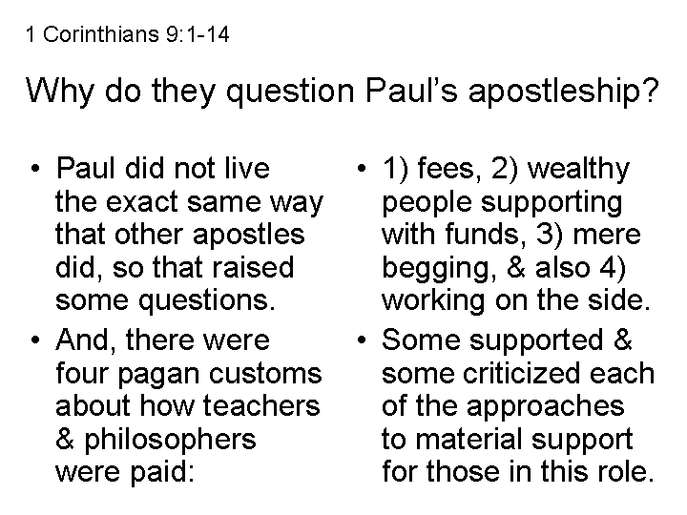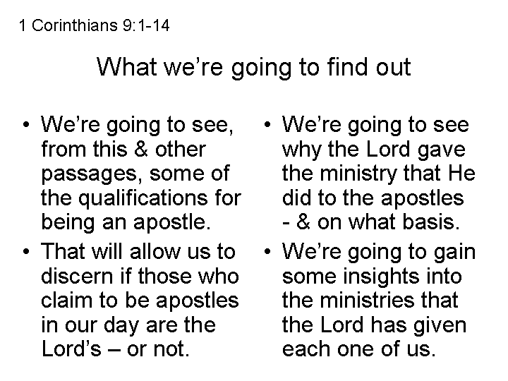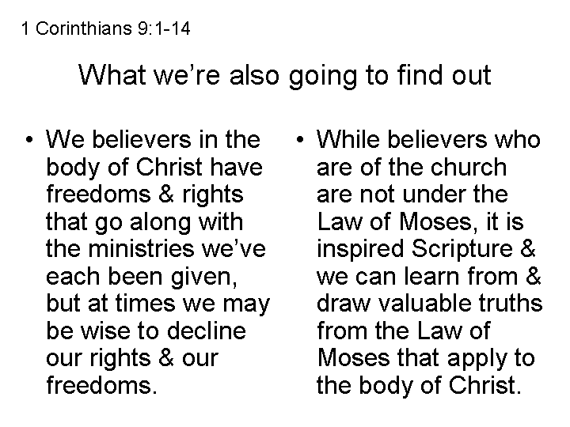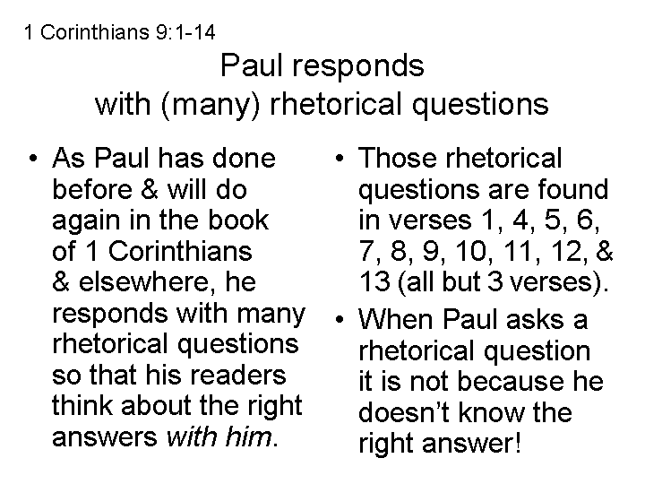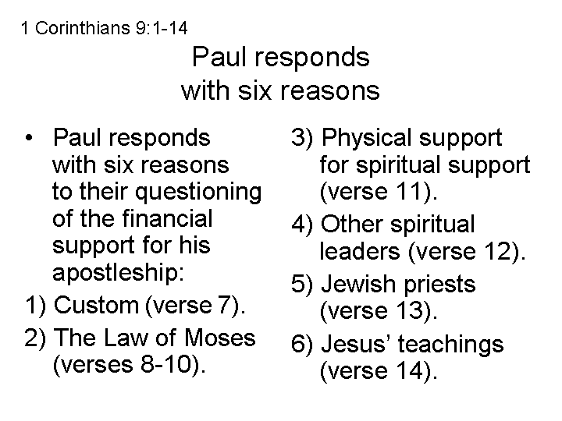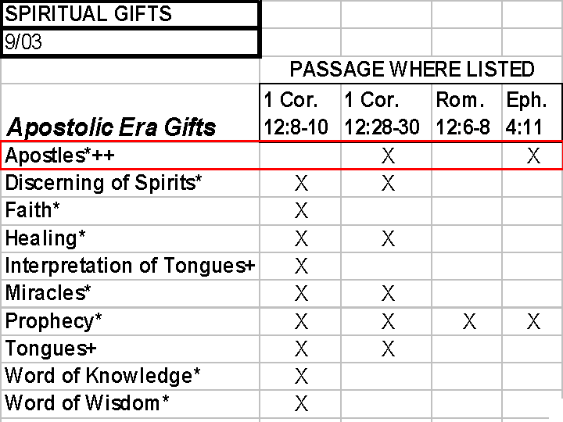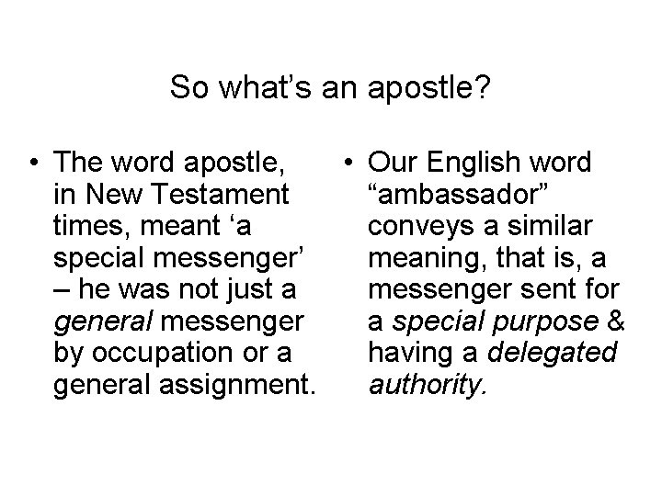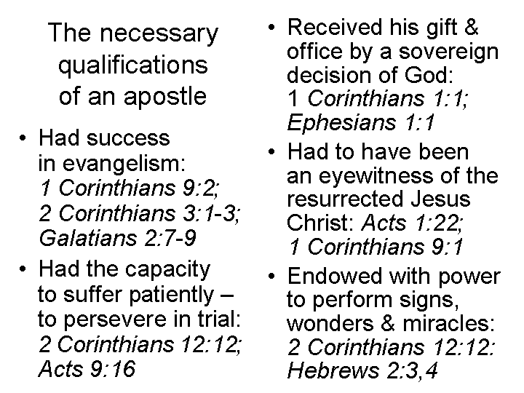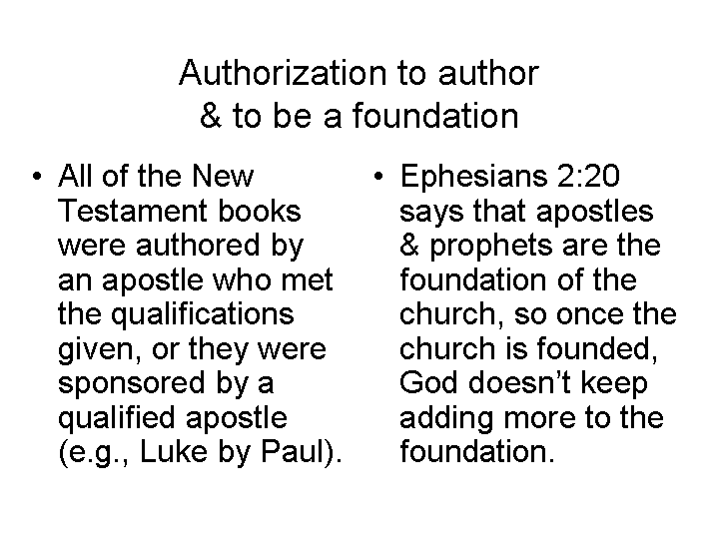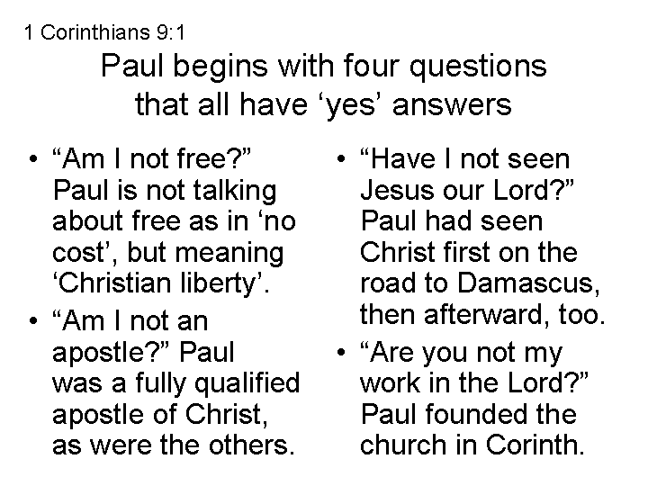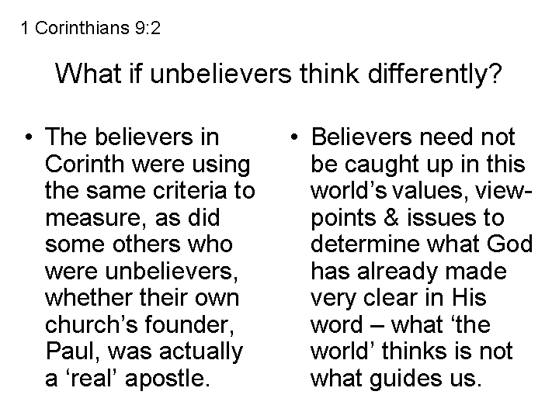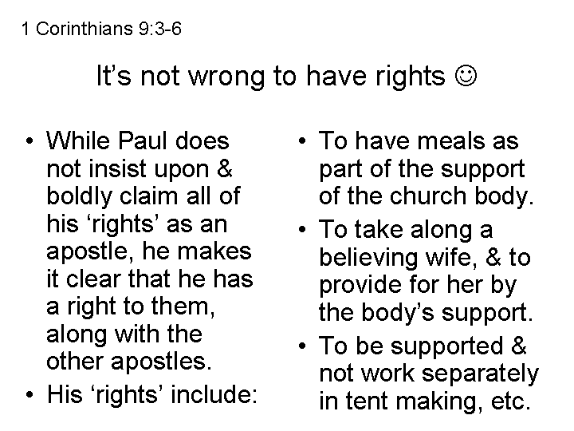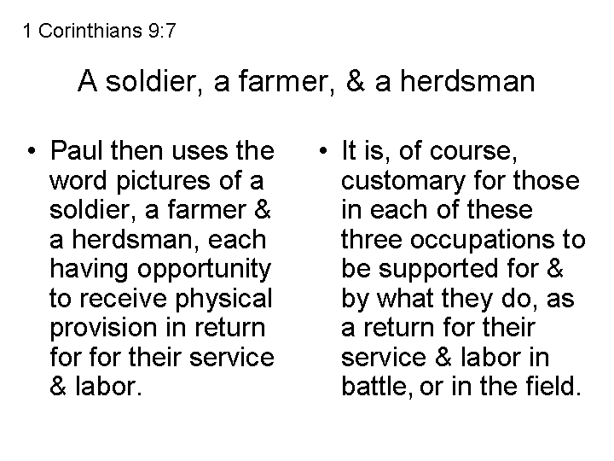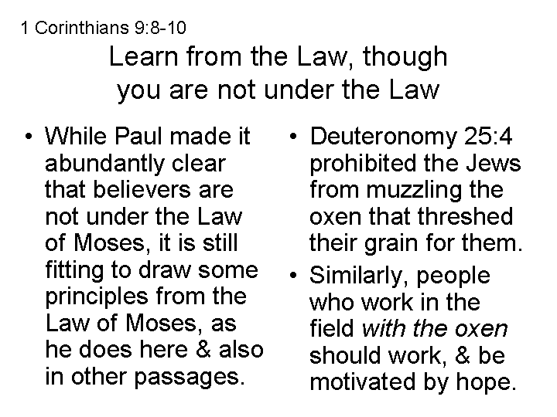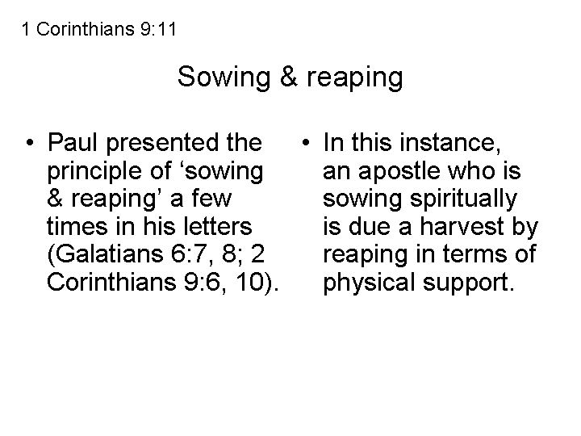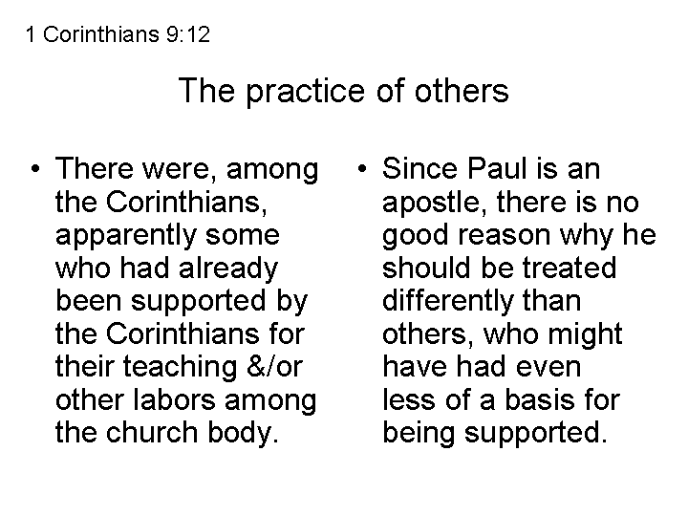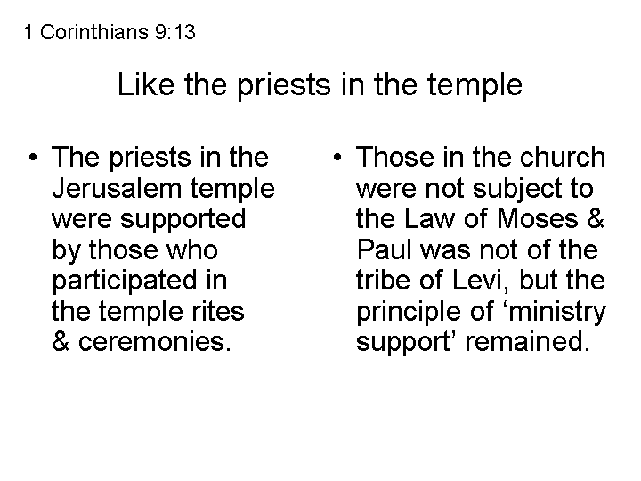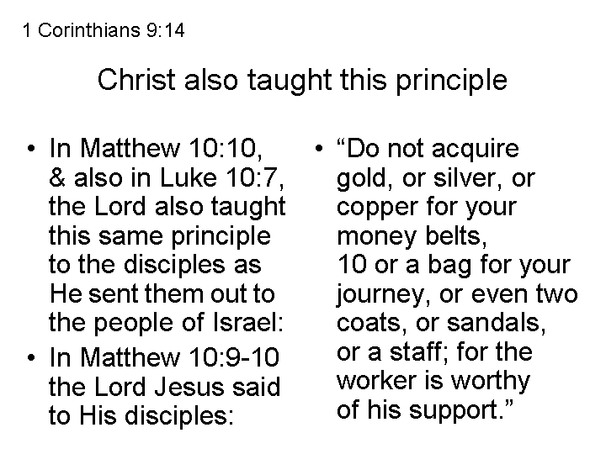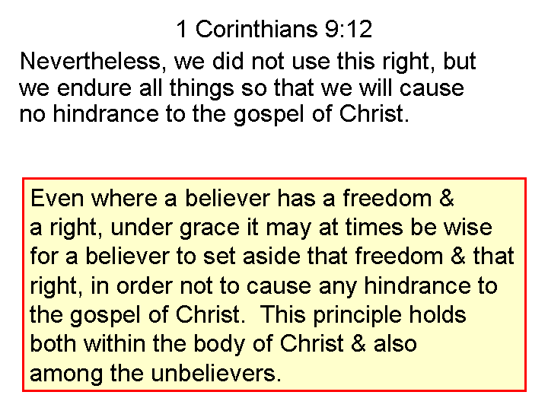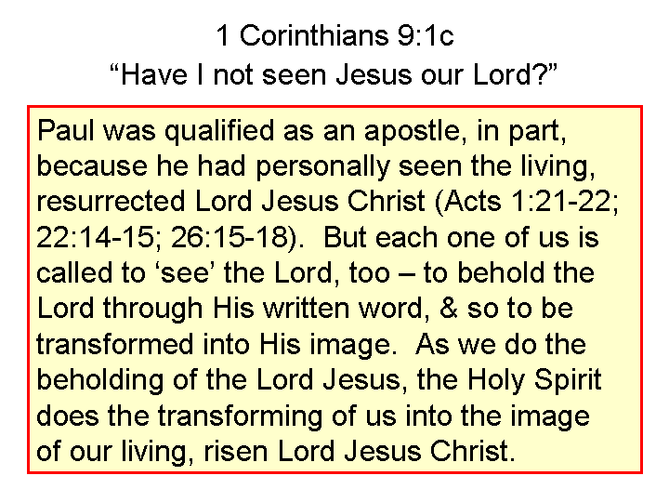

1 Corinthians 9:1-14 Expanded & Explained

As believer, am I not free in Christ? Yes! Am I not an apostle – Christ’s special messenger - with all the rights of an apostle? Of course I am! Have I not seen Jesus our Lord, a fundamental qualification for being an apostle? Certainly! Are you believers in Corinth not my work in the Lord? Most certainly you are! 2 If to others besides you I am not an apostle, at least I am to you believers in Corinth; for you are the certain and official seal of my apostleship in the Lord.

3 My defense to those who mistakenly examine me is this: 4 Do we apostles not have a right to eat food and drink at the expense of others to whom we minister? 5 Do we not have a right, but not the obligation, to take along a believing wife, even as the rest of the apostles and the brothers of the Lord Jesus Christ and, explicitly, Cephas (Peter)? 6 Or do only Barnabas and I by some quirk of principle not have a right to refrain from working, such that we are made an exception? 7 Let’s look at some principles drawn from some examples in society: Who at any time serves as a soldier at his own expense? Nobody! Who plants a vineyard and does not eat the fruit of it – the planter’s work? Not a one! Or who tends a flock and does not use the milk of the flock that he has worked with? Not even one!

8 I am not speaking these things to you according to purely human judgment, am I? Or does not the Law of Moses also express the principles I am conveying? 9 For it is written in the Law of Moses, "You shall not muzzle the ox while he is threshing, so that the ox can eat of the same food he threshes." God is not ultimately concerned only about oxen in such a principle of law, is He? 10 Or is He really speaking altogether for our sake? Yes, for our sake it was written, because the plowman ought to plow in hope, and the thresher to thresh in hope of sharing the crops – those are basic principles of motivation. 11 If we sowed the most important spiritual things in you, is it too much if we reap the needed but ultimately less important material things from you? 12 If others share the right of compensation over you, do we not more? Nevertheless, we did not use this right we were due, but we endure all things, by working hard to earn our own way, so that we will cause no hindrance to the gospel of Christ. 13 Do you not know that those in the temple who perform sacred services eat the food of the temple, and similarly those who attend regularly to the altar have their share from the altar? 14 So also the Lord Jesus directed those who proclaim the gospel to get their living from the gospel (Matthew 10:9-14).

__________________________________________________________________________________________________________________________________________________________________________________________________________________________________________________________________________________________________________________________________________________________________________________________________________________________________________________________________________________________________________________________________________________________________________________________________________________________________________________________________________________________________________________________________________________________________________________________________________________________________________

