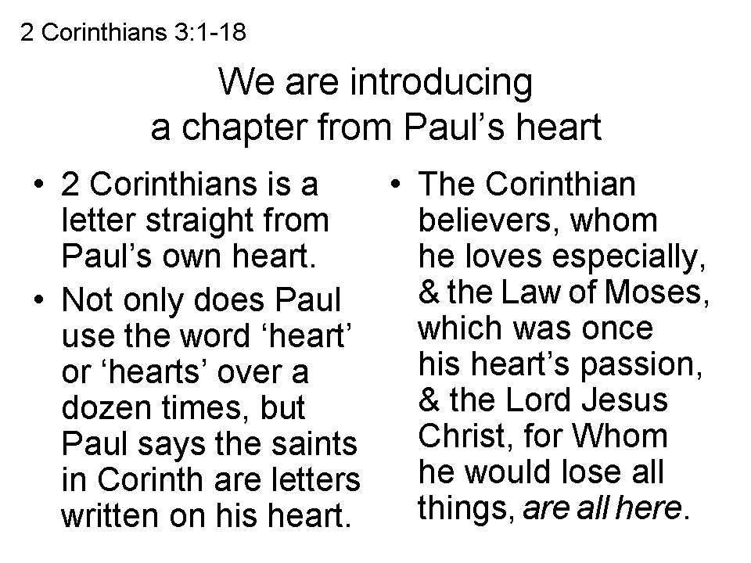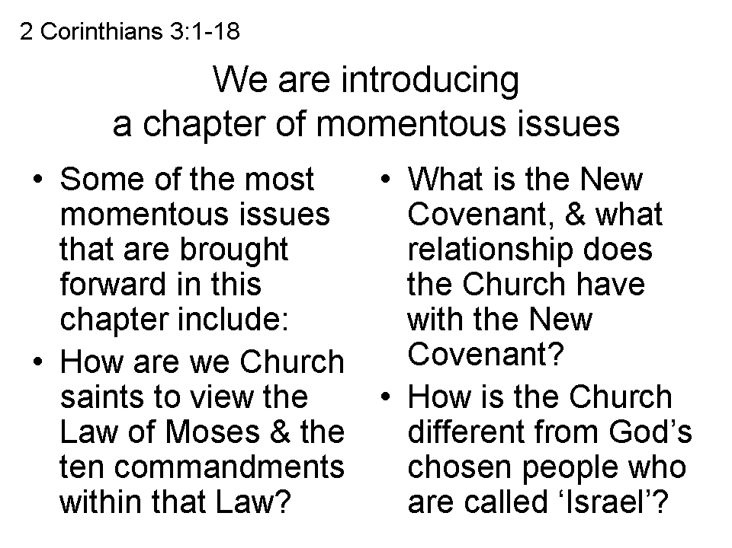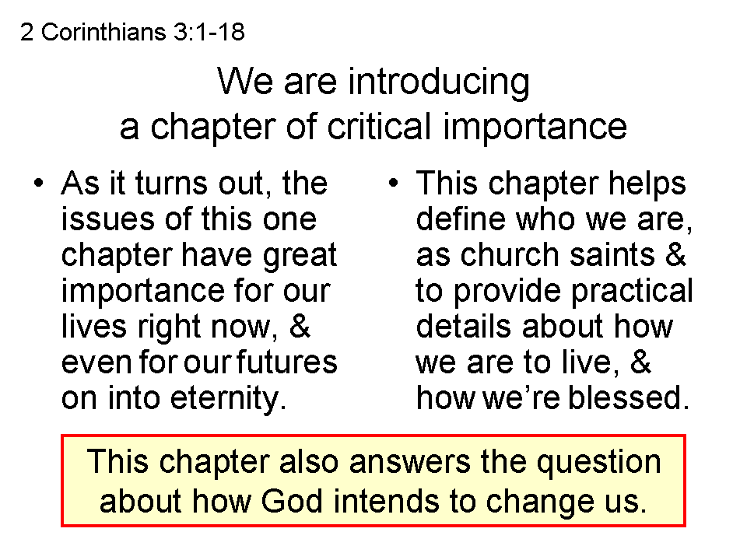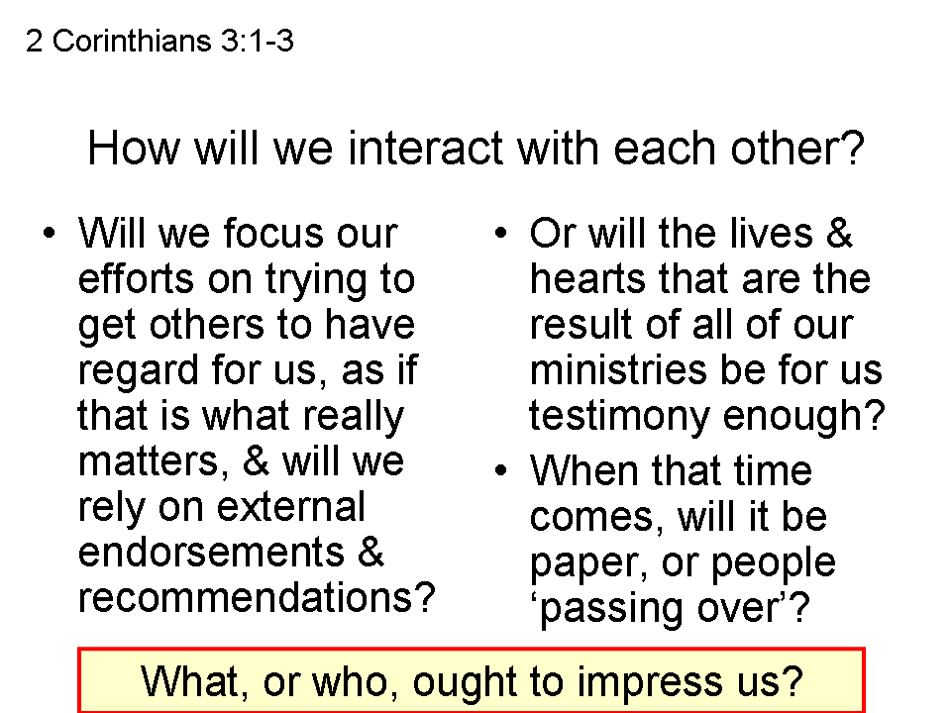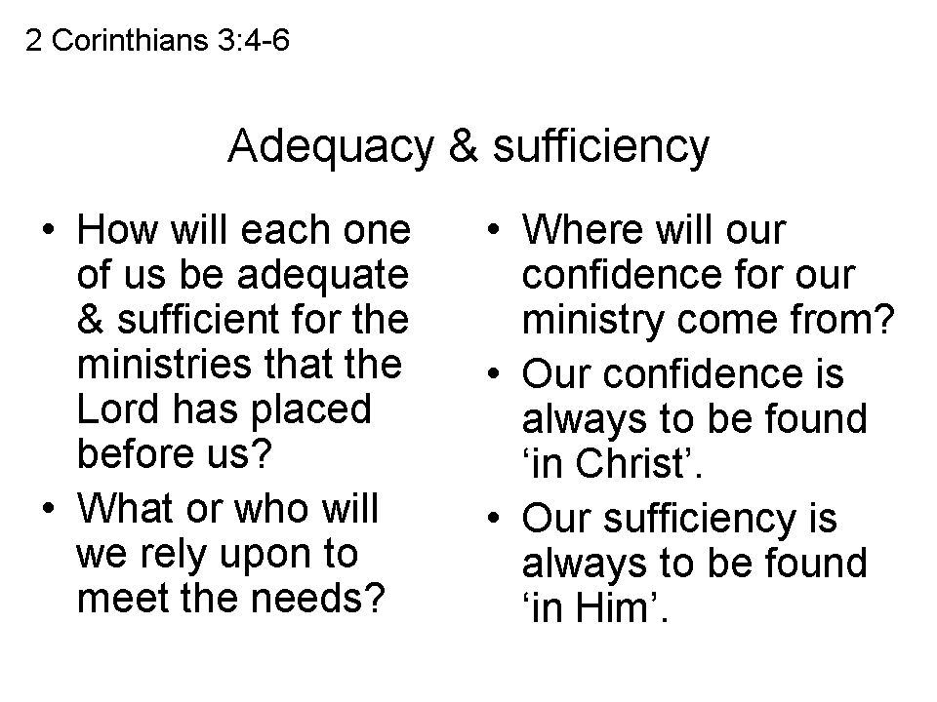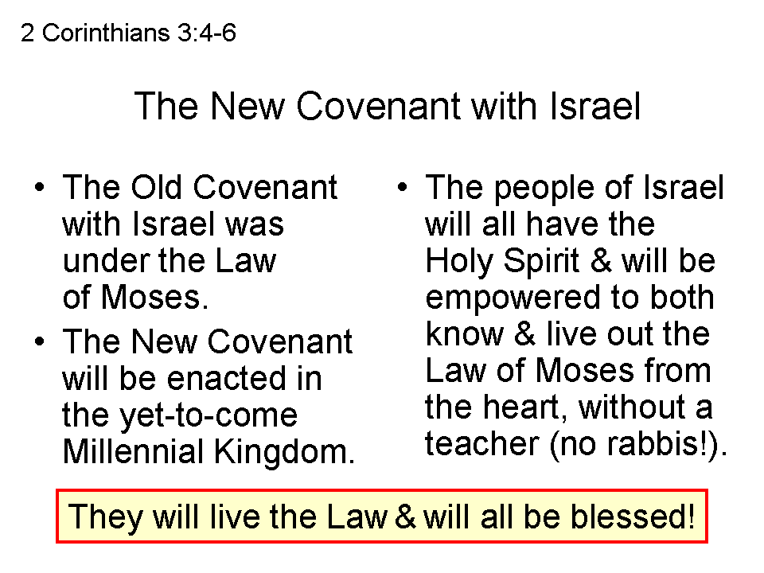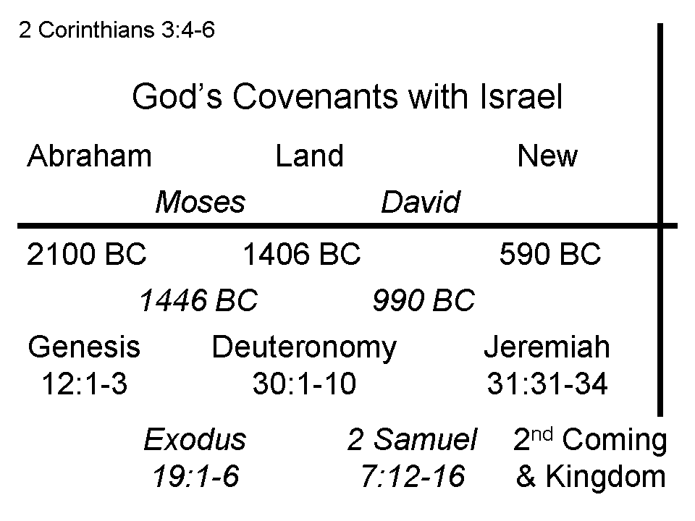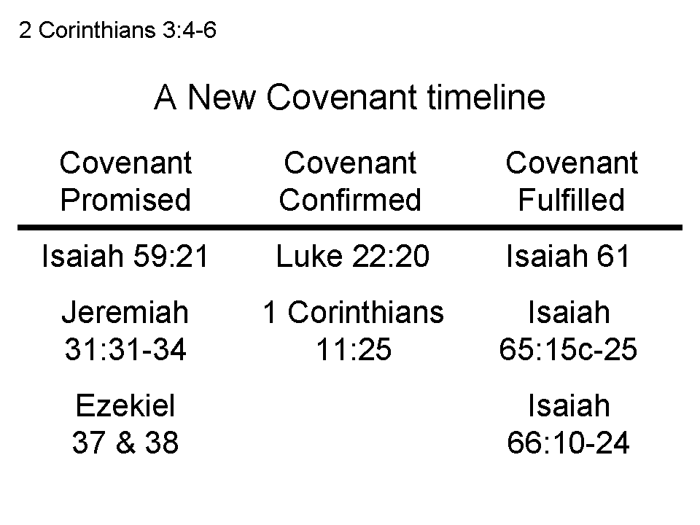
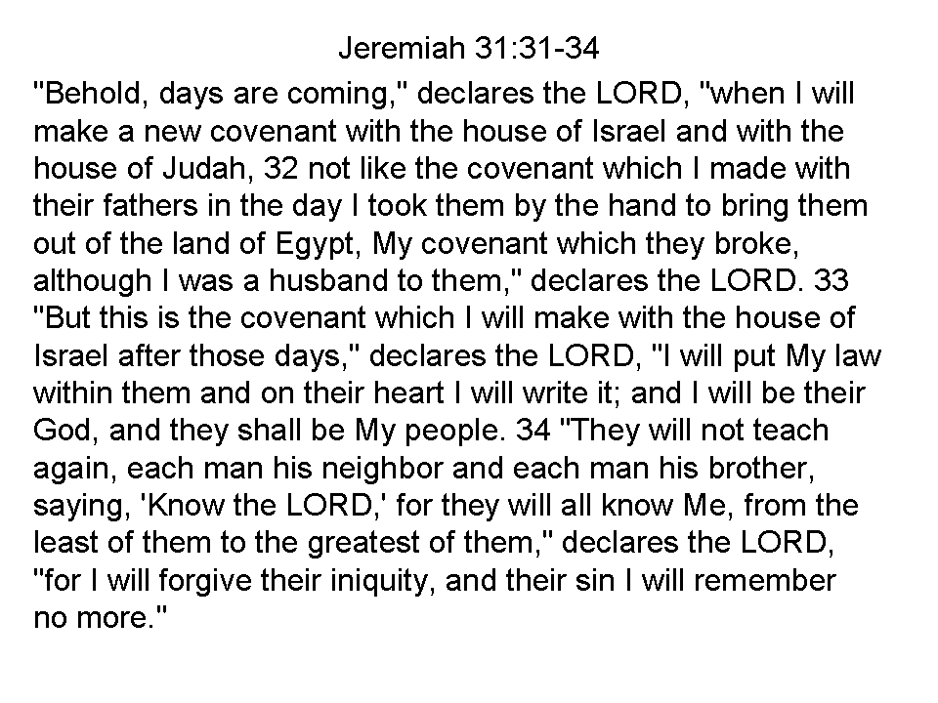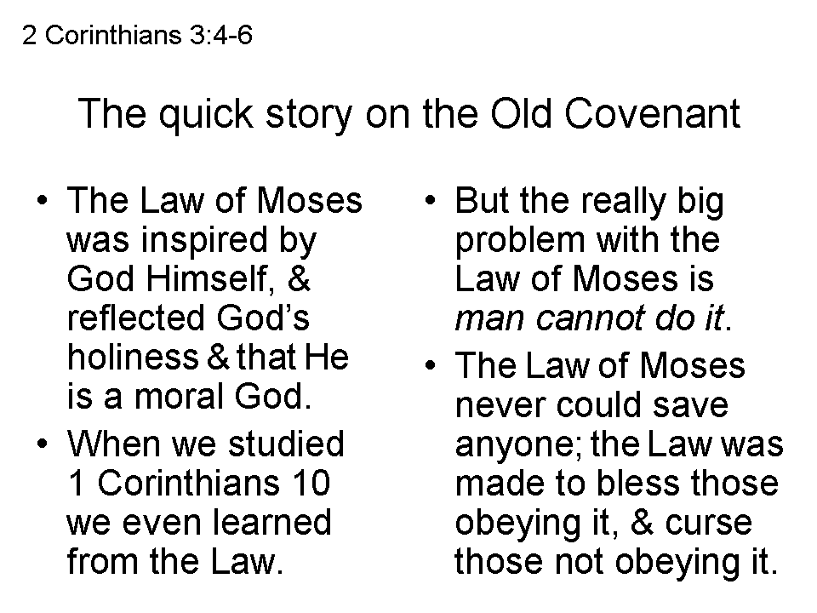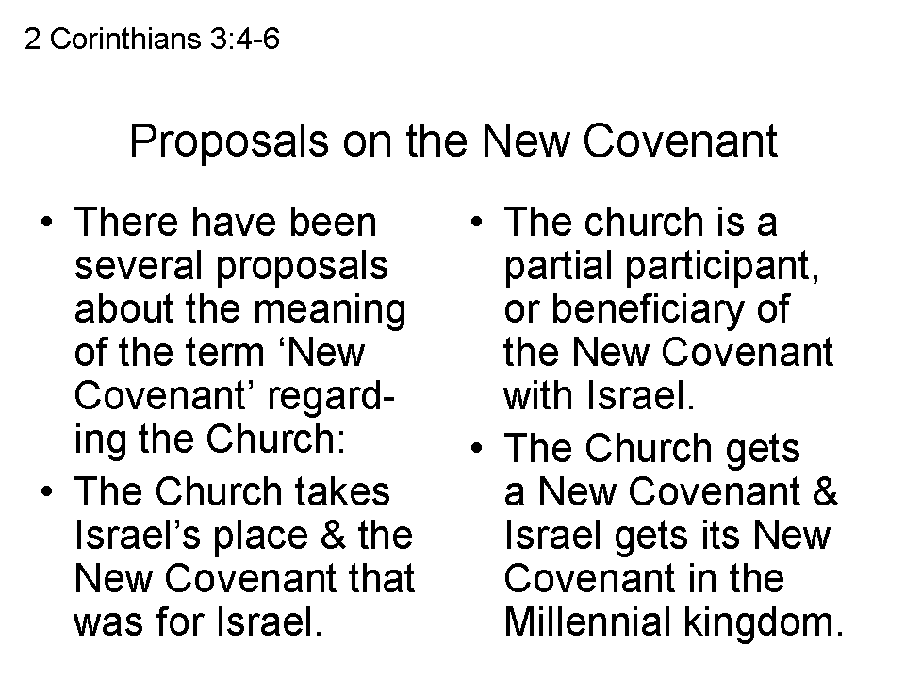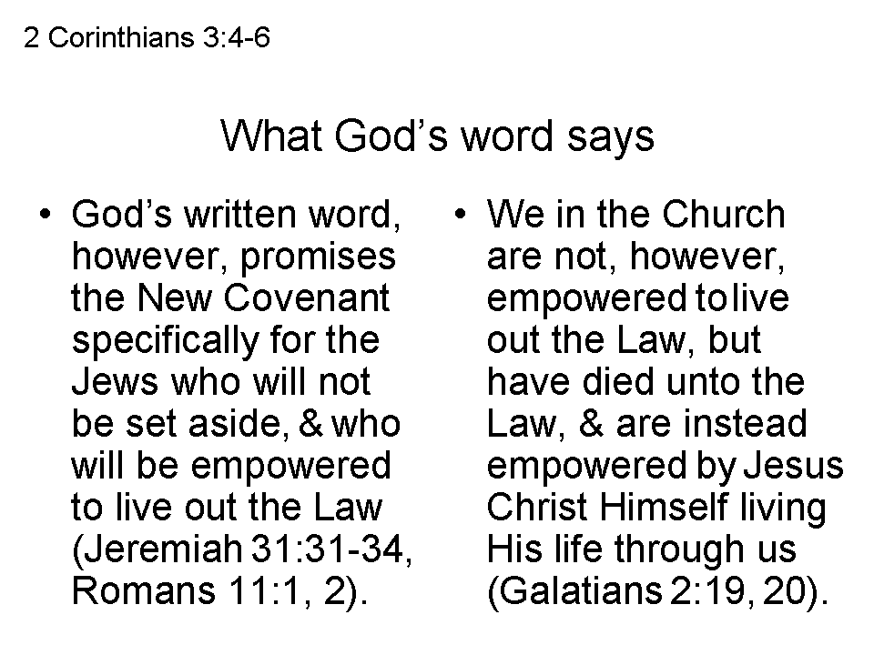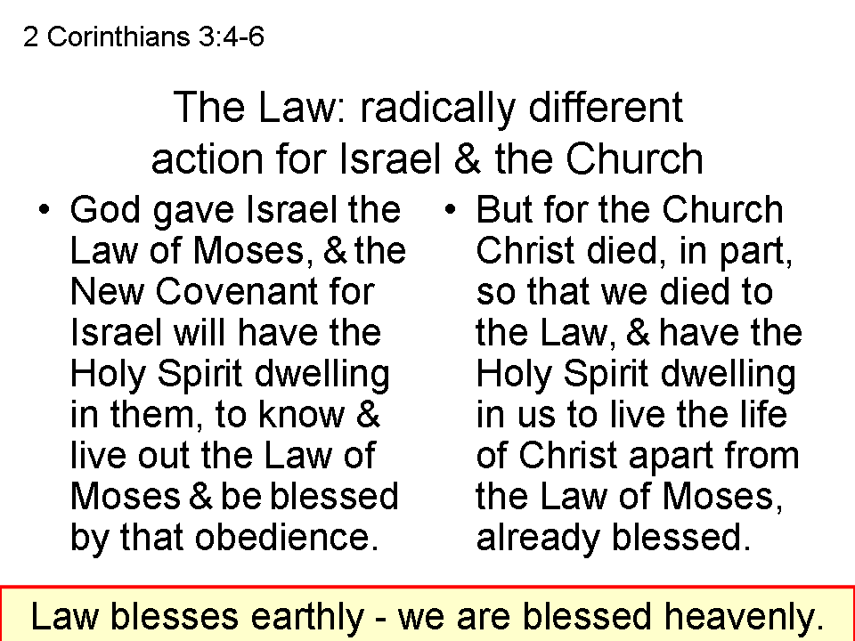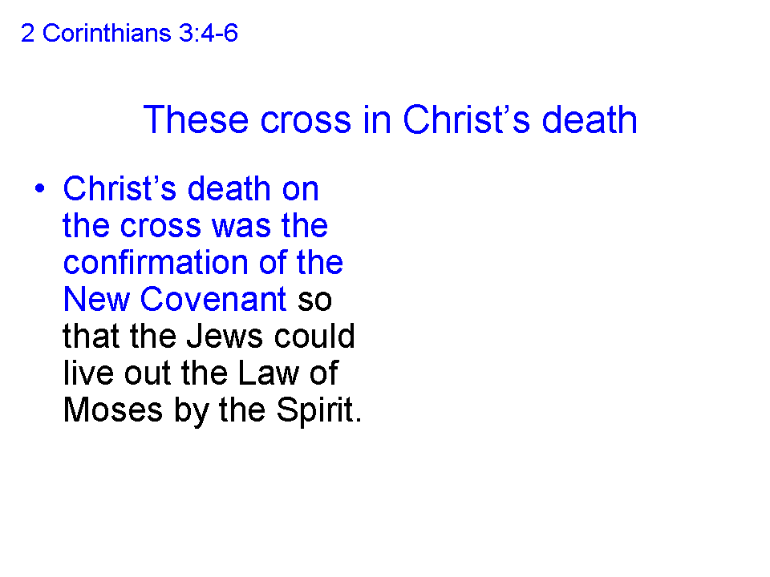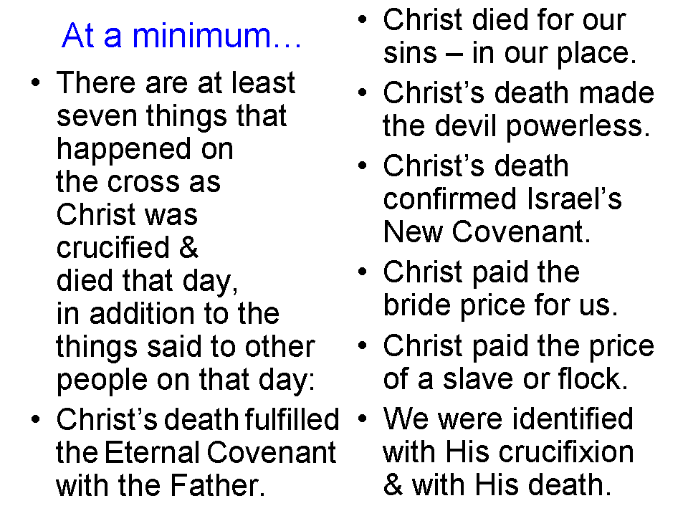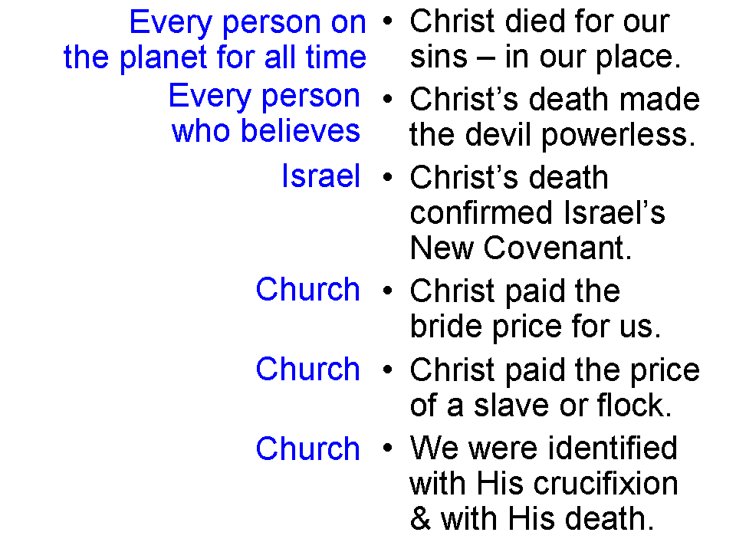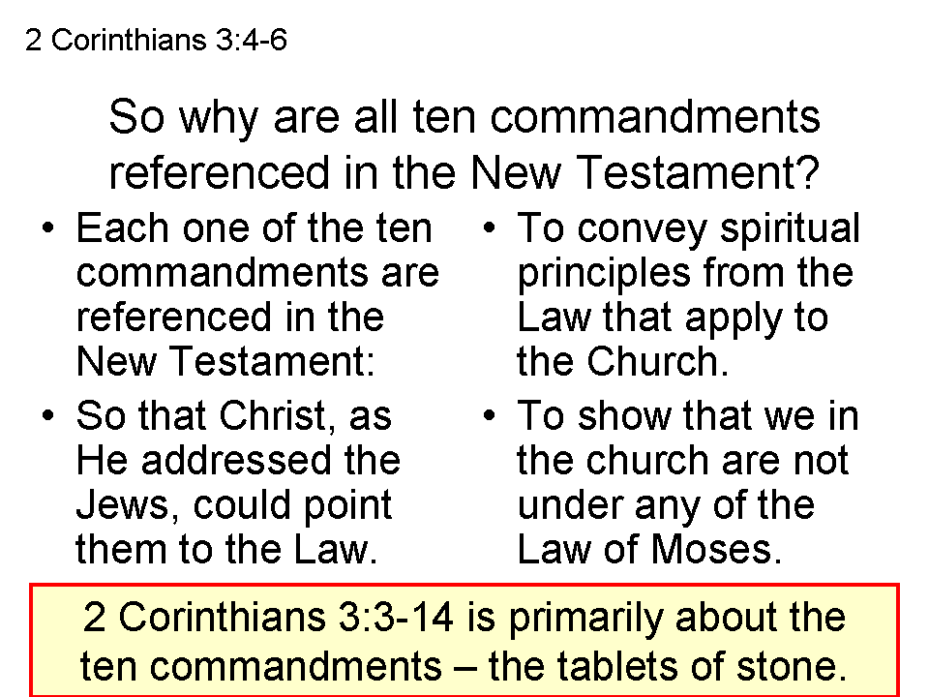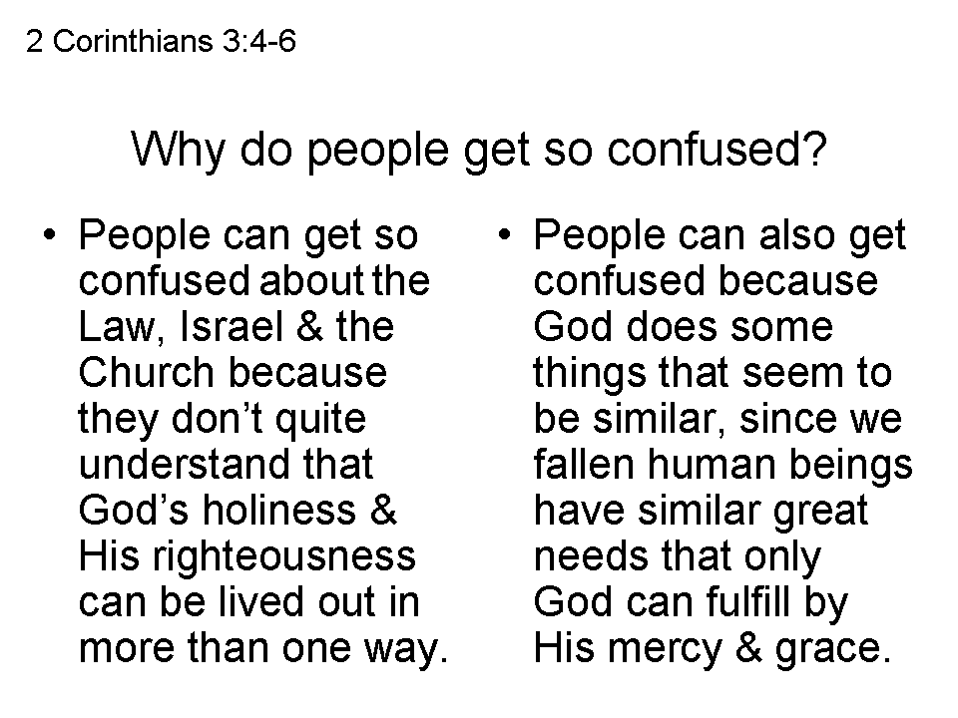

The Ten Commandments Were Written By The Finger Of God On Tablets Of Stone:

As is recorded in Exodus 24:12; 31:18-32:19; 34:1-29, the ten commandments were written by the finger of God on tablets of stone for Moses to take down Mt Sinai to the people. As the interlinear version of the Greek Old Testament shows (Strong’s number over Greek over English), Paul used the exact same Greek words in 2 Corinthians 3:3 and 3:7 as were used in the Greek Old Testament for tablets of stone (Strong’s numbers 4109, 3035 - and 3037, for a word closely related to 3035). Paul’s discussion of the giving of the Law in 2 Corinthians 3:3-14 is from this exact same passage in Exodus, when the ten commandments were made by God Himself, Who gave them to Moses.

Exodus 31:18 (Strong’s / Greek / English Old Testament Interlinear)
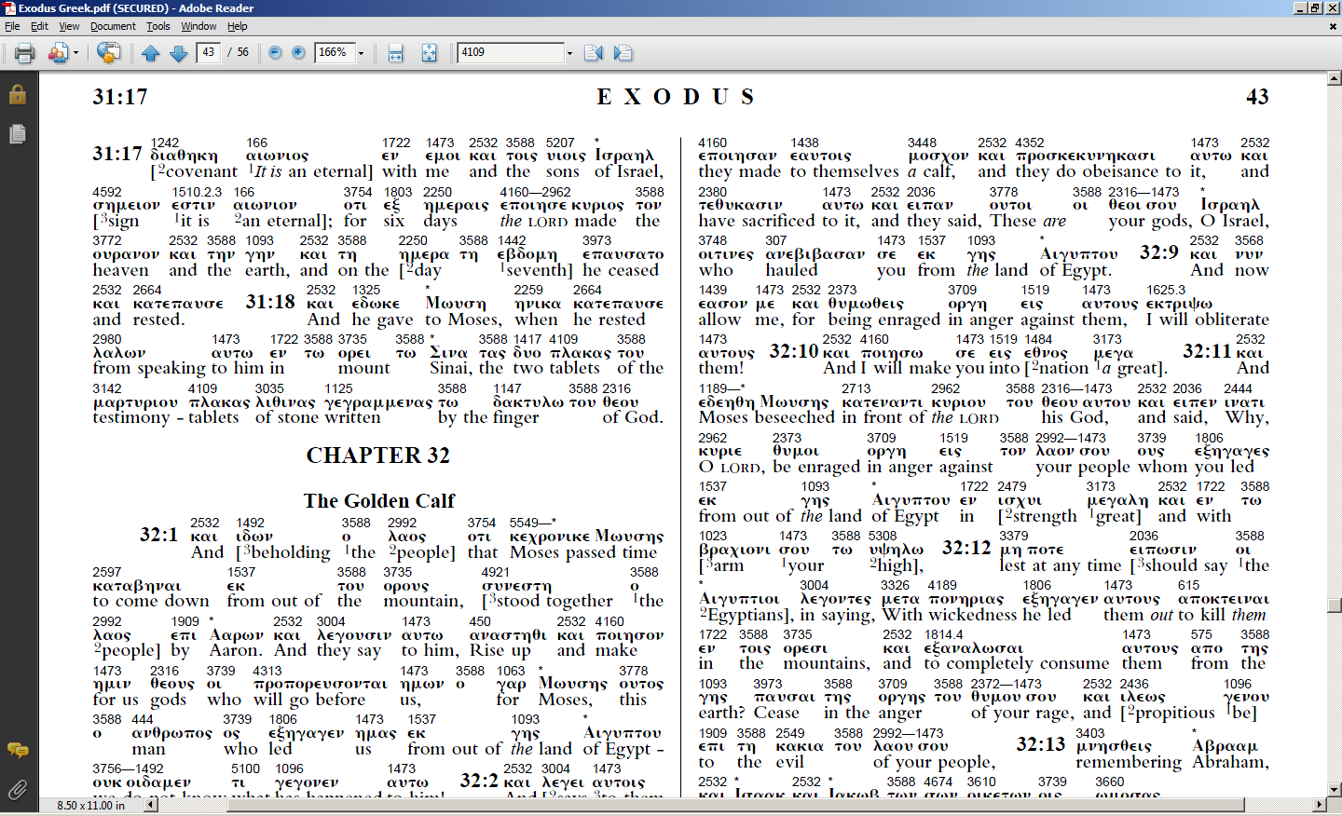

2 Corinthians 3:3 (Strong’s / Greek / English New Testament Interlinear)
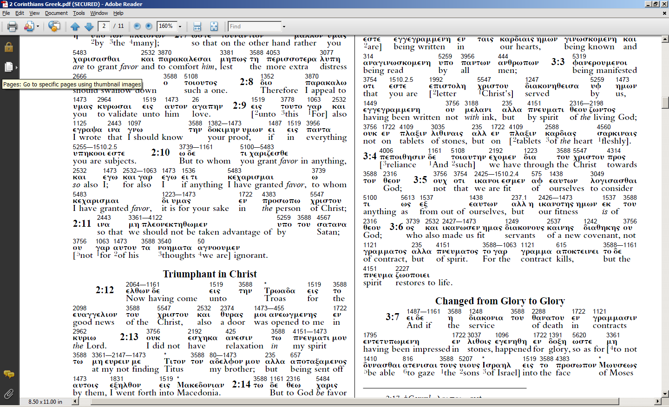

2 Corinthians 3:7 (Strong’s / Greek / English New Testament Interlinear)

