Matthew 5:31-32 (NASU)
It was said, 'Whoever sends his wife away, let him give her a certificate of divorce'; 32 but I say to you that everyone who divorces his wife, except for the reason of unchastity, makes her commit adultery; and whoever marries a divorced woman commits adultery.

The above quote from the Sermon on the Mount (Matthew chapters 5-7) is easily and often understood to say that every man who divorces his wife, except for the reason of unfaithfulness in marriage causes the divorced woman to commit adultery, and whoever marries that woman so divorced is committing adultery. But what is missing from that apparently clear conclusion is an understanding of the history and culture behind what Jesus said, and therefore the reason why what Jesus said was likely so disturbing to his audience. In Matthew 5:31 the Lord is quoting from Deuteronomy 24:1-4 in the Law of Moses, which specifically allowed and made provision for divorce and remarriage. If Jesus’ words are not understood in their historical and cultural context, and are taken to simply forbid divorce, then Jesus was to be understood as changing the Law of Moses, which is something that He said He had not come to do! See Matthew 5:17-19.

The Jewish court systems
In the century before the New Testament era, the Jews established two court systems for marriages and divorces. The Shammai courts allowed divorce only for adultery, abandonment, neglect and abuse. The Hillel courts allowed divorce for any reason – no questions asked (Matthew 1: 19). Jesus explained in greater detail where He stood (with the Shammai court) in Matthew 19, but in the Sermon on the Mount His statement about the invalid Hillel court divorces was cut to a bare minimum. The great majority of Jews used the Hillel courts, such that the Shammai courts ended in 70 AD [at the Roman destruction of Jerusalem].

So what’s the problem?
As stated above, the Law of Moses itself allowed for divorce and remarriage (Deuteronomy 24:1-4), and the Shammai courts permitted divorce on the basis of:

1) Deuteronomy 24.1: ‘an indecent matter,’ that is, adultery;
2) Genesis 1.22, 28: ‘be fruitful and multiply.’ The Jews thought that this command made infertility a ground for divorce, and they applied it also to blemishes which made the person repulsive to their partner;
3) Exodus 21.10f: ‘you shall not diminish her food, clothing or love.’ This text referred originally to a slave wife when a man took a second wife. The lawyers argued that if a slave wife had these rights, then so did a free wife and so did a husband. These three
rights became grounds for divorce if a husband or wife neglected their spouse’s material or emotional support, or subjected their spouse to physical or emotional abuse.
The Hillel courts allowed divorce on the basis of “any matter’. In Matthew 19:3-9 the question is brought before Jesus and He responded more fully. Other passages in which Jesus addressed this same subject are Mark 10:2-12, and Luke 16:18, but are more abbreviated than the corresponding passages in Matthew’s accounts. In putting together the various accounts with the historical and cultural backgrounds, we can summarize Jesus teachings on divorce and remarriage:

- Jesus agreed with the basis of divorce and remarriage allowed by the Shammai courts, but did not view divorce as commanded, which was how the Pharisees put the question to Jesus originally (Matthew 19:7).
- Jesus pronounced that the ‘any matter’ no-questions-asked divorces of the Hillel courts were invalid, such that the person who remarried after such a divorce was committing adultery.

There are some additional historical and cultural points which will shed further light on the nature of what Jesus said in Matthew 5:31-32 (as well as the other passages in the gospels referenced above).

- Roman Law required (from 18 BC on) remarriage of someone of child-bearing age after a divorce, with certain exceptions and conditions, although enforcement of that law was variable.
- The rules of the Hillel and Shammai courts regarding divorce were summarized by ‘any matter’ for the Hillel rules, and ‘the reason of unchastity’ for the Shammai rules. It is likely, for example, that Joseph intended to divorce Mary (to ‘put her away’) through the Hillel courts, before he knew that her pregnancy was of the Lord (Matthew 1:19).
- The Hillel courts accepted the Shammai court decisions, and vice versa. So while Jesus agreed with the Shammai courts’ basis for allowing divorce, both court systems were polluted by granting illegal marriages, even if Jesus said that only the divorces in the Hillel courts were invalid.

By making all Hillel court marriages invalid, and invalidating any marriage in the Hillel or Shammai courts after that, Jesus was saying that the Jews had MAJOR problems in the legality of the invalidly married people entering the inner courts of the temple, and their offspring for ten generations (Deuteronomy 23:2), and the laws of inheritance (see next page). By saying that Hillel court divorces where invalid, and the Hillel divorces were by far the majority of divorces, Jesus was saying that:

- Many Jews were essentially committing adultery (subject to the death penalty!). This major legal problem included many Levites, who regularly did the sacrifices in the inner courts of the temple.
- Many such Jews who entered the inner courts of the temple to do the required sacrifices were in violation of temple rules (also subject to the death penalty)!
- The offspring of all such Jews were illegitimate, which invalidated their eligibility for entrance into the temple and to inherit property for ten generations (see next page).

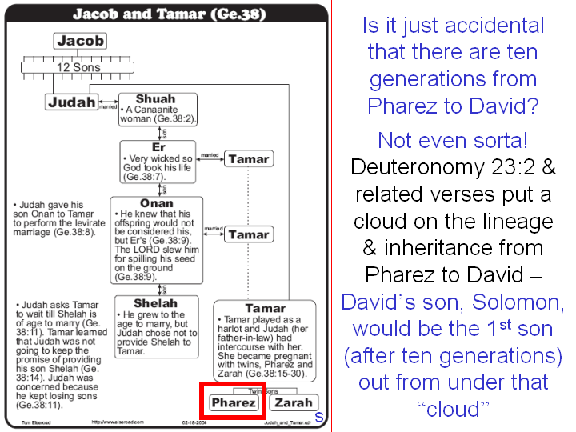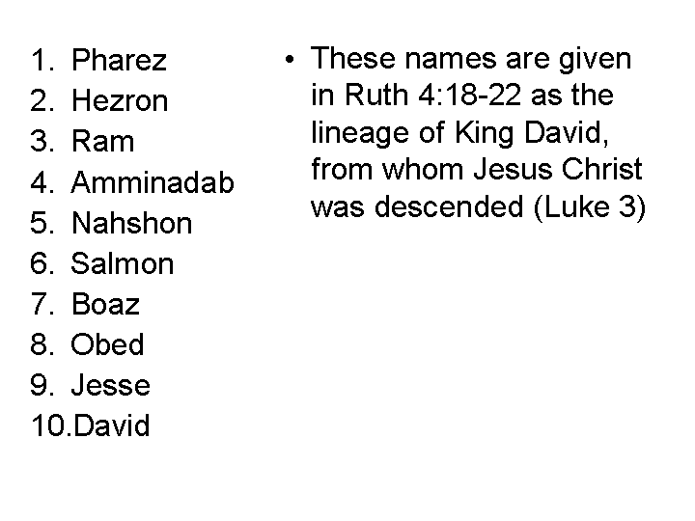

This paragraph is from the earlier document in this elective: HHBC - The Sermon on the Mount, 02 The Content: What’s inside the Sermon? – page 6.
The numbered items 1-3 above are quoted from Divorce and Remarriage in the 1st and 21st Century, David Instone-Brewer, Grove Books, 2001. Bible books not abbreviated.

