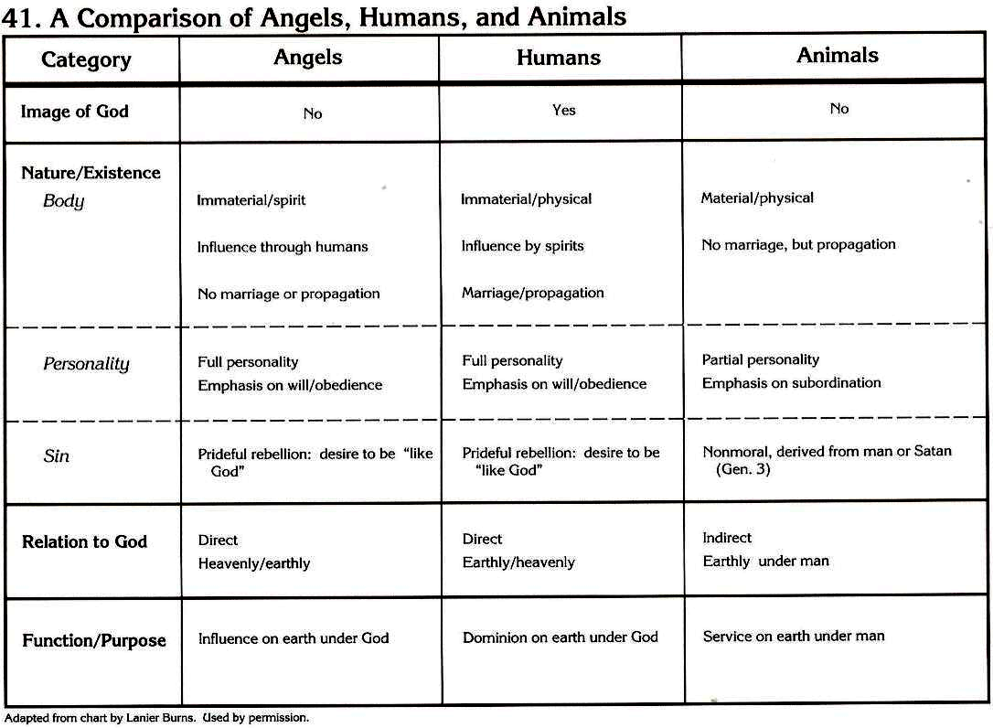
From Charts of Christian Theology & Doctrine, c 1992, H. Wayne House. Used by permission of the author given via e-mail 12/1997.
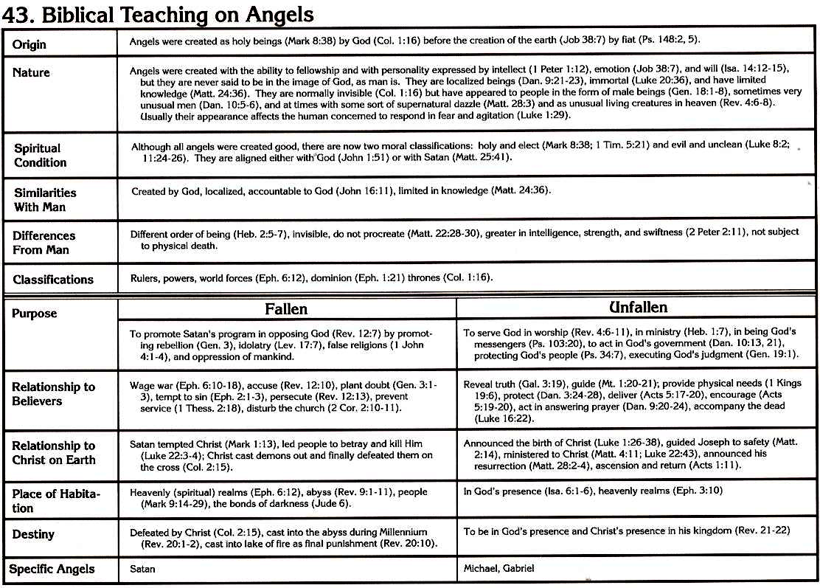 From Charts of Christian Theology & Doctrine, c 1992, H. Wayne House. Used by permission of the author given via e-mail 12/1997.

