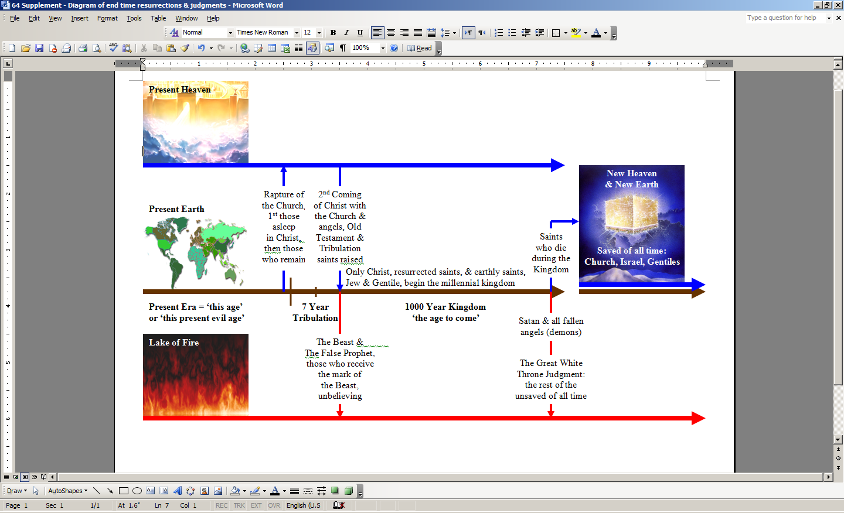
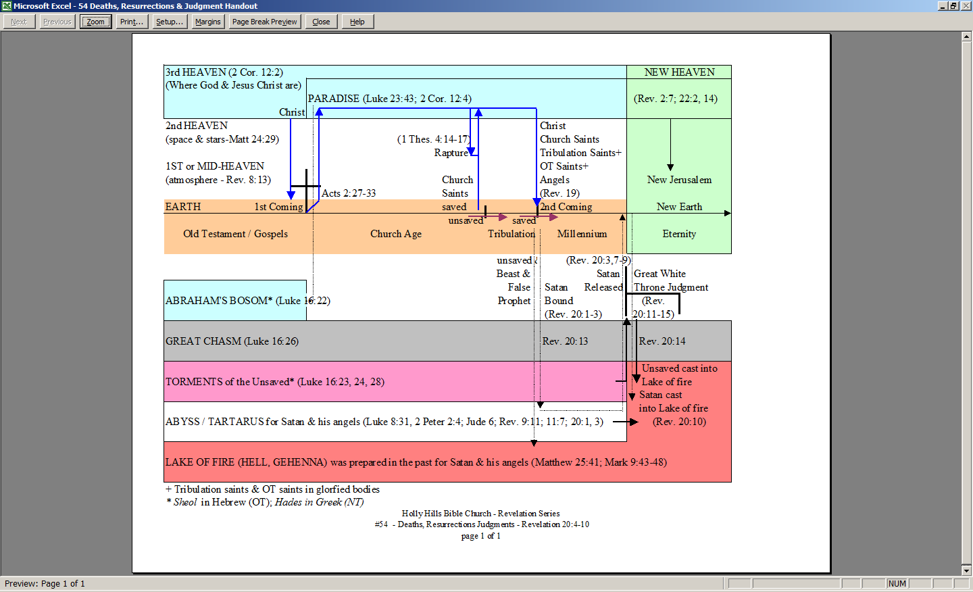
+ Tribulation saints & OT saints in glorfied bodies
* Sheol in Hebrew (OT); Hades in Greek (NT)
