Pretribulation Rapture

From fog to clarity
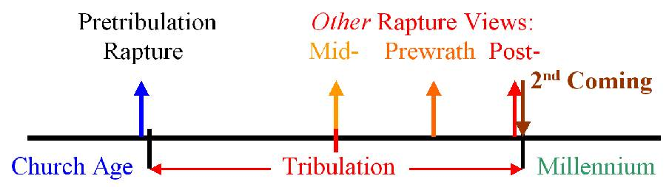
Within Christendom, there are several different views regarding what the word of God reveals about things to come. We sought to briefly introduce those views in our first meeting. Among those who tend to take a more literal view of the prophetic passages in Scripture, there are those known as Premillennialists, who foresee a future seven year Tribulation period, followed by a 1000 reign of Christ on the earth. Among those with this general view, there are several views as to when the Lord will take up the saints who are in the church, and this event has come to be known as ‘the rapture”. At Holly Hills Bible Church we hold forth and teach a ‘pretribulation rapture’, that is, that Christ will come for His church to take them to be with Him before the seven year Tribulation begins (various rapture views are illustrated in the graphic above). What we have termed “the rapture” is presented in more than two dozen New Testament passages, but is most clearly described in 1 Thessalonians 4:13-18:

But we do not want you to be uninformed, brethren, about those who are asleep, so that you will not grieve as do the rest who have no hope. For if we believe that Jesus died and rose again, even so God will bring with Him those who have fallen asleep in Jesus. For this we say to you by the word of the Lord, that we who are alive and remain until the coming of the Lord, will not precede those who have fallen asleep. For the Lord Himself will descend from heaven with a shout, with the voice of the archangel and with the trumpet of God, and the dead in Christ will rise first. Then we who are alive and remain will be caught up together with them in the clouds to meet the Lord in the air, and so we shall always be with the Lord. Therefore comfort one another with these words.

Though you will not find the word ‘rapture’ in Scripture, the word ‘rapture’ comes to us from the Greek word that is translated as “caught up” in 1 Thessalonians 4:17:

Greek Latin English
original translation word

harpazo↓ raeptius ↓ rapture

The event we call “the rapture” will end the church age on earth, which began on the day described in Acts chapter 2. All church age believers – both those who have died and those living when this event occurs – will be caught up to be with the Lord Jesus Christ. This rapture event will remove those who have placed their faith in Christ for salvation prior to the seven year period of time known as the Tribulation, which is a time of God’s wrath upon the earth. Now why is it so important that the church is taken out of the earth before the Tribulation period begins? And is a pretribulation rapture clear in Scripture?
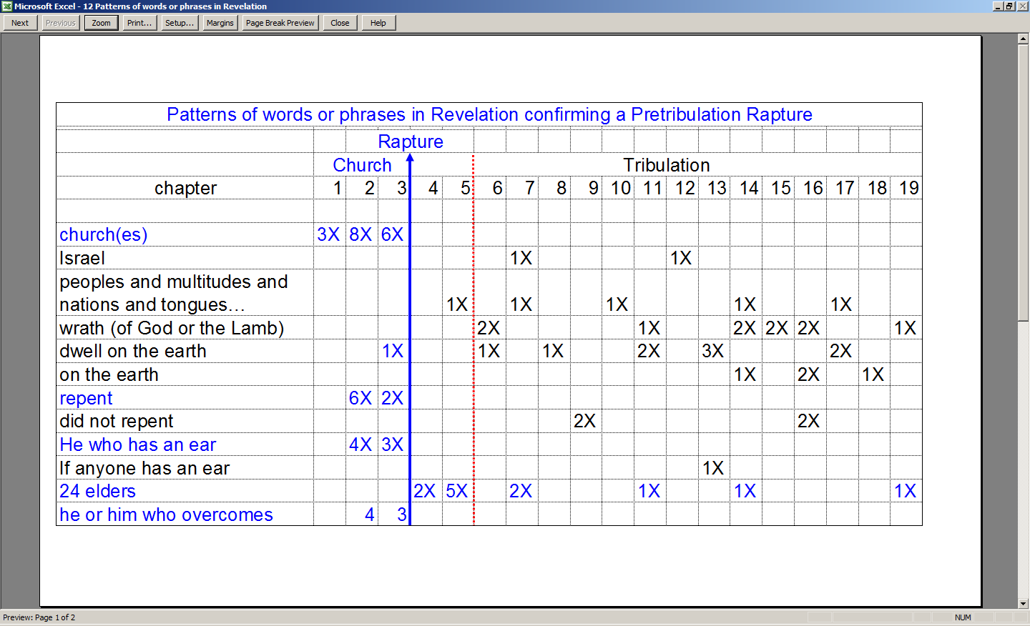
See the next two pages for discussion of these words and phrases. See the last two pages for charts summarizing Revelation.

Church or churches
A church or the churches are brought up a total of 17 times in the first three chapters of the book of Revelation, but not once after that, in chapters 4 through 19, which are the chapters regarding the heavenly scene just before the Tribulation or during the Tribulation that comes upon the earth. This can be contrasted with the use of the word ‘synagogue’ or ‘synagogues’, a gathering of Jews, which shows up in Revelation 2:9 and 3:9, and dozens of times in the four Gospels and in the book of Acts.

Israel
Revelation 7:4-8 and 12:1 both refer to the tribes of Israel, though it must be made clear that the Revelation 12:1 reference draws from the dream that Joseph had and told his family about in Genesis 37:9,10. The reference to the sons of Israel in Revelation 2:14 is not about the church, but about the people of Israel when they were being led astray by Balaam who had been hired by Balak (Numbers 22-24). There are also many other Jewish references in Revelation chapters 6 through 19.

Peoples and multitudes and nations and tongues
This phrase, or something very similar, is used four times, distributed througout the Tribulation period in Revelation, in references primarily to the Gentiles. Israel, in contrast, is written of in Scripture as “people” and/or “nation” in the singular (Isaiah 51:4; Haggai 2:14). It is used once in Revelation 5:9 in reference to the peoples whom Christ has purchased with His blood (which includes the Gentiles).

Wrath
That the church is not going to be subject to the wrath (Greek: orgē) of God is a consistent message in the New Testament:

Romans 5:9-10
Much more then, having now been justified by His blood, we shall be saved from the wrath of God through Him. 10 For if while we were enemies we were reconciled to God through the death of His Son, much more, having been reconciled, we shall be saved by His life.

1 Thessalonians 1: 9-10
For they themselves report about us what kind of a reception we had with you, and how you turned to God from idols to serve a living and true God, 10 and to wait for His Son from heaven, whom He raised from the dead, that is Jesus, who rescues us from the wrath to come.

1 Thessalonians 5: 9-10
For God has not destined us for wrath, but for obtaining salvation through our Lord Jesus Christ, 10 who died for us, so that whether we are awake or asleep, we will live together with Him.

The word ‘wrath’ appears ten times in the book of Revelation starting in chapter 6 and ending in chapter 19 – from one end to the other end of the Tribulation period. This wrath of God (or the Lamb) is precisely what we in the church are promised not to receive in the verses shown above.

‘Dwell on the earth’ or ‘on the earth’
There are eleven uses of the phrase ‘dwell on the earth’ or ‘on the earth’ in Revelation chapters 6 through 19, and the only use of ‘dwell on the earth’ that has a clear reference to the church is found in Revelation 3:10b, and it is a promise to keep us from the hour of testing (Greek: peirasmos – an assay by fire) which is to come upon the whole world, to test those who dwell on the earth:
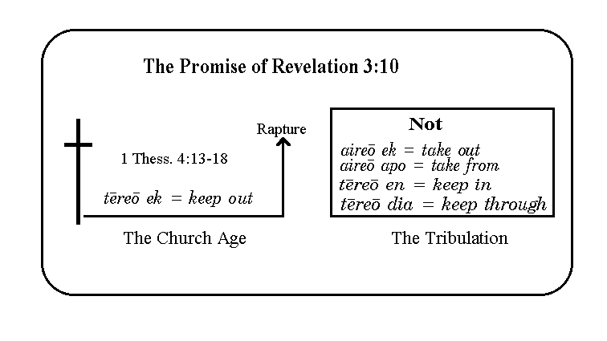
“I also will keep you from the hour of testing, that hour which is about to come upon the whole world, to test those who dwell on the earth.”

‘Repent’ and ‘did not repent’
While the churches are told to ‘repent’ (2:5, 16, 21, 22; 3:3, 19), what is said of those in the Tribulation period is that they did not repent.

‘He who has an ear’ and ‘If anyone has an ear’
In the address to each of the churches in Revelation chapters 2 and 3, each message is ended with “He who has an ear, let him hear what the Spirit says to the churches”. But in the middle of the Tribulation period we neither hear of any continuing address to the churches nor “He who has an ear…”. Instead we read in Revelation 13:9, “If anyone has an ear…”, with no appeal to what the Spirit says to the churches.

The 24 elders
We will not fully address the identity of the 24 elders until we study Revelation 4:1-4, but if the 24 elders, who only appear in Revelation chapters 4-19, are taken to be representative of the church in the heavenlies, then their presence in only those chapters is further evidence of a pretribulation rapture. As we will soon see, the evidence that the 24 elders are to be identified as representatives of the church is extensive – it fills more than one page. But a pretribulation rapture view does not stand or fall on the understanding that the 24 elders are representatives of the church in the heavenlies.

Why isn’t the rapture explicitly described in the book of Revelation?
Now as we continue to go through the book of Revelation, you will notice that there is no major passage in Revelation that explicitly describes the rapture. While that might at first puzzle us, upon closer examination we will see that there are good reasons for that. Let’s begin by listing some of the teachings which were given either primarily or uniquely for Paul the apostle to teach and explain:
- How the Gentiles are part of the church (Ephesians 3:6)
- That we are sealed with the Holy Spirit (Ephesians 1:13; 4:30; 2 Corinthians 1:21, 22)
- Spiritual Gifts (Romans 12, I Corinthians 12-14, Ephesians 4)
- Indwelling of the Holy Spirit (1 Corinthians 3:16)
- Mysteries – things previously unknown or unexplained (Colossians 1:25-27)
- The Church – it’s nature and purposes (Ephesians chapters 1-4)
- Body of Christ (Romans 7:4; 1 Corinthians 10:16; Ephesians 4:12)
- The Flesh – that part of the human nature inherited from Adam (Galatians chapter 5)
- The Rapture – what we are taking a closer look at now. Paul makes more reference to and explanation of the rapture than any other New Testament author

Also, while the rapture was explained by Paul in multiple passages and about 70% of the book of Revelation is composed of Old Testament passages, John’s focus after the messages to the seven churches is directed toward various groups of people, and not just the church, those primarily being:

- Israel – with all the earthly promises made to them
- Gentiles – non-Jews, “…peoples and multitudes and nations and tongues…”
- Tribulation saints – with all the horrific trials and martyrdom awaiting them
- The lost – for all the expressions of wrath that will come upon them

Nonetheless, the absence of the church on earth during the time of the Tribulation is quite apparent, and as we‘ll see in our studies to come, the church is clearly shown to be in heaven during this time, as represented by the 24 elders.

It will be important for us, as we proceed through the rest of Revelation, to keep the contrasts between the rapture of the church and the second coming of Christ to earth to reign as Israel’s King and the King of Kings and Lord of Lords over the Gentiles distinct in our minds. Below are listed just 13 points of contrast between the rapture and the second coming, though one biblical scholar has noted as many as 48 points of contrast:

Rapture Second Coming

1. Rapture of all believers 1. No Rapture at all
2. Raptured saints go to heaven 2. Raptured saints return to earth
3. Earth not judged 3. Earth judged
4. Imminent, signless 4. Follows definite predicted signs
5. Not in the Old Testament (OT) 5. Predicted often in the OT
6. Believers only 6. Affects all men
7. Before the day of wrath 7. Concluding the day of wrath
8. No reference to Satan 8. Satan bound
9. Christ comes for His own 9. Christ comes with His own
10. He comes in the air 10. He comes to the earth
- He claims His bride 11. He comes with His bride
- Only His own see Him 12. Every eye shall see Him
13. Tribulation begins 13. Millennial kingdom begins
Now since the idea of a rapture might seem rather foreign to our thinking at first, a person might ask, has such a thing ever happened before? The direct answer is, “no”, at least not with a large group, since the New Testament teaching is unique in that regard. But we can answer “yes” in a couple individual cases in the Old Testament:

Enoch – Genesis 5:21-24: Then Enoch walked with God three hundred years after he became the father of Methuselah, and he had other sons and daughters. So all the days of Enoch were three hundred and sixty-five years. Enoch walked with God; and he was not, for God took him.

Enoch is even mentioned in the New Testament in this same regard…

Hebrews 11:5: By faith Enoch was taken up so that he would not see death; and he was not found because God took him up; for he obtained the witness that before his being taken up he was pleasing to God.

Elijah – 2 Kings 2:11: As they [Elijah and Elisha] were going along and talking, behold, there appeared a chariot of fire and horses of fire which separated the two of them. And Elijah went up by a whirlwind to heaven.

So there are two Old Testament examples of a rapture-like catching up to be with the Lord, and in reality our going up and being given a new body in this event called the rapture has similarities to our Lord’s ascension described in Acts chapter 1. Our ascension then will be like His ascension because we have been identified with Christ. That future event is only making a reality in our condition what has already been made true and certain in our position in Christ.

See the accompanying chart with the footer “Rapture passages”. Regarding that chart:

The most prominent feature in common between these passages is the use of the pronouns we, you and us in almost all of these passages. These indicate that the rapture could have happened even in the lives of the first century saints and apostles. Even today the rapture is imminent – not that the rapture must happen within some near time frame, but that it could happen at any moment – even our next breath (just like our Lord’s first coming). There is every indication in Scripture that not only was it possible for our Lord to come for us at any moment, but that this very expectation is to be the norm for the Christian.

The rapture is not about avoiding any big troubles in this life
At this point it is critical that we come to the right understanding regarding the rapture of those who have placed their faith in Christ for salvation. The rapture is not about getting out of the troubles we’re now in, although we’ve got to admit that may have some appeal to us. There are those who oppose the rapture teachings and try to make these many passages mean something else. These folks commonly claim that those who look for a rapture are just looking to get out of this world’s troubles - but they just don’t understand.

The rapture is not about just getting the doctrine down right, although God’s word is clear that He wants us to do that. Paul’s last chapter to Timothy, in which he writes his last words that we have, includes a charge to Timothy to stand on solid doctrine, and in which he writes, in 2 Timothy 4:8:

…in the future there is laid up for me the crown of righteousness, which the Lord, the righteous Judge, will award to me on that day; and not only to me, but also to all who have loved His appearing.

So the matter of getting our doctrine straight – including the doctrine of the rapture that Paul wrote so much about - is no small matter. But It is clear from Scripture that the things that are affirmed about the rapture are deep matters of the heart:

- The rapture will take place because the Lord, in His love for the Body of Christ – the Church – will take out the church saints to be with Him and not subject them to His own wrath against the world that rejects His grace and mercy – extended freely to them at great cost! The several verses and numerous word patterns we’ve looked at in Revelation make that very clear.
- But even more, the teaching of the rapture is all about our love for the Lord Himself. We love Him because He first loved us (1 John 4:19). Love for the Lord now is the basis for loving His appearing.
- Either we have that blessed hope of His coming for us because we love Him, or we’ll be weighed down with the right things to do and the right doctrine alone. The church at Ephesus had that problem – remember when we looked at that several weeks ago? They had left their first love! How could they love His appearing? They were too busy doing all the other right things!
- The church at Sardis that we looked at about a month ago had lost its life. The church at Sardis appeared to be alive, but was not living by the life of Christ. How could they possibly be longing for the appearance of Christ if they did not live by His life now?
- The church at Laodicea was told that they were neither hot nor cold. Without zeal for the Lord, how could they possibly have any love for His appearing?

What are the conditions of heart and mind and life that keep us from loving His appearing? If we love the Lord now, and live by His life and have zeal that comes from Him, then we will love His appearing - and that’s rewardable!

Titus 2:11-14
For the grace of God has appeared, bringing salvation to all men, 12 instructing us to deny ungodliness and worldly desires and to live sensibly, righteously and godly in the present age, 13 looking for the blessed hope and the appearing of the glory of our great God and Savior, Christ Jesus, 14 who gave Himself for us to redeem us from every lawless deed, and to purify for Himself a people for His own possession, zealous for good deeds.
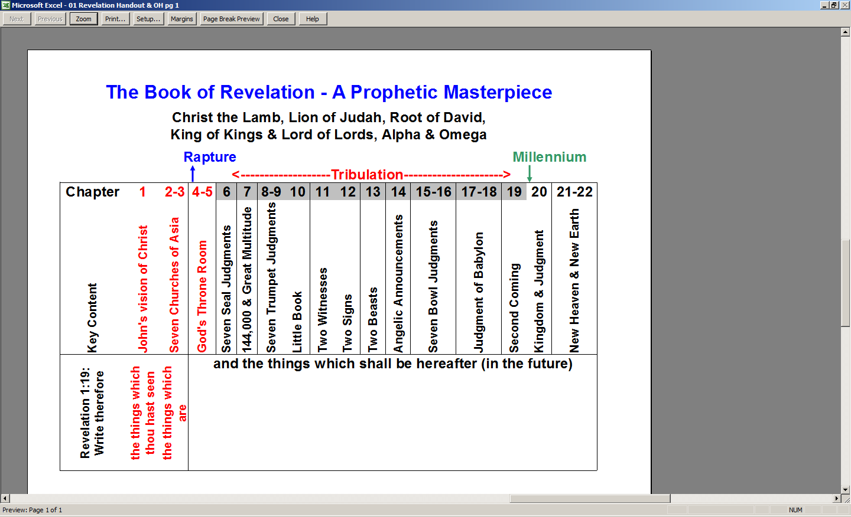
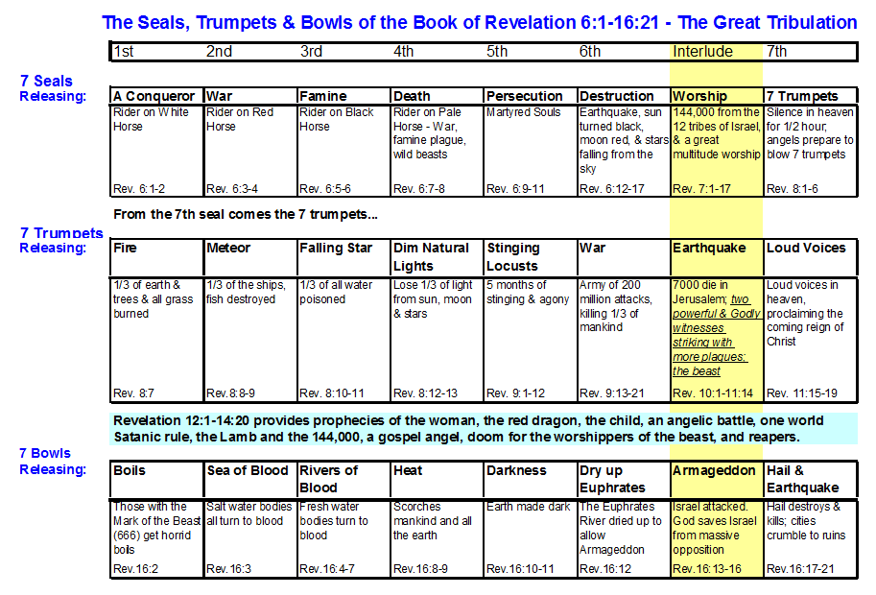

The use of the figurative term ‘hour’ for the seven year Tribulation period is unque to this passage, but is also consistent with using a spectrum of ‘time terms’ for the Tribulation: days, week, months, and years (Daniel 9:27, 7:25; 9:27; 12:7, and Revelation 12:6; 13:5). We will address these time terms for the Tribulation in more detail in our study of Daniel 9:27 and Revelation 12:6, among other passages.

