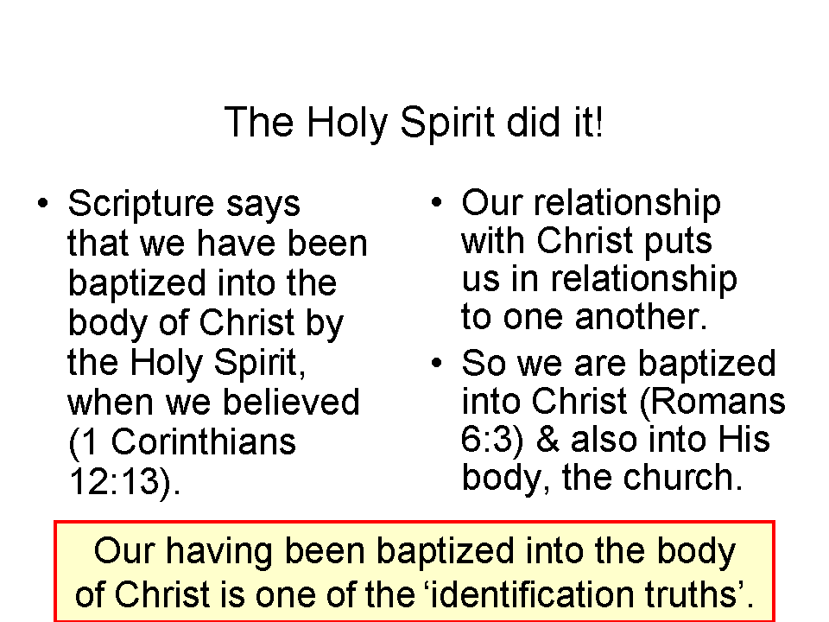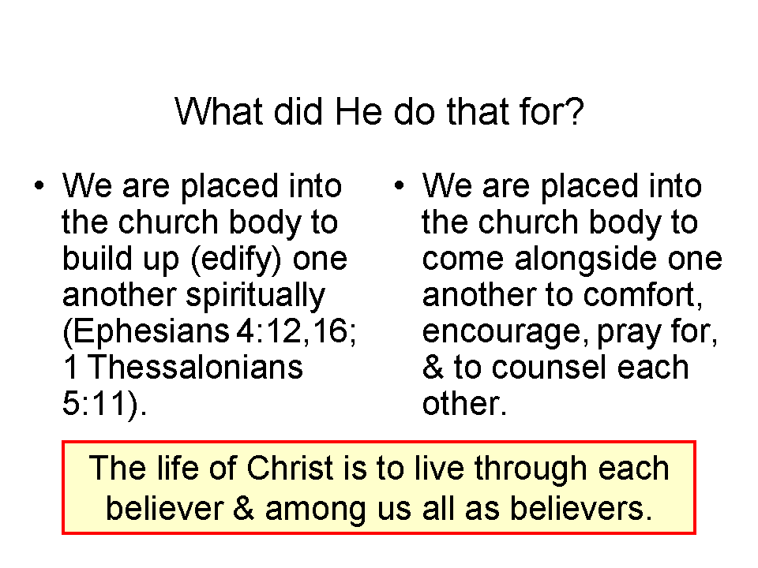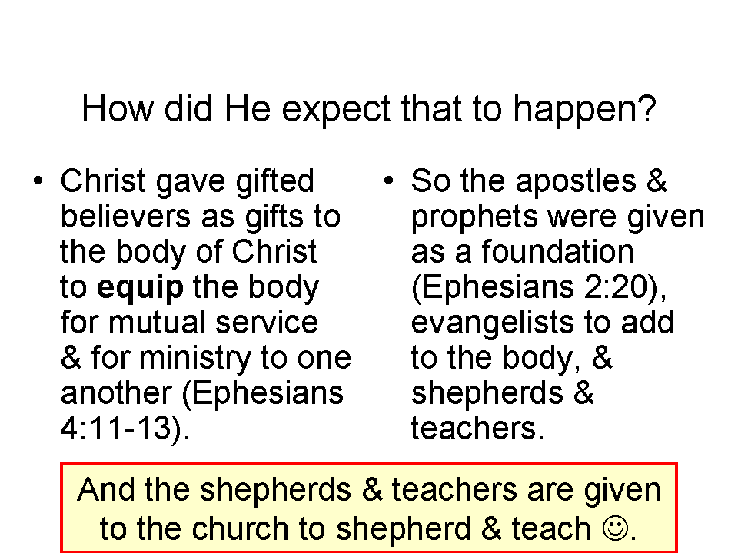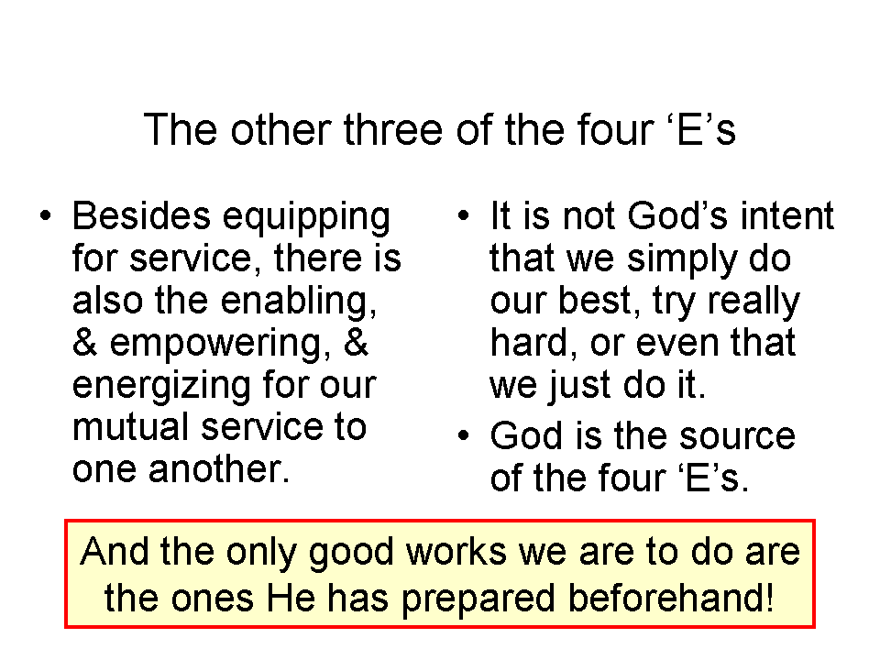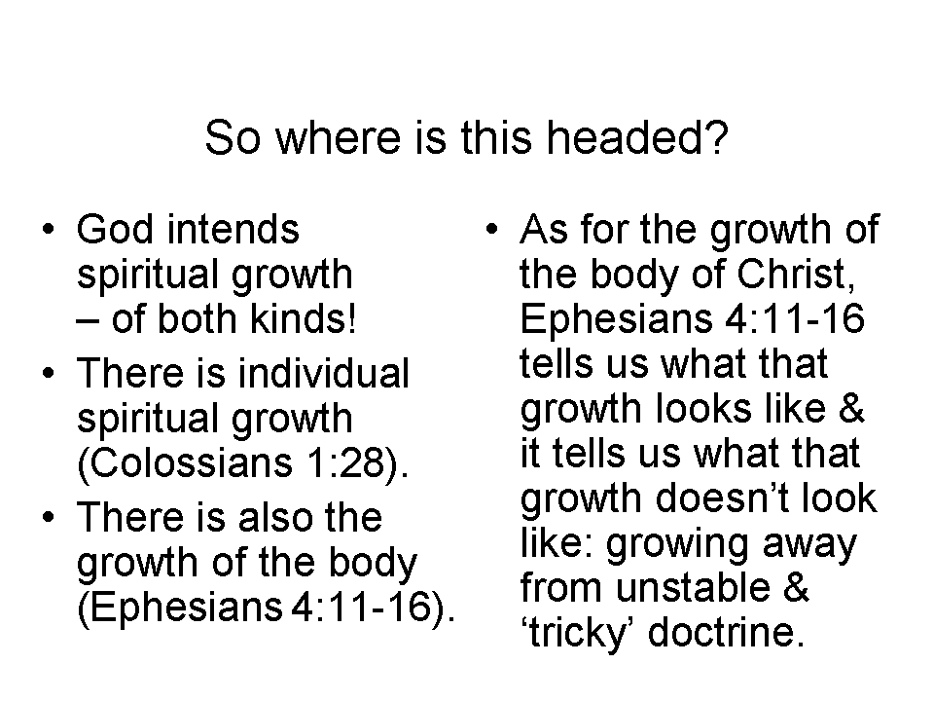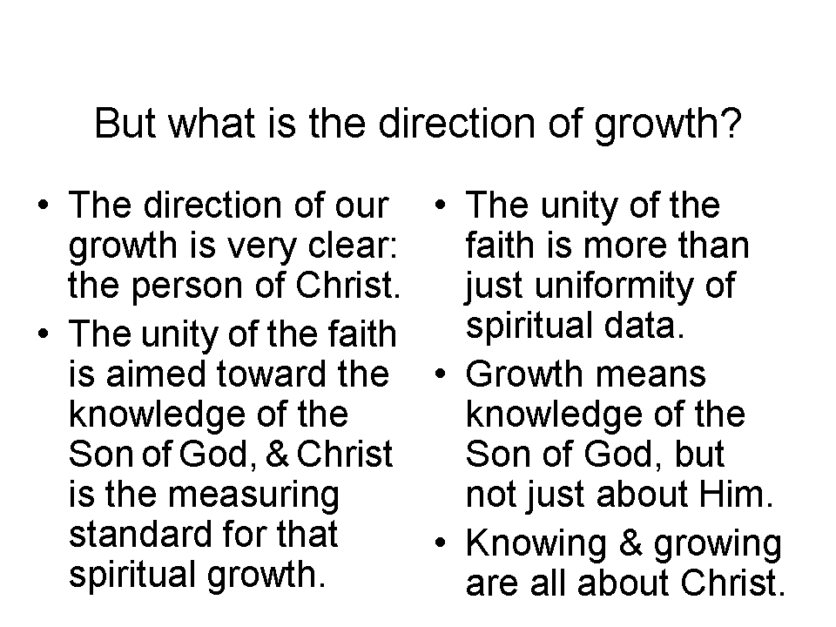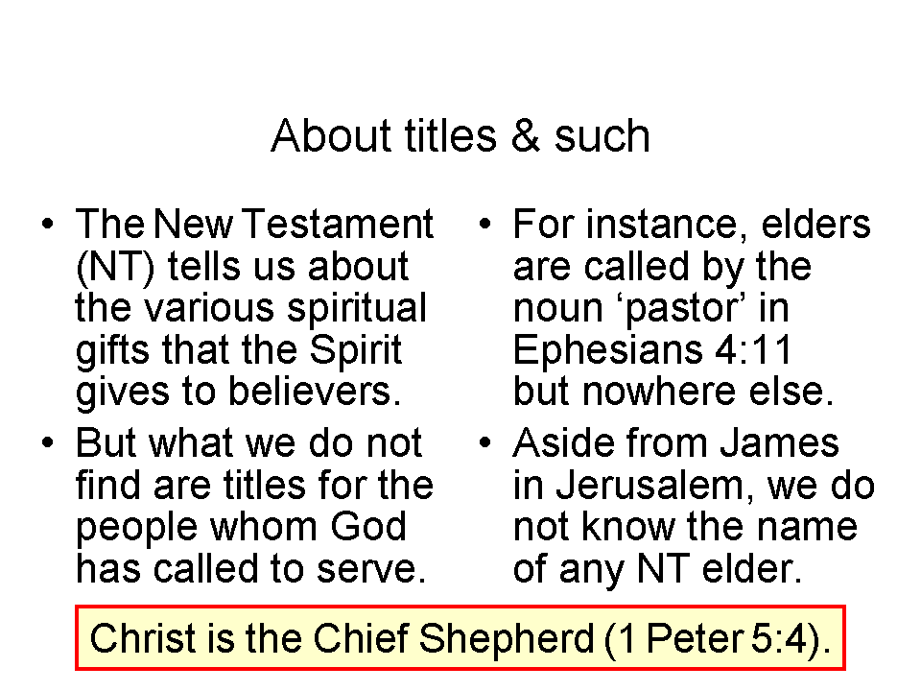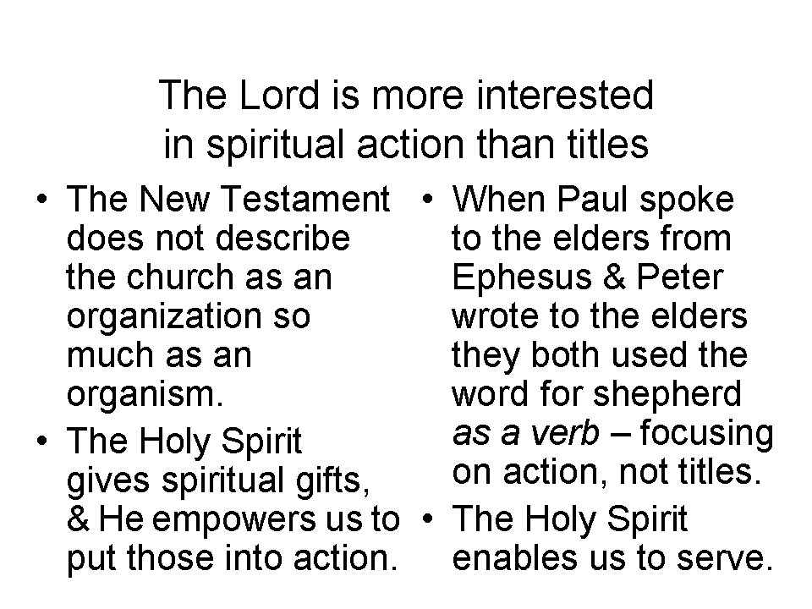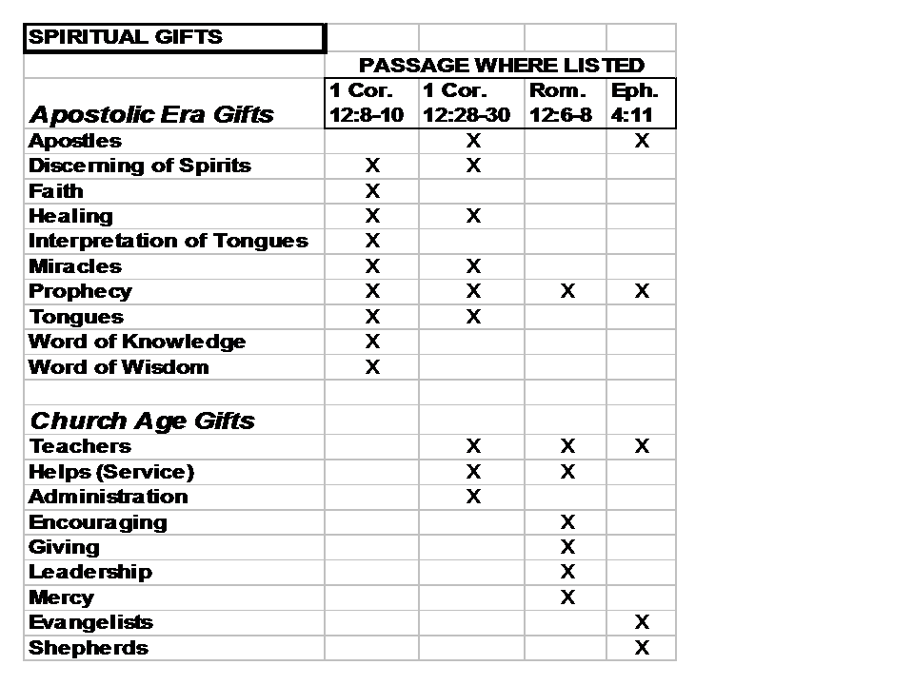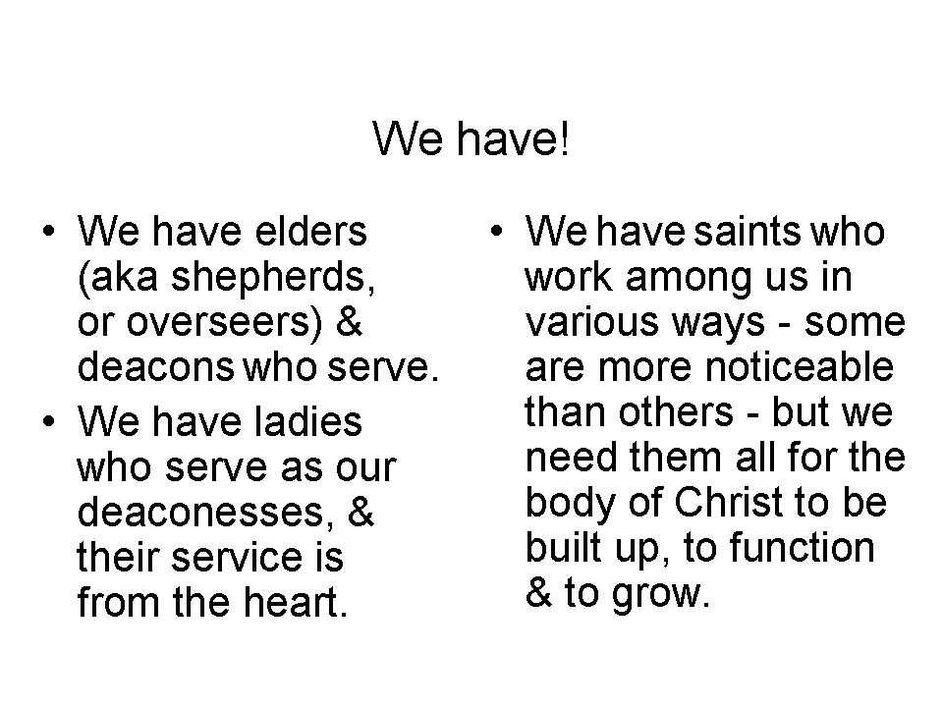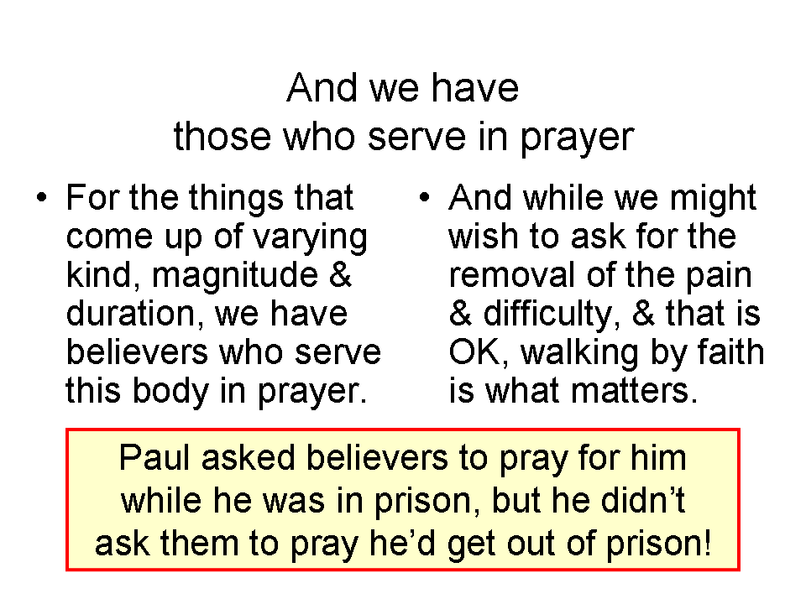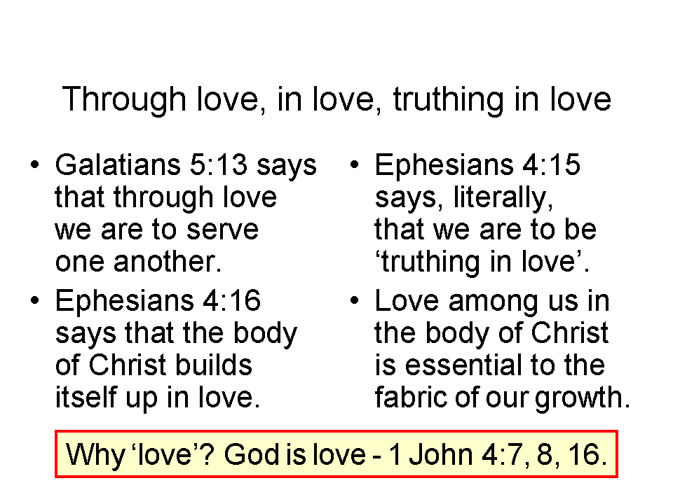
For more insight into the spiritual gifts:
Go to: www.hollyhillsbiblechurch.org, click on “Messages & Audio”, then on “Current Series”, then on “1&2 Corinthians 2009-10”, then go to:
24 1 Corinthians 12:1-13 – Baptized into one body
_________________________________________________________________________________________________________________________________________________________________________________________________________________
For more insight into elders & deacons:
Go to: www.hollyhillsbiblechurch.org, click on “Materials”, then click on “Elders, Deacons & The Church Board”

