Q&A 9: How can there be so many differences of interpretation among those who even have a knowledge of Greek and Hebrew, which we would typically consider to be powerful tools for understanding Scripture properly? Since the Holy Spirit indwells every believer, and one of the Holy Spirit’s ministries is to lead us into truth, as the ‘Spirit of truth’ (John 14:17; 15:26, 16:13), why is it that genuine believers can end up with such varying interpretations of Scripture?

A:

First things first – all the way to the last things!

In order to make what God has intended clear, what Scripture communicates is that the set of teachings from the apostles is consistently called “the faith” and “the truth” – from Acts to Revelation. God did not intend that believers hold to a variety of interpretations nor ‘agree to disagree’ or to embrace all or most of the varying doctrines at once:

1 Corinthians 1:10 (NKJV)
Now I plead with you, brethren, by the name of our Lord Jesus Christ, that you all speak the same thing, and that there be no divisions among you, but that you be perfectly joined together in the same mind and in the same judgment.

Ephesians 4:11-14 (NASU)
And He gave some as apostles, and some as prophets, and some as evangelists, and some as pastors and teachers, 12 for the equipping of the saints for the work of service, to the building up of the body of Christ; 13 until we all attain to the unity of the faith, and of the knowledge of the Son of God, to a mature man, to the measure of the stature which belongs to the fullness of Christ. 14 As a result, we are no longer to be children, tossed here and there by waves and carried about by every wind of doctrine, by the trickery of men, by craftiness in deceitful scheming;

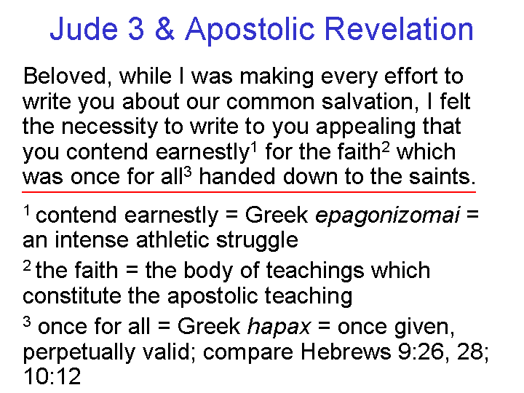
What Scripture conveys is that there was a specific assignment of specific men to write Scripture (the apostles or their sponsored authors). These revelations were given in a specific timeframe, after which subsequent revelations are simply not valid (the time for laying a foundation for the church: Ephesians 2:20; 3:5). There was also a specific and objective inspiration of certain Scriptures, and not of other writings (2 Timothy 3:16, 17).
Grammatical-Historical Interpretation

In order to arrive consistently at the single intended meaning of Scripture, we must abide by a set of principles (fundamental truths and primary guidance) of interpretation based on observation of the elements of the language, history and culture in the context of each passage. The ‘handle’ for this approach to interpretation is ‘grammatical-historical interpretation’, or similar terms, which the Holly Hills Bible Church doctrinal statement explains this way:

Dispensational Interpretation – We believe that Scripture is to be interpreted according to its grammatical and historical context, including that God, Who does not change, deals in a different manner with the Gentile nations, the people of Israel, and the God-created body of heavenly saints called “the Church”. We believe that all who are saved of all time are saved entirely by faith in Christ, either looking forward or back to the cross. (John 14:6; Acts 4:12; Romans 11:1, 2; 1 Corinthians 9:17, 10:32; Ephesians 1:10, 2:11-22, 3:2; Colossians 1:25)

Why a knowledge of Greek and Hebrew doesn’t assure consistent interpretation

There can be differences among Greek and Hebrew scholars on some fairly minor points, but the differences in interpretation are more often due to ‘other factors’ – and those ‘other factors’ can often have a much larger impact on the variations in interpretation. Some of the ‘other factors’ that commonly divert the interpretation of Scripture from a consistently literal understanding are:

- allegorizing imposed upon the text of Scripture, including variations in allegorizing among groups and individual interpreters in where the allegorizing begins and ends.

- a basis of authority outside of Scripture, whether acknowledged or not, such as supplemental books, a person or institution, emotions, experiences, assumptions, ‘science’ or a culturally based ‘principle’.

Examples:

1) Someone holding to what is known as ‘limited atonement’ (the third of five tenets of Calvinism often represented with the acronym ‘TULIP’) would say that Christ died only for the elect: those chosen before the foundation of the world. Then they read:

1 John 2:2
and He Himself [Christ] is the propitiation [satisfaction of God’s character] for our sins; and not for ours only, but also for those of the whole world.

Though it has nothing at all to do with a clear understanding of the Greek word meanings or grammar, to the end of this verse they then mentally add this set of words to arrive at their understanding of the text, as they also do similar verses:
“…for those of the whole world of the elect.”

The idea in this addition to the meaning of Scripture is that Christ died only for those whom God chose and elected beforehand to be saved – and none other. Likewise, they would say that Christ did not die for those whom God did not choose and elect beforehand. That understanding is then read back into the text in passage where that meaning is required by the approach to Scripture:

John 3:16 (NASU)
"For God so loved the world [of the ones whom He already chose and elected], that He gave His only begotten Son, that whoever believes in Him [of the ones whom He already chose and elected] shall not perish [like the ones whom He did not already choose and elect], but have eternal life [which is reserved only for those whom God already chose and elected]."

2) Someone holding to an allegorical interpretation of Revelation 7:1-8 might look up all the Greek word definitions, and analyze the grammar with great skill. But the assumption that this passage should be allegorized such that the Church replaces Israel or is “spiritual Israel’ will actually set aside the precise meanings of words, and the numbers given. The meaning of the ‘sons of Israel’, 144,000, 12,000 for each of the twelve tribes with the names given for each tribe will no longer be taken to mean what they mean literally, even though the literal meaning is known with great precision. Instead these will often be taken for a non-specific number and listing of Church denominations of widely varying sizes.

Most of Christendom, and virtually all of the cult groups hold to some form of allegorized interpretation of Scripture. But there is no objective means of determining when to force an allegory upon the text of Scripture, nor how the allegorical meaning should be determined from the text of Scripture. Allegorical interpretation was imported into Christianity from the Greek pagans (such as Plato) who understood their Greek myths to be allegories – not to be taken literally.

3) Those who see the elimination of gender role distinctions as a priority, typically based on cultural influences, will come to a biblical passage wanting to justifying their egalitarian viewpoint, and so will find ways to set aside the literal meaning of the text in favor of their own viewpoint:

Galatians 3:28 (NASU)
There is neither Jew nor Greek, there is neither slave nor free man, there is neither male nor female; for you are all one in Christ Jesus.

If this is not taken as a statement of the believer’s position ‘in Christ Jesus’, but instead is taken as a setting aside of what would otherwise be biblically defined gender roles, then one could justify any options of sexual behavior or roles among Christians, based on the same logic, since male and female distinctions and roles are thus set aside ‘in Christ’.
1 Timothy 3:1-7 (NASU)
It is a trustworthy statement: if any man [masculine gender in the Greek, though this is not as emphatic as andros in verse 2] aspires to the office of overseer, it is a fine work he desires to do. 2 An overseer, then, must be above reproach, the husband [andros: specifically male] of one wife, temperate, prudent, respectable, hospitable, able to teach, 3 not addicted to wine or pugnacious, but gentle, peaceable, free from the love of money. 4 He must be one who manages his own household well, keeping his children under control with all dignity 5(but if a man does not know how to manage his own household, how will he take care of the church of God?), 6 and not a new convert, so that he will not become conceited and fall into the condemnation incurred by the devil. 7 And he must have a good reputation with those outside the church, so that he will not fall into reproach and the snare of the devil.

Some of the reasons put forth as to why the above passage should be set aside are: Paul was limiting his instructions to what was acceptable in the culture of the time, or ‘we’re not sure what Paul means here’, or even ‘we’re not sure if this book was written by Paul, so we’re not sure we should call this passage ‘inspired Scripture”.

In each of the above three examples, the interpreter comes to the passage with the interpretation and/or need for allegorization already in mind, and interprets the passage according to his preconceived notion, rather than asking what the author intended to say, and how the original readers would have understood what he wrote.

What about the Holy Spirit who is supposed to lead believers into truth?

Certainly the Holy Spirit - the Spirit of truth – has the ministry of leading believers into truth, among a variety of ministries given in the New Testament (John 14:17; 15:26, 16:13). What is also revealed in Scripture is that the believer has a part in carrying out that leading of the Holy Spirit to its ultimate conclusion. Scripture points to diligence and to maturity as two key factors on the believer’s part, impacting the understanding and wise application of Scripture:

2 Timothy 2:15 (NASU)
Be diligent (spudazō, as an active imperative) to present yourself approved to God as a workman who does not need to be ashamed, accurately handling the word of truth.

Hebrews 5:13-14 (NASU)
For everyone who partakes only of milk is not accustomed to the word of righteousness, for he is an infant. 14 But solid food is for the mature, who because of practice (gumnazō, out of a vocabulary of competitive athletics) have (present active participle: ‘are right now having’) their senses trained to discern good and evil.
There are some aspects of the Holy Spirit’s ministry that, as a part of the believer’s eternal position, cannot be resisted or impacted by the believer, such as the Holy Sprit’s indwelling (John 14:6; Romans 5:5; 8:9; 1 Corinthians 3:16). But Scripture makes it quite apparent that there are other aspects of the Holy Spirit’s ministry which can be impacted negatively by the believer’s own mindset, decisions and actions:

Acts 5:3-4 (NASU)
But Peter said, "Ananias, why has Satan filled your heart to lie to the Holy Spirit and to keep back some of the price of the land? 4 While it remained unsold, did it not remain your own? And after it was sold, was it not under your control? Why is it that you have conceived this deed in your heart? You have not lied to men but to God."

Galatians 5:25-26 (NASU)
If we live by the Spirit, let us also walk by the Spirit. [implying that walking by the Spirit is not a given, but an act of the will] 26 Let us not become boastful, challenging one another, envying one another.

Ephesians 4:30 (NASU)
Do not grieve the Holy Spirit of God, by whom you were sealed for the day of redemption.

So it is possible for a believer to override the ministry and leading of the Holy Spirit, in various ways – including the realm of interpretation and application of Scripture. There is no denying that the influences that can impact a believer’s interpretation of Scripture can seem so valid, such as:

- a centuries-old interpretive tradition
- a deeply-held belief rooted in culturally-based ethics and morals
- the influence of a strong personality from the past or the present,
- intense personal experiences perceived subjectively as spiritual in nature, and
- a lack of diligence in handling the word of God (Ephesians 4:1-6; 2 Timothy 2:15).

In the end, we are called to look to the Lord Jesus Christ, and to respond to the ministries of the Holy Spirit, recognizing that as valid as these other influences may seem from a human viewpoint, they only serve to cloud in varying degrees what the apostles called “the faith”, “the truth” and “the gospel”. The practical effect of listening and responding to these other influences in many instances is not so much to plunge the believer headlong into clear immorality or evident heresy, but to neutralize the believer’s effectiveness and distract the believer from clearly beholding the Lord through His word. Along with that, there is a cost to the effectiveness and spiritual quality of the body of Christ if believers within that church body are not mutually pursuing “the unity of the faith”.

2 Timothy 3:16-17 (NASU)
All Scripture is inspired by God and profitable for teaching, for reproof, for correction, for training in righteousness; 17 so that the man (anthrōpos) of God may be adequate, equipped for every good work.

See the handout, “Holly Hills Bible Church – 03 1 Corinthians series – June 21, 2009 1 Corinthians 1:10-17 – I urge… the same mind”.
See the audio and written material for the HHBC elective, “How To Study The Bible” on the HHBC website: http://hollyhillsbiblechurch.org/?page_id=63&series_id=60&series_page=20
http://www.valleybiblefellowship.org/papers/gal_328_frames.htm.
The Greek grammar conveys that he should right now be continuing to be a ‘one-woman kind of man’. This same phrase is also used of the qualifications of an elder in Titus 1:5-9, and of a deacon in 1 Timothy 3:8-13. The equivalent of these phrases wherein a woman is to be a ‘one man kind of woman’ is given in 1 Timothy 5:9, as one requirement for a widow to receive church assistance.

