Q&A 11: Why were certain books included in the Bible – accepted as ‘canon’ - and other books excluded from the Bible – rejected as ‘canon’?

A: This question is part of a larger set of understandings that that Holy Spirit was involved in the 1) inspiration of the original writings of Scripture, 2) the recognition of what was inspired by the Holy Spirit, and what was not, 3) the copying and preservation of Scripture, and 4) the explaining and translation of Scripture such that those with other language backgrounds could understand what had been inspired, recognized, copied and preserved as Scripture. This lesson will focus on the second part of this ‘chain’: the recognition of what is indeed inspired as the word of God and the exclusion of what is not inspired as Scripture.

Recognition of the books of the Old Testament

By New Testament times, the canon of the Old Testament had already been well established, although the Sadducees held only to the inspiration of the first five books of the Old Testament. But the minority Sadducees were ended by the destruction of the temple in Jerusalem in 70 AD. So Josephus, writing toward the end of the first century, summarized the view of the Pharisees, which represented the majority view of the Jews:

From the time of Artaxerxes, moreover, until our present period, all occurrences have been written down but they are not regarded as entitled to the like credit with those which precede them, because there was no certain succession of prophets. Fact has shown what confidence we place in our own writings. For although so many ages have passed away, no one has dared to add to them, nor to take anything from, nor to make alterations. In all Jews it is implanted, even from their birth, to regard them as being the instructions of God, and to abide steadfastly by them, and if it be necessary, to die gladly for them.”

Various references in the New Testament to the books of Moses, the Law and the Prophets, and the Psalms, were spoken of as if the books were well recognized (Matthew 5:17; 7:12; Luke 24:44, etc.), there being no discussions recorded in the New Testament (or elsewhere, for that matter) debating the Old Testament books among the Pharisees, nor questioning which books were meant by the terms ‘Scripture’, “the Law’, etc.

Recognition of the books of the New Testament

The recognition of the books of the New Testament, however took place in a different era, separate from the writings of the Old Testament, and not by those who were exclusively Jews. The slides and notes that follow will outline the key historical sequence and criteria that lead to the recognition of what was inspired and what was not inspired, as well as giving examples and samples of the books that were rejected from recognition as canon.

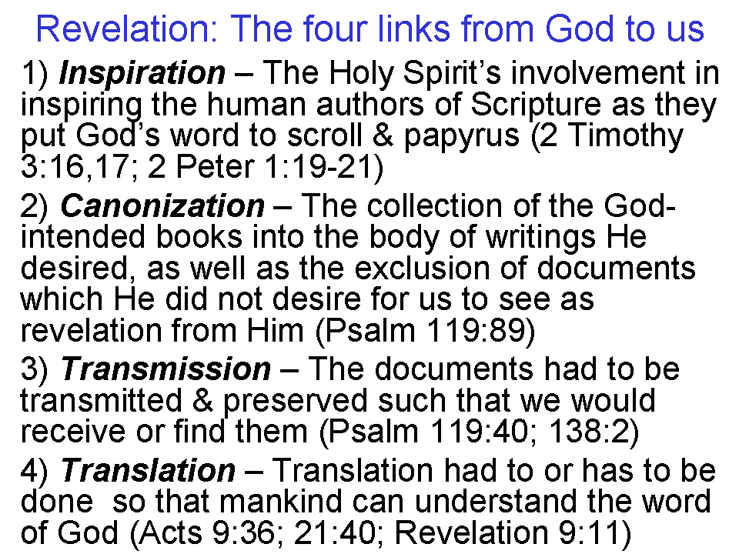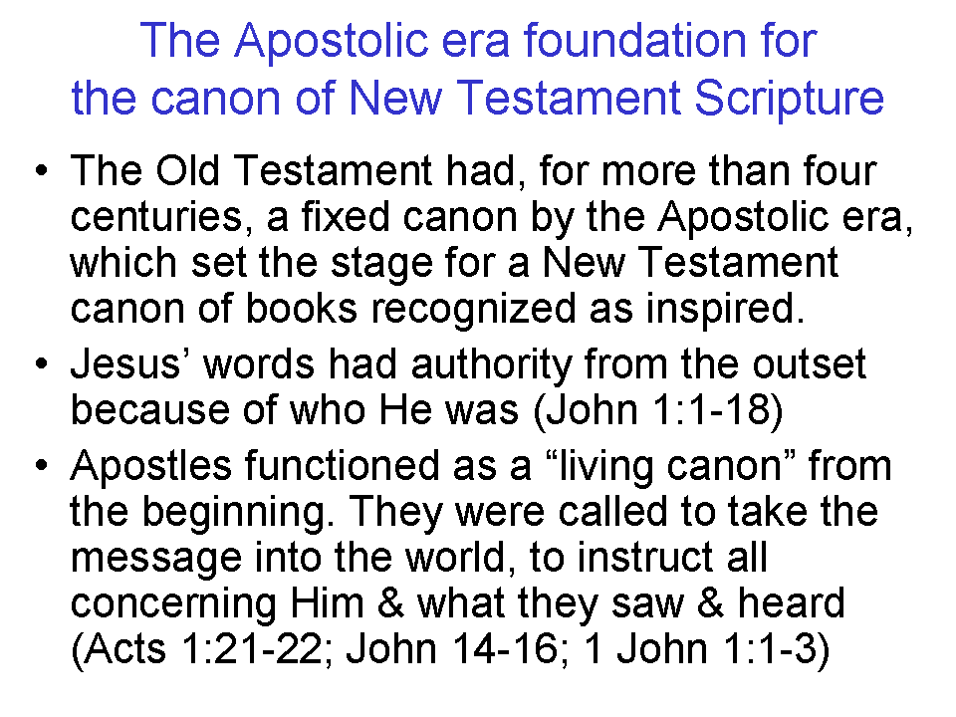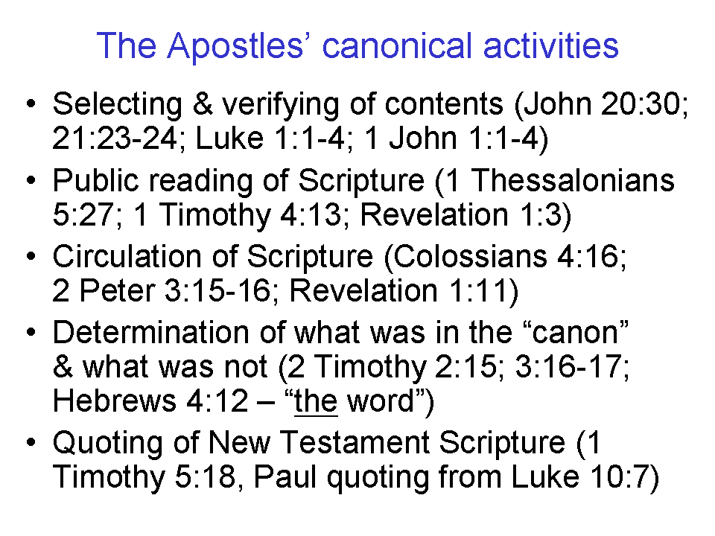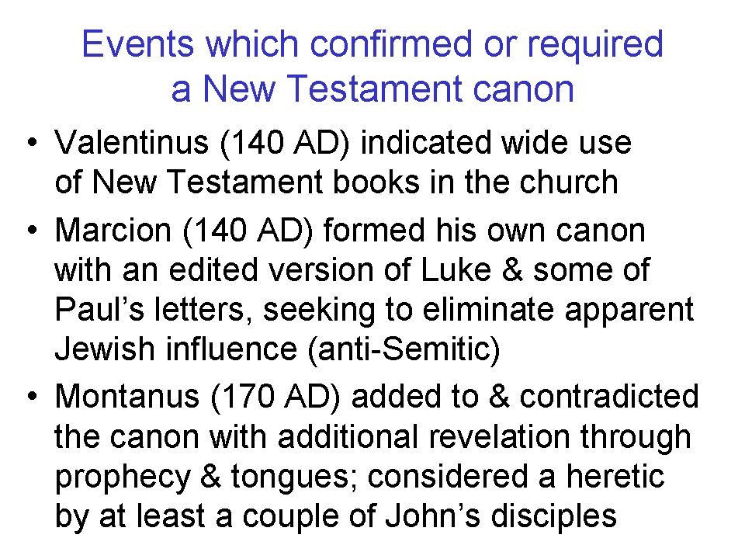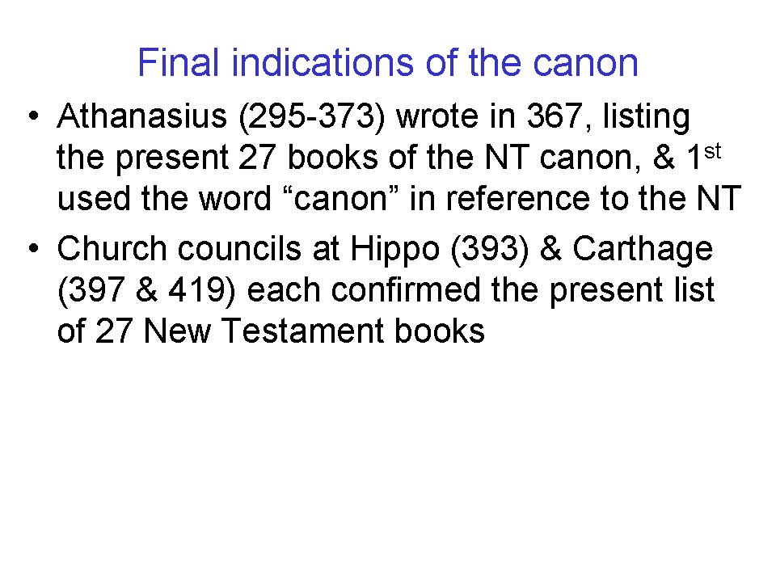
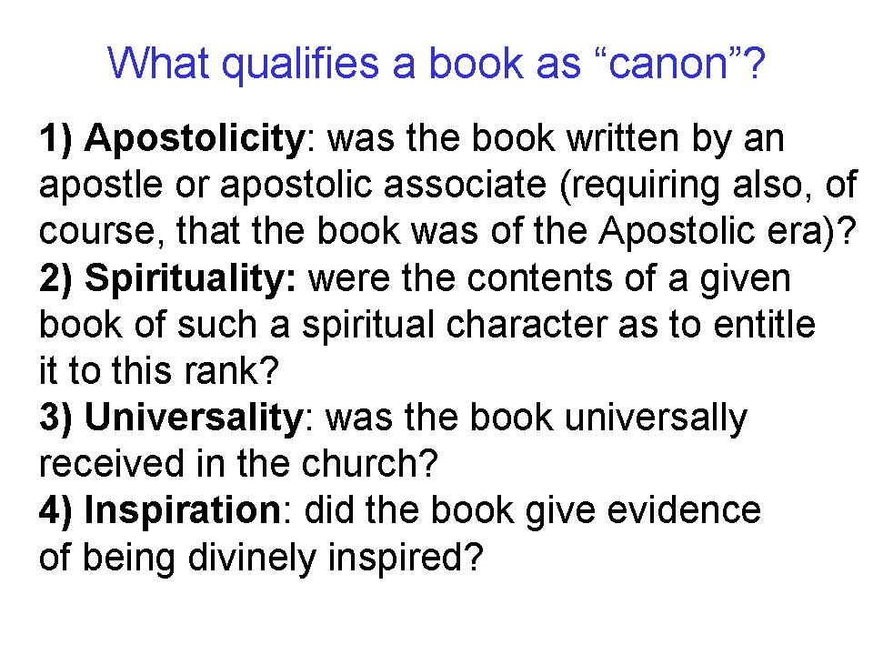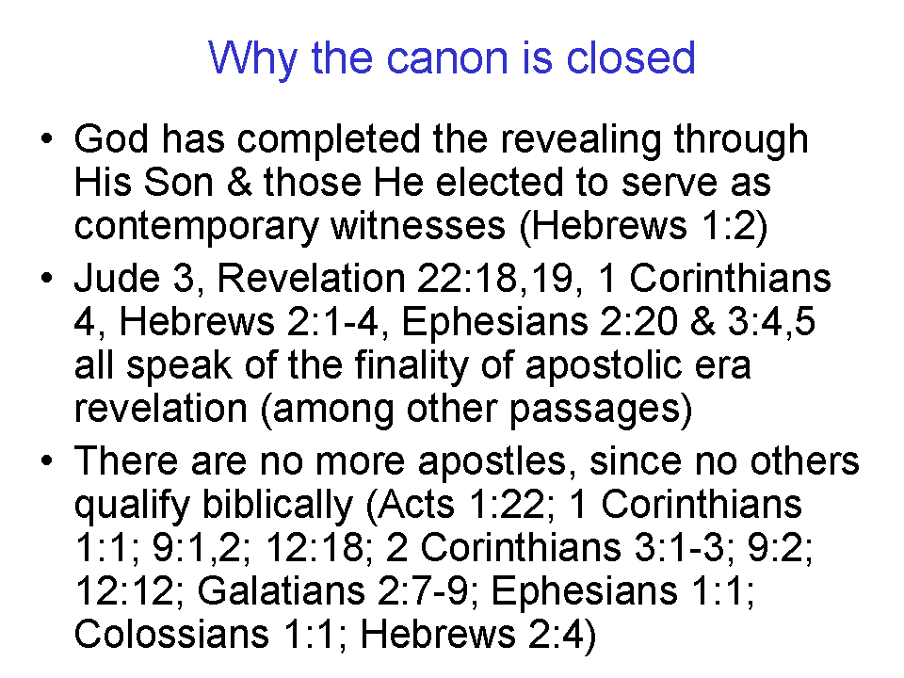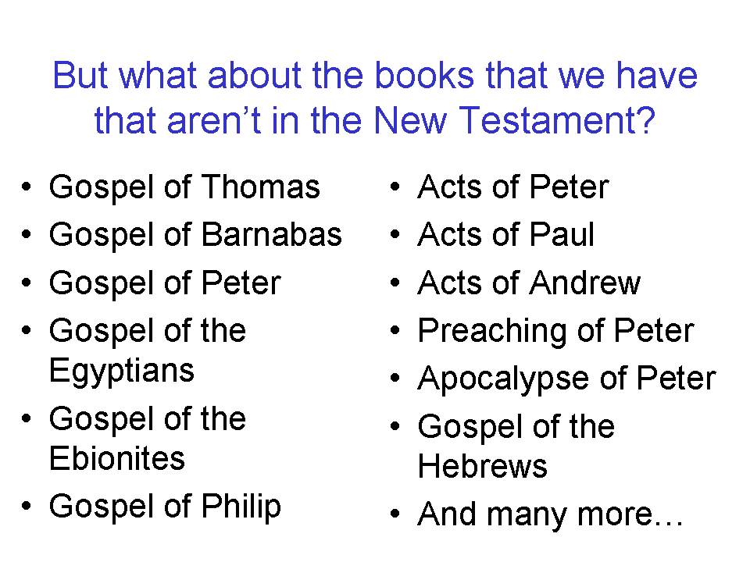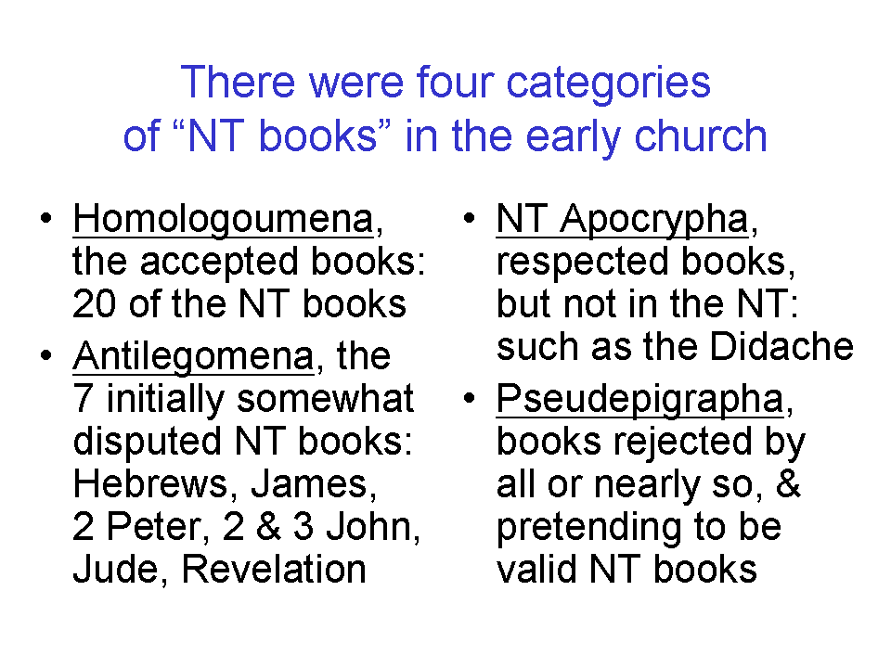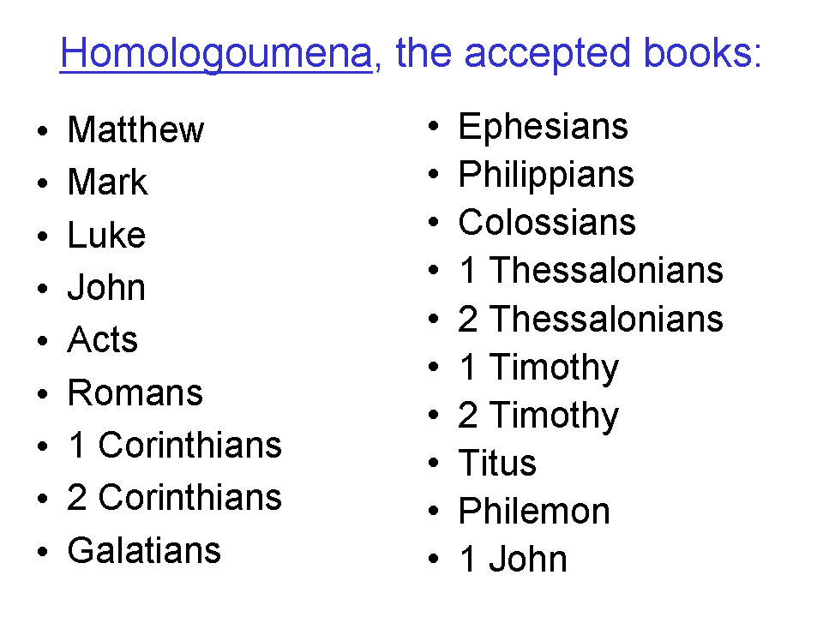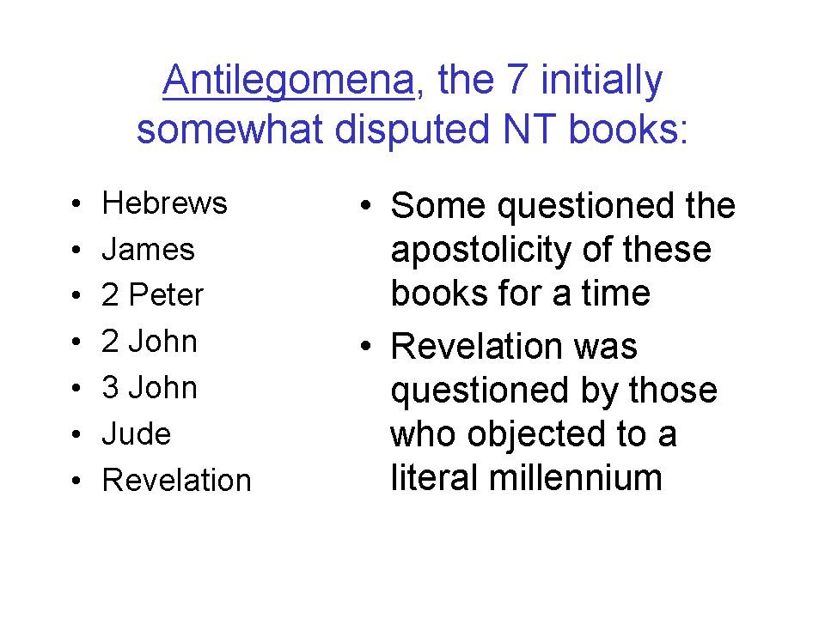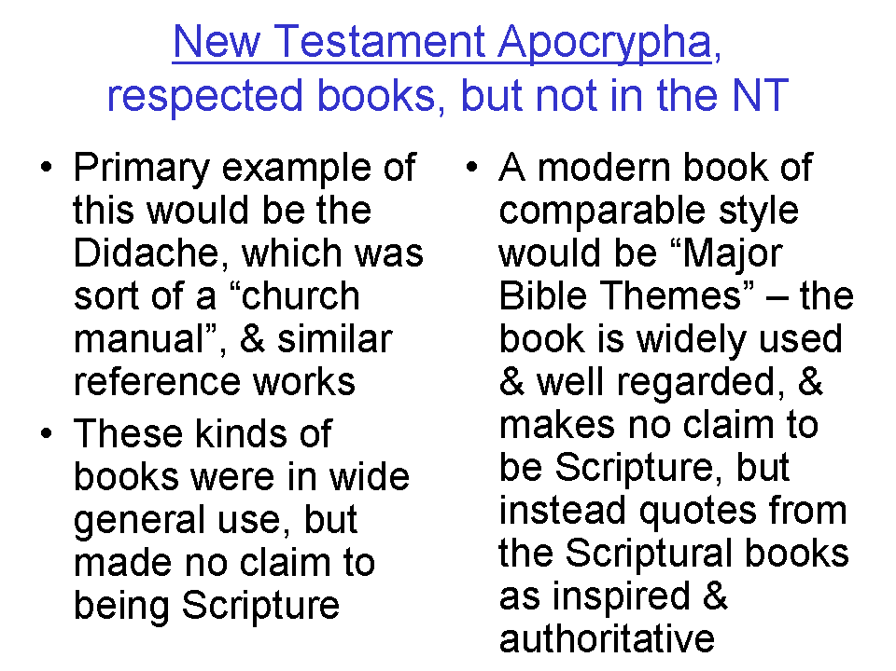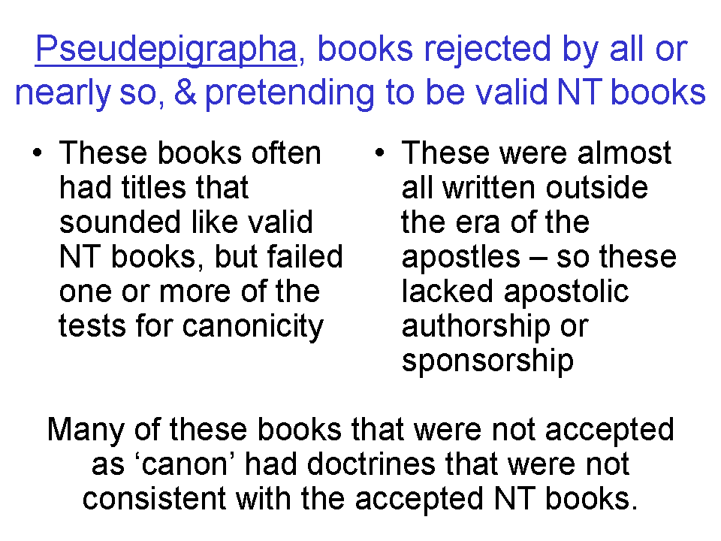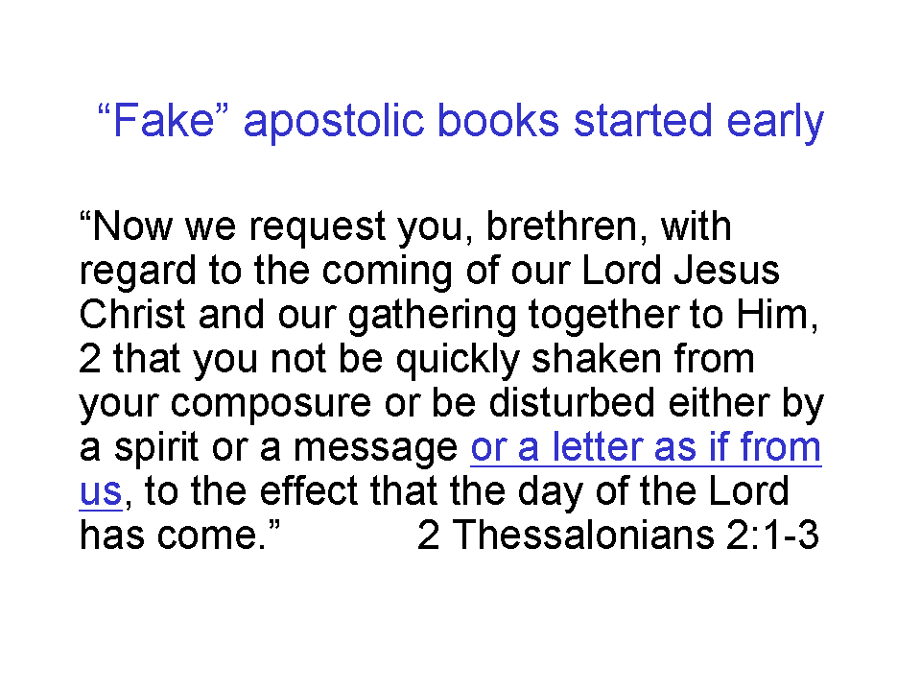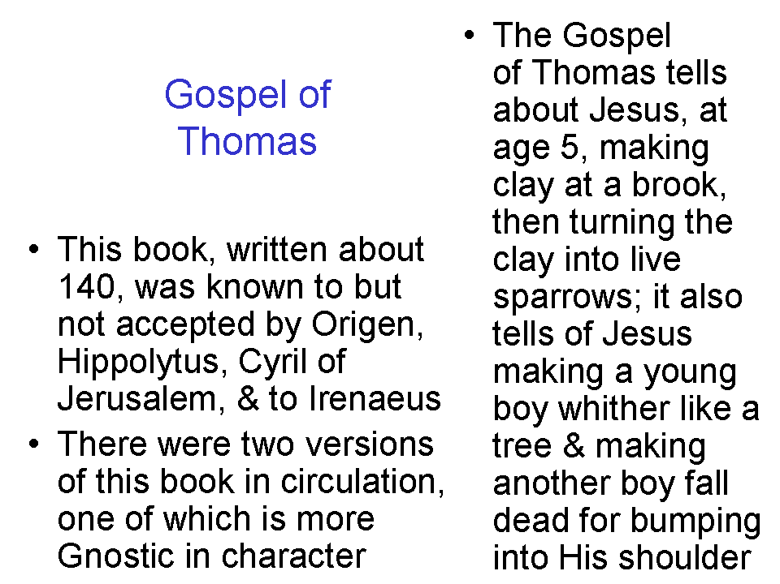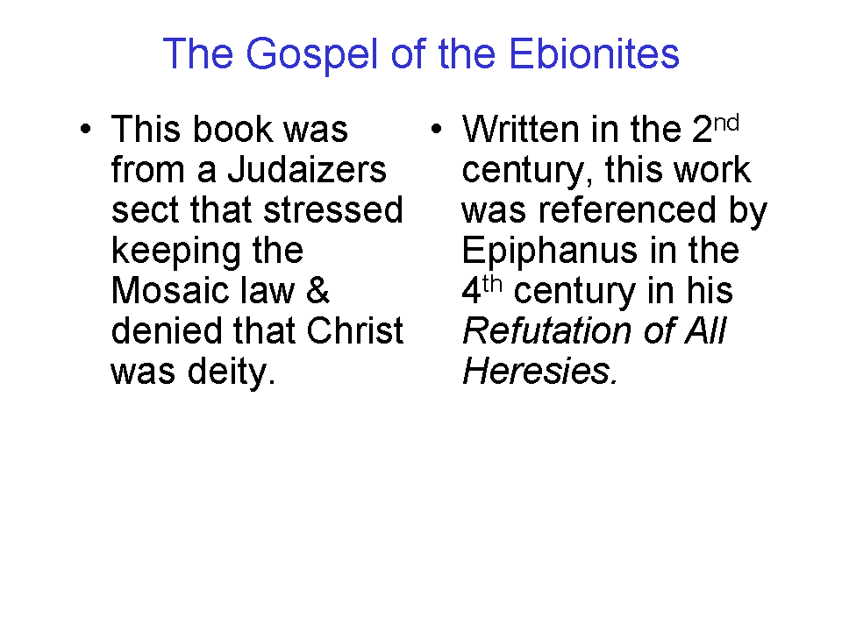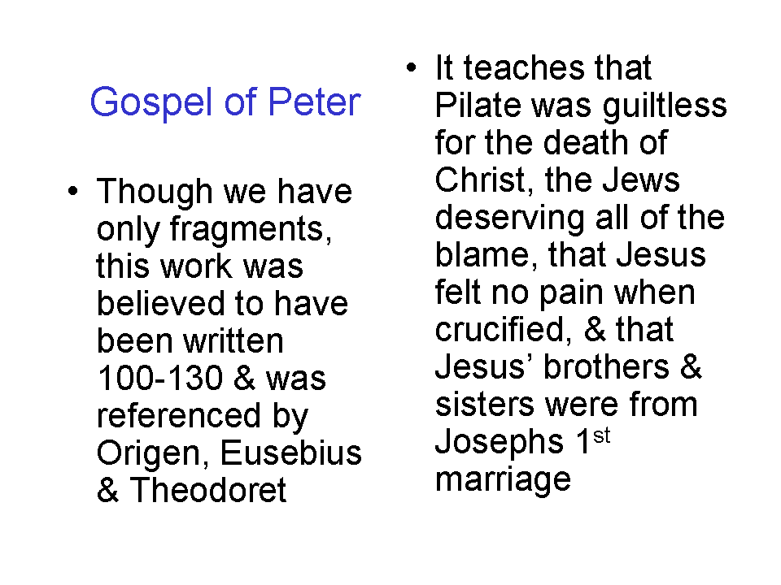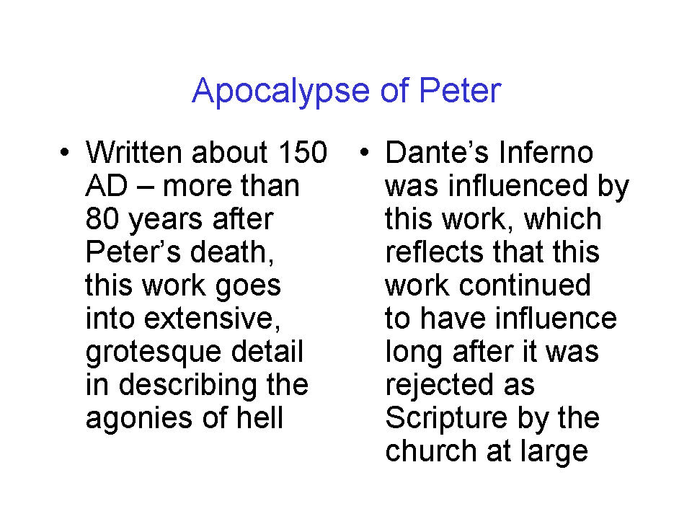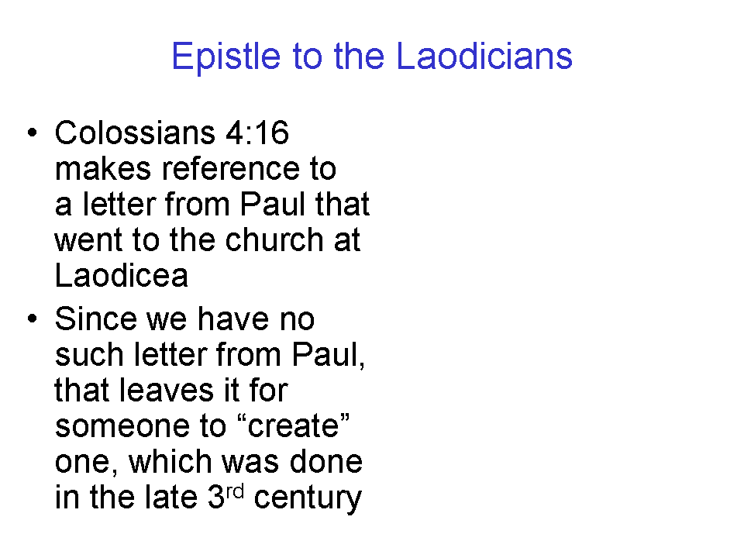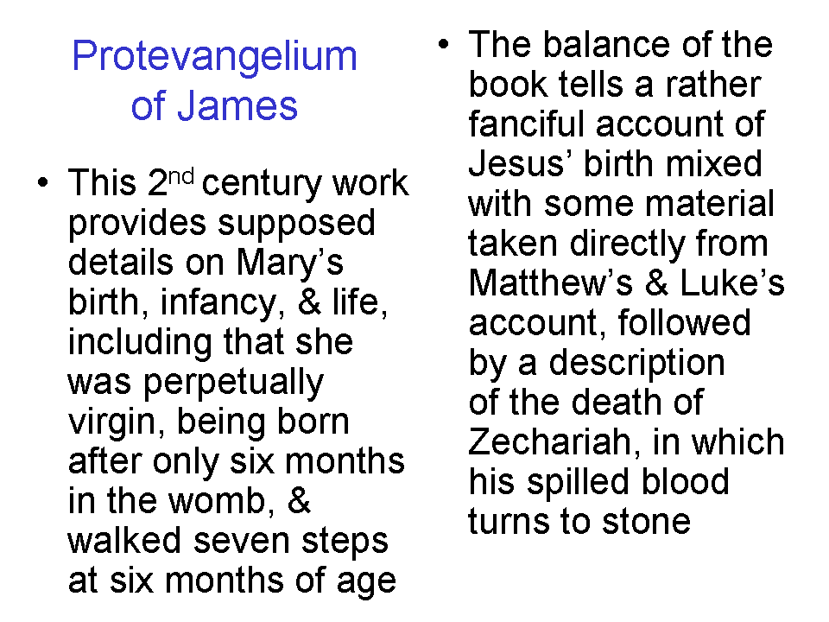
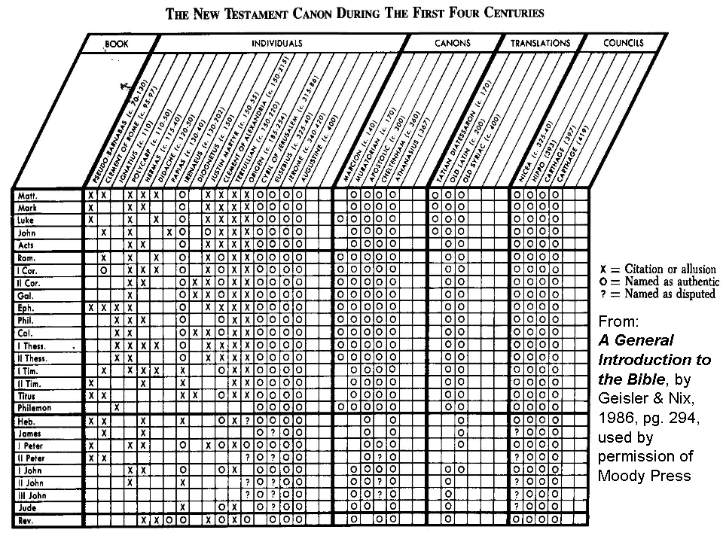
The Apocalypse of Peter

1. ... many of them will be false prophets, and will teach divers ways and doctrines of perdition: but these will become sons of perdition. 3. And then God will come unto my faithful ones who hunger and thirst and are afflicted and purify their souls in this life; and he will judge the sons of lawlessness. 4. And furthermore the Lord said: Let us go into the mountain: Let us pray. 5. And going with him, we, the twelve disciples, begged that he would show us one of our brethren, the righteous who are gone forth out of the world, in order that we might see of what manner of form they are, and having taken courage, might also encourage the men who hear us. 6. And as we prayed, suddenly there appeared two men standing before the Lord towards the East, on whom we were not able to look; 7, for there came forth from their countenance a ray as of the sun, and their raiment was shining, such as eye of man never saw; for no mouth is able to express or heart to conceive the glory with which they were endued, and the beauty of their appearance. 8. And as we looked upon them, we were astounded; for their bodies were whiter than any snow and ruddier than any rose; 9, and the red thereof was mingled with the white, and I am utterly unable to express their beauty; 10, for their hair was curly and bright and seemly both on their face and shoulders, as it were a wreath woven of spikenard and divers-coloured flowers, or like a rainbow in the sky, such was their seemliness. 11. Seeing therefore their beauty we became astounded at them, since they appeared suddenly. 12. And I approached the Lord and said: Who are these? 13. He saith to me: These are your brethren the righteous, whose forms ye desired to see. 14. And I said to him: And where are all the righteous ones and what is the aeon in which they are and have this glory? 15. And the Lord showed me a very great country outside of this world, exceeding bright with light, and the air there lighted with the rays of the sun, and the earth itself blooming with unfading flowers and full of spices and plants, fair-flowering and incorruptible and bearing blessed fruit. 16. And so great was the perfume that it was borne thence even unto us. 17. And the dwellers in that place were clad in the raiment of shining angels and their raiment was like unto their country; and angels hovered about them there. 18. And the glory of the dwellers there was equal, and with one voice they sang praises alternately to the Lord God, rejoicing in that place. 19. The Lord saith to us: This is the place of your high-priests, the righteous men. 20. And over against that place I saw another, squalid, and it was the place of punishment; and those who were punished there and the punishing angels had their raiment dark like the air of the place. 21. And there were certain there hanging by the tongue: and these were the blasphemers of the way of righteousness; and under them lay fire, burning and punishing them. 22. And there was a great lake, full of flaming mire, in which were certain men that pervert righteousness, and tormenting angels afflicted them. 23. And there were also others, women, hanged by their hair over that mire that bubbled up: and these were they who adorned themselves for adultery; and the men who mingled with them in the defilement of adultery, were hanging by the feet and their heads in that mire. And I said: I did not believe that I should come into this place. 24. And I saw the murderers and those who conspired with them, cast into a certain strait place, full of evil snakes, and smitten by those beasts, and thus turning to and fro in that punishment; and worms, as it were clouds of darkness, afflicted them. And the souls of the murdered stood and looked upon the punishment of those murderers and said: O God, thy judgment is just. 25. And near that place I saw another strait place into which the gore and the filth of those who were being punished ran down and became there as it were a lake: and there sat women having the gore up to their necks, and over against them sat many children who were born to them out of due time, crying; and there came forth from them sparks of fire and smote the women in the eyes: and these were the accursed who conceived and caused abortion. 26. And other men and women were burning up to the middle and were cast into a dark place and
were beaten by evil spirits, and their inwards were eaten by restless worms: and these were they who persecuted the righteous and delivered them up. 27. And near those there were again women and men gnawing their own lips, and being punished and receiving a red-hot iron in their eyes: and these were they who blasphemed and slandered the way of righteousness. 28. And over against these again other men and women gnawing their tongues and having flaming fire in their mouths: and these were the false witnesses. 29. And in a certain other place there were pebbles sharper than swords or any spit, red-hot, and women and men in tattered and filthy raiment rolled about on them in punishment: and these were the rich who trusted in their riches and had no pity for orphans and widows, and despised the commandment of God. 30. And in another great lake, full of pitch and blood and mire bubbling up, there stood men and women up to their knees: and these were the usurers and those who take interest on interest. 31. And other men and women were being hurled down from a great cliff and reached the bottom, and again were driven by those who were set over them to climb up upon the cliff, and thence were hurled down again, and had no rest from this punishment: and these were they who defiled their bodies acting as women; and the women who were with them were those who lay with one another as a man with a woman. 32. And alongside of that cliff there was a place full of much fire, and there stood men who with their own hands had made for themselves carven images instead of God. And alongside of these were other men and women, having rods and striking each other and never ceasing from such punishment. 33. And others again near them, women and men, burning and turning themselves and roasting: and these were they that leaving the way of God

Epistle to the Laodiceans

1. Paul, an apostle not of men and not through man, but through Jesus Christ, to the brethren who are in Laodicea: 2. Grace to you and peace from God the Father and the Lord Jesus Christ. 3. I thank Christ in all my prayer that you are steadfast in him and persevering in his works, in expectation of the promise for the day of judgment. 4. And may you not be deceived by the vain talk of some people who tell (you) tales that they may lead you away from the truth of the gospel which is proclaimed by me. 5. And now may God grant that those who come from me for the furtherance of the truth of the gospel (...) may be able to serve and to do good works for the well-being of eternal life. 6. And now my bonds are manifest, which I suffer in Christ, on account of which I am glad and rejoice. 7. This ministers to me unto eternal salvation, which (itself) is effected through your prayers and by the help of the Holy Spirit, whether it be through life or through death. 8. For my life is in Christ and to die is joy (to me). 9. An this will his mercy work in you, that you may have the same love and be of one mind. 10. Therefore, beloved, as you have heard my presence, so hold fast and do in the fear of God, and eternal life will be your portion. 11. For it is God who works in you. 12. And do without hesitation what you do. 13. And for the rest, beloved, rejoice in Christ and beware of those who are out for sordid gain. 14. May all your requests be manifest before God, and be yea steadfast in the mind of Christ. 15. And what is pure, true, proper, just and lovely, do. 16. And what you have heard and received, hold in your heart and peace will be with you. [17. Salute all the brethren with the holy kiss.] 18. The Saints salute you. 19. The grace of the Lord Jesus Christ be with your spirit. 20. And see that this epistle is read to the Colossians and that of the Colossians among you.

Which is why Jesus responded to their question out of one of the five books that they considered inspired (Matthew 22:23-33).
Contra Apion 1.8 ¶¶38–42; other English translations end the first sentence with “…the exact succession of the prophets ceased”. See A General Introduction to the Bible, by Geisler & Nix, 1986, pages 205-206.

