Q&A 18: What about the passages that are used to support loss of salvation?

A: Some general observations

While we have spent a few Sundays presenting those passages and biblical principles that support the eternal security of the believer, we now will address those passages that are often pointed to as evidence that a believer’s salvation can be lost, or that a person can by deliberate unbelief, spiritual negligence, or moral error whether by negligence or choice, come to a place of no longer being saved, though they once were saved. It is claimed that Christians need the threat of loss of salvation in order to be kept on the path of right belief and righteous works. As a general observation, those who hold that the passages that we will shortly address are evidence of loss of salvation set aside, disregard, or are sometimes unaware of the points we have presented over the last few Sundays. Additionally, as we have noted before, there are some generalities that we can make about the approach to Scripture used by those who claim that a passage stands as evidence that a person may be saved and thereafter come to a place of not being saved:

- Passages regarding eternal reward or punishment, which are judged based on works, and law-based judgment of blessing and curses, which are often misunderstood as applying to salvation

- Passages are interpreted without regard for an understanding of eternal position and daily (or temporal) condition (aka standing and state), such as the difference between eternal relationship and fellowship, which may vary in time

- Passages are interpreted setting aside other passages that teach eternal security as an absolute truth, thereby setting aside the principle of consistent interpretation

- Passages that are in a parable form are extended in meaning and application beyond what the parable was intended to convey

- Passages are interpreted without regard for the characteristics of the stewardship in which, or for which, the revelation is written

- Passages are interpreted outside of the context of language, history and culture in which they were originally written

- Passages are interpreted allegorically, which is by nature applied without objective control as to the scope and meaning of allegorical interpretation

- Passages are interpreted as applicable that are in fact presented as a hypothetical possibility in the context

So as we study through these passages, we will encounter one or more of the above interpretive errors that will bring a person to view a passage as evidence that once a person is saved, that same person may become unsaved. But there is one other point to cover: in Calvinism, which includes Lordship Salvation, it is taught that once a person is saved he will not fall away in belief or morals, and the one who does is said never to have been saved. Among other errors, this view assumes that we get to decide who is saved and who is not (we do not: Revelation 20:11-15), and even to tamper with the gospel by adding Lordship with saving belief.
Matthew 25:32-46 (NASU, as the other passages quoted, unless stated otherwise)
"All the nations [Greek: ethnos = Gentiles] will be gathered before Him; and He will separate them from one another, as the shepherd separates the sheep from the goats; 33 and He will put the sheep on His right, and the goats on the left."

34 "Then the King will say to those on His right, 'Come, you who are blessed of My Father, inherit the kingdom prepared [perfect tense] for you from the foundation of the world. 35 'For I was hungry, and you gave Me something to eat; I was thirsty, and you gave Me something to drink; I was a stranger, and you invited Me in; 36 naked, and you clothed Me; I was sick, and you visited Me; I was in prison, and you came to Me.' 37 Then the righteous will answer Him, 'Lord, when did we see You hungry, and feed You, or thirsty, and give You something to drink? 38 'And when did we see You a stranger, and invite You in, or naked, and clothe You? 39 'When did we see You sick, or in prison, and come to You?' 40 The King will answer and say to them, 'Truly I say to you, to the extent that you did it to one of these brothers of Mine, even the least of them, you did it to Me.'"

41 "Then He will also say to those on His left, 'Depart from Me, accursed ones, into the eternal fire which has been prepared [perfect tense] for the devil and his angels; 42 for I was hungry, and you gave Me nothing to eat; I was thirsty, and you gave Me nothing to drink; 43 I was a stranger, and you did not invite Me in; naked, and you did not clothe Me; sick, and in prison, and you did not visit Me.' 44 Then they themselves also will answer, 'Lord, when did we see You hungry, or thirsty, or a stranger, or naked, or sick, or in prison, and did not take care of You?' 45 Then He will answer them, 'Truly I say to you, to the extent that you did not do it to one of the least of these, you did not do it to Me.' 46 These will go away into eternal punishment, but the righteous into eternal life."

The context of this passage is this:

Christ had given the disciples His description of the seven year Tribulation period that is contained in Matthew chapter 24 (and parallel passages are in Mark 13 and Luke 21). At the second coming of Christ, Christ first judges the nation of Israel (Matthew 25:1-31), then the Gentile nations (Matthew 25:32-46). The judgments illustrated and described in Matthew chapter 25 are primarily about two things:

1) Entrance into the Kingdom, where Christ shall reign as the King of Israel and King of kings and Lord of lords over the Gentiles. Entrance into the Kingdom was a very common theme as Christ spoke, and as recorded in the gospels, especially in the book of Matthew.

2) Eternal destiny of those who survive the Tribulation period. Whether Jews or Gentiles, only those who are believers will enter the coming Millennial Kingdom.
Matthew 25:32-46 is often used as the basis for social action among believers in the church now. But Matthew 25:32-46 actually presents the judgment of living Gentiles at the end of the Tribulation period, based upon their treatment of the people of Israel, which is precisely what God promised to Abraham about 3000 years ago:

Genesis 12:1-3
Now the LORD said to Abram,
"Go forth from your country,
And from your relatives
And from your father's house,
To the land which I will show you;
2 And I will make you a great nation,
And I will bless you,
And make your name great;
And so you shall be a blessing;
3 And I will bless those who bless you, [the sheep of Matthew 25:34-40]
And the one who curses you I will curse. [the goats of Matthew 25:41-46]
And in you all the families of the earth will be blessed." [Christ descended from him]

This judgment is not the same as the White Throne Judgment of Revelation 20:11-15.
The evidence of the faith of those who are saved is their treatment of the people of Israel during the Tribulation period. That is consistent with God’s covenant with Abraham. But the salvation is not judged by any human being – not even those in the church, but by Christ Himself, the Bridegroom of the church, the King of Israel, and the King of kings and the Lord of lords over the Gentiles. Christ knows all actions, and all hearts.

Mark 4:1-20
He began to teach again by the sea. And such a very large crowd gathered to Him that He got into a boat in the sea and sat down; and the whole crowd was by the sea on the land. 2 And He was teaching them many things in parables, and was saying to them in His teaching, 3 "Listen to this! Behold, the sower went out to sow; 4 as he was sowing, some seed fell beside the road, and the birds came and ate it up. 5 Other seed fell on the rocky ground where it did not have much soil; and immediately it sprang up because it had no depth of soil. 6 And after the sun had risen, it was scorched; and because it had no root, it withered away. 7 Other seed fell among the thorns, and the thorns came up and choked it, and it yielded no crop. 8 Other seeds fell into the good soil, and as they grew up and increased, they yielded a crop and produced thirty, sixty, and a hundredfold." 9 And He was saying, "He who has ears to hear, let him hear."

10 As soon as He was alone, His followers, along with the twelve, began asking Him about the parables. 11 And He was saying to them, "To you has been given the mystery of the kingdom of God, but those who are outside get everything in parables, 12 so that while seeing, they may see and not perceive, and while hearing, they may hear and not understand, otherwise they might return and be forgiven."

13 And He said to them, "Do you not understand this parable? How will you understand all the parables? 14 The sower sows the word. 15 These are the ones who are beside the road where the word is sown; and when they hear, immediately Satan comes and takes away the word which has been sown in them. 16 In a similar way these are the ones on whom seed was sown on the rocky places, who, when they hear the word, immediately receive it with joy; 17 and they have no firm root in themselves, but are only temporary; then, when affliction or persecution arises because of the word, immediately they fall away. 18 And others are the ones on whom seed was sown among the thorns; these are the ones who have heard the word, 19 but the worries of the world, and the deceitfulness of riches, and the desires for other things enter in and choke the word, and it becomes unfruitful. 20 And those are the ones on whom seed was sown on the good soil; and they hear the word and accept it and bear fruit, thirty, sixty, and a hundredfold."

A critical principle in interpreting parables is to understand what is the point of the parable, and what is not the point of the parable. Parables are meant to illustrate what is true, but should not be extended to establish truth outside of the intended point of the parable, when the intent of a parable is the illustration of truth, rather than establishing a truth based on every point of detail in the parable. The primary focus of this parable is to illustrate the responsiveness of people to the gospel by the character of the soil and the surrounding conditions.

Further, a parable should be interpreted with a distinction between position and condition, where addressing those issues is clearly intended. Consider the questions – and answers – below:

In each of the first three kinds of soils that Jesus uses for the illustration is it Jesus’ intent to say that believers can and do lose their salvation, or is it that there are varying kinds of soil and circumstances? There are varying kinds of soils and circumstances impacting response to the gospel, of course. Can believers fall away from the life God intended and still be saved? Yes. See 1 Corinthians 3:1-4 and Galatians 5:4, both of which are written to believers. In each of the first three kinds of soils and circumstances, is there any instance of any of the plants being restored after ‘crop failure’? No – that is not the point of the parable. Does that mean that once a person falls away as a believer that he can never be restored to fellowship again (contrary to Galatians 6:1), or if that person loses his salvation that he can never be saved again (as some say Hebrews 6:4-6 says)? Consideration of these questions shows that the parable in Mark 4:1-20) is not intended to address doctrine about restoration to fellowship at all, nor supposed loss of salvation, nor restoration to salvation once that salvation is lost, assuming that loss of salvation were even possible. All these questions are addressed with certainty and obvious intent elsewhere in Scripture.

So for several reasons, based on understanding the point of Jesus parable, and the principles required to properly interpret a parable, we can say that Mark 4:1-20 does not teach loss of salvation. The passage does teach that there is a variety of heart conditions and circumstances in regard to responsiveness the gospel, and varying fruitfulness among those who are saved.
John 15:1-6
"I am the true vine, and My Father is the vinedresser. 2 Every branch in Me that does not bear fruit, He takes away; and every branch that bears fruit, He prunes it so that it may bear more fruit. 3 You are already clean because of the word which I have spoken to you. 4 Abide in Me, and I in you. As the branch cannot bear fruit of itself unless it abides in the vine, so neither can you unless you abide in Me. 5 I am the vine, you are the branches; he who abides in Me and I in him, he bears much fruit, for apart from Me you can do nothing. 6 If anyone does not abide in Me, he is thrown away as a branch and dries up; and they gather them, and cast them into the fire and they are burned."

Verse 2 (“takes way”, “prunes”), and verse 6 are sometimes given as evidence that salvation can be lost.

Let’s first take a look at verse 2. The Greek word airō translated is translated “takes away” in the NASU, and this same Greek word is also used in these verses in John:

John 5:8-9 (see also verses 9,10 and 11)
Jesus said to him, "Get up, pick up your pallet and walk." 9 Immediately the man became well, and picked up his pallet and began to walk.

John 20:1
Now on the first day of the week Mary Magdalene came early to the tomb, while it was still dark, and saw the stone already taken away from the tomb.

In ancient Israel, and in much of the ancient world, when a branch was growing along the ground, it was typically lifted up with a rock or a “Y” shaped stick so that it was protected from insects and rot, better able to get air and sunlight, and be up off the ground enough to bear fruit that was not vulnerable to the same hazards.

Note also in verse 2 that the branches Jesus is talking about are “in Me”. The focus is on making the branches that are “in Him” as fruitful as possible. Additionally, the word for ‘clean’ in verse 3 is the same one translated ‘prune’ in verse 2. What cleans us is the spoken and written word of Christ.

Now let’s take a look at verse 6. There are three primary interpretations of John 15:6:

- Verse 6 presents Christians who becomes lost and spend eternity in the Lake of fire.
- Verse 6 presents Christians who in judgment go to heaven but must first go through the fire in which their works are burned up (1 Corinthians 3:10-15).
- Verse 6 presents those who may be professing faith in Christ but are not truly saved.

If the first view were true, it would be quite contrary to John 10:28-29, just four chapters earlier. Such an understanding would also not be consistent with John’s repeated theme that ‘the one who believes has eternal life’ (as in John 5:24; 6:40:47). Further Judas, who was the one who had just left in order to betray Jesus, was one who was superficially among the disciples, but not truly a believer (John 13:21-20). This verse fits him.
The second interpretation misunderstands that the branches – the ones burned up – are the actual people, and not just the works, as in 1 Corinthians 3:10-15. If the works were being burned up it would be the fruit that would be tested by fire, but that is not the case. Jesus said that branches themselves are gathered together and burned up.

The above leads us to the conclusion that Jesus meant that those in verse are the unsaved (the third interpretation) – even if they appear to have an interest in Jesus, or like what Jesus has to say, or hang around with Christians for some period of time. Judas ‘hung around’ with Jesus and the disciples for about three years, but in the end he was not saved.

Philippians 2:12
So then, my beloved, just as you have always obeyed, not as in my presence only, but now much more in my absence, work out your salvation with fear and trembling;

Those who view the above verse as evidence of loss of salvation, if one fails to work out his own salvation with fear and trembling, see working out one’s salvation as necessary to be saved all the way to the end of one’s life. This views says that staying saved is your own responsibility and your own work to do. But the rest of the sentence says this:

Philippians 2:13
for it is God who is at work in you, both to will and to work for His good pleasure.

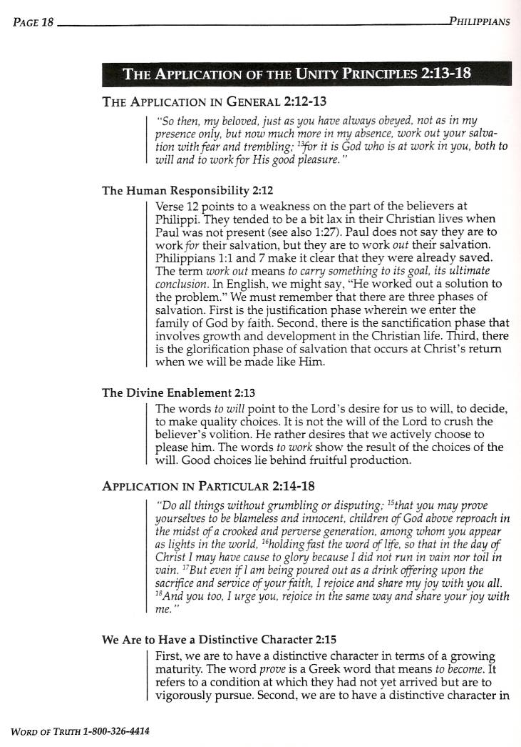
Philippians 2:12, 13 is not about working for our salvation, nor our responsibility to see to it that our salvation that was begun by God is carried through to the end by our own work, but rather about our part in sanctification – spiritual growth and maturity – which God not only accomplished entirely apart from our efforts, but He wishes to carry that salvation to completion by His own working in and through us.

Chester MCalley’s excellent insights into Philippians 2:12 and 13 are given in the text box to the left.

2 Timothy 2:12
If we endure, we will also reign with Him; if we deny Him, He also will deny us;

First, we should add that the entire sentence reads as follows:

2 Timothy 2:11-13
It is a trustworthy statement:

For if we died with Him, we will also live with Him;
12 If we endure, we will also reign with Him;
If we deny Him, He also will deny us;
13 If we are faithless, He remains faithful, for He cannot deny Himself.

There are some critical insights into this passage that must first be gained in order to understand what Paul is saying:

- The “we died with Him” and “we will also live with Him” are both statements of identification truths that we who believe have been identified with Christ in His death and resurrection. What we have said already about the identification truths is that the identification truths are all one way: they point to the permanence and irreversibility of our position in Christ, with not even a threat of reversal.

- The “if” in each part of the verse is in an ‘assumed to be true’ grammatical form. So these “if”s in this passage are not to be taken as a mere possibility, with threatened consequences if the possibility happens to be true for one individual or another.

The above being the case, we can put 2 Timothy 2:11-13 in expanded and explained form:

2 Timothy 2:11-13
It is a trustworthy statement, which Paul wrote repeatedly to both Timothy and Titus as absolutely true and exceedingly valuable in ministry:

For if we, having been identified with Him, died with Him, which is most certainly true
we will also live with Him; having been identified with Him in His resurrection, ascension and seating, which is also most certainly true;

12 and if we endure, as is also certainly the case, we will also reign with Him, having been seated with Him in the heavenlies already;
If we deny Him, as we will do at times, even though we have an eternal relationship with Him, He also will deny us fellowship at those moments that we deny Him – not that this is His desire;

13 If we are faithless, and we will be faithless at times, not believing God for moments of time, He still remains faithful always and forever even during those times, for He cannot deny Himself, since He is eternally of the same character and true to His promises as the Promise Keeper.
Hebrews 6:4-6
For in the case of those who have once been enlightened and have tasted of the heavenly gift and have been made partakers of the Holy Spirit, 5 and have tasted the good word of God and the powers of the age to come, 6 and then have fallen away, it is impossible to renew them again to repentance, since they again crucify to themselves the Son of God and put Him to open shame.

1 John 3
See how great a love the Father has bestowed on us, that we would be called children of God; and such we are. For this reason the world does not know us, because it did not know Him. 2 Beloved, now we are children of God, and it has not appeared as yet what we will be. We know that when He appears, we will be like Him, because we will see Him just as He is. 3 And everyone who has this hope fixed on Him purifies himself, just as He is pure.

4 Everyone who practices sin also practices lawlessness; and sin is lawlessness. 5 You know that He appeared in order to take away sins; and in Him there is no sin. 6 No one who abides in Him sins; no one who sins has seen Him or knows Him. 7 Little children, make sure no one deceives you; the one who practices righteousness is righteous, just as He is righteous; 8 the one who practices sin is of the devil; for the devil has sinned from the beginning. The Son of God appeared for this purpose, to destroy the works of the devil. 9 No one who is born of God practices sin, because His seed abides in him; and he cannot sin, because he is born of God. 10 By this the children of God and the children of the devil are obvious: anyone who does not practice righteousness is not of God, nor the one who does not love his brother.

11 For this is the message which you have heard from the beginning, that we should love one another; 12 not as Cain, who was of the evil one and slew his brother. And for what reason did he slay him? Because his deeds were evil, and his brother's were righteous.

13 Do not be surprised, brethren, if the world hates you. 14 We know that we have passed out of death into life, because we love the brethren. He who does not love abides in death. 15 Everyone who hates his brother is a murderer; and you know that no murderer has eternal life abiding in him. 16 We know love by this, that He laid down His life for us; and we ought to lay down our lives for the brethren. 17 But whoever has the world's goods, and sees his brother in need and closes his heart against him, how does the love of God abide in him? 18 Little children, let us not love with word or with tongue, but in deed and truth. 19 We will know by this that we are of the truth, and will assure our heart before Him 20 in whatever our heart condemns us; for God is greater than our heart and knows all things. 21 Beloved, if our heart does not condemn us, we have confidence before God; 22 and whatever we ask we receive from Him, because we keep His commandments and do the things that are pleasing in His sight.

23 This is His commandment, that we believe in the name of His Son Jesus Christ, and love one another, just as He commanded us. 24 The one who keeps His commandments abides in Him, and He in him. We know by this that He abides in us, by the Spirit whom He has given us.

(but they don't want to talk about any of the other chapters)

Revelation chapters 2-3

The overcomer passages, but they don't want to talk about anything else John ever wrote

Known as the kingdom of God, or the kingdom of heaven.
http://hollyhillsbiblechurch.org/media/Sermon-on-the-Mount_57/handout/03-The-Concept_How-do-we-approach-the-Sermon.doc. See especially pages 3-5.

