Q&A 21: What happens to our bodies after we die?

A:

This question directly addresses how our present body is changed into our new body. Alongside this question is how this present body is changed into our new body if we die physically, and how is that different from how the present body is changed into the new body for the believer who is alive at the time of the rapture. The next question that is implied after this one is, “What will our new bodies by like?”, which is Q&A 22.

Let’s step our way through what Scripture reveals.

We do know there is a resurrection, as the apostle Paul explains for us in 1 Corinthians 15:35-44:

35 But someone will say, "How are the dead raised? And with what kind of body do they come?" 36 You fool! That which you sow does not come to life unless it dies; 37 and that which you sow, you do not sow the body which is to be, but a bare grain, perhaps of wheat or of something else. 38 But God gives it a body just as He wished, and to each of the seeds a body of its own. 39 All flesh is not the same flesh, but there is one flesh of men, and another flesh of beasts, and another flesh of birds, and another of fish. 40 There are also heavenly bodies and earthly bodies, but the glory of the heavenly is one, and the glory of the earthly is another. 41 There is one glory of the sun, and another glory of the moon, and another glory of the stars; for star differs from star in glory.

42 So also is the resurrection of the dead. It is sown a perishable body, it is raised an imperishable body; 43 it is sown in dishonor, it is raised in glory; it is sown in weakness, it is raised in power; 44 it is sown a natural body, it is raised a spiritual body. If there is a natural body, there is also a spiritual body.

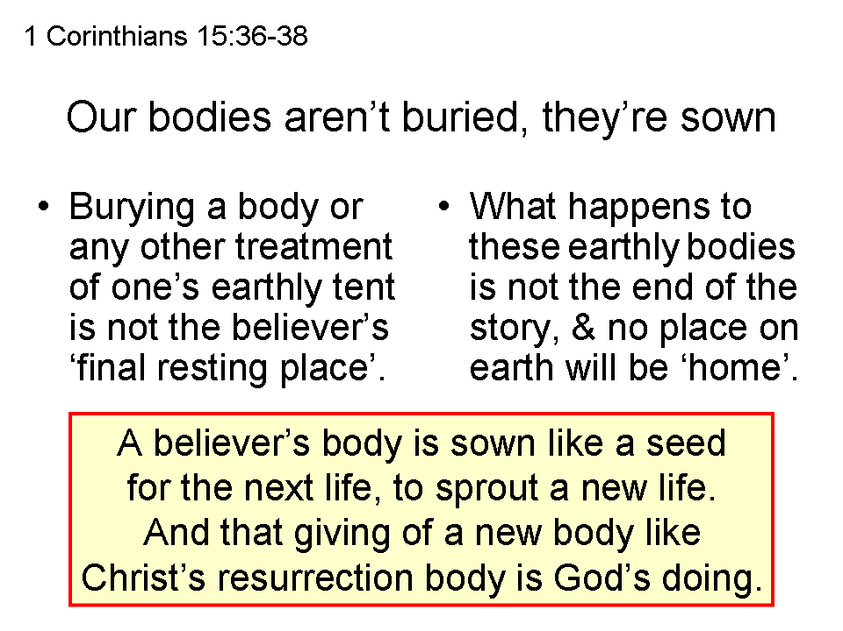
For a more complete explanation of this passage, see the handout and audio for the message on the HHBC website, “33 1 Corinthians 15:35-49 – Where are you from?” Briefly, though, we can say that the present human body is different in kind than the believer’s new body will be, but that the present body is not abandoned and simply replaced by an entirely new substitute body, but that the material that constitutes the present physical human body is changed into the spiritual body that we will have for eternity. In that sense the present human body is not simply buried at death, but is rather sown, from which the new spiritual body will be made. See slide insert above.
Farther along in that same passage, Paul says that the believer’s body will be changed:

1 Corinthians 15:50-57
Now I say this, brethren, that flesh and blood cannot inherit the kingdom of God; nor does the perishable inherit the imperishable. 51 Behold, I tell you a mystery; we will not all sleep, but we will all be changed, 52 in a moment, in the twinkling of an eye, at the last trumpet; for the trumpet will sound, and the dead will be raised imperishable, and we will be changed. 53 For this perishable must put on the imperishable, and this mortal must put on immortality. 54 But when this perishable will have put on the imperishable, and this mortal will have put on immortality, then will come about the saying that is written, "Death is swallowed up in victory. 55 "O Death, where is your victory? O Death, where is your sting?" 56 The sting of death is sin, and the power of sin is the law; 57 but thanks be to God, who gives us the victory through our Lord Jesus Christ.

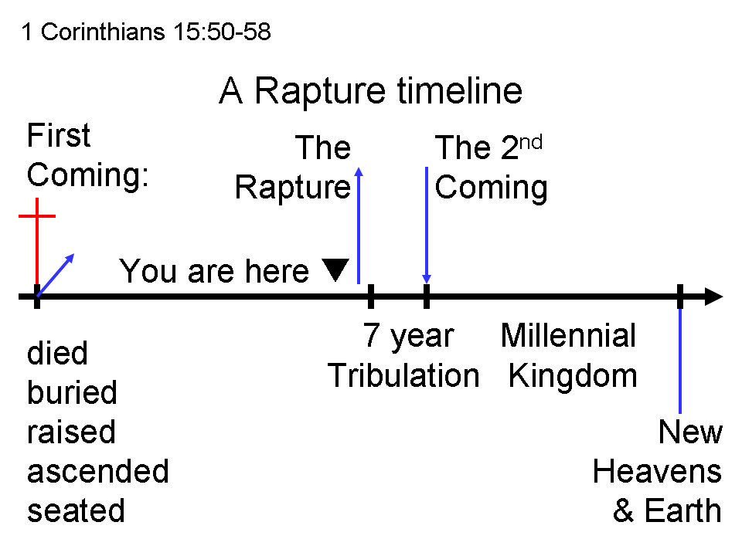
The change that the Lord will bring about will take place in the future – perhaps soon – but when it takes place, it will happen in an instant. What has been termed the rapture (an English word based in Latin that is not in the Bible, but is taught in the passage above and in the passage that we will look at next – see chart to the left). The above passage is explained in more detail in a handout and an audio message on the HHBC website, “34 1 Corinthians 15:50-58 – I tell you a mystery”.

Paul tells us that at that time, we who believe, of the body of Christ, the church, will be taken up to be with Christ, at a time of the Father’s choosing that he describes like this:

1 Thessalonians 4:13-18
But we do not want you to be uninformed, brethren, about those who are asleep, so that you will not grieve as do the rest who have no hope. 14 For if we believe that Jesus died and rose again, even so God will bring with Him those who have fallen asleep in Jesus. 15 For this we say to you by the word of the Lord, that we who are alive and remain until the coming of the Lord, will not precede those who have fallen asleep. 16 For the Lord Himself will descend from heaven with a shout, with the voice of the archangel and with the trumpet of God, and the dead in Christ will rise first. 17 Then we who are alive and remain will be caught up together with them in the clouds to meet the Lord in the air, and so we shall always be with the Lord. 18 Therefore comfort one another with these words.

The above passage dovetails with the 1 Corinthians 15:50-57 passage quoted above, giving some of the same information as the 1 Corinthians 15:5-57 passage, and also some additional details. One of those details is that those who have died in the Lord will rise first. Another is that the Lord Himself will descend from heaven to catch us all up to be with Him, and bring the raptured church – those asleep in the Lord and those alive at the time - to heaven with Him, so that we shall always be with the Lord. So these passages describe the change from these present earthly bodies to those bodies that we will have.
And it is a comfort to know these things, isn’t it!?

Now there is confirmation that the present human body of a believer will not simply be replaced by another altogether, but rather that the present human body will be changed. This confirmation comes in two forms:

Colossians 1:18
He is also head of the body, the church; and He is the beginning, the firstborn from the dead, so that He Himself will come to have first place in everything.

So Christ’s resurrection is the first – the prototype of our own resurrections. And in Christ’s resurrection His body was not just newly created and the old one left in place, but rather His resurrected body was made from the physical human body that was wrapped in burial cloths but was miraculously removed, leaving the cloths in place:

John 20:1-8
Now on the first day of the week Mary Magdalene came early to the tomb, while it was still dark, and saw the stone already taken away from the tomb. 2 So she ran and came to Simon Peter and to the other disciple whom Jesus loved, and said to them, "They have taken away the Lord out of the tomb, and we do not know where they have laid Him." 3 So Peter and the other disciple went forth, and they were going to the tomb. 4 The two were running together; and the other disciple ran ahead faster than Peter and came to the tomb first; 5 and stooping and looking in, he saw the linen wrappings lying there; but he did not go in. 6 And so Simon Peter also came, following him, and entered the tomb; and he saw the linen wrappings lying there, 7 and the face-cloth which had been on His head, not lying with the linen wrappings, but rolled up in a place by itself. 8 So the other disciple who had first come to the tomb then also entered, and he saw and believed.

Christ’s resurrection was not like that of Lazarus’ resurrection a week earlier, who had to be unwrapped by others, when Jesus raised Lazarus back to this present life, with a body like our present mortal bodies (John 11:1-44). At some point Lazarus, living again in this present human body, would die again.

Q&A 22: What will our new bodies be like?

Now we move on to the question that grows out of the first one. The believer’s new body will be different from the present body, even though made from the material of the present body. There will be a miraculous change form the present human form of body to the new one. But how will the new body be different – what does God reveal to us about the characteristics of this new body?

We talked about Christ’s resurrection body being the prototype of the believer’s new body. In addition to the passages shown above, we also know that we will be like Him:

1 John 3:2
2 Beloved, now we are children of God, and it has not appeared as yet what we will be. We know that when He appears, we will be like Him, because we will see Him just as He is.

Yet, though we know we will be like Him, we don’t know exactly what that will be. We have some clues, based on what happened in the case of Christ’s resurrection, and how Jesus appeared before His ascension:

John 20:1
Now on the first day of the week Mary Magdalene came early to the tomb, while it was still dark, and saw the stone already taken away from the tomb.

The stone was gone, but apparently that was only so we would know He had risen, because just a short time later, in John 20:19-20 we read:

So when it was evening on that day, the first day of the week, and when the doors were shut where the disciples were, for fear of the Jews, Jesus came and stood in their midst and said to them, " Peace be with you."

Jesus could apparently enter through walls without doors being opened. He could talk to His disciples – so He still was quite able to communicate in a language they could hear and understand. We see in a subsequent account, events taking place just a short time later:

John 21:1-6.
After these things Jesus manifested Himself again to the disciples at the Sea of Tiberias, and He manifested Himself in this way. 2 Simon Peter, and Thomas called Didymus, and Nathanael of Cana in Galilee, and the sons of Zebedee, and two others of His disciples were together. 3 Simon Peter said to them, "I am going fishing." They said to him, "We will also come with you." They went out and got into the boat; and that night they caught nothing.

4 But when the day was now breaking, Jesus stood on the beach; yet the disciples did not know that it was Jesus. 5 So Jesus said to them, "Children, you do not have any fish, do you?" They answered Him, "No." 6 And He said to them, "Cast the net on the right-hand side of the boat and you will find a catch." So they cast, and then they were not able to haul it in because of the great number of fish.

Then we see that it appears Jesus could eat if He so desired:

John 21:12
Jesus said to them, "Come and have breakfast."
John 21:15
So when they had finished breakfast, Jesus said to Simon Peter, "Simon, son of John, do you love Me more than these?"

This is more by implication than statement, so we can’t be 100% positive from this account, but it does seem at least quite possible that He was eating among them.

It does seem that all the usual constraints were set aside unless He wanted to use them – He could walk through walls and disappear at will, He also could stand on the floor of the upper room and cook breakfast for them on the beach at the Sea. But when it came time for Christ to ascend, this is the description that we read:

Acts 1:6-9
So when they had come together, they were asking Him, saying, "Lord, is it at this time You are restoring the kingdom to Israel?" 7 He said to them, "It is not for you to know times or epochs which the Father has fixed by His own authority; 8 but you will receive power when the Holy Spirit has come upon you; and you shall be My witnesses both in Jerusalem, and in all Judea and Samaria, and even to the remotest part of the earth."
9 And after He had said these things, He was lifted up while they were looking on, and a cloud received Him out of their sight.

But will there be male and female, and marriage, in our new bodies?

Jesus answers this question in the course of answering a different question.

Matthew 22:23-33
On that day some Sadducees (who say there is no resurrection) came to Jesus and questioned Him, 24 asking, "Teacher, Moses said, 'If a man dies having no children, his brother as next of kin shall marry his wife, and raise up children for his brother.' 25 "Now there were seven brothers with us; and the first married and died, and having no children left his wife to his brother; 26 so also the second, and the third, down to the seventh. 27 "Last of all, the woman died. 28 "In the resurrection, therefore, whose wife of the seven will she be? For they all had married her."

29 But Jesus answered and said to them, "You are mistaken, not understanding the Scriptures nor the power of God. 30 "For in the resurrection they neither marry nor are given in marriage, but are like angels in heaven. 31 "But regarding the resurrection of the dead, have you not read what was spoken to you by God: 32' I AM the God of Abraham, and the God of Isaac, and the God of Jacob'? He is not the God of the dead but of the living."

It is verse 30 in this context that answers our question most directly. Our new bodies will not have male and female, at least such as to be married or reproduce in them. Marriage on this earth will be superseded in heaven by the romance of Christ and the church, the eternal model for Christian marriage in time.

(http://hollyhillsbiblechurch.org/?page_id=63&series_id=93).
(http://hollyhillsbiblechurch.org/?page_id=63&series_id=93).

