Q&A 31: What does the Bible teach about covenants?

A:

Introduction to covenants in the Bible

Covenants are found in both the Old and New Testaments, between:

- Persons of the Trinity
- God and mankind
- One man and another

Covenants are either unilateral (“I will do this…”), or bilateral (“I will do this, and you will do that”).

Covenants are either conditional (“If you do this, then I will do that, but if you don’t do this, then I will bring about a different outcome”) or unconditional (“I will do this regardless of what you do or don’t do”).

Covenants are either limited in duration (as must be the case between two humans), or they are not limited in duration (as only God can fully carry out).

Covenants can be either earthly (physical) in subject matter or they can be spiritual in subject matter, or a combination of those two.

Covenants commonly had three elements: 1) an oath, 2) swearing by a deity, and 3) a physical gesture or sign. This is seen multiple times in Genesis. For example see:

- Genesis 9:9-17 (God swears by Himself, “I Myself will make this covenant”)
- Genesis 21:22-34
- Genesis 24:1-9
- Genesis 26:26-33
- Genesis 31:43-54

It is the swearing by a deity, and the confirming sign that makes a covenant differ from a conventional human contract, along with the possibility that the covenant may be endless.

While there are numerous examples of one person making a covenant with another person (such as Abraham and Abimelech, in Genesis 21:27-31), we will focus from here forward on those covenants in which God is a ‘party’ to the covenant, since those are most significant. Take note that God can act within a covenant, or can act outside a covenant.

Additionally, we will also focus particular and greater attention on those covenants that have a particular impact upon or issue regarding the church (present on earth from Acts 2 to the rapture).
The biblical covenants - the quick summary

Between the Father & the Son, impacting Christ and all mankind:

- Eternal Covenant (Hebrews 13:20)

With Adam, impacting Adam & all mankind:

- Edenic Covenant (Genesis 1:26-31; 2:16-17; Hosea 6:7)
- Adamic Covenant (Genesis 3:14-19; consequences of Adam breaking the Edenic Covenant)

With Noah, impacting Noah and all subsequent mankind:

- Noahic Covenant (Genesis 9:1-17)

With Abraham, impacting his descendents through Isaac and Jacob, then all mankind:

- Abrahamic Covenant (12:1-3,7; 13:14-18; 15:1-21; 17:1-21 - and that's the short list!)

With a representative of or all of Israel, impacting Israel:

- Mosaic Covenant (Exodus 20:1-31:18; Psalm 147:20)
- Palestinian (Land) Covenant (Deuteronomy 28:1-68; 30:1-10)
- Davidic Covenant (2 Samuel 7:4-17; 1 Chronicles 17:4-15)
- New Covenant (Isaiah 44:3-5; 55:2-3; 59:21; Jeremiah 31:31-33; Ezekiel 36 & 37)

Now let’s pursue each of these covenants in a bit more detail:

The Eternal Covenant

The eternal covenant, taken from Hebrews 13:20, would be between the Father and the Son, also involving the Holy Spirit, would be regarding the incarnation, death and resurrection of Christ, and impacting Christ as the God / Man, with results for all mankind:

Hebrews 13:20-21
Now the God of peace, who brought up from the dead the great Shepherd of the sheep through the blood of the eternal covenant, even Jesus our Lord, 21 equip you in every good thing to do His will, working in us that which is pleasing in His sight, through Jesus Christ, to whom be the glory forever and ever. Amen.

Now some have said (Constable, Kent, et al) that the eternal covenant is the New Covenant, since it is an eternal covenant, but 1) there are a few covenants that are eternal, in the sense that they are lasting, as we shall soon see, and 2) there would have to have been eternal agreement between the Persons of the Trinity about Christ’s incarnation, death and resurrection – even from eternity past.

Edenic Covenant

The Edenic covenant was with Adam, impacting Adam and consequently all mankind:

Genesis 1:26-31
Then God said, "Let Us make man in Our image, according to Our likeness; and let them rule over the fish of the sea and over the birds of the sky and over the cattle and over all the earth, and over every creeping thing that creeps on the earth." 27 God created man in His own image, in the image of God He created him; male and female He created them. 28 God blessed them; and God said to them, "Be fruitful and multiply, and fill the earth, and subdue it; and rule over the fish of the sea and over the birds of the sky and over every living thing that moves on the earth." 29 Then God said, "Behold, I have given you every plant yielding seed that is on the surface of all the earth, and every tree which has fruit yielding seed; it shall be food for you; 30 and to every beast of the earth and to every bird of the sky and to every thing that moves on the earth which has life, I have given every green plant for food"; and it was so. 31 God saw all that He had made, and behold, it was very good. And there was evening and there was morning, the sixth day.

Genesis 2:15-17
Then the LORD God took the man and put him into the garden of Eden to cultivate it and keep it. 16 The LORD God commanded the man, saying, "From any tree of the garden you may eat freely; 17 but from the tree of the knowledge of good and evil you shall not eat, for in the day that you eat from it you will surely die."

Hosea 6:7
But like Adam they have transgressed the covenant; there they have dealt treacherously against Me.

The Edenic Covenant was spoken from God to Adam, was conditional, and was limited to the time from when God gave Adam instructions as to what to do and not to do, until Adam broke the covenant, which required a radical modification of the Edenic Covenant, known as the Adamic Covenant, consisting of consequences for breaking the Edenic Covenant.

Adamic Covenant

Adamic Covenant consists of God’s radical modifications of the Edenic Covenant, plus some additions to the Edenic Covenant:

Genesis 3:8-24
They heard the sound of the LORD God walking in the garden in the cool of the day, and the man and his wife hid themselves from the presence of the LORD God among the trees of the garden. 9 Then the LORD God called to the man, and said to him, "Where are you?" 10 He said, "I heard the sound of You in the garden, and I was afraid because I was naked; so I hid myself." 11 And He said, "Who told you that you were naked? Have you eaten from the tree of which I commanded you not to eat?" 12 The man said, "The woman whom You gave to be with me, she gave me from the tree, and I ate." 13 Then the LORD God said to the woman, "What is this you have done?" And the woman said, "The serpent deceived me, and I ate." 14 The LORD God said to the serpent, "Because you have done this, cursed are you more than all cattle, and more than every beast of the field; on your belly you will go, and dust you will eat all the days of your life; 15 and I will put enmity between you and the woman, and between your seed and her seed; He shall bruise you on the head, and you shall bruise him on the heel." 16 To the woman He said, "I will greatly multiply Your pain in childbirth, in pain you will bring forth children; yet your desire will be for your husband, and he will rule over you." 17 Then to Adam He said, "Because you have listened to the voice of your wife, and have eaten from the tree about which I commanded you, saying, 'You shall not eat from it'; cursed is the ground because of you; in toil you will eat of it all the days of your life. 18 "Both thorns and thistles it shall grow for you; and you will eat the plants of the field; 19 By the sweat of your face You will eat bread, till you return to the ground, because from it you were taken; for you are dust, and to dust you shall return."

20 Now the man called his wife's name Eve, because she was the mother of all the living. 21 The LORD God made garments of skin for Adam and his wife, and clothed them.
22 Then the LORD God said, "Behold, the man has become like one of Us, knowing good and evil; and now, he might stretch out his hand, and take also from the tree of life, and eat, and live forever"-- 23 therefore the LORD God sent him out from the garden of Eden, to cultivate the ground from which he was taken. 24 So He drove the man out; and at the east of the garden of Eden He stationed the cherubim and the flaming sword which turned every direction to guard the way to the tree of life.

While a great deal more could be said of the Adamic Covenant, note that Genesis 3:15 is a gracious part of the Adamic Covenant that relates to several other covenants, in that it foretells Christ’s death on the cross, and His resurrection.

Noahic Covenant

This covenant was with Noah directly, and having an impact on Noah, his extended family, and all subsequent mankind:

Genesis 9:1-17
And God blessed Noah and his sons and said to them, "Be fruitful and multiply, and fill the earth. 2 The fear of you and the terror of you will be on every beast of the earth and on every bird of the sky; with everything that creeps on the ground, and all the fish of the sea, into your hand they are given. 3 Every moving thing that is alive shall be food for you; I give all to you, as I gave the green plant. 4 Only you shall not eat flesh with its life, that is, its blood. 5 Surely I will require your lifeblood; from every beast I will require it. And from every man, from every man's brother I will require the life of man."

6 "Whoever sheds man's blood, by man his blood shall be shed, for in the image of God
He made man. 7 As for you, be fruitful and multiply; populate the earth abundantly and multiply in it."
8 Then God spoke to Noah and to his sons with him, saying, 9 "Now behold, I Myself do establish My covenant with you, and with your descendants after you; 10 and with every living creature that is with you, the birds, the cattle, and every beast of the earth with you; of all that comes out of the ark, even every beast of the earth. 11 "I establish My covenant with you; and all flesh shall never again be cut off by the water of the flood, neither shall there again be a flood to destroy the earth." 12 God said, "This is the sign of the covenant which I am making between Me and you and every living creature that is with you, for all successive generations; 13 I set My bow in the cloud, and it shall be for a sign of a covenant between Me and the earth. 14 "It shall come about, when I bring a cloud over the earth, that the bow will be seen in the cloud, 15 and I will remember My covenant, which is between Me and you and every living creature of all flesh; and never again shall the water become a flood to destroy all flesh. 16 "When the bow is in the cloud, then I will look upon it, to remember the everlasting covenant between God and every living creature of all flesh that is on the earth." 17 And God said to Noah, "This is the sign of the covenant which I have established between Me and all flesh that is on the earth."

The terms of the Noahic Covenant, from the time it was made, continue until the end of this present heavens and earth (2 Peter 3:10-13; Revelation 21:1).

Abrahamic Covenant

God made a covenant with Abraham (first called Abram), impacting his descendents through Isaac and Jacob, then all mankind. The Abrahamic Covenant is given in Genesis 12:1-3,7; 13:14-18; 15:1-21; 17:1-21 - and that's the short list! We’ll shortly see a more complete listing.

Genesis 12:1-7
Now the LORD said to Abram [later to be called Abraham], "Go forth from your country, and from your relatives and from your father's house, to the land which I will show you; 2 and I will make you a great nation, and I will bless you, and make your name great; and so you shall be a blessing; 3 and I will bless those who bless you, and the one who curses you I will curse. and in you all the families of the earth will be blessed."

4 So Abram went forth as the LORD had spoken to him; and Lot went with him. Now Abram was seventy-five years old when he departed from Haran. 5 Abram took Sarai his wife and Lot his nephew, and all their possessions which they had accumulated, and the persons which they had acquired in Haran, and they set out for the land of Canaan; thus they came to the land of Canaan. 6 Abram passed through the land as far as the site of Shechem, to the oak of Moreh. Now the Canaanite was then in the land. 7 The LORD appeared to Abram and said, "To your descendants I will give this land." So he built an altar there to the LORD who had appeared to him.

Although God doesn’t call what He made with Abraham ‘a covenant’ until Genesis 15:18, the number of times that God reiterates, details, and explains His covenant with Abraham is really quite remarkable.
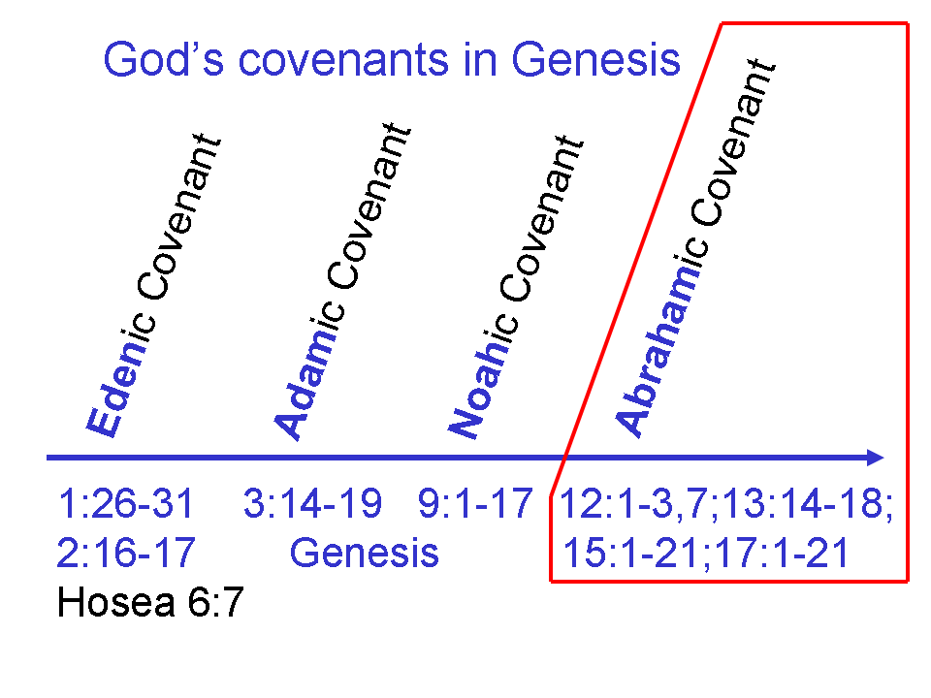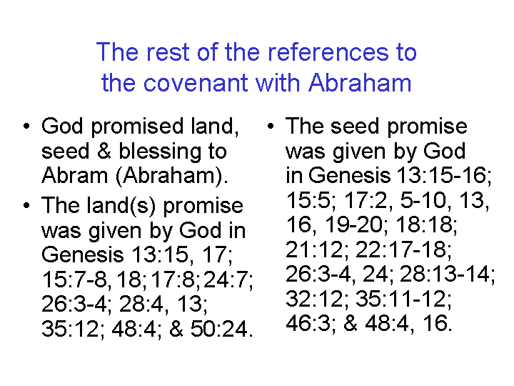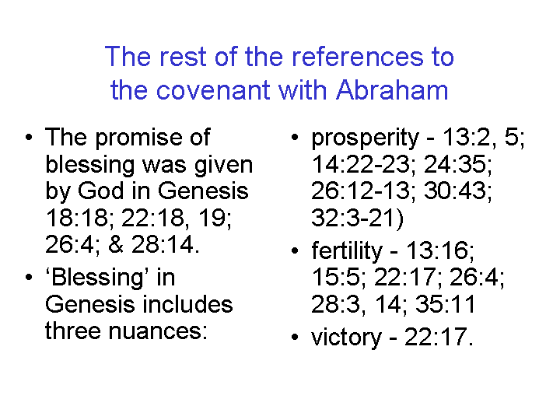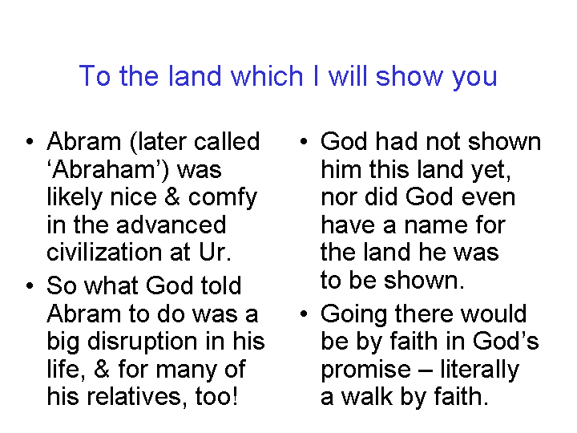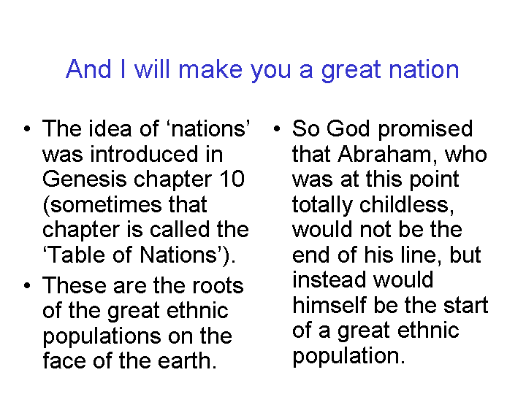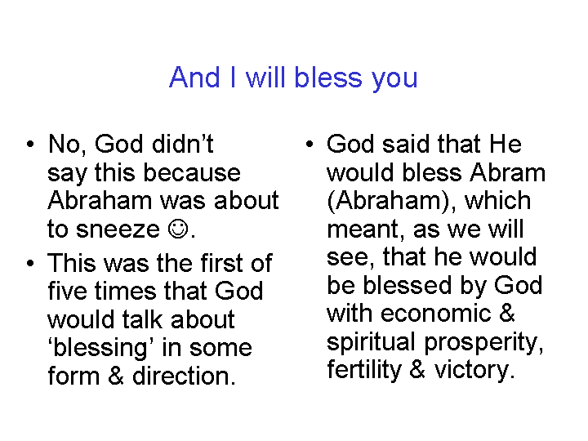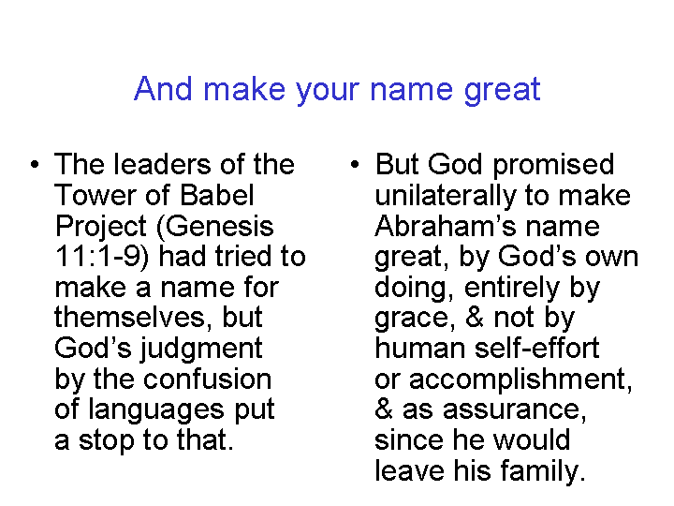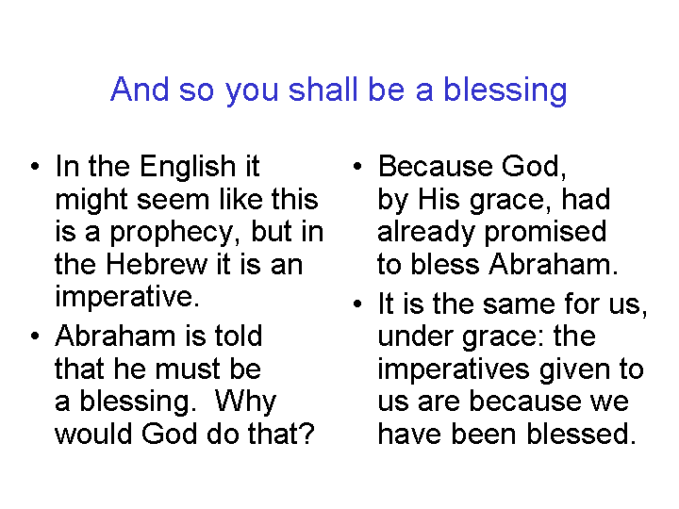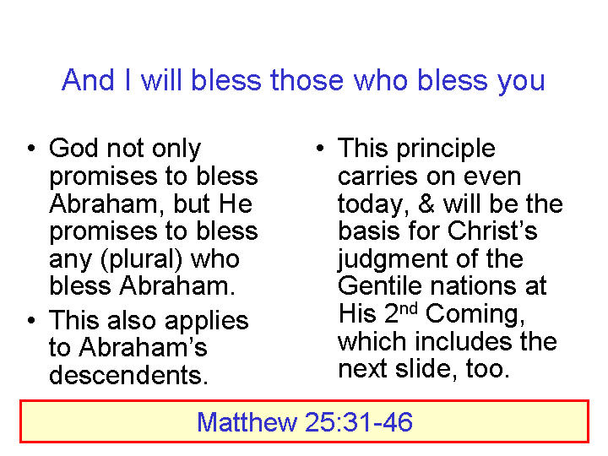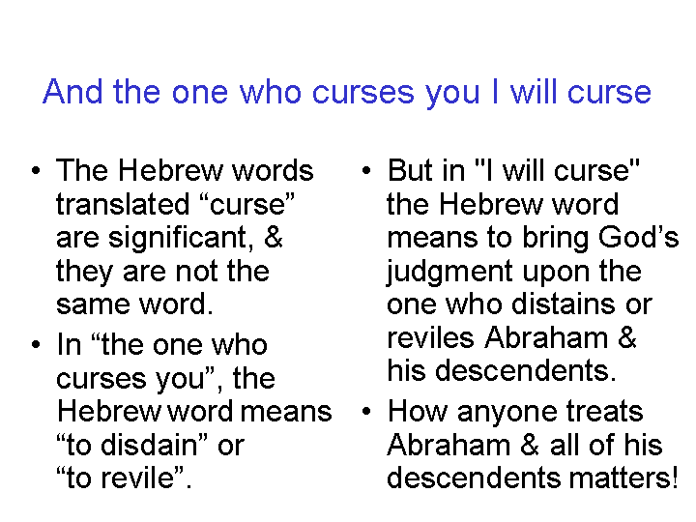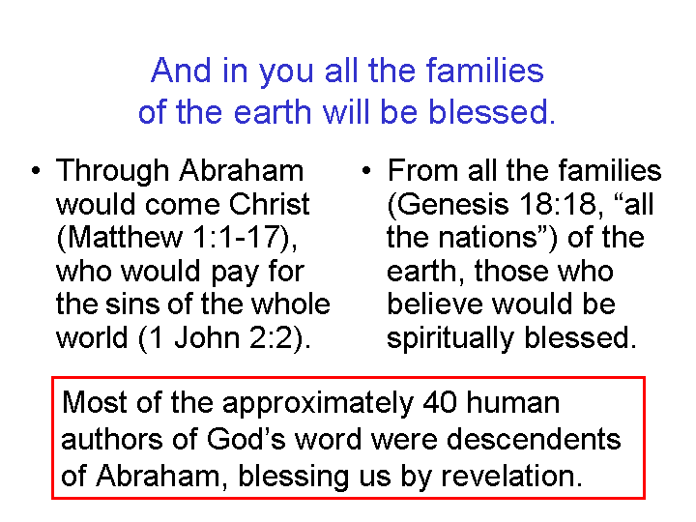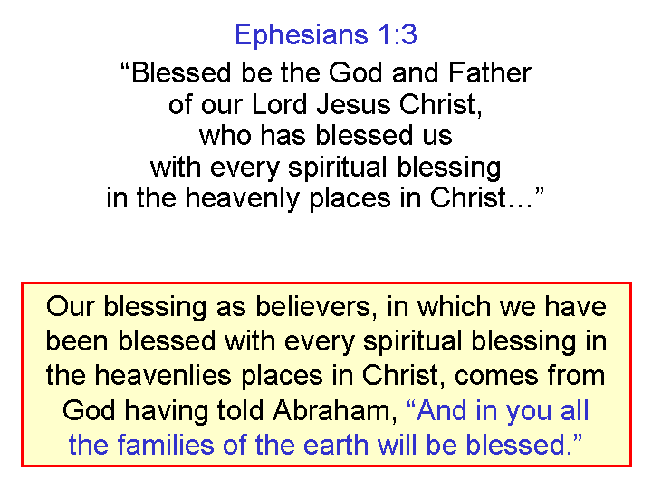

We will find that the next four covenants will be with Israel, or a representative of Israel, all of whom are descendents of Abraham, through the lineage of Isaac and Jacob.

Mosaic Covenant

The Mosaic Covenant, the foundation for which is given in Exodus 20:1-31:18 is the Law of Moses. While we will not quote major sections of it, because of its size, we can summarize and reference some of its key features:

- The Law of Moses contains 613 laws, 365 of which were things not to do.
- The Law of Moses was given only to the people of Israel, and not to any other people (Psalm 147:20) to adopt or to pick and choose from, or to alter in any way (Galatians 5:3; James 2:10).
- The Law of Moses reflects God’s character, including His moral character.

The Palestinian (Land) Covenant

The Law of Moses was written for the people of Israel who were to live in the land of Israel – if they obeyed the Law of Moses. But the people of Israel were to keep the whole law in order to determine their blessings in the land, including that they remain in the land, or curses, whether cursed in the land or cursed by being ejected from the land, along with other curses (Deuteronomy 28:1-68; 30:1-10).
Davidic Covenant

The Davidic Covenant was God’s promise to Israel’s King David through the prophet Nathan that there would be a descendant ‘from the house of David’, seated on the throne of David, to reign over the kingdom of Israel forever (2 Samuel 7:4-17; 1 Chronicles 17:4-15; Psalm 89:1-4). These features were reiterated by the angel Gabriel to Mary, the descendant of David, who would be the mother of Jesus:

Luke 1:26-33
Now in the sixth month the angel Gabriel was sent from God to a city in Galilee called Nazareth, 27 to a virgin engaged to a man whose name was Joseph, of the descendants of David; and the virgin's name was Mary. 28 And coming in, he said to her, "Greetings, favored one! The Lord is with you." 29 But she was very perplexed at this statement, and kept pondering what kind of salutation this was. 30 The angel said to her, "Do not be afraid, Mary; for you have found favor with God. 31 "And behold, you will conceive in your womb and bear a son, and you shall name Him Jesus. 32 "He will be great and will be called the Son of the Most High; and the Lord God will give Him the throne of His father David; 33 and He will reign over the house of Jacob forever, and His kingdom will have no end."

The fulfillment of the Davidic Covenant will ultimately be in the yet-to-come Millennial Kingdom on this present earth (Revelation 20), and in the New Jerusalem (Revelation 21 and 22), when Christ shall reign as King of Israel, and King of Kings and Lord of Lords over the Gentile nations.

New Covenant

The New Covenant was given explicitly to Israel with the following key features (Isaiah 44:3-5; 55:2-3; 59:21; Jeremiah 31:31-33; Ezekiel 36 and 37):

The people of Israel would be empowered by a continuous, universal indwelling of the Holy Spirit to live out the Law of Moses from the heart, in the land of Israel, without need of a teacher, and so be blessed in all the ways given in the Palestinian Covenant, with a focus upon earthy blessings.

The descriptions of the earthly blessings that Israel will have under the New Covenant are conveyed in many passages of the Old Testament prophets, including the book of Isaiah.

What’s coming next?

We will next address what relationship the church has with the New Covenant, and more particularly, what relationship Christ has with all of the covenants. Additionally, we will show the connections between the Covenants and the Stewardships.

