Q&A 36: How many were in the Exodus and how did they and the livestock survive?

A:
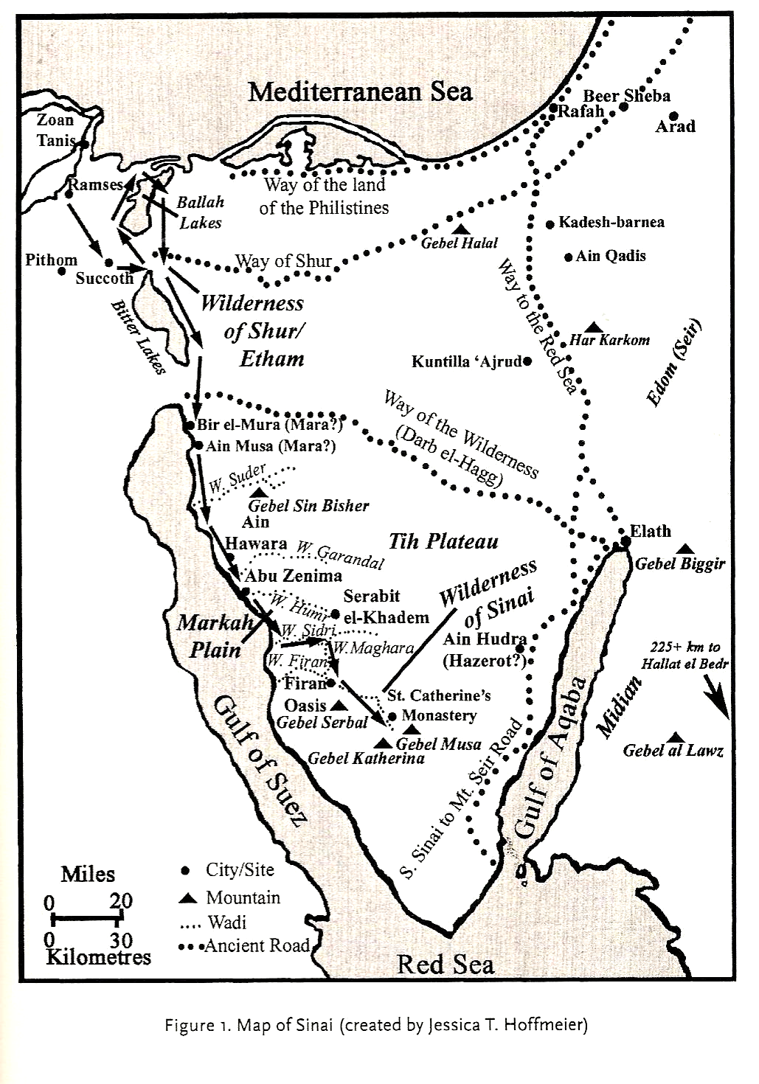
Estimates of the number of Israelites during the Exodus fall at about two million individuals, with some estimates higher or lower, depending upon the assumptions one makes alongside the available biblical data (Exodus 12:37; 38:26; Numbers 1:45-47).
Exodus map by Hoffmeier, Israel in the Sinai

The Sinai Peninsula is certainly limited in water and food resources that would be required to support the Israelite population. So for someone to ask the question given above is quite reasonable.

Annual precipitation in the Sinai varies, of course, but Eerdman’s Bible Dictionary summarizes the three regions of precipitation this way:

(1) a northern plain of sand dunes and gravel near the Mediterranean coast, with rainfall of 7.5-10 cm. (3-4 in.); (2) the large central et-Tih plateau, drained by the el-Arish system, covered with chalk and flint toward the center and limestone toward the south, with rainfall of 2.5-5 cm. (1-2 in.); (3) the high granite mountains of the south, including Jebel Mûsã, the traditional Mt. Sinai, at 2285 m. (7296 ft.), with rainfall at 7.5-10 cm. (3-4 in.).

Those figures are for the present climate, though there is some evidence that the climate was a bit wetter in the past. Desertification of the Sinai took place in the 17th and 18th centuries AD that makes current estimates of the resources in the Sinai lower than they would have been at the time of the Exodus.
There are desert oases here and there along the way, but in the areas in between those oases the vegetation and water supply are likely to be sparse. So the general approach would have been to stay near the oases, and move quickly between them, carrying some reserves.

There are evidences of God’s extraordinary or miraculous provision for the Israelites in both food (Exodus 16 and Numbers 11) and water (Exodus 15 and 17). And it is at least possible, if not likely, that the Lord may have made additional provisions of this kind which are not recorded. Manna appears to have been a long-term provision until the Israelites entered Canaan.

Q&A 37: Is Exodus 21:7-11 sexist and biased against women?

A:

When reading the Bible, it is exceedingly important to understand context. Part of the context is within the Bible itself, and part of that context is history and culture. One of the patterns in the Law of Moses was to set limits and constraints on the Israelites so they would not be like the cultures around them – the Law of Moses would set them apart.
Exodus 21:7-11
"If a man sells his daughter as a female slave, she is not to go free as the male slaves do. 8 "If she is displeasing in the eyes of her master who designated her for himself, then he shall let her be redeemed. He does not have authority to sell her to a foreign people because of his unfairness to her. 9 "If he designates her for his son, he shall deal with her according to the custom of daughters. 10 "If he takes to himself another woman, he may not reduce her food, her clothing, or her conjugal rights. 11 "If he will not do these three things for her, then she shall go out for nothing, without payment of money.

For example, the cultures surrounding the Israelites were largely cultures of revenge for the sake of family honor: take revenge greater than the damage done to yourself or your family. So the Law of Moses set a limit on punishments that prevented escalation of revenge and continuation of revenge: an eye for an eye, a tooth for a tooth. The Law of Moses was, in this way, more merciful.

So passages like Exodus 21:7-11 should be viewed not as permitting only a daughter to be sold into slavery, but setting limitations as to minimum fair treatment. There were male slaves who were sold into slavery as well (Exodus 21:7, 20). Further, if these laws applied to a daughter sold into slavery, then, the rabbis reasoned, they also applied to other daughters as well, at least as a minimum of fair treatment – they certainly were to be treated just as fairly.

Scripture does not present the males and females as total equals in roles and rights, as if the gender distinction didn’t matter, but Scripture does set standards in place so as to avoid considering the woman as anything less than the man as a person, and to prevent unequal justice:

Jesus stood up for the woman caught in adultery, at least in part because the Law of Moses said that both the man and woman were to be brought to justice (Leviticus 20:10-16; John 8:1-11).

Galatians 3:28-29
There is neither Jew nor Greek, there is neither slave nor free man, there is neither male nor female; for you are all one in Christ Jesus. 29 And if you belong to Christ, then you are Abraham's descendants, heirs according to promise.

1 Peter 3:7
You husbands in the same way, live with your wives in an understanding way, as with someone weaker, since she is a woman; and show her honor as a fellow heir of the grace of life, so that your prayers will not be hindered.

Q&A 38: Ecclesiastes 9:5, “The dead have no thoughts” – consistent with afterlife?

A:

Ecclesiastes 9:2-6
It is the same for all. There is one fate for the righteous and for the wicked; for the good, for the clean and for the unclean; for the man who offers a sacrifice and for the one who does not sacrifice. As the good man is, so is the sinner; as the swearer is, so is the one who is afraid to swear. 3 This is an evil in all that is done under the sun, that there is one fate for all men. Furthermore, the hearts of the sons of men are full of evil and insanity is in their hearts throughout their lives. Afterwards they go to the dead. 4 For whoever is joined with all the living, there is hope; surely a live dog is better than a dead lion. 5 For the living know they will die; but the dead do not know anything, nor have they any longer a reward, for their memory is forgotten. 6 Indeed their love, their hate and their zeal have already perished, and they will no longer have a share in all that is done under the sun.
As we read this passage, we would do well to keep in mind that the book of Ecclesiastes presents the earthly, human viewpoint – the viewpoint that is dismal and disappointing without God. So while Scripture overall, even in the Jewish perspective, clearly teaches a conscious afterlife and resurrection (Job 19:25-27; Daniel 12:2, Luke 16:19-31), Ecclesiastes 9:5 is presenting the earthly, man-centered viewpoint. Ecclesiastes 9:5 is therefore saying that the dead know nothing about what is going on with us who are living, and cannot communicate with us. Because Ecclesiastes presents the view this side of the grave, it is not intending to make a statement about consciousness or the lack of it in the afterlife.

On the basis of Exodus 20:10, the Jews came to require that a man must give a certificate of divorce to his wife for his failure to provide material support (food, clothing, housing), or for affection, or in the case of his abandonment of her, as well as adultery, when the Jews’ latitude to carry out capital punishment came to be limited by the Romans (Matthew 19:9).

