Q&A 39: What is meant by “The heavens are rolled up like a scroll” Isaiah 34:4?

A:

Isaiah 34:4
And all the host of heaven will wear away,
And the sky will be rolled up like a scroll;
All their hosts will also wither away
As a leaf withers from the vine,
Or as one withers from the fig tree.

This verse contains similes (using ‘like’ or ‘as’) and metaphors (similar, but not using ‘like’ or ‘as’), as were commonly used by the Old Testament prophets, as well as the apostle Peter in 2 Peter, and John when he wrote the book of Revelation:

2 Peter 3:10-13
But the day of the Lord will come like a thief, in which the heavens will pass away with a roar and the elements will be destroyed with intense heat, and the earth and its works will be burned up. 11 Since all these things are to be destroyed in this way, what sort of people ought you to be in holy conduct and godliness, 12 looking for and hastening the coming of the day of God, because of which the heavens will be destroyed by burning, and the elements will melt with intense heat!

Revelation 6:12-14
I looked when He broke the sixth seal, and there was a great earthquake; and the sun became black as sackcloth made of hair, and the whole moon became like blood; 13 and the stars of the sky fell to the earth, as a fig tree casts its unripe figs when shaken by a great wind. 14 The sky was split apart like a scroll when it is rolled up, and every mountain and island were moved out of their places.

Revelation 20:11
Then I saw a great white throne and Him who sat upon it, from whose presence earth and heaven fled away, and no place was found for them.

So these are all figures of speech that describe the judgment upon or end of this present heavens and earth in terms that were well understood in biblical times. The use of the rolling up the scroll as a point of comparison has a few likely kinds of communication:

1) A scroll is rolled up when the reader is done with it, and his reading is likely ended, which would compare well with the end of the earth.

2) A scroll rolled up is likely put away, possibly out of sight or at least out of usual use as an open scroll, which also fits the end of the earth scenario.

3) A scroll that has been left rolled up quickly rolls back up to return to its rolled state.
Q&A 40: What is the history of Israel’s tribes and are ten (or any) of the tribes ‘lost’?

A:

Below is a simple chart of the sons of Jacob, who were the heads of the tribes of Israel, along with several key descendents. The life of Jacob through the lives of Manasseh and Ephraim are recorded for us in Genesis chapters 25-50, where these sons and their families end up in Egypt.

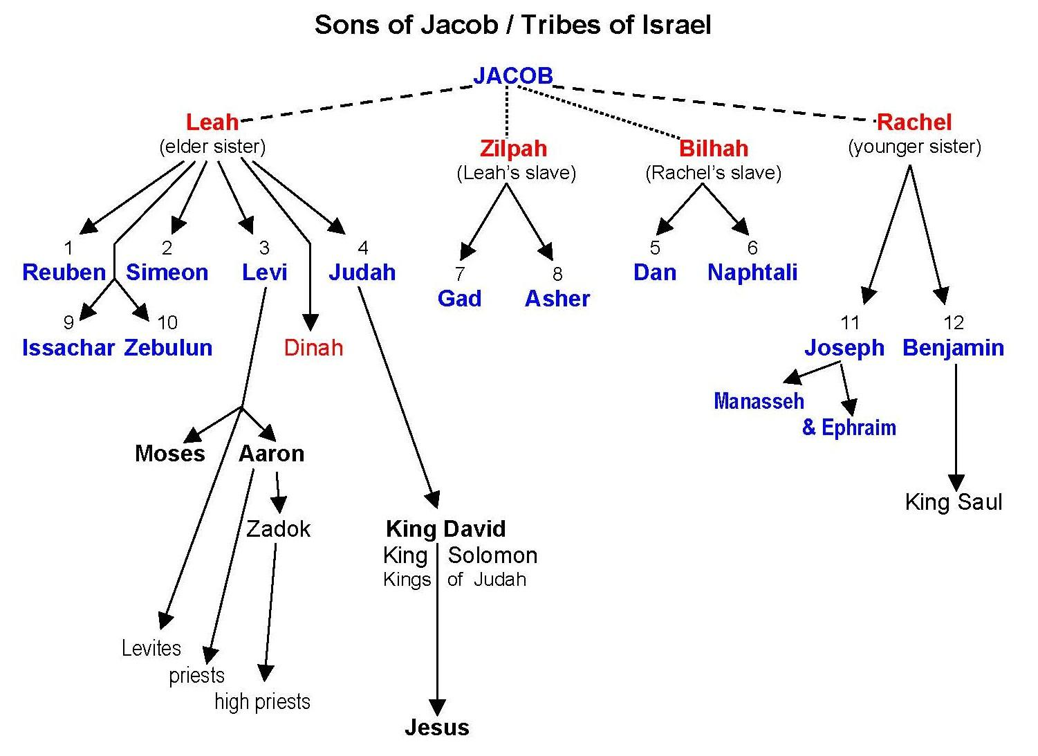

Their exodus from Egypt (about 1446 BC), wandering in the wilderness, and conquest of the land of Canaan (begun about 1406 BC) are recorded in the books of Exodus through Joshua. Their identification by tribe and the record and location of the tribes through this period appear to be fairly clear. The tribes remained identifiable and generally held to their originally assigned tribal lands through the time of King Solomon. Following the death of Solomon in about 931 BC, however, civil war broke out between the tribes, and the tribes of Judah and Benjamin became the southern kingdom of Judah, and the other tribes became the northern kingdom of Israel. From the time of Solomon’s rule over Israel until the end of the Old Testament period is charted on the next page. Examine particularly the place and date shown as “Assyria conquers Israel”.

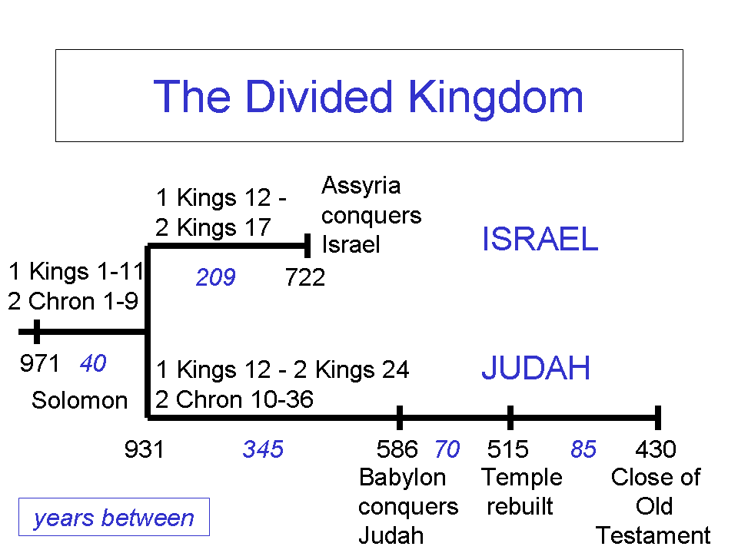
There have been those who have spoken of or written about ‘the ten lost tribes of Israel’. This typically refers to the ten tribes of the northern kingdom known as ‘Israel’ or ‘Ephraim’ which are said to have been ‘lost’ to the two tribes of the southern kingdom when the Assyrians supposedly carried all of those ten tribes into captivity. Some have even taught that these ten tribes never rejoined the other two tribes, but instead relocated to northern Europe. Those who hold this view might say, for instance, that the tribe of Dan became the people that we call the Danes, still identifiable in the name of the modern nation of Denmark. Some of those who hold to this view teach a specific kind of this teaching known as British Israelism or Anglo Israelism.

But there are some serious problems with the view that the ten tribes of Israel were ‘lost’, which include:

- It is contrary to what the Bible says in both the Old and New Testaments
- It is in conflict with the findings of archaeology and science

Now let’s take a brief look at the evidence and draw some appropriate conclusions.

How it all began
After a united kingdom under kings Saul, David and Solomon, a civil war divided the people of Israel about 931 BC. Benjamin and Judah comprised the southern kingdom of Judah, for its prominent tribe, and the other ten tribes in the northern kingdom were called ‘Israel’ or ‘Ephraim’, for its prominent tribe.

But many in the northern kingdom moved to the southern kingdom
People from all of the tribes of the northern kingdom (called ‘Israel’) moved to the southern kingdom of Judah in order to escape the idolatry that was promoted there:

2 Chronicles 11:14-16
For the Levites left their pasture lands and their property and came to Judah and Jerusalem, for Jeroboam [king of the northern kingdom] and his sons had excluded them from serving as priests to the Lord. 15 He set up priests of his own for the [idolatrous] high places, for the satyrs and for the calves which he had made. 16 Those from all the tribes of Israel who set their hearts on seeking the Lord God of Israel followed them to Jerusalem [in the southern kingdom of Judah, where the valid temple was located], to sacrifice to the Lord God of their fathers.

2 Chronicles 15:9
He [King Asa] gathered all Judah and Benjamin and those from Ephraim, Manasseh and Simeon who resided with them, for many defected to him from Israel when they saw that the Lord his God was with him.

Not all of the people in the northern kingdom were taken into captivity
The Assyrians took a number of the inhabitants of the northern kingdom of Israel into captivity, beginning with the tribes of Reuben and Gad in 733-732 BC, and then the rest of the northern tribes in 722-715 BC. But there were still a great many from the northern tribes of Israel who escaped from the Assyrians and therefore remained in the territory that had been the northern kingdom. This is reflected in the records of the time of king Hezekiah of Judah:

2 Chronicles 30:1
Now Hezekiah sent to all Israel and Judah and wrote letters also to Ephraim and Manasseh, that they should come to the house of the Lord at Jerusalem to celebrate the Passover to the Lord God of Israel.

2 Chronicles 30:5-6
So they established a decree to circulate a proclamation throughout all Israel from Beersheba even to Dan, that they should come to celebrate the Passover to the Lord God of Israel at Jerusalem. For they had not celebrated it in great numbers as it was prescribed. 6 The couriers went throughout all Israel and Judah with the letters from the hand of the king and his princes, even according to the command of the king, saying, "O sons of Israel, return to the Lord God of Abraham, Isaac and Israel, that He may return to those of you who escaped and are left from the hand of the kings of Assyria."

2 Chronicles 30:10-12
So the couriers passed from city to city through the country of Ephraim and Manasseh, and as far as Zebulun, but they laughed them to scorn and mocked them. 11 Nevertheless some men of Asher, Manasseh and Zebulun humbled themselves and came to Jerusalem. 12 The hand of God was also on Judah to give them one heart to do what the king and the princes commanded by the word of the Lord.

2 Chronicles 30:18
For a multitude of the people, even many from Ephraim and Manasseh, Issachar and Zebulun, had not purified themselves, yet they ate the Passover otherwise than prescribed.

2 Chronicles 30:25
All the assembly of Judah rejoiced, with the priests and the Levites and all the assembly that came from Israel, both the sojourners who came from the land of Israel and those living in Judah.

2 Chronicles 31:1
Now when all this was finished, all Israel who were present went out to the cities of Judah, broke the pillars in pieces, cut down the Asherim and pulled down the high places and the altars throughout all Judah and Benjamin, as well as in Ephraim and Manasseh, until they had destroyed them all. Then all the sons of Israel returned to their cities, each to his possession.

Even later a remnant of the northern tribes was still involved with and supporting the worship at the temple in Jerusalem, which was in the kingdom of Judah, 624 BC:

2 Chronicles 34:9
They came to Hilkiah the high priest and delivered the money that was brought into the house of God, which the Levites, the doorkeepers, had collected from Manasseh and Ephraim, and from all the remnant of Israel, and from all Judah and Benjamin and the inhabitants of Jerusalem.

2 Chronicles 35:17-18
Thus the sons of Israel who were present celebrated the Passover at that time, and the Feast of Unleavened Bread seven days. 18 There had not been celebrated a Passover like it in Israel since the days of Samuel the prophet; nor had any of the kings of Israel celebrated such a Passover as Josiah did with the priests, the Levites, all Judah and Israel who were present, and the inhabitants of Jerusalem.

Later, when the Babylonians overcame the Assyrian empire, the Babylonians took people from the kingdom of Judah, which included those from all of the tribes of Israel, into captivity in Babylon:

2 Chronicles 36:20
Those who had escaped from the sword he carried away to Babylon; and they were servants to him and to his sons until the rule of the kingdom of Persia

Later still, Cyrus the king of Persia issued a decree that allowed the people of Israel to return to their land and to rebuild the temple as recorded in the book of Ezra.

Ezra 6:16-17
And the sons of Israel, the priests, the Levites and the rest of the exiles, celebrated the dedication of this house of God with joy. 17 They offered for the dedication of this temple of God 100 bulls, 200 rams, 400 lambs, and as a sin offering for all Israel 12 male goats, corresponding to the number of the tribes of Israel.

Ezra 8:35
The exiles who had come from the captivity offered burnt offerings to the God of Israel: 12 bulls for all Israel, 96 rams, 77 lambs, 12 male goats for a sin offering, all as a burnt offering to the LORD.

In New Testament times
The recognition of the twelve tribes and of individual tribes of the northern kingdom continued into the New Testament.

Luke 2:36,38
And there was a prophetess, Anna the daughter of Phanuel, of the tribe of Asher. She was advanced in years and had lived with her husband seven years after her marriage… 38 At that very moment she came up and began giving thanks to God, and continued to speak of Him to all those who were looking for the redemption of Jerusalem.

Acts 26:6-7
"And now I am standing trial for the hope of the promise made by God to our fathers; 7 the promise to which our twelve tribes hope to attain, as they earnestly serve God night and day.

James 1:1
James, a bond-servant of God and of the Lord Jesus Christ,
To the twelve tribes who are dispersed abroad: Greetings.

The terms ‘Jew’, ‘Israelite’ and ‘Hebrew’ are basically synonyms
Contrary to what at least some proponents of ‘the ten lost tribes of Israel’ are prone to teach, there is no evidence in Scripture that ‘Jews’ refers only to those of the tribe of Judah, or that ‘Israel’ refers only to the ten tribes of the northern kingdom. Christ was called the ‘King of the Jews’ (Matthew 2:2; Mark 15:2, et al) as well as the ‘King of Israel’ (John 1:49; 12:13, et al). The two titles clearly appear to be synonyms. Paul, who was of the tribe of Benjamin, said that he was a Jew, an Israelite, of the nation of Israel, and a Hebrew, as well as a descendent of Abraham:

Acts 21:39
But Paul said, "I am a Jew of Tarsus in Cilicia, a citizen of no insignificant city; and I beg you, allow me to speak to the people."

Romans 11:1
For I too am an Israelite, a descendant of Abraham, of the tribe of Benjamin.

2 Corinthians 11:22
Are they Hebrews? So am I. Are they Israelites? So am I. Are they descendants of Abraham? So am I.

Philippians 3:5
…circumcised the eighth day, of the nation of Israel, of the tribe of Benjamin, a Hebrew of Hebrews; as to the Law, a Pharisee…

What about archaeology and science?
Though much more could be written, one example of a conflict between the ‘the ten lost tribes of Israel’ teaching and archaeology is that the records of the Assyrians indicate that they took away only 27,290 people out of several hundred thousand in the northern kingdom. Most of the population of the northern kingdom remained there or moved to Judah.

Also, genetic evidence indicates that the people that we call Jews are of Middle Eastern extraction, and that the northern Europeans are not.

Conclusion
All of the above means that we can take God’s word for what it says, including when God says of Ephraim (the nickname for the Jews of the northern kingdom) and Judah (the nickname for the Jews of the southern kingdom) in Ezekiel 37:15-23, “And they will be My people, and I will be their God.” Though the Jews were indeed scattered among the nations of the earth, there never were ten lost tribes, or any lost tribes. God knows which tribe each Jew belongs to, and will be ever faithful to His promises to them all.

http://www.bible-history.com/links.php?cat=36&sub=342&cat_name=Biblical+Archaeology&subcat_name=Assyria
? http://bioanthropology.huji.ac.il/pdf/Nebel_2001b.pdf; http://www.pnas.org/content/97/12/6769.full.pdf

