Q&A 46: When were the Gospels written?

While the four gospels – Matthew, Mark, Luke and John – do not have a date written on them according to our present system of dating and chronology (the Gregorian Calendar), the date or range of possible dates of authorship assigned to each gospel does become a biblical issue. The reason that the date becomes a biblical issue is because each of the four gospels presents itself as a true, historical account of the events of selected events in the life of Christ, reflecting eyewitness testimony, either as witnessed directly by the author of that gospel, and/or as gathered from eyewitnesses by the author. Any date of authorship of any gospel that would place that gospel outside of the range of drawing on eyewitness testimony would undermine the historical veracity and truthfulness of the gospel account. The one gospel that does not portray itself as being written by a direct eyewitness, but by someone who spoke to eyewitnesses and drew upon historical documents is the gospel of Luke. Dr. Luke introduces his gospel with these words:

Luke 1:1-4 (NASU; all subsequent quotes are also NASU unless stated otherwise)
Inasmuch as many have undertaken to compile an account of the things accomplished among us, 2 just as they were handed down to us by those who from the beginning were eyewitnesses and servants of the word, 3 it seemed fitting for me as well, having investigated everything carefully from the beginning, to write it out for you in consecutive order, most excellent Theophilus; 4 so that you may know the exact truth about the things you have been taught.

In the epistle of 1 John we find this insightful introduction:

1 John 1:1-4 (compare with John 1:1-18)
What was from the beginning, what we have heard, what we have seen with our eyes, what we have looked at and touched with our hands, concerning the Word of Life-- 2 and the life was manifested, and we have seen and testify and proclaim to you the eternal life, which was with the Father and was manifested to us-- 3 what we have seen and heard we proclaim to you also, so that you too may have fellowship with us; and indeed our fellowship is with the Father, and with His Son Jesus Christ. 4 These things we write, so that our joy may be made complete.

There are those, of course, who are motivated by their underlying belief system (i.e., they are minimalists) to conclude that the gospels were not written by eyewitnesses or by those who had access to eyewitness testimony. Those who hold to a minimalist belief system are therefore strongly inclined to date the gospels late enough to preclude content based upon access to eyewitness testimony. But for those who hold that the four gospels are based upon eyewitness testimony or those who had access to eyewitness testimony, some dates of authorship include:
Scholar / Gospel book | Matthew | Mark | Luke | John
Ryrie | 50s or 60s | 50s or 60s | 60 | 85-90
F.F. Bruce | 40 | 45 | 54 | ---
Wenham | 40 | 45 | Mid 50s | ---
J.A.T. Robinson | 40-60+ | 45-60 | 57-60+ | 40-65+

In truth, there is little reason to set aside the earliest of these dates, as the continuing ability to confer among the eyewitnesses and to inquire of eyewitnesses and to have access to official documents is improved under the earlier dates and fits best with the character of the testimony in passages in Luke and 1 John that were quoted above.

The Roman destruction of Jerusalem in 70 AD also serves as a pivotal marker in time for access to genealogical records as well as other formal and informal documentation. In addition, some aspects of Jewish culture ended in 70 AD, such that mention of those aspects of Jewish culture at a later date becomes less likely (the two-court system of Hillel and Shammai, Sadducees, names of specific individuals such as Malchus, servant of the high priest, etc.).

Now Christians will encounter a number of individual scholars, organizations, and media presentations that will express and even actively promote later dates for the gospels, and will set aside major portions of the gospels as mistaken, mythological, hearsay, propaganda, highly edited, etc. While we could address these in more detail, the common thread among these critics of the gospels is that they have unverifiable prepositions that drive their conclusions rather than historical facts and evidence that can only lead one to their conclusions.

Faith is not believing what you know isn’t true, nor belief because of ignorance, but faith has a foundation in historicity – historical reality. The preface by Dr. Luke and the apostle John quoted above are of that very character.

Q&A 47: Why did Jesus tell the disciples to ask anything and it will be done?

John 15:7
"If you abide in Me, and My words abide in you, ask whatever you wish, and it will be done for you.

The disciples were specifically given the ability to perform signs and wonders and miracles as a validation of their appointment as apostles:

2 Corinthians 12:12
The signs of a true apostle were performed among you with all perseverance, by signs and wonders and miracles.

See also Acts 2:43; 4:30; 5:12; 6:8; 8:6, 13; 14:3; 15:12; 19:11; Romans 15:19; Galatians 3:5.

In Hebrews 2:3, 4 says of the apostolic era:

…After it [the great salvation] was at the first spoken through the Lord, it was confirmed to us by those who heard, 4 God also testifying with them, both by signs and wonders and by various miracles and by gifts of the Holy Spirit according to His own will.

What we find is that the apostles did not ask if the Lord would do signs and wonders through them, but whenever the apostles said that something would be done (healing, casting out demons, etc.). It simply and universally happened, just as the apostles ordered, as we read about with Peter and John in the next chapter following Acts chapter 2, which records the events and words of the day of Pentecost:

Acts 3:1-8
Now Peter and John were going up to the temple at the ninth hour, the hour of prayer. 2 And a man who had been lame from his mother's womb was being carried along, whom they used to set down every day at the gate of the temple which is called Beautiful, in order to beg alms of those who were entering the temple. 3 When he saw Peter and John about to go into the temple, he began asking to receive alms. 4 But Peter, along with John, fixed his gaze on him and said, "Look at us!" 5 And he began to give them his attention, expecting to receive something from them. 6 But Peter said, "I do not possess silver and gold, but what I do have I give to you: In the name of Jesus Christ the Nazarene--walk!" 7 And seizing him by the right hand, he raised him up; and immediately his feet and his ankles were strengthened. 8 With a leap he stood upright and began to walk; and he entered the temple with them, walking and leaping and praising God.

Peter was not hesitant or cautionary in his healing – it simply happened. But we also find that these signs and wonders and miracles, while validating the apostles, did not seem to allow them to escape persecution and trials of various kinds. Indeed, the apostle Paul asked three times that the ‘thorn in the flesh’ be removed from him, and the Lord declined Paul’s request (2 Corinthians 12:7-10).

The mistake that many make today is to assume that these apostolic signs, wonders and miracles, and the gifts that go along with them are normative in our post-apostolic era. While God can indeed perform miracles, we do not have the promise nor the sign gifts as did the apostles and those in the era of the apostles.

On the following page is a table on the spiritual gifts which presents the biblical evidences of an apostle, those gifts that are distinctly for the apostolic era, as well as those spiritual gifts which are fitting to the church age.
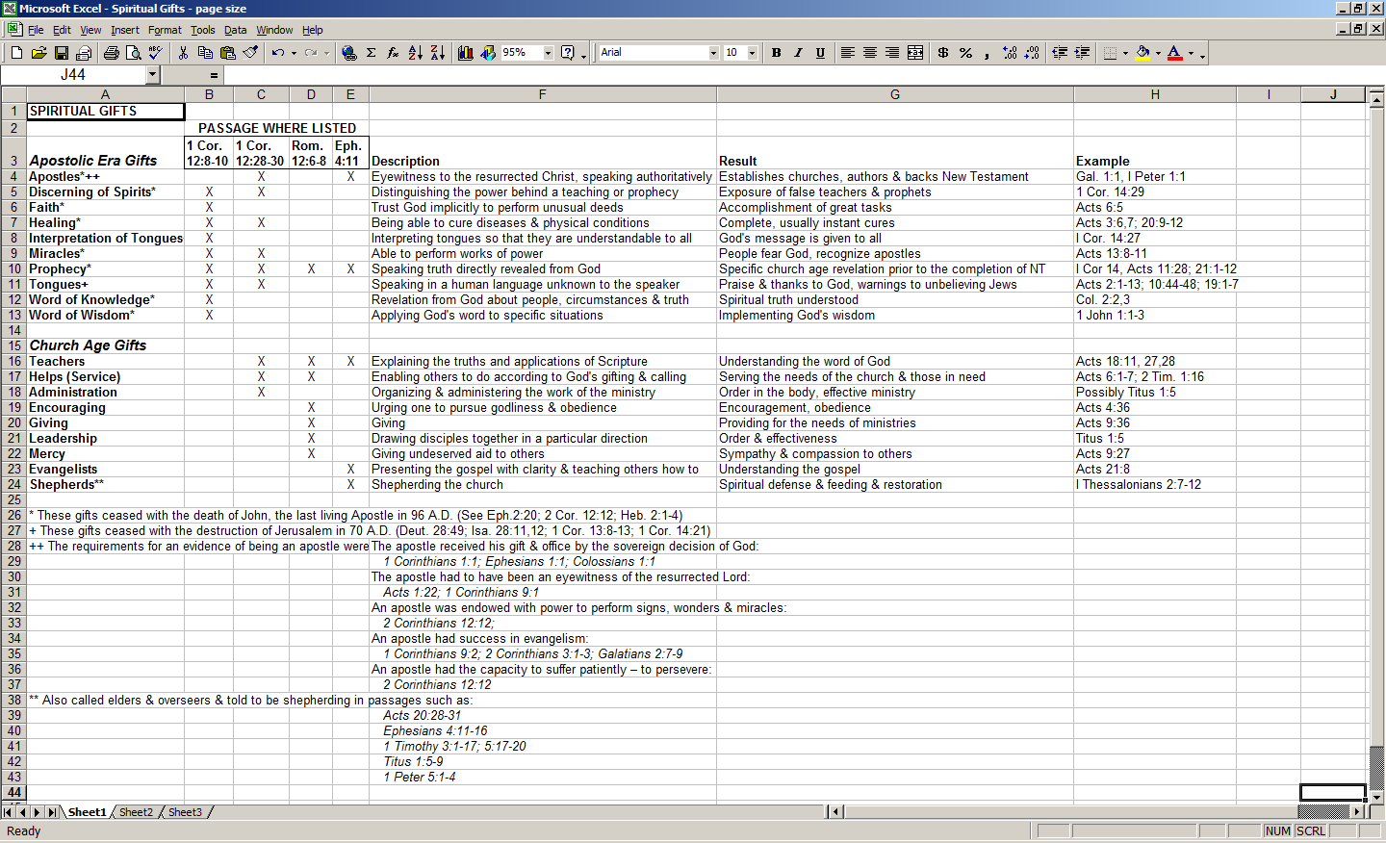
Q&A 48: What is blasphemy against the Holy Spirit?

Matthew 12:31-32
Therefore I say to you, any sin and blasphemy shall be forgiven people, but blasphemy against the Spirit shall not be forgiven. 32 "Whoever speaks a word against the Son of Man, it shall be forgiven him; but whoever speaks against the Holy Spirit, it shall not be forgiven him, either in this age or in the age to come."

This verse has a specific context, which is that of attributing the works of Jesus Christ, having seen them personally, to Satan (Matthew 12:24; see also Mark 3:20-30). That specific context is not presently a possibility, since people cannot see the works of Jesus personally as the Pharisees did, and attribute those works to Satan.

However, what is possible at this present time, and is the universal unforgiveable sin - blasphemy against the Holy Spirit – is rejection of Christ. Why does this constitute blasphemy against the Holy Spirit? Because it is the Holy Spirit who has a ministry of striving with the hearts of people (Genesis 6:3), of conviction (John 16:8-11), and of directing people’s hearts to Christ (John 16:14). Those who have sealed themselves off from the ministry of the Holy Spirit to unbelievers will remain unbelievers and so reject Christ, and the salvation that comes through Christ alone.

Jesus and the Eyewitnesses, The Gospels as Eyewitness Testimony, Richard Bauckham, 2006.

