Q&A 52: Is it ever right for a Christian to sue another Christian?

If a conflict arises between believers that has the character and potential to be brought before civil courts, law enforcement authorities, or the public in some magnitude, what does God’s word have to say about how such a conflict should be handled? What is at stake in such a situation?

- The apostle Paul addresses this circumstance directly in 1 Corinthians:

1 Corinthians 6:1-8 (NASU)
Does any one of you, when he has a case against his neighbor, dare to go to law before the unrighteous and not before the saints? 2 Or do you not know that the saints will judge the world? If the world is judged by you, are you not competent to constitute the smallest law courts? 3 Do you not know that we will judge angels? How much more matters of this life? 4 So if you have law courts dealing with matters of this life, do you appoint them as judges who are of no account in the church? 5 I say this to your shame. Is it so, that there is not among you one wise man who will be able to decide between his brethren, 6 but brother goes to law with brother, and that before unbelievers? 7 Actually, then, it is already a defeat for you, that you have lawsuits with one another. Why not rather be wronged? Why not rather be defrauded? 8 On the contrary, you yourselves wrong and defraud. You do this even to your brethren.

So it is clear that believers are to take conflicts between them to be settled among believers, and not before secular courts and legal authorities.

2) What is at stake in civil disputes, legal matters and public displays of conflict between believers is the honor and attractiveness of the gospel.

The apostle Paul wrote to Titus, giving direction on various matters, and in Titus 2:1-10 he gave Titus specific on how to instruct believers of varying age and gender to behave in certain ways for these reasons:

- so that the word of God will not be dishonored
- so that the opponent will be put to shame, having nothing bad to say about us
- so that they will adorn the doctrine of God our Savior in every respect

What is at stake is the honor of Christ, and of the gospel and of the body of Christ and the attractiveness of the gospel – the most important thing that we can present to the world.

In view of the above, the elders of Holly Hills would like to offer to serve as a believer’s ‘board of arbitration’, if needed, in any capacity or form that will serve to preserve the honor and attractiveness of the gospel, and to resolve matters in a way that preserves fellowship among those in the body of Christ. If you have such a need, please contact any of the elders to begin their involvement toward godly resolution of the conflict.

Having said these things there are also some important points of exception and qualification to the above:

- The above is in reference to lawsuits between believers in the case of a tort – an offense between parties, but not a crime. What is said above does not apply to reporting another Christian for a crime that has been committed. A Christian may be legally required to report a crime, and to cooperate in the investigation of a crime, committed by a Christian. Government does have a legitimate function, and 1 Corinthians 6:1-8 should not be used to set aside what is taught in passages such as Romans 13:1-7.

- There are those who are not Christians at all but will simply claim to be Christians and will use the 1 Corinthians 6:1-8 passage to avoid being held responsible for their failings and offenses against someone who is a Christian. This presents a little more difficult situation, of course, and must be considered carefully in view of the facts and in view of Scripture.

- Just because someone is a Christian, or claims to be, does not mean that a believer should suddenly be unwise and gullible. It is fair and prudent to confirm that the other Christian holds to the same understanding of 1 Corinthians 6:1-8, check references, get recommendations, and even check with the Better Business Bureau or other agencies before making substantial business and financial commitments.

- 1 Corinthians 6:1-8 should not be viewed as a blanket approval to be either litigious or gullible with unbelievers, and a yoke that leads to compromise with unbelievers is not approved by Scripture either (2 Corinthians 6:14-18).

Q&A 53: What did Paul mean by ‘baptism of the dead’?

1 Corinthians 15:29
Otherwise, what will those do who are baptized for the dead? If the dead are not raised at all, why then are they baptized for them?

This verse probably wins first prize for having the greatest number of proposed interpretations compared to all other verses. More than 200 different interpretations of this verse have been proposed. What is apparent is that the believers in Corinth seem to have understood just what Paul meant, and they also understood that the dead are raised.

We can bring our understanding of this verse into focus in these ways:

- Paul did not want believers to be baptized as a proxy for dead people in order to save the dead by that proxy baptism. This has been the interpretation of the Mormons (LDS), and the basis on which they study genealogies and baptize Mormon descendents on behalf of their dead ancestors in order to save them after the fact.
- The baptism is most likely water baptism of Christians. Some have observed that there was a pagan practice of baptism for the dead, but it is difficult to imagine the Paul would use a pagan baptism practice to justify Christian belief and practice.

- "the ones who are baptized" most likely refers to a small group of believers within the church, but not everyone. That is why Paul would use the pronoun “they”, rather than “we” or “you” in the plural.

- "the dead" for whom some were being baptized were likely believers who died.

- These believers who died had almost certainly already been baptized before they died.

The most likely interpretation:

If the Greek text conveys ‘because of’ rather than ‘on behalf of’, then some believers who have been saved by faith in Christ & are then baptized have done so because they heard the testimony of some who have since died.

Or possibly:

If the text is understood to mean that believers are baptized as an outward expression of their faith in Christ, then these take the place of the believers who have died, and continue as a living testimony.

Given the brevity of this singular reference in 1 Corinthians 15:29, it is difficult to know with great certainty what Paul meant. But what is clear is that Paul meant to support the belief in the resurrection of the dead. The entire chapter makes that point very clear.

Q&A 54: Does the Bible prohibit musical instruments in church services?

As a background to this question, we should point out that in the first half of the 1800s the Campbell family, following conflict with some Presbyterian and Baptist churches formed their own church which ultimately went from names such as Reformed Baptist to Church of Christ to Disciples of Christ to Christian Church. The Cambellite churches crossed paths with the Mormons, the Christadelphians, the Seventh Day Adventists and Jehovah’s Witnesses in their earlier history. These churches added to faith the listing and confession of all sins prior to baptism within the denomination as necessary for salvation, along with teaching that salvation could be lost. In 1860 the disagreement within these groups created a division, such that now about half of the Church of Christ congregations teach that musical instruments are not permitted in the church services. The main reason given for this prohibition is that the New Testament does not require the use of musical instruments in church services. Another justification for this ‘no musical instruments’ teaching is that musical instruments were used in pagan religious celebrations and worship.

While the Bible does not require musical instruments in church services, there are several reasons to believe that musical instruments are not prohibited from church services nor even problematic:

- Musical instruments such as trumpets and harps were used in the temple worship in Jerusalem, and the apostles made no objection to their use when they gathered there as recorded several times in the early chapters of Acts. Jesus drove out the money changers and animals that were being sold in the temple courtyard, but he did not drive out the temple musicians!

- Paul made reference to musical instruments in the context of apostolic era spiritual gifts and church services, but made no inference that the instruments were spiritually or morally suspect (verse 7):

1 Corinthians 14:6-8
But now, brethren, if I come to you speaking in tongues, what will I profit you unless I speak to you either by way of revelation or of knowledge or of prophecy or of teaching? 7 Yet even lifeless things, either flute or harp, in producing a sound, if they do not produce a distinction in the tones, how will it be known what is played on the flute or on the harp? 8 For if the bugle produces an indistinct sound, who will prepare himself for battle?

- In both Ephesians 5:19 and Colossians 3:16 Paul wrote that believers who are filled with the Spirit and in whom the word of Christ dwells richly make melody with ‘psalms’. The Greek word translated psalms is psalmos, which is from a root word that means ‘to strum’, as with a stringed instrument.

- Harps are described as being in heaven (Revelation 5:8; 14:2; 15:2), where we are now seated (Ephesians 2:6), and where we have a heavenly citizenship (Philippians 3:20).

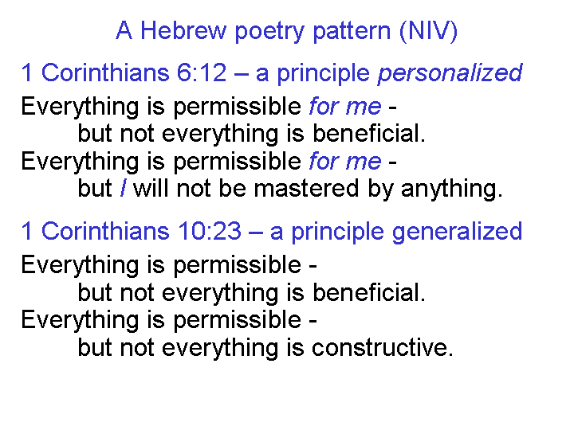
In the end, we must ask the question, “Are we in the church permitted to do all that is not forbidden, or are we forbidden to do all that is not commanded?” The slide to the left shows the way that Paul put his answers to that question in 1 Corinthians 6:12 and 10:23. There is nothing about musical instruments that is biblically prohibited or problematic. So whether by voice or instrument or both, may the Lord be glorified!

