Q&A 55: How do we reconcile “God is not willing that any should perish” with “lest they should believe and be saved”?

Here are the two verses in question (all quotes NASU unless stated otherwise):

2 Peter 3:10
The Lord is not slow about His promise, as some count slowness, but is patient toward you, not wishing for any to perish but for all to come to repentance.

Luke 8:11-12
"Now the parable is this: the seed is the word of God. 12 "Those beside the road are those who have heard; then the devil comes and takes away the word from their heart, so that they will not believe and be saved."

2 Peter 3:10 is in the context of events from the present time (‘last days’) forward to the end of the present heavens and earth. The word that is translated, ‘wishing’ indicates God’s permissive will, that is, it reveals what God desires, but not what God determines. A different Greek word would have been used if the verse were intended to say that God absolutely wills that none should perish and therefore every single person will be saved, without fail. God has a will in this matter of salvation, and that is that none would perish. But God does not fix His will in this matter such that the human will is entirely overwhelmed and without freedom to choose. God’s greater will is that people have the freedom to choose to believe so as to be saved or not to believe, so as to perish. Christ died and was buried and rose again to make it possible to be saved, and He sent the Holy Spirit to convict the hearts of the unbelievers so that they might have a willingness to believe (contrary to the fixed inclination of the sin nature). But though God is not willing that any should perish God does not absolutely and irresistibly will that all will be saved. In “Believe in the Lord Jesus, and you will be saved…” (Acts 16:31) the word translated “Believe” contains an appeal to the will of the unbeliever – there is a freedom for the unbeliever to choose, but that unbeliever must choose faith in Christ in order to be saved.

In Luke 8:11-12, we are looking at a portion of the parable of the sower which was considered on November 21st, 2010 (46 Q&A 45: How do we view passages about picking up your cross daily, the parable of the sower, and similar passages and parables spoken by Christ in His earthly ministry?). The King James Version and the New King James version translated the last portion of that passage as, “…lest they should believe and be saved”. There are two things about this passage that we should note carefully:

1) It is the devil who comes and takes away the word from their heart, and – to draw from the wording of 2 Peter 3:9 - the devil is willing that all should perish.

2) The Greek word pair behind the KJV/NKJV “lest” and the NASU/NIV “so that… not” is explaining why the devil comes and takes away the word. The devil does not desire that any should respond favorably to the word of God and believe and be saved. God and the devil have very different wills!
Q&A 56: Why should we pray more than once for anything?

We could give a quick answer to this simple question, but then we would miss some rich truths, so we won’t give the quick answer. Here’s the longer and better answer:

Given God’s knowledge of all circumstances and all of our hearts, God does not need us to pray so that God is informed. If we don’t pray, God is not any less aware of anything. On that basis it would be possible to ask why we should pray at all! God doesn’t need us to pray in order to keep him fully informed. So why does God want us to pray at all?

Even more, God knew about our requests from even before we were born, and knows how the situation will turn out, and how He will answer it. Given God’s infinite knowledge and power, can our prayers make any difference at all?

The apostle Paul provides an example of asking three times, and God did not rebuke nor ridicule Paul for asking those three times. God just said “No” to Paul’s request. (2 Corinthians 12:7-9).

So does God value our prayers? In Revelation 5:8-9, John writes about the heavenly scene:

“When He had taken the book, the four living creatures and the twenty-four elders fell down before the Lamb, each one holding a harp and golden bowls full of incense, which are the prayers of the saints.”

So in heaven the prayers of the saints are kept in golden bowls! Not clay pots or wooden boxes, but golden bowls. The prayers of the saints are indeed highly valued in heaven. Even if God says, “No” to a particular request, he still values the prayer – why?

Christ died for our sins and was buried and rose again so that we could have relationship with Him. Beyond that, He did these things so that we could have fellowship with Him. God does not need for us to pray – there is nothing deficient in His character that would make Him need for us to pray. But He wants us to pray in order that the relationship that we have with Him extend into fellowship. He doesn’t have to include our prayers in what He does, but He wants us to be included in what He is doing, and prayer is God’s way of carrying that out. No, vain repetitions are not what God has in mind, as if the number of requests is what God will finally respond to. But God desires that we continue to talk to Him about the concerns on our hearts because it’s part of extending and expressing eternal relationship into ongoing fellowship.

Q&A 57: When will the various groups of people be resurrected and judged?

See the chart on the following page and slides that will be presented. We will not attempt a written explanation in this document.

Present Heaven

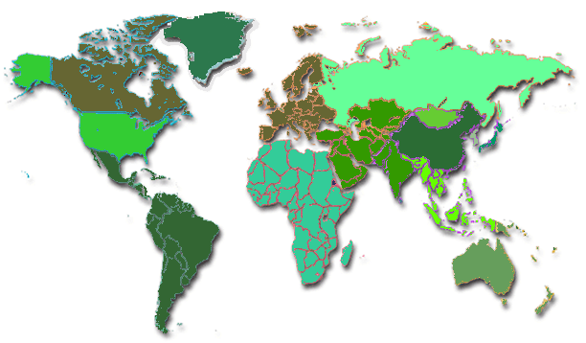

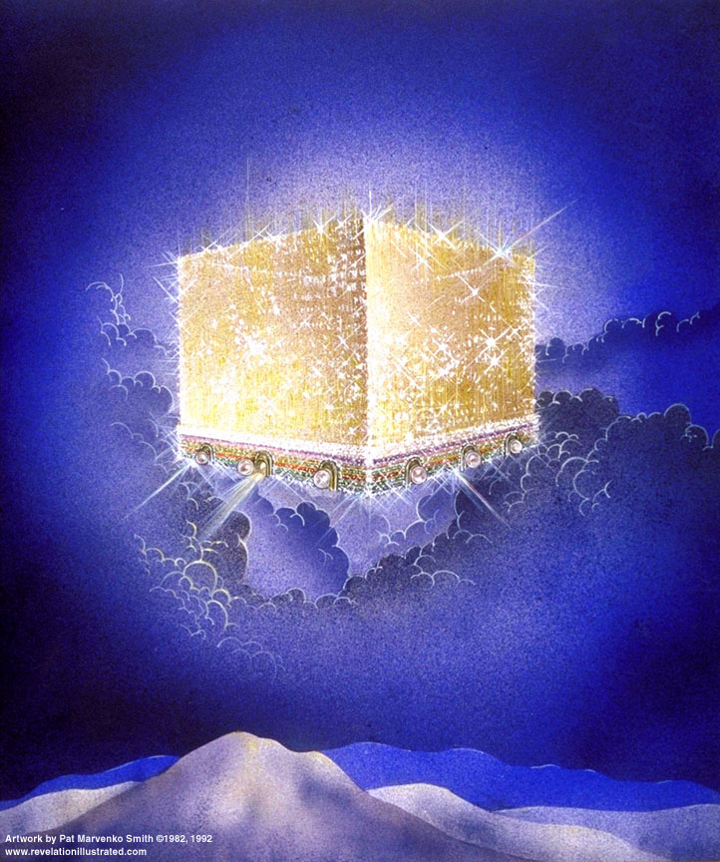
New Heaven & New Earth
Present Earth
Lake of Fire
7 Year Tribulation
1000 Year Kingdom
Present Era = ‘this age’
Rapture of the Church, 1st those asleep in Christ, then those who remain
2nd Coming of Christ with the Church, saints of all prior times, angels
The Beast & The False Prophet, & those who receive the mark of the Beast
Saints who die during the Kingdom
The Great White Throne Judgment: the rest of the unsaved of all time
Satan & all fallen angels (demons)
Saved of all time: Church, Israel, Gentiles
Christ, resurrected saints & earthly saints

