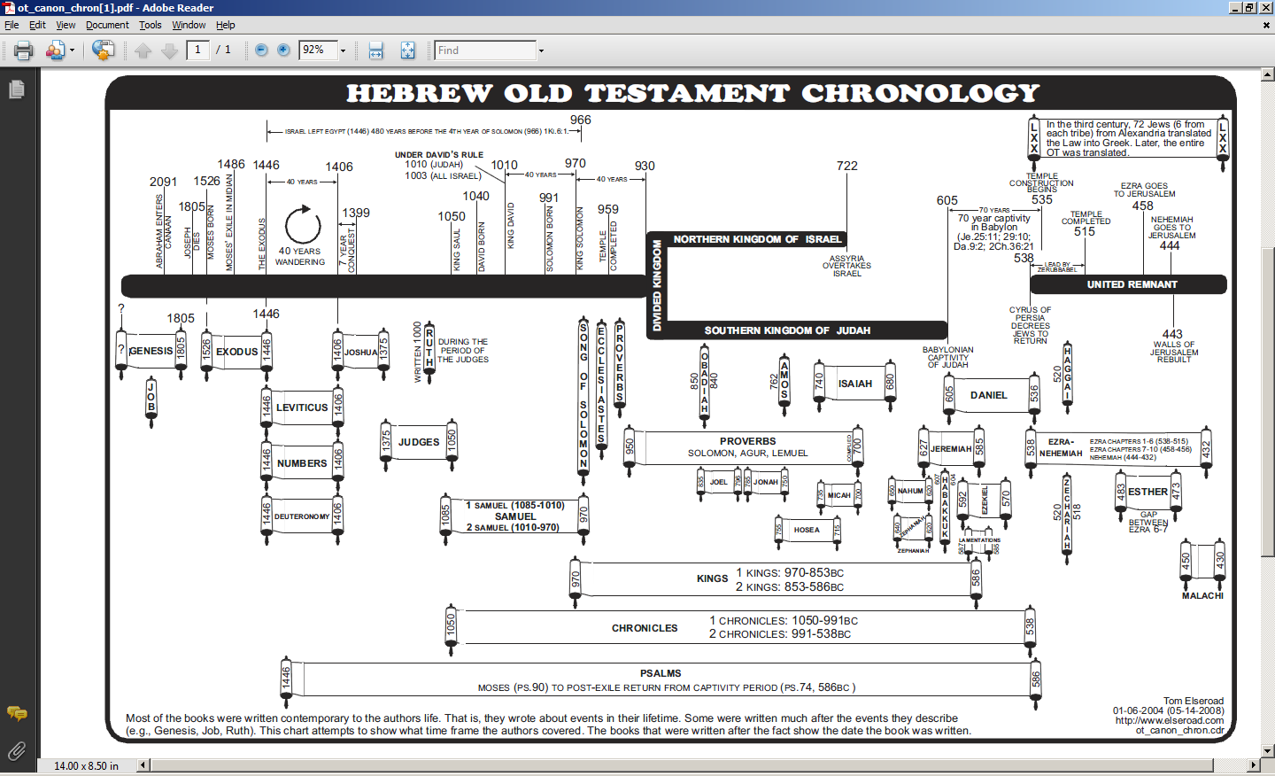
< Should be 536 BC >

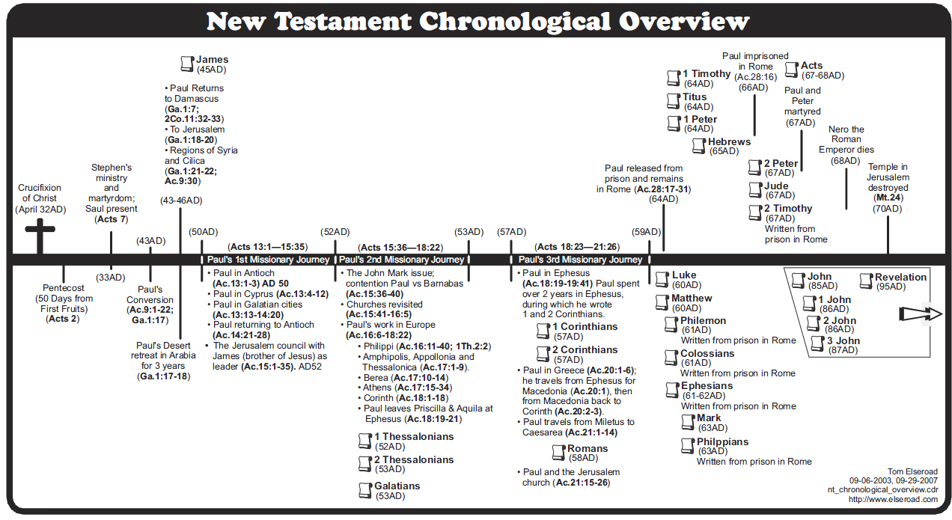
While we at HHBC would be inclined to place several of these dates earlier (Crucifixion, Paul’s conversion & 1st & 2nd missionary journeys & events in that timeframe, Galatians, the four Gospels, Acts), the general presentation of ‘progressive revelation’ is well done.

