Revelation 1:1-8

The Revelation of Jesus Christ, which God gave Him to show to His bond-servants, the things which must soon take place; and He sent and communicated it by His angel to His bond-servant John, 2 who testified to the word of God and to the testimony of Jesus Christ, even to all that he saw.

This book is a revelation of and from Jesus Christ. It is intended to be revealing, and not intended to be or remain mysterious. Jesus Christ, the One being revealed and revealing, is the Savior and the Anointed One (= the Messiah) who is the prophet, priest and king of the Jews. God the Father gave the revelation to Jesus Christ, Who gave it to an angel, who gave it to the apostle John:

Christ, in Greek, is Christou,

also known as the Messiah, the

Anointed One, because He is

a Prophet, a Priest & a King:

He is a Prophet:

Deuteronomy 18:15-19

Isaiah 61:1-2a

He is a Priest:

Psalm 110:1-7

Hebrews 2:17-10:21

He is the King of the Jews:

Genesis 49:10

Isaiah 7:14
Matthew 2:2; 27:11

God > Jesus > Angel > John

Each giving was an ‘entrusting’. The word translated ‘show’ means to explain. His sending was by special appointment. The ultimate audience for this revelation is those who believe, who are His bond-servants.

In the phrase, “things which must soon take place”, the word ‘must’ conveys that these things are not merely a possibility, nor even a likelihood, but rather that they are certain to come to pass. The same or similar phrases appear in Revelation 1:19, 4:1 and 22:6. The word ‘soon’ is translated from the Greek word taxei from which we get our English words tachycardia (rapid heartbeat) and tachometer (showing RPMs in an engine). In this context, the word conveys that the events in the book of Revelation will take place in rapid succession, and that they are imminent – they could begin at any time.

Verse 2 carries with it a legal sense, not in being legalistic, but in that it speaks strongly of testifying truthfully and according to careful observation:

2 who testified to the word of God and to the testimony of Jesus Christ, even to all that he saw.

As always, John is concerned that we understand that these are real, actual events and beings that he saw (compare to 1 John 1:1-4). John writes emphatically that what he is writing in this book is valid testimony, as if he were testifying in court as an eyewitness:

- testified…testimony: in the King James Version (KJV), bare record…testimony; this is based on the root word John uses several times: 1:2, 9, 6:9, and 20:4.
- word of God: the words of God, being God’s own message and communication.
- even to all that he saw: this is consistent with what John wrote in epistle of I John:1:1-3, “have seen” appears three times.
- I saw: John wrote 38 times in the book of Revelation, “I saw”. Fourteen of those times he will say, “And I saw”, implying connection and proximity of time with what went before.
3 Blessed is he who reads and those who hear the words of the prophecy, and heed the things which are written in it; for the time is near.

‘Blessed’ occurs seven times in the book of Revelation. It means spiritually blessed, with those blessings given from God. This first ‘blessed’ states blessings for those who read and hear this book, and heed it. Three of those verses with “Blessed…” are given in the middle of the Tribulation period. The sixth one (Revelation 22:7) assumes you’ve read that far, so it says just, “blessed are those who heed this prophecy”. To ‘heed’ means to take note or keep watch.

The word translated ‘he who reads’ is singular, but ‘those who hear’ is plural. In context, the one reading is not reading privately, but before others. This is not, of course, to discourage private reading, but rather to underscore the value of understanding this together.

4 John to the seven churches that are in Asia: Grace to you and peace, from Him who is and who was and who is to come, and from the seven Spirits who are before His throne

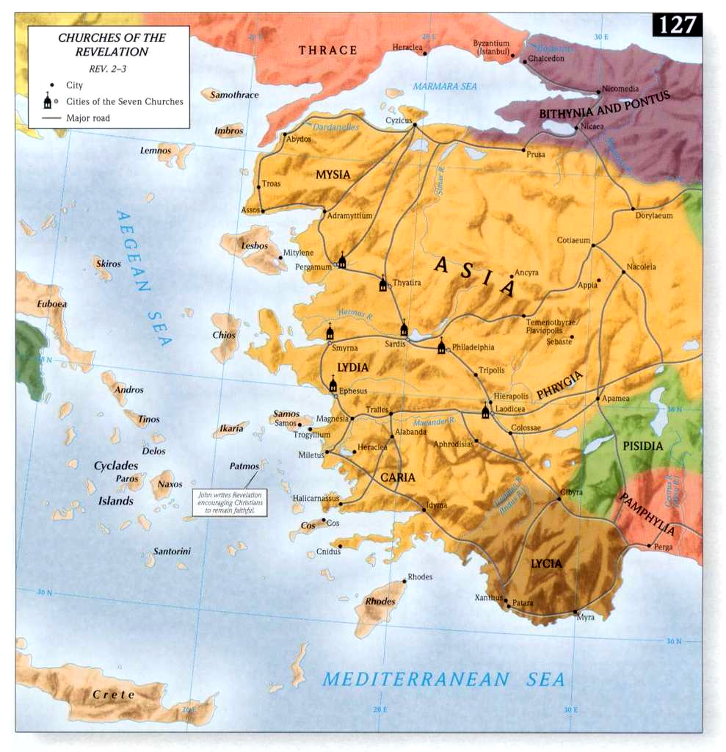
John focuses on addressing the seven churches in Asia:

- These churches are not located in Asia as we now call Asia, the continent, but rather Asia which was the Roman province in the western end of what is now Turkey.
- They were connected by Roman roads, including more minor roads not shown in the accompanying map, and all on the Roman postal route.
- John was, according to extrabiblical writings, with these seven churches, specifically in Ephesus. These people are on his heart and mind, and John is able to receive assessments, commendations, and warnings for these seven churches directly from the Lord Jesus Christ.
- These seven churches are addressed directly in chapters 2 and 3 of Revelation, which we will begin studying in a couple of weeks.
In the phrase, “grace to you and peace”, grace is the Greek greeting (charis). Grace was given us in Christ before times eternal (2 Timothy 1:9), and God’s grace is sufficient for us now (2 Corinthians 12:19, Hebrews 4:16). Grace will also be brought to us at the revelation of Christ Jesus (1 Peter 1:13). Peace is the Jewish greeting (Gk: eirene = shalom in Hebrew) the consequence of salvation. Peace is the product of knowing and appropriating God’s grace.

The words, “from Him who is and who was and who is to come” are very significant in the book of Revelation. Since Christ the Son has been and will be spoken of, and the Holy Spirit will be spoken of next, this is taken to refer to God the Father – see also verse 6 in this context. God the Father is referred to as the source of grace and peace in Romans 1:7, I Corinthians 1:3; Ephesians 1:2, Colossians 1:2, I Timothy 1:2, II Timothy 1:2 and Titus 1:4. This phrase or a variation of it, occurs several more times in Revelation, which we’ll examine shortly.

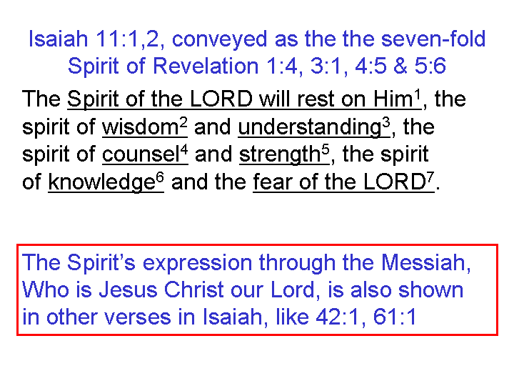
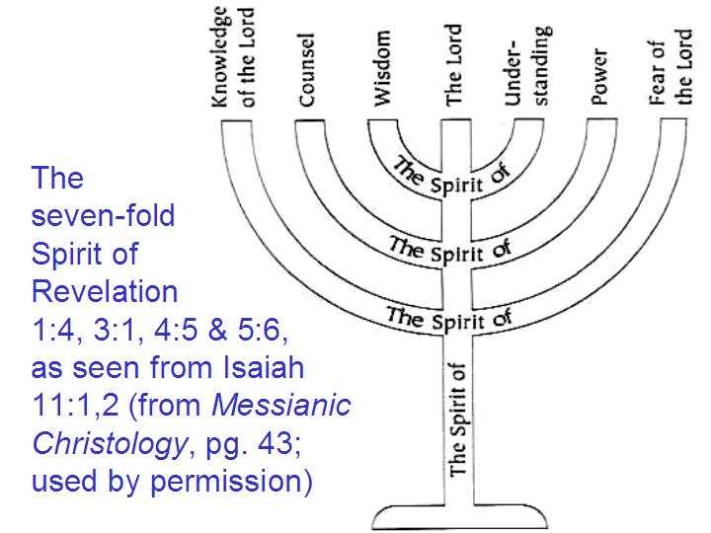
Some have taken the phrase, “and from the seven Spirits who are before His throne” to be a reference to ‘the angels’ of each of the churches in chapters 2 and 3, but John never refers to angels as spirits. Additionally, 2 of the 4 verses referring to ‘seven spirits’ are after the messages to the seven churches, and seem to have nothing at all to do with the seven churches of Asia. It seems better to see this as a reference to the seven-fold ministry of the Holy Spirit, who has seven characteristics as displayed through the promised Messiah during the Millennium. This would also make complete the references to the three persons of the Trinity.

5 and from Jesus Christ, the faithful witness, the firstborn of the dead, and the ruler of the kings of the earth. To Him who loves us and released us from our sins by His blood -- 6 and He has made us to be a kingdom, priests to His God and Father -- to Him be the glory and the dominion forever and ever. Amen.

The word pair, “faithful witness” has prophetic and legal meaning, being the opposite of a false witness (Proverbs 14:5; Jeremiah 42:5). While witnesses among the Jews had to be 2 or 3 in number (e.g., Deuteronomy 19:15), the Lord Himself can act as a witness alone, because He is by His character faithful and true, and He needs no independent verification. John will use these same words singularly or in combination throughout Revelation.
Though John writes, “the firstborn of the dead” here, the words are identical to what Paul wrote in Colossians. 1:18 (Gk: prototokos = firstborn). Christ was the first to come alive from death permanently. Jesus raised Lazarus, and Paul raised up one young man, Eutycus, but these died again. Christ was the first raised, just as we shall be after Him! That is our hope! One more item to note: This not saying that Christ rose from the state of death, but, as the Greek indicates, from among the dead ones! These dead ones, we are told in I Thessalonians 4:13-18, will rise first at the rapture, then we who are alive.

John next writes, “and the ruler of the kings of the earth” (KJV: ruler = prince). These words literally means, “the one who rules the kings of the earth”. While God was and is and will be sovereign over all, Christ’s bodily reign as ruler over all the kings of the earth is yet future. Revelation keeps looking ahead to it, finally proclaiming it’s reality in Revelation chapter 20.
The phrase is reiterated in Revelation in 15:3 (King of all the nations) and again in 17:14 and 19:16, where Christ is called ‘the King of Kings and Lord of Lords’ (or vice versa) prior to His actually reigning. The Tribulation is the time of transition, where the demise of the kingdoms of this world will become reality.

Christ’s present ministry with us is “Him who loves us”. In the Greek text, this phrase is conveying “to Him who is constantly loving us”. When we have fallen hard, He is constantly loving us. When we are hurting, He is constantly loving us. When life is baffling beyond all bounds, He is constantly loving us. This phrase, “Him who loves us”, is just one of the many reasons why this book is a blessing.

Christ’s past ministry came with the result that He, “released us from our sins by His blood”. That He released us - freed us - means that we were not free before. We were slaves to the old oature, being the nature that pertained the old man: all of who we were in Adam. Christ is the One who frees us - not another, and not ourselves. It was accomplished by His blood.

When John wrote, “He has made us to be a kingdom, priests to His God and Father”, he was writing at a time when the temple in Jerusalem was no more – so there were no active Jewish priests. About this passage, one translator has written it as, “He created us to be a royal reign of priests to God even the Father”. This is carrying the same message as that of Peter, when he said in 1 Peter 2:9:

But you [speaking to believers] are a chosen race, a royal priesthood, a holy nation, a people for god's own possession, so that you may proclaim the excellencies of Him who has called you out of darkness into His marvelous light

Now something very important for us to take note of: All those who by belief in Christ the savior for salvation are priests – every one. In the Old Testament and in the Gospels priests were uniquely given direct access to God. That is your role now, if you are a believer. You have direct access to God. You can come to Him without an intermediary to stand between you and God. Everywhere you go, you are a priest – having access to God in your car, your house, your place of work and at the store. You represent God before all the people.
Then John writes, “to Him be the glory and the dominion forever and ever. Amen.” The reign of Christ is not going to be a ‘flash in the pan’. People have copied or taken from the Roman Empire even up to this last century:

- The title ‘Caesar’ is the source for the German title Kaiser, and the Russian title Czar

Many have borrowed from Rome’s symbol the eagle
- Many nations have sought to establish empires – some after Rome’s image
- Even the Pope uses a title taken from the Emperor Constantine: Pontifex Maximus

But Rome faded, and these have already faded or will fade from the scene. But only the reign of Christ will be forever and ever. The words in our English Bibles “forever and ever” are from the Greek text which literally says, “into the eternities of the eternities”. “Amen” is added to the end of our prayers and those of others and to some hymns means, “So be it!” or “Let it be!”.

7 behold, he is coming with the clouds, and every eye will see Him, even those who pierced Him; and all the tribes of the earth will mourn over Him. So it is to be. Amen.

This verse speaks of Christ’s future ministry. John quotes Zechariah 12:10. “Behold” is written here for the first of 25 times. John uses it to call us to take a long and contemplative look. When John speaks of his own looking, and writes, “Behold!”, it refers to something that grabbed Him! It is in every case an awesome sight! John is here looking ahead to the 2nd coming of Christ – giving us a preview – of which Chapter 19 gives us the detail and fulfillment.

“Coming with the clouds” is a reference to Christ’s coming with a great multitude of the heavenly host. As Revelation 19:14 says:

And the armies which are in heaven, clothed in fine linen, white and clean, were following Him on white horses.

Perhaps the mass of white horses and white garments together will look as clouds from a distance, but this could even refer to literal clouds as in Acts 1:9. Regardless, He will be coming with the clouds and His origin for the coming will be heavenly.

John writes in the last half of verse 7 that, “Every eye will see Him, even those who pierced Him All the tribes of the earth will mourn over Him”. From this we know that this will not be a secret takeover, and will not be visible to a select few, but visible to the whole world, perhaps now made possible via modern television technology, but by whatever means made visible to all on the planet. Christ was pierced by Roman soldiers at the demand of the Jews. Both Jews and Gentiles had responsibility in His death on the cross. The entire earth – every tribe - will see Him, and mourn over His coming. There will be many reasons for great distress, ranging from loss of power, wasted lives, the end of the horrors of the Tribulation, and other reasons for deep mourning.

8 "I am the Alpha and the Omega," says the Lord God, "who is and who was and who is to come, the Almighty."

“I AM” may easily escape our attention, but we should note that these are the same words and construction as Jesus used in the gospel of John and for which the Jews sought to stone Him for claiming to be God! This is the phrase that the Lord God used with Moses when the Lord said from the burning bush: “Tell them I AM has sent you!”

Alpha and Omega are the first and last letters in the Greek alphabet. The Jewish rabbis used to say that God was the Aleph and Tov – the first and last letters in the Hebrew alphabet. In English we say something similar. A store owner might advertise that their store has everything from A to Z. They mean everything. This expression carries a similar idea. It says that God is over everything – there is nothing outside His sovereignty, understanding, or capacity. There is no time that exceeds His domain. He is not subject to the limitations of time, as we know it.

John uses a pair of words in this verse that draw from Isaiah and the Old Testament passages, and is even consistent with what John wrote in the gospel of John. The key points to be brought out from this and other similar verses in Revelation, as supported by the slides below, are: 1) Christ is deity, both by John’s repeated testimony and even by Christ’s own words (John 10:33) God’s character is that He dwells in the eternal present, and is not subject to the limitations of time, having created it as a basic aspect of the present universe, nor does He change in time.

