Revelation 3:7-13 - The City of Philadelphia

Philadelphia was founded by either King of Sardis Eumenes II or his brother Attalus II in the 2 century BC. The Romans attempted to turn Attalus against his brother and when he remained loyal he earned the nickname Philadelphus. The city’s name reflects the love between the brothers. Philadelphia was located at the juncture of several major roads and became the gateway to eastern Asia Minor. Unlike the other cities of Revelation, today there aren’t any ruins of the ancient city. There are 4 big reasons for this:

- Earthquakes. Like Sardis, the city was destroyed by the earthquake in 17 AD. Daily aftershocks forced residents to abandon the city and for a time they lived in the countryside.
- Once Christianity became legal in 312 AD, the religious buildings of Christendom covered some of the sites.
- The military sweep of Islam through the area of Philadelphia 6 centuries later destroyed even more of the city.
- The modern city of Alashehir covers the old city of Philadelphia with so many paved streets and buildings that you cannot get access to much underneath it all.

Roman Emperor Worship: The Throne of Satan

- Philadelphia enjoyed long and favorable relationships with Rome.
- A temple devoted to Caesar Augustus and Rome was established in 27 B.C.
- After the emperor Tiberius helped the city rebuild after the earthquake of 17 A.D. the city called itself Neocaesarea to show its gratitude.
- During the reign of Vespasian (AD 69-79), who came from the Flavian family, the city showed its devotion to the emperor by calling itself Philadelphia Flavia.

Worship of Pagan Gods and Goddesses: The Depths of Satan

An inscription from Philadelphia mentions a number of gods and goddesses.
- Zeus, the chief god was mentioned.
- The inscription also mentions the savior gods, including Good Fortune, Virtue, Health, and other deities.
- There was an altar to Hestia, the goddess of hearth and home.
- Philadelphia, like Thyatira, had a number of trade guilds, which held their meetings in the pagan temples and included gross pagan rituals.

Jewish Synagogue Religion: The Synagogue of Satan

- There was a Jewish synagogue in Philadelphia in the late 1st century AD.
- A 3rd century inscription from a nearby town also mentions a synagogue, indicating that a Jewish community lived in the area for a long time.
- According to Revelation 3:9, at least some members of the synagogue at Philadelphia apparently showed hostility toward the Christian community.

7 "And to the angel of the church in Philadelphia write:
He who is holy, who is true, who has the key of David, who opens and no one will shut, and who shuts and no one opens, says this:

(See supplemental handout)

- Now Christ having “the key” means that He is uniquely the One who is able to open the door to the fulfillment of the promise to David, which is Him reigning over the house of Jacob, on the throne of David, in the Millennial kingdom.
- Keys were mentioned once before in Revelation 1:18, where Christ is said to have “the keys of death and Hades”.
- Notice that the opening and shutting of the door is Christ’s to do and nobody else’s.

8 "I know your deeds. Behold, I have put before you an open door which no one can shut, because you have a little power, and have kept My word, and have not denied My name.

- We might be inclined to just sort of read past that, but the word behold is used 25 times in Revelation, and always occurs at a point where the reader is urged to stop and look intently. In our modern vernacular, we would say something like, “Take a mental picture”.

- Since the identity of Christ in verse 7 is entirely Messianic – referring to the Millennial kingdom – the 1000 year reign of Christ on earth – we should take “the open door” here as a guaranteed access to and involvement with the Millennial kingdom - in which Christ will reign for 1000 years.

- Little power ___________________________________________________________

________________________________________________________________________

9 "Behold, I will cause those of the synagogue of Satan, who say that they are Jews and are not, but lie -- I will make them come and bow down at your feet, and make them know that I have loved you.
Here we have the synagogue of Satan showing up again – after they first showed up in Revelation 2:9 – with the church at Smyrna:

- These are the Jews – who have now willfully rejected their Messiah.
- They insist that their Jewish genealogy and legal observance are sufficient.
- To the Jews who claimed their Jewishness from Abraham – Jesus said “before Abraham was born, I AM” - and they sought to kill Him.

Christ is indicating here that He will bring about the Jew’s realization:

- Realization that Christ is indeed the Messiah foretold in the Old Testament.
- Realization that Christ has a special relationship with each believer.
- Realization that Christ has loved His Body – the church (Revelation 1:5 - Him who constantly loves us).
- All the while these Jews thought they were serving God by persecuting the believers whom the Messiah loved.

Know is the word Christ uses to each of the 7 churches when He says, “I know your deeds”. It is His intimate knowledge of the believer. Here He tells these Jews who think they’ve got it figured out that He will make them know as He knows us that He loves us. That will be a very painful realization for the Jew, because they will know that someone else has the love of God. Read Mark 3:1-6 and discuss.
______________________________________________________________________________________________________________________________________________________

10 "Because you have kept the word of My perseverance, I also will keep you from the hour of testing, that hour which is about to come upon the whole world, to test those who dwell on the earth.

- This fits with a rapture of the church – the taking of believers of this age to be with the Lord Jesus – before the Tribulation.
- Any other meaning that would allow the church to be taken through the worldwide tribulation in whole or in part would require a different choice of words in the original language, as shown in this chart:
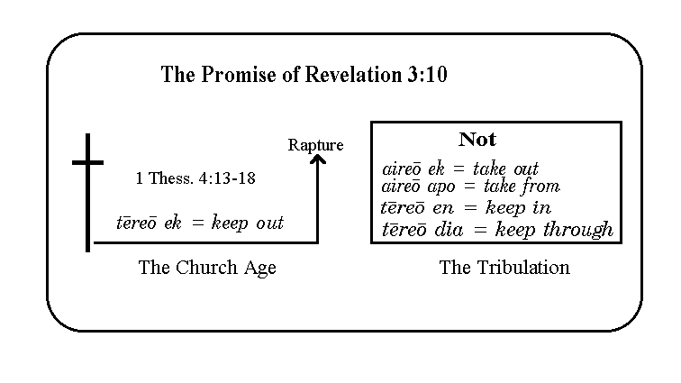

- It would not be right for us to take the promise to the Philadelphians as applying generally to the church - and that includes you and me – if the Lord had not made it quite clear in these other passages that we can count on it.
- The word hour is used similarly in Revelation 14:7 and 14:15.
- In Revelation 14:7 the time of the Tribulation is called “the hour of His judgment”.
- The word hour is used figuratively here and in Revelation 14 to portray the literal 7-year period of unparalleled tribulation that is to come upon the earth.

11 "I am coming quickly; hold fast what you have, so that no one will take your crown.

Notice that when Christ says that He is coming quickly:
- This does not mean that He was telling them that His coming would be soon in their estimation.

- 2 Peter 3:3-9 tells us that though the Lord may come at any time, His coming may seem long to us. ______________________________________________________________
___________________________________________________________________

- What Christ is saying is that when He comes, He will come very quickly and suddenly and once things begin, they will proceed with rapid succession and certainty.

- This is now the 3rd - and last time - that Christ has told a church to “hold fast”:
- Remember, He also said this to the churches at Pergamum and Thyatira.
- What is different here is that He says to hold fast so that no one will take their reward.
- One gets the impression that Christ desires to reward us when we go to be with Him. That is a perspective that He desires for us to have!
- His life in us will bring about that desire in us as we depend upon His life and not our own. The flesh wants to seek reward here on planet earth. Consider the Jews who Christ will make realize that their Messiah loves all who have and will believe Him. Think how they realize they have missed out on their reward.

Read John 2:8 and discuss:

- The warning in Revelation 3:11 is not saying somebody else might get the reward that was destined for us, rather that by giving in to the world and the Satanic enemy, what was to be ours is forfeited.

12 "He who overcomes, I will make him a pillar in the temple of My God, and he will not go out from it anymore; and I will write on him the name of My God, and the name of the city of My God, the new Jerusalem, which comes down out of heaven from My God, and My new name.

Why does Christ say, “My God” 4 times in this verse?
- He said it to the church of Sardis once as well.
- Christ is not denying that He Himself is God – Thomas exclaimed to Christ, “My Lord and My God!” when he saw Christ resurrected.

Here is our answer:
- Christ calls the Father – His Father, “My God”.
- We see that in Mark 15:34 that Christ calls out from the cross, “My God, My God, why have you forsaken Me?” – He is calling out to the Father.
- In John 20:17, Our Lord says to Martha in the garden, on the day of His resurrection, "Stop clinging to Me, for I have not yet ascended to the Father; but go to My brethren and say to them, “I ascend to My Father and your Father, and My God and your God.”

What does Christ mean by “a pillar in the temple of My God”?
- The temple in the New Jerusalem has no physical temple, because the Lord and the Lamb are its temple.
- In Philadelphia, the frequent earthquakes –when they were larger - often toppled pillars – they were not very permanent.
- Even the Jews there had lost their temple a quarter century before, in the attack of the Roman army against Jerusalem.
- In contrast to both of these, the Lord is promising to make these believers a permanent part of the temple, which is a dwelling forever with the Lord.
- No earthquake or army will ever touch it.
- Moreover – their dwelling would be forever with the Lord.

What about this referring to Christ’s “new name”?
- After the emperor Tiberius helped the city rebuild after the earthquake of 17 A.D. the city called itself Neocaesarea to show its gratitude
- Even the “Neo-” preface in the name Neocaesarea means “New”

- Also, during the reign of Vespasian (AD 69-79), who came from the Flavian family, the city showed its devotion to the emperor by calling itself Philadelphia Flavia.
- Here Christ says that He will have a new name, & it will be written on the believers, but it will not be changing all the time!

13 "He who has an ear, let him hear what the Spirit says to the churches.'

The invitation is here for us again. Take a moment to write down something God is teaching you or reminding of.
__________________________________________________________________________
__________________________________________________________________________
__________________________________________________________________________

