Revelation 3:14-22 - Laodicea

Our study of Laodicea brings us to a pivotal place
Laodicea is the 7th and last of the seven churches of Asia Minor. It is the last place that the heavenly church, physically on the earth, is directly addressed in Revelation, until the very last part of the book. While the patterns that have been used as Christ has been addressing the seven churches remains, there are still unique features to the message.

We have said that John writes like a musician, and the character of the ‘musical score’ of Revelation is about to change dramatically. Let’s take a last look at this prophetic masterpiece before that dramatic change.

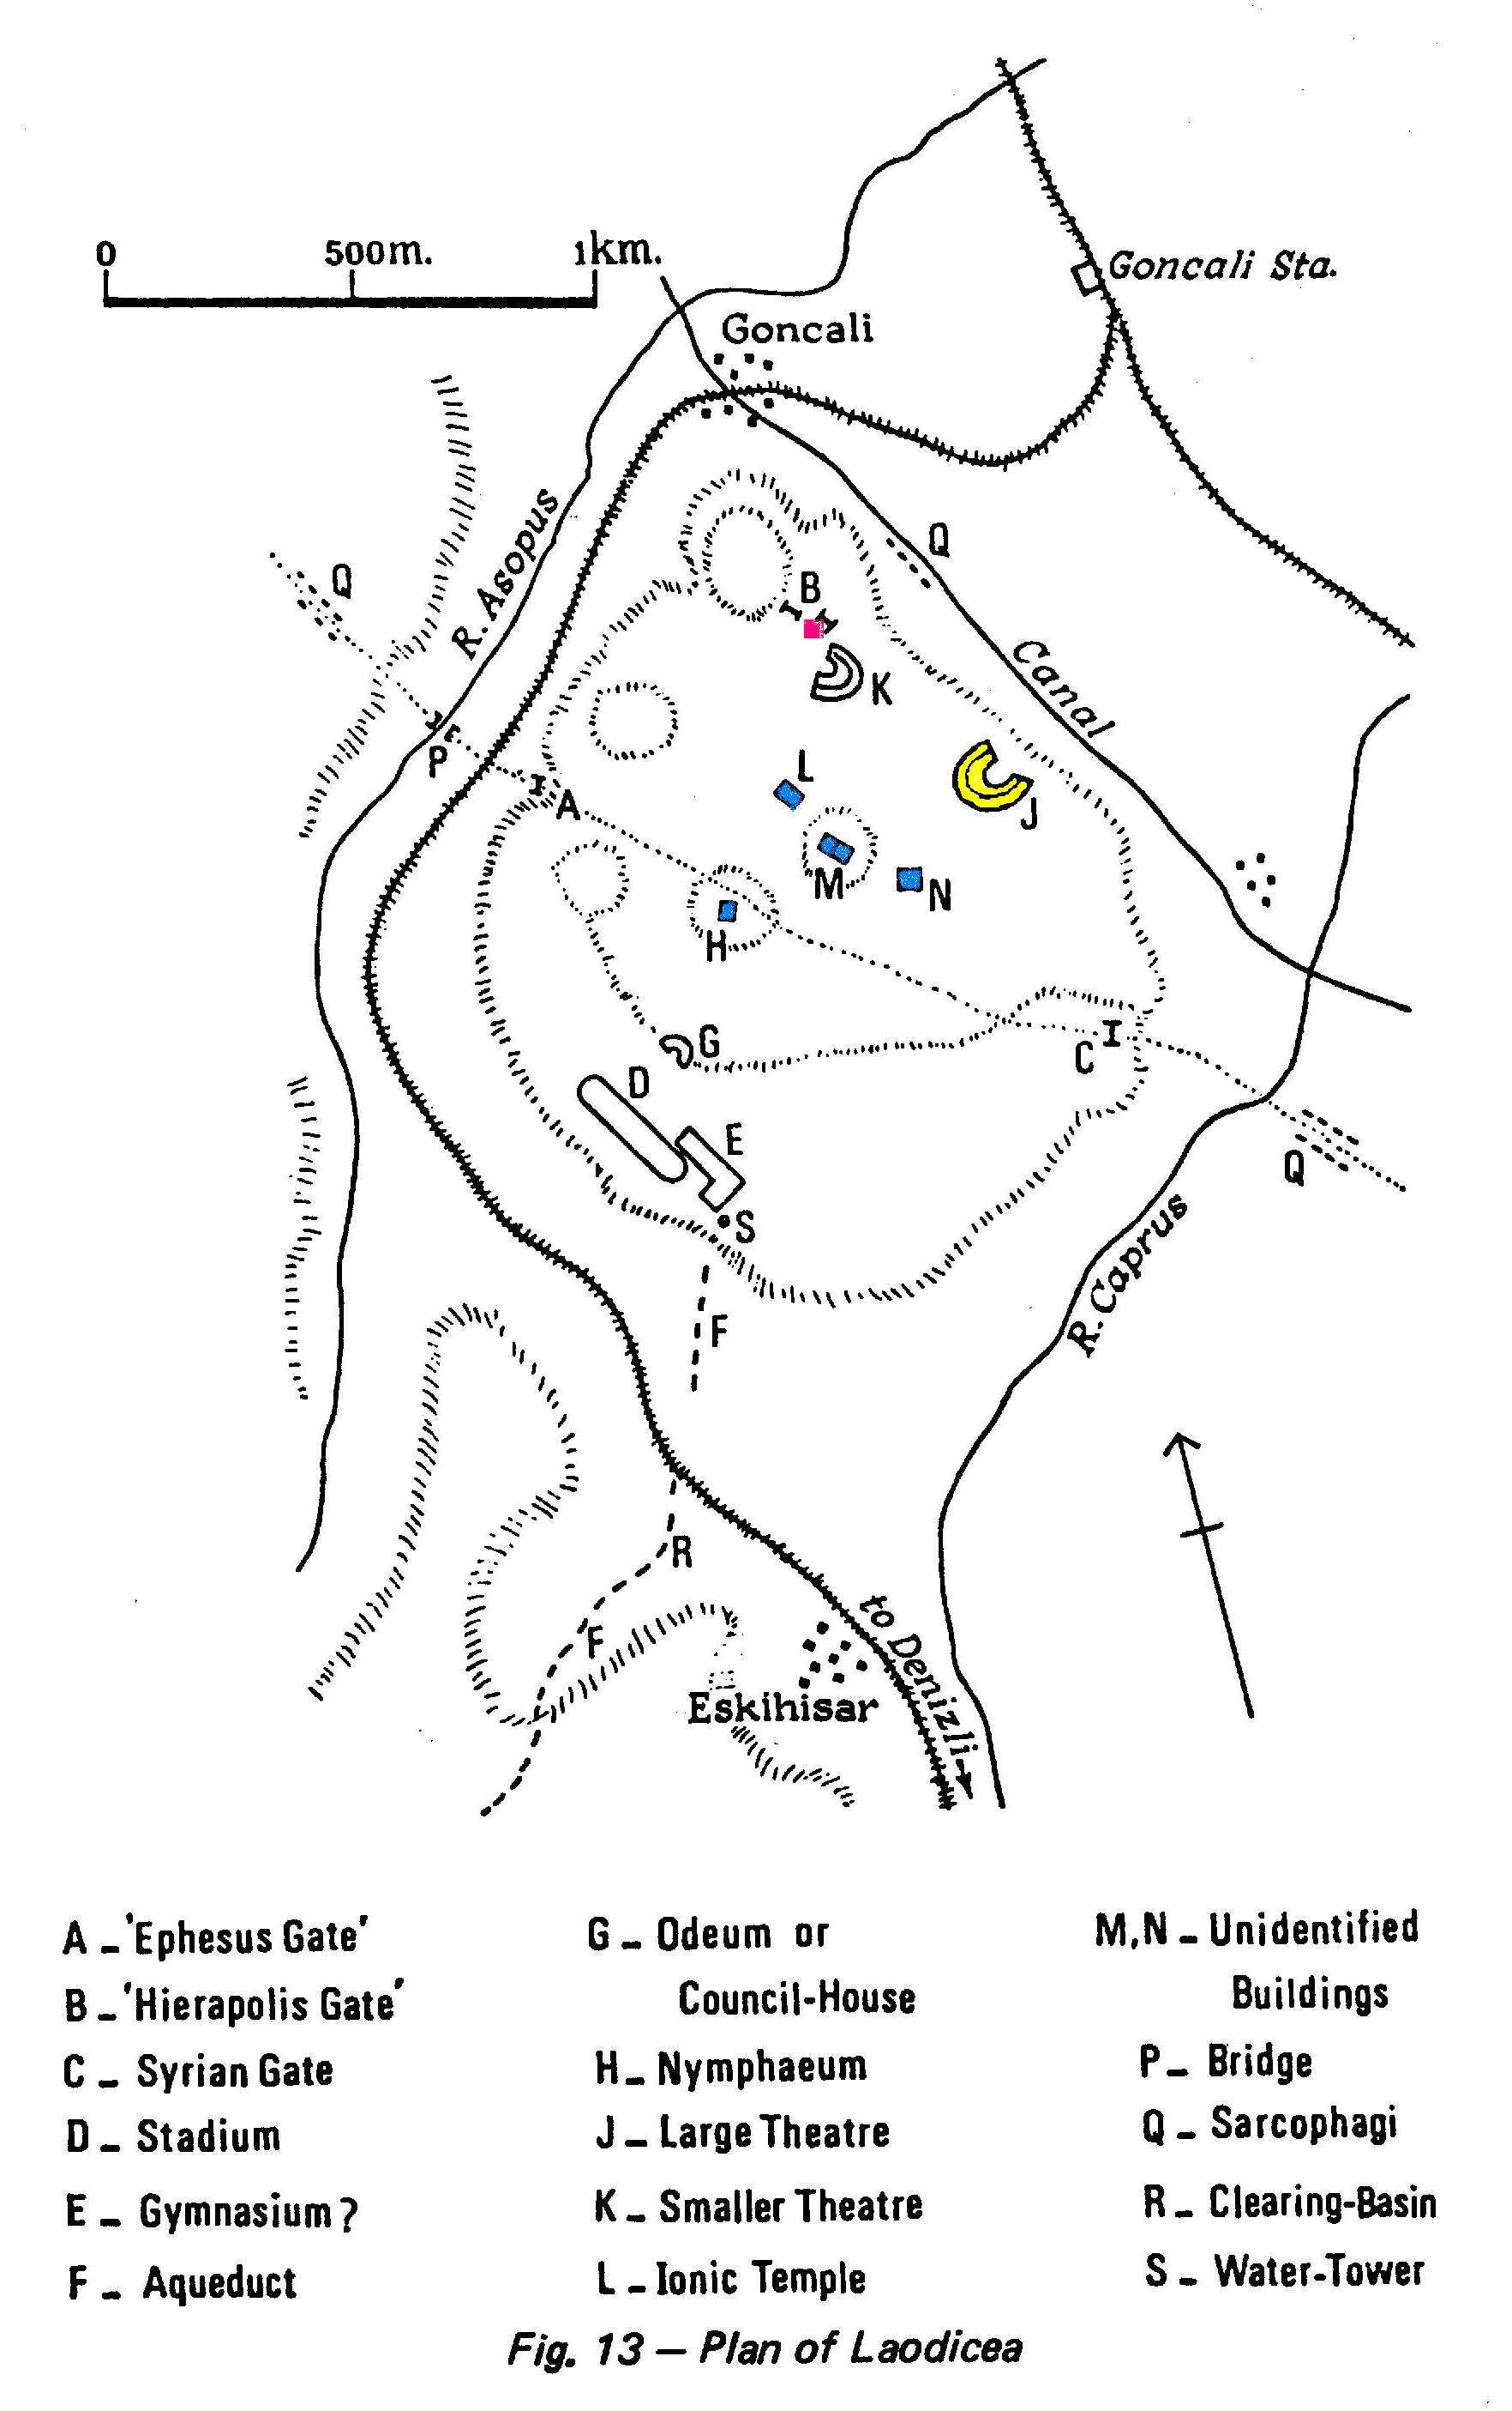
Laodicea’s background
Laodicea lies at a major crossroads in the valleys of Asia Minor. It was was situated on a hill overlooking fertile valleys and majestic mountains, its scenery was beautiful.

Laodicea was an important center for legal administration and commerce. Court cases from the region were heard at Laodicea. Funds were placed in the city's banks for safekeeping. Although damaged by earthquakes during the reign of Augustus (27 B.C.-A.D.14) and again in A.D. 60, the city kept rebuilding with its own funds and prospering.

Laodicea was a center for the regional textile industry, which is a something we’ll want to come back to in a bit. The sheep that grazed in the nearby valleys produced a black wool that was exceptionally soft.

Laodicea had two theaters (J and K on the map on the prior page), the larger one was dedicated to the emperor Vespasian. The city also had a stadium, gymnasium, and other public structures that were sometimes paid for by wealthy benefactors (D and E on the map on the prior page),. Gladiator games were held in the stadium. Laodicea was located near the local temple of Zeus, and a famous school of medicine was connected with this temple.

Laodicea had a significant Jewish community that was given the right to observe the Sabbath and keep other traditional practices. Funds for the support of the temple had been collected at Laodicea from Jews in the region in order to be sent to Jerusalem, until the temple was destroyed in 70 AD. The quantity of gold then collected was large, suggesting that the Jewish community was also large - about 7500 adult males in that district – and they were well off, too. Although there was friction between Christians and Jews in some cities in that area, Revelation does not say that such tensions were a problem at Laodicea, nor are we aware of any such tensions from any other source.

Revelation 3:14
"To the angel of the church in Laodicea write: The Amen, the faithful and true Witness, the Beginning of the creation of God, says this:

This verse was to focus their attention - and ours - on the person of the risen, ascended and seated Lord Jesus, and how He alone is the answer and solution to our every true need. As we’ll see shortly, the promise to the overcomers calls us to the Lord as well.

Now, about “The Amen,”
Amen was a legal term at the time, which would “hit home” with the Laodiceans, since their city was a regional legal center. This is the Greek word “amen”, from the Hebrew word “aman”. “Aman” is from a root meaning “to be firm, stable, sure, established, and trustworthy”. The Hebrew word is used in Isaiah 65:16 of God as “the God of truth,” literally, “the God of Amen.”The word was used to acknowledge and emphasize what was valid, sure and true, or important and significant and we use it that way today.

“Amen” also implied the idea of finality or “the last word”, which leads us to a really good question: Have we come to a place in our perspective on the matters of life where Christ’s word is the last word? I’m not talking about subjecting ourselves to legalism – far from it! What I’m talking about is recognizing in our hearts and minds that we have no place to dicker with the Lord about the truth of what He has said! It’s a matter of recognizing who He is and who we are apart from Him and who we are in Him and that only in beholding Him do we share His glory! Only in Him! Have each one of us come to that place? He is the Amen – the last word!

And as for the phrase, “the faithful and true Witness,” we’ve spoken about that phrase before, but suffice it to say that this is a phrase that in various forms shows up in Revelation again and again. It is quoted here because the phrase has both prophetic and legal meaning – it meant the opposite of “false witness”. Christ was qualified both prophetically and legally to testify, since He spoke the truth without fail. This phrase actually defines the word “Amen” and it gives double emphasis. Again, with Laodicea being a regional legal center, this had a usage the saints at Loadicea could relate to. The testimony of the one who is “faithful and true” was a prerequisite to judgment.

And as for the phrase, “the Beginning of the creation of God”, this is telling us that Christ is the creator of all things. In the identity “Alpha and Omega”, this would be the “Alpha”. The word ‘arche’, translated “beginning” here, means “first cause”, not “first created being”. Colossians 1:15-17 tells us:

15 He is the image of the invisible God, the firstborn of all creation. 16 For by Him all things were created, both in the heavens and on earth, visible and invisible, whether thrones or dominions or rulers or authorities -- all things have been created through Him and for Him. 17 He is before all things, and in Him all things hold together.

When we find that the material things of this universe just don’t hold the satisfaction, answers, and significance they once did, it is then that the truth of this verse starts to hit home, does’nt it? We come to a place of recognizing that the creation itself doesn’t answer the deepest longings of our hearts. We come to realize that we have to go back to the beginning to get the right perspective - and that means to Christ Himself. The One who was at the beginning and is the beginning is the One who is the answer now and will be the answer evermore.

15 "I know your deeds, that you are neither cold nor hot; I wish that you were cold or hot. 16 So because you are lukewarm, and neither hot nor cold, I will spit you out of My mouth."

Like we’ve heard before, the Lord knows their deeds! But the Lord does not elaborate on their deeds. In fact, He doesn’t even list them in the least. He immediately turns His attention to something else: Across the valley from Laodicea was the city of Hierapolis. Laodicea, Colossae and Hierapolis were all three right near one another, Colossae being just upriver from Laodicea and Hierapolis.

Notice also on your map of Laodicea that there was an aqueduct coming from the spring on the south side of Laodicea – the spring being about four miles away, but there seems also to have been more than one spring in one location. Since these three cities were so close to each other, that is why we read about all three of them in Colossians 4:12-16:

Epaphras, who is one of your number, a bondslave of Jesus Christ, sends you his greetings, always laboring earnestly for you in his prayers, that you may stand perfect and fully assured in all the will of God. 13 For I testify for him that he has a deep concern for you and for those who are in Laodicea and Hierapolis. 14 Luke, the beloved physician, sends you his greetings, and also Demas. 15 Greet the brethren who are in Laodicea and also Nympha and the church that is in her house. 16 When this letter is read among you, have it also read in the church of the Laodiceans; and you, for your part read my letter that is coming from Laodicea.

Now here is the reason why taking note of these three cities matters to the fullest understanding of this verse:
- Hierapolis just 6 mi away, had hot water coming from its springs
- Colossae, upriver 10 mi, had cold water springs feeding its water supply
- Laodicea, however, had a hot spring about 4 mi away, so the water from the hot spring turned lukewarm in the aqueduct by the time it reached the city of Laodicea – it was neither hot nor cold!

The word “hot” in this verse is a translation from the Greek word “zestos”. It means “really hot”, even boiling, and is the same Greek word used in Romans 12:10-11, where Paul writes:

Be devoted to one another in brotherly love; give preference to one another in honor; 11 not lagging behind in diligence, fervent in spirit, serving the Lord;

The Greek word behind “fervent” in Romans 12:11 is the same word translated “hot” in Revelation 3:15, 16. Paul’s exhortation - and the Lord’s longing for us, is that we be “boiling”. Are you, by the Lord’s life within you, a “boiling” Christian?

Hot water feels good after a long day of hard work. It helps relieve aches and soreness, and the moisture can feel good to inhale for a time. The hot springs at Hierapolis made for nice, hot therapeutic baths. People use hot water for teas and other hot beverages in many different cultures.

Cold water is good when we are hot and thirsty. It provides the refreshment we seek on a hot day, and it cools the body when we’re overheated. It rehydrates us when we’re needing it most.

But lukewarm showers are not desirable on a cold day. We all know the disappointment when the hot water tank starts to turn cold just before it’s our turn to shower. And a nice lukewarm glass of water when it’s hot just doesn’t sound right. Someone who is tired and in need of water isn’t usually longing for a lukewarm glass of water. That is why Christ says that He would rather that they were hot or cold. Lukewarm is just not right!

The physical characteristic of the water made a perfect illustration for the spiritual characteristic of the church in this city! The saints at Laodicea had simply become so complacent that they were spiritually lukewarm. They were neither refreshing to the spiritually weary nor therapeutic to the spiritually ill:
  - Ephesus had lost its 1st love of Christ and from Christ!
  - Sardis had lost its life which only comes from dependence upon Christ!
  - Laodicea had lost its zeal for Christ and zeal which comes from Christ!

Most translations have it that Christ says He will spit or spue them out of his mouth. That is a weak translation of the Greek word. The Greek word emesai actually means “vomit”. To “spit” is another Greek word altogether. Christ’s rejection of their lukewarmness was nauseating! To the Lord, indifference is worse than opposition. Nominal, apathetic, indifferent Christianity not only does not please Christ – He finds it repulsive and nauseating!

17 "Because you say, "I am rich, and have become wealthy, and have need of nothing," and you do not know that you are wretched and miserable and poor and blind and naked, 18 I advise you to buy from Me gold refined by fire so that you may become rich, and white garments so that you may clothe yourself, and that the shame of your nakedness will not be revealed; and eye salve to anoint your eyes so that you may see.

Worldly wealth can cloak spiritual poverty. Notice what Paul writes to the church at Colossae - and remember that Paul wanted this letter read in Laodicea as well

Colossians 2:1-3
For I want you to know how great a struggle I have on your behalf and for those who are at Laodicea, and for all those who have not personally seen my face, 2 that their hearts may be encouraged, having been knit together in love, and attaining to all the wealth that comes from the full assurance of understanding, resulting in a true knowledge of God's mystery, that is, Christ Himself, 3 in whom are hidden all the treasures of wisdom and knowledge.

Do you notice Paul’s emphasis on spiritual wealth from about 45 years earlier? We know, however, that over the decades between the writing of this letter to the church at Colossae, until the time of the writing of Revelation four and half decades later, Colossae went into economic decline while Laodicea gained even more wealth.

When Christ says that they are wretched, it means that they were in an awful condition! This is the same word Paul uses in Romans 7 when he says, “O wretched man that I am”!

When Christ describes them as miserable, the Greek word means to be worthy of extreme pity, and was used in those days to describe those who had been pillaged and devastated by an invading army. They were in the worst possible state!

When Christ tells them that they are poor, He is saying that they are like stooping beggars! Desperately poor – scavenging for crumbs! What a sharp contrast from their self-assessment that they needed nothing!

When Christ says they are blind, He is likely making reference to the fact that the Laodiceans produced a world famous eye salve from the local mineral deposits, which was a mixture of the Phrygian powder and olive oil. Such remedies were peddled throughout the length and breadth of the empire by itinerant vendors and marked with specially prepared stamps. The Laodiceans made this world famous eye salve, and they were famous for their medical school. But these did little to cure their spiritual blindness. He was telling them that they could not see their own spiritual condition.

When Christ informs them that they are naked, He is no doubt making a contrast with the textile industry for which Laodicea was famous and which contributed to their wealth. As we mentioned earlier, Laodicea had a huge textile business, centered around the raven black wool grown in that area. A certain type of fabric came to be known as “Laodicean”. A particular type of tunic made in Laodicea was known as a ‘trimita’. It was so popular and well-known that people nicknamed Laodicea “Trimitaria”, after the trimitia tunic. But Christ was telling them that in contrast to their wealth from textiles, they were spiritually naked!

In verse 18 Christ tells them, “I advise you to buy from Me gold refined by fire so that you may become rich,”. No they cannot afford to buy anything Christ has to offer, because, it is Christ’s price to pay. He is telling them that in Him will they find richness.

…and white garments so that you may clothe yourself, and that the shame of your nakedness will not be revealed; The Laodiceans were famous for their textiles and garments, and for the black wool of which many of their garments were made. But here Christ tells them to buy white garments – His purity. He tells tham that their black ones would not do. They must be clothed in Christ!

…and eye salve to anoint your eyes so that you may see. We talked about the production of eye salve at Laodicea before. Christ’s eye salve – the insights from Christ - would allow them to see spiritually, which they had not been doing before because of their spiritual blindness.

In the first half of verse 19 Christ says, "Those whom I love, I reprove and discipline”

Hebrews 12:6
Repent: What it is…
- English word conveys the idea of sorrow or contrition
- Greek idea focuses more on total change in thought & behavior based on a fundamental change in terminal values, the values of God, & indicates that we are to make a decision decisively (Luke 3:8, Hebrews 6.1, and Acts 26.20)

Repent: What it is not…
- a vow that we will never do it again
- a determination to do better next time
- a promise to serve the Lord
- crawling our way back to God
- a guilt complex whereby we feel bad about sins
- a legalistic way of trying to get God's approval
our best efforts

… for those whom the Lord loves He disciplines, and He scourges every son whom He receives.

Notice that He says that He loves them, but He is telling them that discipline – and the Greek word here means “child training” - is coming upon them unless they repond to Christ in His appeal to “… therefore be zealous and repent.”

He is exhorting them to be zealous – to have the zeal that they do not have now, being spiritually apathetic. The word ‘repent’ is used eight times in the messages to the churches (this is the last one). It is used four more times in the book of Revelation after this, but in each of those instances it is phrased, “did not repent…”.
20 "Behold, I stand at the door and knock; if anyone hears My voice and opens the door, I will come in to him and will dine with him, and he with Me.

We see the word “behold” again, so let’s stop, and take a mental picture. In that place and time, the custom was to come to the door and knock while calling out your name (see Acts 12:13-14 - Peter at the door). That is why Christ here knocks and then says that if anyone hears His voice and opens the door that He will come in. This verse is often used for evangelistic purposes, and it may well be that there were unbelievers among the nondescript Christians in Laodicea, but Christ is here appealing to believers who already have a relationship with Him to be in fellowship with Him. He told them in the verse before that He loves them – using the Greek word phileo: typically, a love that is based on existing relationship.

It is possible for believers to indeed have a relationship with the Lord, but lack fellowship with Him. It was the issue of fellowship that Christ was addressing here. Isn’t that the key point of this passage? Christ desires to fellowship with us. When He says to repent, it is not that He desires that we just get busy or get religious, or feel bad about things, but that He desires fellowship with us.

21 "He who overcomes, I will grant to him to sit down with Me on My throne, as I also overcame and sat down with My Father on His throne.

Ephesians 1:19b-20
These are in accordance with the working of the strength of His might [that’s the Father’s might – we know from vs 17] 20 which He brought about in Christ, when He raised Him from the dead and seated Him at His right hand in the heavenly places,

Ephesians 2:4-7
4 But God, being rich in mercy, because of His great love with which He loved us,
5 even when we were dead in our transgressions, made us alive together with Christ (by grace you have been saved), 6 and raised us up with Him, and seated us with Him in the heavenly places in Christ Jesus, 7 so that in the ages to come He might show the surpassing riches of His grace in kindness toward us in Christ Jesus.

Positionally, this has already been accomplished - we can know it by faith. But in our present condition – how we are here on planet earth – we might be either resting and living in our eternal position or not – and the Laodicean believers apparently were not. Their present condition was not matching their eternal position. What Christ is promising the overcomers (those who have placed their faith in Christ for salvation) is that a time would come when they would be seated with Him in the heavenly places such that their condition would be identical with their eternal position. This will be true of us as overcomers, when we walk through heaven’s gates. We will be seated with Him, but it will not then depend upon faith, because our faith will have been fulfilled. It will be eternal reality, because we will see Him as He is.

22 "He who has an ear, let him hear what the Spirit says to the churches.'"

