Revelation 5:6-10 – Sing It!

Be it never so humble, there’s no place like our heavenly home

We are continuing to look at the heavenly scene through the eyes of John. This is home – home with Christ our Savior, the Lamb who was slain for each one of us.

6 And I saw between the throne (with the four living creatures) and the elders a Lamb standing, as if slain, having seven horns and seven eyes, which are the seven Spirits of God, sent out into all the earth.

John again says that he saw, that is, he witnessed the things that he recorded for us in these verses. The Being who is drawing all of his attention, and all the attention of those in the heavenly throne room, is standing between the throne, which is surrounded by the four living creatures and the 24 elders. Verse 5, and now verse 6 refer to the 24 elders as simply ‘elders’, having given us enough context so that we know who these beings are. They are, as we saw a few weeks back, representatives of the resurrected and glorified Church – the Body of Christ in heaven. But neither the four living creatures nor the elders are the focus of John’s attention, but rather a Lamb.

A Lamb standing, as if slain,
This reference to Christ as the Lamb is drawing upon the 53rd chapter of Isaiah, where the entire chapter, given about seven centuries before the birth of Christ, tells of the Messiah’s suffering on our behalf.

In Isaiah 53, the seventh verse, the Messiah is described as being like a lamb led to slaughter – taking the penalty due for sin - on our behalf. Now, in the New Testament outside of Revelation, it is only John’s gospel that directly refers to Christ as the Lamb.
This is shown in the gospel of John chapter 1, verses 26 and 29, where John the Baptist proclaims in each place, “Behold, the Lamb of God…”. In Revelation, Christ is referred to as “the Lamb” also, but with differences. In each of the references in John chapter 1, John the Baptist is declaring Christ as the Lamb, but at that point in history Christ had not yet been slain. He had not yet been given - in the context of history - as God’s sacrifice for your sin and for mine. But in Revelation 5:6, Christ is seen as having been slain.
John describes Him as standing “as if” slain, though he would never again describe the Lamb with “as if”. Subsequent references to “the Lamb” in Revelation will refer to Him as simply “slain”.

This verse is the first of 28 references in Revelation to Christ as a or the Lamb. Christ is referred to as a or the Lamb more frequenetly than any other title in Revelation. It is a name which transcends all ages and spans of time, and continues on into eternity. Even though God will ultimately wipe away every tear from our eyes, for eternity we will still refer to Christ our Lord as “the Lamb” – the One slain in our place (Revelation 21:9, 14, 22, 23; 22:1, 3).

The Lamb and the Little Lamb

Christ the Lamb is referred to in the book of Revelation as “the Lamb”, in a way which differs from how He is called “the Lamb” in the gospel of John. In the gospel of John He is twice referred to as “the Lamb” (Greek: amnos). But in the book of Revelation, in every instance where Christ is called “the Lamb”, the Greek word is arnion = “The little Lamb”.

Is it not amazing that in this awesome heavenly scene where Christ is so prominent,

where He alone is qualified to open the seals, and who will be the One who expresses wrath to those still upon the earth, and who will be described as having a huge barbarian’s sword coming out of His mouth, and will conquer the earth with the word of His mouth, and reign upon the earth for 1000 years, that this same One would be referred to as “the little Lamb” – diminuitive - all the way on into eternity future!

having seven horns and seven eyes, which are the seven Spirits of God, sent out into all the earth.

The figurative meanings of horn or horns:

Two principal applications of this metaphor will be found: strength and honor. Horns being the chief source of attack and defense with the animals to which God has given them, they are employed in Scripture as emblems of the power of God (Ps 18:2), of Christ (Luke 1:69; Rev 5:6), of Ephraim (Deut 33:17), of the wicked (Ps 22:21; 75:10), and of the righteous, of kingdoms (Dan 7:7-8,24; 8:3,5-6,20), and of anti-Christian powers (Rev 13:1; 17:3,7).

The budding or sprouting of horns is figurative of the commencement or revival of a nation or power (Ps 132:17; Ezek 29:21); raising up, of arrogance (Ps 75:4-5) and also of glory (v. 10); exalting, of increase of power and glory (1 Sam 2:1,10; Ps 89:17,24; 92:10; 112:9); pushing with, of conquests (Deut 33:17; 1 Kings 22:11; Mic 4:13); bringing down, of degradation (Job 16:15, I have "thrust," i.e., laid low, "my horn in the dust," as a wounded animal); cutting off, of destruction of power (Ps 75:10; Jer 48:25; Lam 2:3).

From The New Unger's Bible Dictionary. Moody Press of Chicago, IL 1988

A “horn”, in the Jewish understanding of things, represents ‘power’. The word “horn” or “horns” is used that way in both Old and New Testamants.

- The horns of an animal, as in male sheep (rams) are used for defense and for attack.
- Horns can be used to hit suddenly with force, knocking someone down.
- The horns can also be used to push with a continuous motion, so as to push someone in any direction.
- The symbolism of the horn or horns can mean either power used in a good way, or in a bad way.
- Obviously as it refers to Christ, the intention is to convey power in a good sense.
- Here Christ, the little Lamb, is described as having seven horns.
- Now we know that creatures do not typically have seven horns; two is the norm for most creatures.
- The number seven is given for three different things in this verse.

Now we should not be inclined to accept symbolism of various kinds in this passage or in any other passage, unless the meaning of a symbol is either very evident in the Scriptures, or clearly understood by a study of the culture to which the book is addressed. In the book of Revelation, the number seven is used so frequently, that it can hardly be ignored, and we’ve got three instances of the use of the number seven in this verse alone: seven horns, seven eyes and seven Spirits.

Seven is the number of completeness - totality
God made the world in six days, and rested on the seventh, commanding Israel to observe the same, with seven days in a complete week. God commanded Israel to do the same with the land for seven years instead of seven days: work the land for six years, then let it rest for a year. When God warned Israel not to disobey in Leviticus 26, He told them if they disobeyed, He would increase the plagues upon them seven times. So seven, among the Jews, was the number of totality and completeness.

Therefore, if the Lamb had seven horns and seven eyes, and the seven fold Holy Spirit, that tells us that His power, His vision, insight and understanding which are the expression of the Holy Spirit through Him are complete and total. The Lamb is all-powerful (omnipotent), and all-knowing (omniscient).

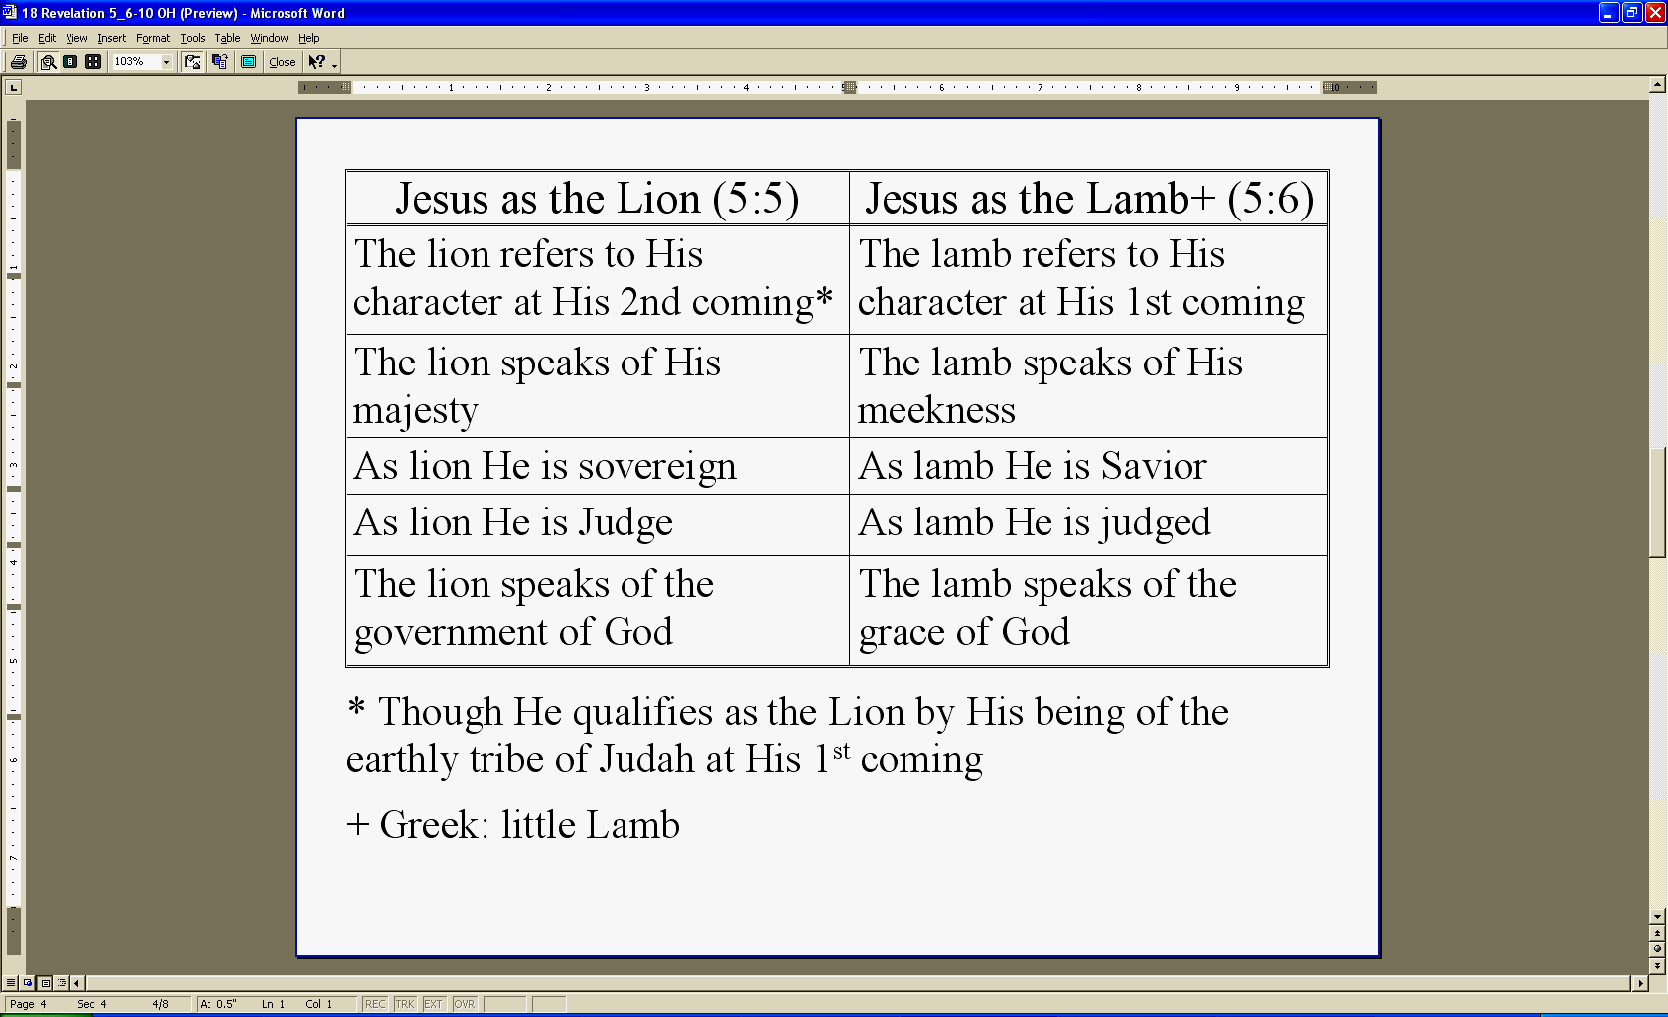
Notice some of the contrast between Christ as the Lion from verse 5 and Christ as the little Lamb from verse 6.

Though He qualifies as the Lion by His being of the earthly tribe of Judah at His first coming, what is amazing to ponder at this point is that this little Lamb, this Root of David, this Lion of Judah, this omnipotent and omniscient being, who is worthy to receive and break the seals and open the scroll…

Is the One with whom we have been identified, which God has accomplished because of our faith in Him. We were identified, that is, united with Him, in His death, burial, resurrection, ascension and seating in the heavenlies. He is the One whose glory is being shared with us, as we behold Him, we are being transformed from glory to glory. So what we are seeing here is not something alien to us and our identity. It is being revealed to us in detail here so that we will better understand who we are in Christ and our future in Christ and where we live now in our position in Him.
7 And He came and took the book out of the right hand of Him who sat on the throne.
This is not the first time that Scripture records that our Lord Jesus Christ took a book.
Luke 4:16-21 records that when Christ was in Nazareth, His home town, He took a book then Christ read the book then, and He read from Isaiah 61:1 and 2. But He stopped in the middle of verse 2 of Isaiah 61, because up to that point the reading applied to His first coming, what Christ did not read in the synagogue of Nazareth that day had to do with His second coming. If Christ had continued on with that verse – that passage – He would have read Isaiah 61:2, “…And the day of vengeance of our God”. But He did not read that part of the verse because that time had not yet come. At the time we are reading about in Revelation chapter 5, a time yet furture to us, that time has come. Christ’s first coming had to do with declaring the Messiah to Israel and bringing in the means of salvation – through Christ’s death. Christ’s second coming – now about to be unsealed, would be brought in for judgment against mankind – those who had rejected the provision made for them through the little Lamb of God – slain for them.

What we see in verse 7 is not just the passing of some ordinary book from one person to another. It is the Father’s declaration that now is the time. It is the declaration of the One sitting on the throne that after the centuries of earth time have gone by, after men upon the earth have in great part figured that everything will always go on as it has…that now at this pivotal moment in history a massive change is about to take place. The end time clock has just ticked to that pivotal instant when the Father hands the scroll to the Son – the Lamb – and the millennium of Christ the Messiah’s reign on earth will be ushered in with a seven year period of judgment and transition. It will include a final and unmistakable appeal to mankind to look to the Lamb, God’s little Lamb, while there is still time.

This is not just a matter of the timing of the Father – though it certainly is that. The Father knows the right time for the church age to end. The Father knows just the right time to bring us home. He knows just the time to set up the transition period into the Millennial reign of Christ. But this brief sentence, verse 7, is also packed full of significance about another pivotal matter:

It is not only about the One sitting on the throne who with His right hand is passing off this eternally significant and unique scroll. It is also about the worthiness and qualifications and character of the One who is receiving the scroll into His hand. It is about Christ, the Lamb, and His unique qualifications to receive the scroll. Only Christ the Lamb of God – the little Lamb:
- Was slain from the foundation of the world
- Was promised from the day man first chose to take the path God had forbidden
- Was foretold to generations in hundreds of prophecies
- Was born of Abraham’s seed, then Judah’s, then David’s, in Bethlehem, fulfilling every prophecy about His coming
- Was God’s sacrifice for us who could not buy our own way out
- Was crucified, buried, resurrected, ascended and seated in the heavenlies
- That One – fully God and fully man - was the singular One who could take the scroll and open it

We’re reading about this pivotal moment right now. Someday, and I hope it’s soon, we’ll watch this event together, and this is how you and I will respond to what we see.

8 When He had taken the book, the four living creatures and the twenty-four elders fell down before the Lamb, each one holding a harp and golden bowls full of incense, which are the prayers of the saints. 9 And they sang a new song, saying,

Imagine when we see these four living creatures withour own eyes. We’ll see the elders, because they will be us. Their response when they see the passing of the book is not, “Well, there goes another one of those books being passed!” No, they respond by falling on their faces before the Lamb. They recognize the significance of this moment. But even more, they recognize the incomparable worth and matchless glory of the Lamb! That is what, or rather who, they are responding to.

Some of the words and phrases in verses 8 and 9 come straight out of Old and New Testament passages:

Psalms 33:1-3
Sing for joy in the LORD, O you righteous ones;
Praise is becoming to the upright.
2 Give thanks to the LORD with the lyre;
Sing praises to Him with a harp of ten strings.
3 Sing to Him a new song;
Play skillfully with a shout of joy.

Psalms 144:9
I will sing a new song to You, O God;
Upon a harp of ten strings I will sing praises to You,

Psalms 141:2
May my prayer be counted as incense before You;
The lifting up of my hands as the evening offering.

Luke 1:8-10
Now it happened that while he [Zachariah] was performing his priestly service before God in the appointed order of his division, 9 according to the custom of the priestly office, he was chosen by lot to enter the temple of the Lord and burn incense. 10 And the whole multitude of the people were in prayer outside at the hour of the incense offering.

where the prayers of the saints are
Those who have put their trust in Christ for salvation are saints. Prayers of the saints are in the presence of God, in God’s throne room. Next time you are praying and you are wondering what God is doing with these prayers of yours, think of this passage. The prayers of the saints are held in golden bowls, containers of value. This tells us that God treasures our prayers. They don’t end on planet earth. The golden bowls and incense are symbols of the spiritual reality in the heavenly realms.
Here is what the four living creatures and the heavenly elders sing – their new song:

9 "Worthy are You to take the book and to break its seals; for You were slain, and purchased for God with Your blood men from every tribe and tongue and people and nation. 10 "You have made them to be a kingdom and priests to our God; and they will reign upon the earth."

The Lamb, that little Lamb, is being declared worthy to open the seals. As we studied last week:

- Both Jews and Gentiles would recognize that only the person qualified to open the scroll could do so.
- This is not just some sort of nice song, but it is a public proclamation that the Lamb is worthy to open the seals and the scroll.
- These heavenly beings are witnesses to His worthiness, and we will be there.

