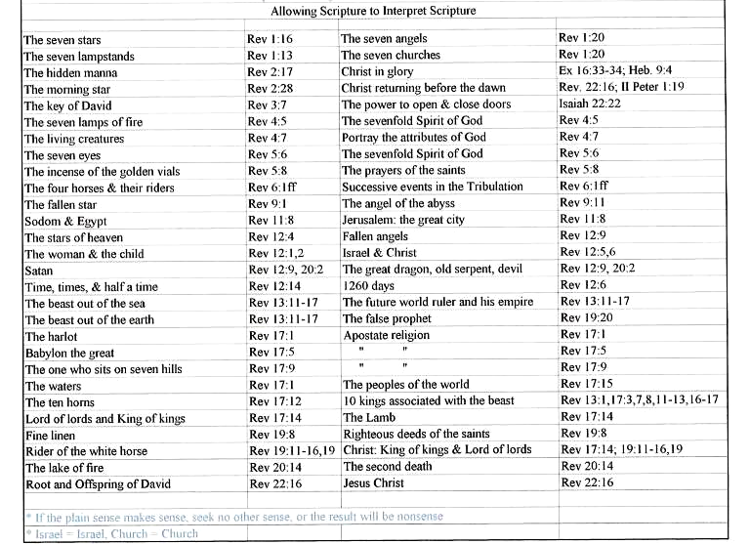

Literal Interpretation
- Old Testament Authors
- Jews following completion of Old Testament (Matthew 2:5, Micah 5:2)
- Christ (Spoke of a real Moses and Abraham)
- Apostles
- Orthodox Jews

If the plan sense makes sense, seek no other sense, or the result will be nonsense.

Allegorical Interpretation
- Plato interpreted the Greek myths as allegories.
- Philo, a Jewish scholar, started interpreting the Old Testament as an allegory.
- Origen, a Christian scholar, viewed the Old and New Testament as an allegory.
- Augustine also viewed Scripture as an allegory.
- The Catholic Church carried on this view.
- Even many reformed churches viewed Scripture, particularly prophecy, as an allegory.

“By these winds we suppose are meant those errors and corruptions in religion which would occasion a great deal of trouble and mischief to the church of God.” Matthew Henry
Winds are longer winds and the passage suddenly has a very different meaning.

Remnants That Aren’t For Sale

Jehovah’s Witnesses say that Jesus is the Archangel and he is the other angel seen in this passage. Also that the 144,000 are those faithful Jehovah’s Witnesses who are saved by works and destined for heaven up to the year 1935 because in the year 1935 they had 144,000 and after that there wasn’t anymore room in heaven. So, the rest of Jehovah’s Witnesses would fill the new earth.

That is the Jehovah’s Witnesses allegory for this passage. It’s no longer about what the Bible actually says, rather it’s about what someone has made it to mean. Israel is no longer Israel and the Tribes are no longer the Tribes. The passage again is suddenly saying something very different than what it intends.

The problem with allegorical interpretation is that there is no control over what the passage could mean. In fact it could mean anything. Whatever I want it to mean and since I want to be in control I’ll make it out to be something that pleases me or pleases the masses or pleases political correctness or pleases fill in the blank_________________,

We’re not going to do that. We’re going to opt for the literal method that Jesus and the Apostles used and know what we’re reading. Here we go...

1 After this I saw four angels standing at the four corners of the earth, holding back the four winds of the earth, so that no wind would blow on the earth or on the sea or on any tree.

Does this “four corners” teach that the earth is flat? Is the Bible full of myths and nonsense?
No. In the Old Testament, Job 26:7 explains that the earth is suspended in space, the obvious comparison being with the spherical sun and moon that everybody could see.

A literal translation of Job 26:10 is:
"He described a circle upon the face of the waters, until the day and night come to an end." A spherical earth is also described in Isaiah 40:21-22 - "the circle of the earth". Proverbs 8:27 also suggests a round earth by use of the word circle. If you are overlooking the ocean, the horizon appears as a circle.

Now can you imagine what people on the earth will be thinking at that moment? “We’ve had a powerful conqueror, horrific war, famine, pestilence, and unprecedented cosmic disturbances….” Now that the wind has stopped, “Does this mean these earth-shattering crises are over…or is this just the calm before the next storm?” It’s kind of like when the kids in the house are really, really quiet…you just know that there’s some serious trouble brewing, right?

2 And I saw another angel ascending from the rising of the sun, having the seal of the living God; and he cried out with a loud voice to the four angels to whom it was granted to harm the earth and the sea,

Notice that God is not simply called “God” in this verse He is called the “living God”. He is living, as opposed to the Antichrist, who reigns on earth during the Tribulation period. The Antichrist is not only no god at all, but he is as good as dead. His time will soon come to an end.

The phrase “living God” is used 28 times in Scripture and every time it’s used it is bursting with significance. This is the last time it is used in Scripture, but we have been told in Colossians 3:4:

“When Christ, who is our life, is revealed, then you also will be revealed with Him in glory.”

This world’s gods are as good as dead, and have no life in them at all. But we have the resurrection life of Christ. We serve a living God, not a dead one and He is our life! Right now! Right here!

The importance of seals and what they meant in cultural context:

Matthew 27:66

And they went and made the grave secure, and along with the guard they set a seal on the stone.

John 3:33

“He who has received His testimony has set his seal to this, that God is true. “

John 6:27

"Do not work for the food which perishes, but for the food which endures to eternal life, which the Son of Man will give to you, for on Him the Father, God, has set His seal."

Three characteristics of a seal:
- Identification
- Authority

Protection
Because of the seriousness of falsifying an official seal in the Roman Empire (capital punishment), something that was sealed was considered to be unquestionably true.

3 saying, "Do not harm the earth or the sea or the trees until we have sealed the bond-servants of our God on their foreheads."

Characteristics of a Bond Servant:
- Owned by someone else – they had been bought.

1 Corinthians 6:19-20
19 Or do you not know that your body is a temple of the Holy Spirit who is in you, whom you have from God, and that you are not your own? 20 For you have been bought with a price: therefore glorify God in your body.

1 Corinthians 7:23
23 You were bought with a price; do not become slaves of men.

- Their wills were entirely subject to another another’s will

The Seal of Revelation 7:3,4: Why?

Identification: Soldiers and craft guild members were often marked on their foreheads to show that they belonged to or were devoted to a pagan deity

- Authority: They would speak with the authority of the living God, proclaiming the true Gospel

Protection: Revelation 9:3-4
3 Then out of the smoke came locusts upon the earth, and power was given them, as the scorpions of the earth have power. 4 They were told not to hurt the grass of the earth, nor any green thing, nor any tree, but only the men who do not have the seal of God on their foreheads

Contrast: The mark of the beast would soon come (Revelation 13) which would be condemning.

4 And I heard the number of those who were sealed, one hundred and forty-four thousand sealed from every tribe of the sons of Israel: 5 From the tribe of Judah, twelve thousand were sealed, from the tribe of Reuben twelve thousand, from the tribe of Gad twelve thousand, 6 from the tribe of Asher twelve thousand, from the tribe of Naphtali twelve thousand, from the tribe of Manasseh twelve thousand, 7 from the tribe of Simeon twelve thousand, from the tribe of Levi twelve thousand, from the tribe of Issachar twelve thousand, 8 from the tribe of Zebulun twelve thousand, from the tribe of Joseph twelve thousand, from the tribe of Benjamin, twelve thousand were sealed.

The 12 Tribes of Israel
The 12 sons of Judah
Genesis 49 | Revelation 7
Reuben | Judah
Simeon | Reuben
Levi | Gad
Judah | Asher
Zebulun | Naphtali
Issachar | Manasseh
Dan | Simeon
Gad | Levi
Asher | Issachar
Naphtali | Zebulun
Joseph (sons: Manasseh & Ephraim) | Joseph
Benjamin | Benjamin
*Names dropped in Revelation 7 list of tribes

These tribes were dropped from the list of the 12 Tribes of Israel between Genesis 49 and Revelation 7:

DAN is omitted because the tribe left its inheritance and moved north to Laish and practiced idolatry. They chose to move away and settle in the vicinity of Tyre and Sidon, thereby rejecting the word of the Lord. Being the only tribe that failed to conquer its territory (Judges 1:34), it turned to idolatry as an alternative to obeying God (Judges 18:14-31).

EPHRAIM, the ½ tribe under Joseph, is omitted because it, too, was idolatrous (Judges 17:1-13). Ephraim was foremost in the defection from the house of David (2 Samuel 2:9) and was an ally of the enemies of Judah (Isaiah 7:2, 5; Hosea 5:3).

Replacing Dan and Ephraim in the list of the 12 Tribes of Israel in Revelation 7:

MANASSEH and JOSEPH: A peculiar characteristic of the breakdown of Revelation 7:5-8 is the inclusion of Manasseh and Joseph in the same list. Manasseh was the faithful son of Joseph. Joseph was given a double portion by Jacob (Genesis 17:16-17; 37:3), so this may explain both Joseph’s name and his son Manasseh’s name in the list of the 12 tribes.

