Revelation 9:1-12 – Unwelcome Visitors

What we just did, and what we’re about to do

We finished taking a look at Revelation chapter 8 last week, and that took us through the 2nd through the 4th trumpet judgments. We heard a warning from mid-heaven, which is the place of high noon, about three more trumpet judgments to come: the three “woes”. In Greek they were called - are you ready for this: ouai! There are three of them, and this morning we will look at the 5th trumpet judgment, which is the 1st of the three ouais. There is so much description and detail that it will take our entire time to address all the content satisfactorily. This judgment involves some fascinating spiritual insights into Satan and other demonic spiritual beings.

1 Then the fifth angel sounded, and I saw a star from heaven which had fallen to the earth; and the key of the bottomless pit was given to him.

We’ve read about how the other angels sounded the trumpet, so this is no different in that respect. But what is different is that these blasts from these military trumpets clearly revealed physical consequences from the heavens. This trumpet blast, however, has both spiritual and physical consequences. In this case, John tells us he sees a star, which in the Greek is aster. The rest of the context, however, makes it clear that John’s use of the word “star” is figurative for a personal being, and not a physical object .

The indicators that this is referring to a personal being are:

- Use of the personal pronoun “he” or “him” in verses 1 and 2 implies that this is a personal being. In the Greek text, the pronoun “him” is an intensive, personal pronoun, so it is very specific.

- This aster is given a key and he turns around immediately and uses it, as we’ll see in verse 2, which is consistent with a “personal being”, but is not consistent with an impersonal object.

While a great many of the prior judgments have been substantially physical in nature, such as falling meteors, earthquakes, etc., this particular judgment involves special and limited authorization that is given to Satan and his hierarchy of imprisoned demons. In order for us to get the right sense of what is happening here, we must first lay a foundation regarding the Scriptural teaching about Satan and fallen angels. We will be referring to a number of other passages, and while we will not have time to go into detail in any other passages, we will be drawing truths from them in order to get the background of understanding necessary to properly understand our passage at hand. At times we will reference other resource so that you can pursue those for more detail, if you would like to do so. Then we will proceed directly through this passage this morning.

Some Biblical Truths About Angels:

All angelic beings were created at once:
(Job 38:4-7; Colossians 1:16)

They are neither male nor female, but are represented as males:
(Matthew 22:30; Genesis 18:1, 2)

Angels were created holy with a time window within which they had the power of contrary choice: (Mark 8:38; Jude 6)

One third of the angels chose against God and the other two thirds chose with God. Those who rebelled were sentenced, and the wills and eternal destinies of each group of angels were thereafter fixed: (Revelation 12:3, 4; Matthew 25:41; Mark 5:1-7)

As the text box above shows, all angelic beings were created at once. Some hold that they were created with the rest of the physical creation, others that they were created before. But the Job 38 passage assures us that they were created no later than the initial physical creation. Unlike human beings, which are brought into being spread over time, angels were brought into existence all at once, with no evidence of baby angels, as cute as that might seem to us human beings.

They are neither male nor female. Interestingly, while our culture for centuries has represented angels often as babies and women, those instances where we have evidence from Scriptures indicates that they took on a male appearance when in physical bodies.

Angels were created holy with a time window within which they had the power of contrary choice. Apparently angels were given, as was man, a time window after their creation in which they had the power of choice as to whether they would side with God or against Him, with Satan. For these beings, their choice appears to have been individually made. That contrasts with humans, in which our fall was made federally in Adam, our head.

One third of the angels chose against God and the other two thirds chose with God. We will see this aspect in more detail as we embark upon Revelation chapter 12. Those who decided with the Lord would have an eternal destiny. Those who decided against the Lord, and with Satan, had an eternal destiny as well. My guess would be that with human beings the proportions are the other way around: most human beings refuse God’s gracious offer of salvation.

How Many Angels Are There?

Some different figures are given in different circumstances:
10,000s: Deuteronomy 33:2
a whole mountain full: II Kings 6:17
1000s & 1000s and 10,000 X 10,000: Daniel 7:10
12 legions (one legion is 3,000-6,000): Matthew 26:53
But, the complete answer is:
innumerable hosts of angels (by human ability to count): Hebrews 12:22

The angels were sentenced, and the wills and eternal destinies of each group of angels were thereafter fixed and determined, apparently unchangeable. We are not given any evidence that these angelic creatures thereafter had or now have or will have the power of choice to reverse their eternal position, condition or destiny. Unlike ourselves, the angels do not appear, once having fallen, to have any means of salvation made available to them.

Angels are not omnipresent, but are limited in space (Daniel 9:21-23; 10:10-14). They are, like us, and unlike God, limited in the space in which they can be present, so they cannot be everywhere at once. Some seem to have specific assignment as to certain areas or locations.

Angels are powerful and mighty, but are not omnipotent (Psalm 103:20; Daniel 10:10-14; 2 Peter 2:11). They are described in Scripture as doing some mighty things. As we’ve seen and will see in this book of Revelation, the angels carry out measures that have immediate and extensive global impact. But these are things for which they are authorized and specifically empowered. We don’t ever get the idea that angels can do whatever they wish whenever they wish. They are not all-powerful.

Angels are not omniscient, so their knowledge is limited (Matthew 24:36; Ephesians 3:10; 1 Peter 1:11-12). We have multiple instances that show that the angels have intelligence, and yet are limited in what they know about what is going on. Even more, they are limited about what they know of what is going to go on in the future. Those who have chosen to side with Satan and are right now here on planet earth are apparently fearful of being tormented before the allotted time (Matthew 8:29).

Angels are not divine, which is why we are not to worship them (Colossians 2:18; Revelation 19:10; 22:8-9). Worship of angels is not only a movement which has gathered momentum in our time, but was very popular during the time in which the New Testament was written. As we will see in the weeks and months to come, John will mistakenly worship angels twice in the book of Revelation, and the angels will immediately correct him for doing so. A great many people in our culture have directed degrees of worship and adoration towards angels and this is something that any godly angel would refuse. Though God involved angels in communications regarding the birth, resurrection and ascension of our Lord Jesus Christ, angels have no power to save us, nor do they act as intermediaries between ourselves and our Lord . 2 Corinthians 3:18 makes it clear that we are to behold Christ – not angels.

Angels are of an angelic spirit body that allows appearance in bodily form (Genesis 18-19; Matthew 1:20; Luke 1:11; John 20:12). We will see the fallen angels take on a bodily form in Revelation chapter 9 that is both fascinating and grotesque.

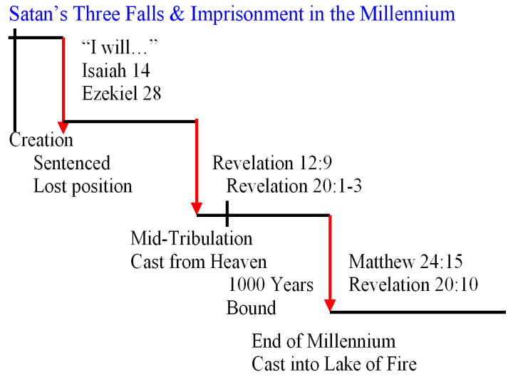
Here at Holly Hills Bible Church we have thankfully had a long history of teaching about the believer’s position and condition. Satan himself, however, has a position and a condition and a nature and an identity: He was once above all the angels, but chose to be willful and to vainly seek to exalt himself as God. That resulted in his losing his place in heaven. His position and his condition were therefore fixed eternally. His sinful nature remains unchanged from that point through all eternity, and his ungodly identity remains the same throughout eternity. What will change over time - in the future – is that Satan will lose his access to heaven, as we once saw that he had in Job chapters 1 and 2, in the middle of the Tribulation. We’ll look at that in more depth when we get to Revelation chapter 12. He will be bound for 1000 years during the Millennium – following the Tribulation. Thereafter he will have a brief period of limited freedom and will then be cast eternally into the Lake of Fire.

Of the one third of the angels who chose to side with Satan and against God, these fall into two groups:

- Unhindered fallen angels, confined to earth, who know that their previously given sentence is to be carried out in the future, & fear being disembodied or being sent to the abyss (Matthew 8:25, 25:41; Mark 5:1-7).

- Chained and imprisoned fallen angels are being kept in the darkness of the abyss or pit, awaiting the carrying out of their final judgment & sentence (Luke 8:31; 2 Peter 2:4; Jude 6). These will have five months of release to torment, with specific constraints, those who dwell upon the earth (Revelation 9:1-11).

Satan is called the Prince, or Ruler, of fallen angels (demons; Matthew 9:34; 12:24; Mark 3:22; Luke 11:15; Ephesians 6:12, speaking of a demonic hierarchy). Demons are also called the ministers, or ambassadors of Satan (Luke 4:35; 9:1,42; John 10:21).

2 He opened the bottomless pit, and smoke went up out of the pit, like the smoke of a great furnace; and the sun and the air were darkened by the smoke of the pit.
3 Then out of the smoke came locusts upon the earth, and power was given them, as the scorpions of the earth have power.

This passage describes Satan as opening the bottomless pit (Greek: abyssos). You probably don’t want to go there. Once this pit is opened, we see the word “smoke used three times. Smoke comes out of the pit, and John compares it to the smoke of a great furnace. Here’s this word “great” again – huge! – massive! It would seem as though instantly the sun and the atmosphere are darkened by this “smoke”.

The fallen angelic beings (demonic beings) are permitted to take the form of a locust-like creature, including being empowered to deliver a painful sting, like scorpions. But the description of these beings, and what they do, is not limited to verses 2 and 3 – we are about to be told more.

4 They were told not to hurt the grass of the earth, nor any green thing, nor any tree, but only the men who do not have the seal of God on their foreheads.
5 And they were not permitted to kill anyone, but to torment for five months; and their torment was like the torment of a scorpion when it stings a man.
6 And in those days men will seek death and will not find it; they will long to die, and death flees from them.

These fallen angelic beings are given specific limitations on what they are allowed to do, not allowed to do, and the duration in which thy must do it:

- A form like a locust (with more description in verses 7 through 10)
- Ability to deliver a painful sting, like a scorpion, but not to kill
- They are not to sting any plant life, but only humans that don’t have the seal of God on their foreheads (the 144,000 of Revelation chapters 7 and 14)

Those who are stung will wish to die, but will not be able. The language seems to say that death, though they long for it, will be prevented.

7 The appearance of the locusts was like horses prepared for battle; and on their heads appeared to be crowns like gold, and their faces were like the faces of men.
8 They had hair like the hair of women, and their teeth were like the teeth of lions.
9 They had breastplates like breastplates of iron; and the sound of their wings was like the sound of chariots, of many horses rushing to battle.
10 They have tails like scorpions, and stings; and in their tails is their power to hurt men for five months.

The description given of the appearance of these beings can by bulleted like this:

- like horses prepared for battle
- on their heads appeared to be crowns like gold
- faces were like the faces of men
- hair like the hair of women
- teeth were like the teeth of lions
- breastplates like breastplates of iron
- the sound of their wings was like the sound of chariots… horses rushing to battle

Verse 10 is a composite of the content of verses 3 and 5, pointing out the power to deliver pain like a scorpion, for a period of five months.

11 They have as king over them, the angel of the abyss; his name in Hebrew is Abaddon, and in the Greek he has the name Apollyon.

Here are the reasons that the Star, the king over the stinging beings, the angel of the abyss, Abbadon, and Apollyon of Revelation 9:1-11 are all to be identified with Satan:

- Angels are called “stars” (Job 38:4-7), and Satan is referred to as a star & is described as falling from heaven (Isaiah 14:12 and Luke 10:18). This fits with Revelation 9:1, 2.

- The explicit reference to Abaddon and Apollyon in Revelation 9:11, as “destroyer” makes sense only if it refers to the “star” who opened the shaft of the abyss in Revelation 9:1,2.

- In 2 Thessalonians 2:3, the Antichrist is called “the son of destruction”, a word related to “destroyer” (Apollyon).

- In Revelation 20:1, the angel who opens the abyss comes from heaven and this angel who has the key to and opens the pit is not named Abaddon or Apollyon there.

- Satan is the ruler of the demons and they are his “ministers” (Matthew 9:34; 12:24; Mark 3:22; Luke 11:15; Revelation 9:11).

This verse may by the basis for some to picture Satan as being in charge of Hell. But the Lake of Fire is Satan’s ultimate destination, not the abyss, and in the Lake of Fire Satan will be thrown into it to be tormented forever. In these verses Satan is only allowed to direct these fallen creatures to the extent that he is directed by God to do so, and only because he was given a key to the abyss, which he apparently does not normally have.

Some of Satan’s Names as Given in Scripture:

Lucifer (bright star): Isaiah 14:12-14

Father of lies: John 8:44

Murderer: John 8:44; 1 John 3:8

Ruler of this world: John 12:31, 14:30; 16:11
Prince of the power of the air: Ephesians 2:2

Dragon: Revelation 20:2
Serpent of old: Revelation 20:2
Devil: John 8:44; Revelation 20:2
Satan: Job: 1:6-2:7; Zechariah 3:1, 2; Revelation 20:2
Accuser of our brethren: Revelation 12:10
Gk: Apollyon, Heb: Abaddon: Revelation 9:11
(destroyer)

12 The first woe is past; behold, two woes are still coming after these things.

Remember Revelation 8:13
Then I looked, and I heard an eagle flying in midheaven, saying with a loud voice, "Woe, woe, woe to those who dwell on the earth, because of the remaining blasts of the trumpet of the three angels who are about to sound!"

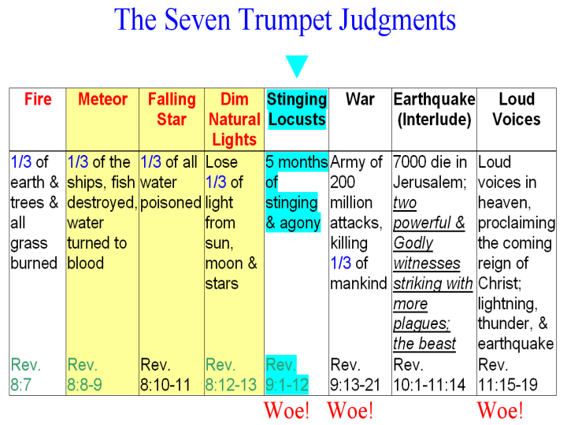

The Abyss or Bottomless Pit: The Greek word is abussos = a + bussos = no + depth. The word is therefore, used for “bottomless”, or “abyss”. The word pair used in Revelation 9:1 & 2 is frear = pit and abussos = bottomless, so the word pair is often translated “bottomless pit”.

