Revelation 9:13-21 – Hordes

13 Then the sixth angel sounded, and I heard a voice from the four horns of the golden altar which is before God,

We have heard mention of the heavenly “golden altar” before, back in Revelation chapter 8. At that time we didn’t take too close a look at the character and significance of the altar, but this time we will.

By the requirements of the Law given to Israel, though the altar is golden in appearance (actually bronze: 2 Chronicles 4:1), it was in fact a rather bloody place: Sacrifices of animals were done constantly. The priests had to do ‘tough duty’ in their activities related to the altar, between keeping fires going constantly, and fulfilling all the periodic and annual sacrifices before the Lord. At times the pace of sacrifices was even hectic and tiring.

Scripture references to “the golden altar…”:

Numbers 4:11
"Over the golden altar they shall spread a blue cloth and cover it with a covering of porpoise skin, and shall insert its poles;

1 Kings 7:48
Solomon made all the furniture which was in the house of the LORD: the golden altar and the golden table on which was the bread of the Presence;

2 Chronicles 4:19
Solomon also made all the things that were in the house of God: even the golden altar, the tables with the bread of the Presence on them,

Hebrews 9:4
…having a golden altar of incense and the ark of the covenant covered on all sides with gold, in which was a golden jar holding the manna, and Aaron's rod which budded, and the tables of the covenant;

The golden altar, as we see above, was a key part of the temple sacrificial system that the Lord specified to the Jews. It was the place that they conducted and presented their sacrifices to the Lord.

The book of Revelation has two places where the golden altar in heaven is brought up, and this passage is the second and last place. The previous reference was:

Revelation 8:3
Another angel came and stood at the altar, holding a golden censer; and much incense was given to him, so that he might add it to the prayers of all the saints on the golden altar which was before the throne.

Though it is called the “golden altar” in both places, in Revelation 8:3 it is the golden altar before the throne. But in Revelation 9:13 it is the golden altar before God. God is on His throne, in the place of power and authority. He is in charge! This golden altar in heaven is different from the one in the earthly temple. Whatever is on this golden altar in heaven is indeed right before God - it is in His presence.

But there is more for us to take note of: The altar is noted here in Revelation 9:13 as having four horns, which might not seem like a really big deal to us, but the horns of the altar are specifically described and their use detailed in the Old Testament Law. A horn, to the Jewish mind, symbolized power:

The figurative meaning of horns:

Horns being the chief source of attack & defense with the animals to which God has given them, are employed in Scripture as emblems of the power of God (Psalm 18:2), and of Christ (Luke 1:69; Revelation 5:6).

So the mention of horns in this passage is not incidental:

- Horns represent the power of God Himself
- Horns are in the presence of God Himself

Let’s not overlook what some of the aspects of the altar in the Old Testament means to us now in this, the church dispensation (or age):
The Perpetual Fire on the Altar

For the Jews…Leviticus 6:12-13 (NASU)

The fire on the altar shall be kept burning on it. It shall not go out, but the priest shall burn wood on it every morning; and he shall lay out the burnt offering on it, and offer up in smoke the fat portions of the peace offerings on it. Fire shall be kept burning continually on the altar; it is not to go out.

For the Church…1 Thessalonians 5:19 (NIV)

Do not put out the Spirit's fire;

In the Old Testament, the priests were to keep the fire on the altar going non-stop. First, God says to keep the fire going all the time, it is not to go out. Then He describes in detail how it is to keep the fire burning. Finally, God says again to keep the fire going all the time, it is not to go out. A person might even get the impression that God wanted the fire going all the time – that He didn’t want it to go out!

But let’s look in the New Testament, where Paul writes to the church at Thessalonika, and tells them that they are not to put out the Spirit’s fire. While the priests of the OT had to work to keep the fire going, Paul, in comparing the Holy Spirit to the fire of the altar, says not to put it out. Don’t worry about maintaining the “fire” of the Holy Spirit. We don’t have to work it up or even keep the flames fed with fuel – that is not your job or mine to do – unlike the priests in the Old Testament. But we are exhorted by Paul not to put out those flames – the opposite of what the Old Testament priests had to do. God will do what He wants in our lives and express His passion and fire in our lives unless we suppress Him. Because we are indwelt by the Holy Spirit, the burning of the flame of the Holy Spirit is by the Holy Spirit – it is natural for the believer! It’s putting out the flame that is unnatural for the believer.

Let’s look at another application of this altar:

The Altar For the Jews…Levitucus 3:5-8 (NASU)
"Then Aaron's sons shall offer it up in smoke on the altar on the burnt offering, which is on the wood that is on the fire; it is an offering by fire of a soothing aroma to the LORD. "But if his offering for a sacrifice of peace offerings to the Lord is from the flock, he shall offer it, male or female, without defect. "If he is going to offer a lamb for his offering, then he shall offer it before the Lord, and he shall lay his hand on the head of his offering and slay it before the tent of meeting, and Aaron's sons shall sprinkle its blood around on the altar.
The Altar For the Church…Romans 12:1 (NASU)
Therefore I urge you, brethren, by the mercies of God, to present your bodies a living and holy sacrifice, acceptable to God, which is your spiritual service of worship.

The Jews in the Old Testament were to place a male or female lamb on the altar. The lamb without blemish was to be slain, sprinkling the blood on the altar. But in the New Testament, Paul writes to the Christians in Rome, and tells them to present their own bodies – remember that presenting is done on the altar – as a living sacrifice. You are to be the priest who puts the sacrifice on the altar, and you are to be the sacrifice, too, and you are to stay there – constantly presented before God as a sacrifice - constantly in His presence. Stay there living, by the life of Christ. Stay there holy, by the righteousness of Christ. That is what is acceptable to God, and that will be your spiritual service of worship. You’re called to stay on that constantly burning altar, presented before the Lord all the time.

14 one saying to the sixth angel who had the trumpet, "Release the four angels who are bound at the great river Euphrates."
15 And the four angels, who had been prepared for the hour and day and month and year, were released, so that they would kill a third of mankind.

Back in Revelation chapter 9, we are not told who is behind the voice that calls for the four angels to be released. But the voice directs the angel who had blown the 6th trumpet to release the four angels who had been bound at the Great River Euphrates. So what is it about the Great River Euphrates?

The Great Euphrates River:

The Euphrates River is mentioned 30 times in Scripture, from Genesis 2 to Revelation 16. It is called “great” not just for its size, but because of its ancient and future significance:

- Proximity and relation to the Garden of Eden
- Runs through Shinar, the area of the Tower of Babel
- Runs past the pagan city of Ur, original home of Abraham
- Runs through the Babylonian, Assyrian, Neo-Babylonian, Medo-Persian and Parthian Empires
- Will be the start place of the 6th trumpet judgment
- Will be dried up to allow the 6th bowl judgment

The River is called Great not just because of its size, but because of its tremendous spiritual and historical significance. Scripture mentions this river 30 times! Adam and Eve were set there in the garden, and the Tower of Babel was near there. Abraham came from there. Great Empires were associated with its area of drainage. It is the starting place for this, the 6th trumpet judgment, and will also be involved with the 6th bowl judgment as well. After that, the Bible never mentions it again.

The evidence is convincing that these four angels are not angels on God’s side, but are instead evil angels who carry out God’s plan because God is sovereign. In that regard, they are similar to Satan and the fallen angels that we saw in last week’s passage.

The book of Revelation mentions lots of angels, but the only other place that mentions an angelic creature being bound is in Revelation 20. There Satan is described as being bound. So binding evil angelic creatures is something that is done by God’s direct command, but, we believers are never told to “bind Satan”. In fact, we are warned in two New Testament passages not to do so. These passages in 2 Peter and Jude say that reviling angelic majesties - like rebuking or binding Satan - is of the flesh. It is not godly, and is not ‘spiritual’.

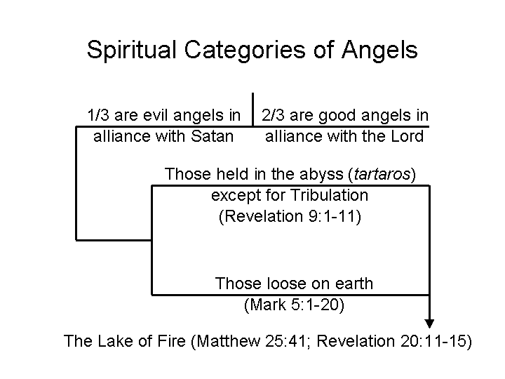
This chart gives us a breakdown of angels that stand with the Lord, and those who are not and stand with Satan. The evil angels are divided among those who can go about loose on this earth, and the group that is restrained – some for the time of the Tribulation. All demonic beings – fallen angels - end up in the Lake of Fire.

Bound Angels?

The word “bound” (Greek root deo) is found only 2 times in the book of Revelation:

Revelation 9:14
one saying to the sixth angel who had the trumpet, "Release the four angels who are bound* at the great river Euphrates."

Revelation 20:2
And he laid hold of the dragon, the serpent of old, who is the devil and Satan, and bound him for a thousand years;
* bound is in a perfect passive participle – they had been completely bound in the past – not by their own doing, but outside of themselves

These bound evil angels did not bind themselves, nor are they restrained of their own will. Their release is not of their own will either, but is done by an outside force. In fact, they had been prepared – the Greek word is in the perfect tense – which means completely prepared in the past. Given that the hour and day and month and year are all established in advance, these verses speak volumes of the sovereignty of God. God is in charge. This is not happening because God suddenly thought about it – or reacted in a last-minute panic. Everything about this event is deliberate – anticipated in advance. While in the previous judgment, mankind would wish to die and cannot, in this judgment one third of mankind will die. By today’s population count, that would be about 2 billion people. The precise number then we don’t know, but it will be a massive, horrific and devastating slaughter of human flesh. One third of those who wished they could die because of the locusts‘scorpion-like sting in the previous judgment will now get their wish, just a bit too late to save them from the agony of the sting.
16 The number of the armies of the horsemen was two hundred million; I heard the number of them.
17 And this is how I saw in the vision the horses and those who sat on them: the riders had breastplates the color of fire and of hyacinth and of brimstone; and the heads of the horses are like the heads of lions; and out of their mouths proceed fire and smoke and brimstone.
18 A third of mankind was killed by these three plagues, by the fire and the smoke and the brimstone which proceeded out of their mouths.
19 For the power of the horses is in their mouths and in their tails; for their tails are like serpents and have heads, and with them they do harm.

The army that is associated with these four evil angels is demonic, like those we read about last week, coming from the bottomless pit – the abyssos. John says that he heard the number of them, like he heard the number of the Jews in Revelation chapter 7. The number is 20,000 times 10,000 in the Greek. So most English translations have it as 200 million. What is interesting about this demonic army is that they are not described as being opposed by any human army, nor are they described as seeking to conquer any lands or take anything. When they are done, we are not told they have anything to gain by their killing - they just kill and kill and kill for no apparent end. Their father the devil is a liar and murderer from the beginning. What John describes of them has some interesting similarities to the armies of the Parthians – an empire immediately to the east of the Roman Empire.

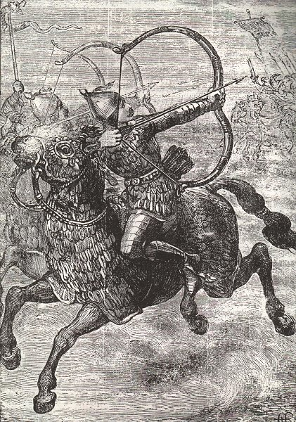
The Parthians had an empire to the east of the Roman Empire – and sometimes fought the Romans rather well. In 40 BC the Parthians even took Jerusalem from the Romans for a time. The Euphrates River runs right along the western edge of the Parthian Empire. The Parthians were able to shoot backwards from a horse with great skill. The Parthians wiped out two Roman legions that way before the Romans figured out that if the Parthians were riding away, that did not mean the Parthians were in full retreat. The Romans learned that it’s not a good idea to run after these guys! Notice that the heads of these horses – given their battle armor – tended to make the heads appear more like that of a lion.

The Parthian horses’ tails were bound so as to look like a snake (see picture and overhead slide). This passage describes the tails of these horses as being like snakes. The Parthian warriors, however, did not have anything like the ability to project fire and smoke and brimstone. That is unique to this demonic army, and apparently very, very deadly. There are those who will try to make this into some kind of vast army of tanks. Considering the demonic origin of these beings and the number of tanks this would require, it does not seem like that is what John is describing.

20 The rest of mankind, who were not killed by these plagues, did not repent of the works of their hands, so as not to worship demons, and the idols of gold and of silver and of brass and of stone and of wood, which can neither see nor hear nor walk;
21 and they did not repent of their murders nor of their sorceries nor of their immorality nor of their thefts.

Now by the time these plagues are completed, billions - not millions - but billions of people will be killed. The response of those who remain will be absolutely amazing. After all the obviously miraculous but ghastly events they will have seen, and after knowing that this series of judgments is most certainly from the hand of God, the great many of them will be totally unrepentant.

Repent: What it is…
- The English word often conveys the idea of sorrow or contrition
- However, the Greek idea behind the word in the Bible focuses more on total change in thought and behavior based on a fundamental change in values, the values of God, and indicates that we are to make a decision decisively (Luke 3:8, Hebrews 6.1, and Acts 26.20)

Repent: What it is not…
- a vow that we will never do it again
- a determination to do better next time
- a promise to serve the Lord
- a guilt complex whereby we feel bad about sins
- a legalistic way of trying to get God's approval by our best efforts

This pattern of not repenting is true of the Jews in both the Old Testament and the New Testament, as we see in these verses.

Jeremiah 15:7
"I will winnow them with a winnowing fork
At the gates of the land; I will bereave them of children, I will destroy My people;
They did not repent of their ways.

Matthew 11:20
Then He [Jesus] began to denounce the cities in which most of His miracles were done, because they did not repent.

But what we are seeing here is that the phrase is repeated twice in this passage and twice more in Revelation chapter 16. It is true of the entire world – not just the Jews. Isn’t this amazing? Isn’t this astounding?

Notice what these people did not repent of:

  - They did not repent of the works of their own hands
  - They were insistent on religion that came of their own creation
  - If it involves religion, then their thinking was, “I’ve got to do something!”
  - “If I’ve got to worship something, then it must be something I make with my own hands!”

Leviticus 17:7; Deuteronomy 32:17 and Psalms 106:37 all describe idol worship as worship of demons – even to the point of sacrificing their own children to these demons!

We’ve seen the demon locusts sting them mercilessly for five months. Then the demons savagely kill one third of mankind. How does mankind respond? Mankind makes idols so they can worship these wretched demons!

Mankind Will Be Willfully Religious, Demonic & Idolatrous (Revelation 9:20)

John 3:19-21
And this is the judgment, that the light is come into the world, and men loved the darkness rather than the light; for their deeds were evil. 20 For everyone who does evil hates the light, and does not come to the light, lest his deeds should be exposed. 21 But he who practices the truth comes to the light, that his deeds may be manifested as having been wrought in God.

1 Corinthians 10:19-20
19 What do I mean then? That a thing sacrificed to idols is anything, or that an idol is anything? 20 No, but I say that the things which the Gentiles sacrifice, they sacrifice to demons and not to God; and I do not want you to become sharers in demons.

What we see here in these verses is that mankind largely insists on abject refusal of the offer of mercy and grace and salvation and eternal life through Christ. Mankind instead chooses his own homemade religion. Mankind is willfully fixated on humanistic religion, idolatry and demonism. Don’t you find that baffling? Isn’t that incomprehensible? But these New Testament verses make it plain that the nature of mankind is such that they prefer this over taking God up on this marvelous offer. What mankind worships – in doing so – is demons.

Mankind Will Be Totally Morally Decadent (Revelation 9:21)

Murders (plural): Murder will be rampant; killing another human being will be acceptable

Sorcery (plural): The Greek word is pharmakon, “a drug, incantation, or enchantment.” It was used in John’s time in

- magical arts
- witchcraft
- demonism

Immorality: The Greek word is porneia; rampant sexual abuse and unspeakable sexual perversions

Thefts (plural): complete moral breakdown where mankind will steal and cheat at every turn

Along with the demonic influence, we find this passage revealing other well-entrenched behaviors among those remaining on the earth. Their murders, which are described in plural, are done without hesitation or apparent remorse. Taking another human life will be done without second thought. The Greek word which is translated sorcery is pharmakon. Basically, it means drugs. Drugs were used in John’s time – especially in Ephesus – for magical arts, witchcraft, and varieties of demonic influence. During the Tribulation the populace will be overrun by illicit drug use. Immorality, composed of sexual abuse perversion, will be rampant – everywhere at anyone’s expense. Theft will be taking place at every turn - stealing for drugs - killing for drugs - killing in the name of a demonic power. All varieties of moral decadence will explode in frequency and perversity. But the demons can’t take all the credit - it is from within people’s hearts:
From Within the Heart of Man - Mark 7:21-22

"For from within, out of the heart of men, proceed the evil thoughts, fornications, thefts, murders, adulteries, 22 deeds of coveting and wickedness, as well as deceit, sensuality, envy, slander, pride and foolishness.

Works of the Flesh - Galatians 5:19-21

Now the deeds of the flesh are evident, which are: immorality, impurity, sensuality, 20 idolatry, sorcery, enmities, strife, jealousy, outbursts of anger, disputes, dissensions, factions, 21 envying, drunkenness, carousing, and things like these

