Revelation 11:15-19 – Seventh Trumpet: Culmination

Can you imagine?

Can you imagine what it was like for John the apostle to have walked alongside our Lord… Having ridden in a boat with Christ across the Sea of Galilee, and watching Christ calm the storm? Having seen Christ walk on the water? Having seen Christ hanging on that cruel Roman cross? Having rushed to the tomb to see the empty gravecloths? Having seen Thomas turn from skeptic to believer as the Lord invited him to touch and to see that the Lord had indeed been crucified, buried and resurrected? Having seen Christ ascend into heaven…

Now… imagine John seeing these earthly and heavenly scenes we’re reading of in Revelation... that One with whom He walked is now seated in the heavenlies. That One whom he saw hanging on that cruel Roman cross is now being worshipped by innumerable angelic hosts. That One whom He saw ascending into heaven from the Mount of Olives is now being worshipped by glorified saints. As a matter of fact, in the heavenly scene we are looking at this morning John is describing the glorified church – that includes you and me - worshipping Christ. But while we are there, the focus is not now on us, but on the Lord Himself.

One point for us to take note of is the relationship between the three sets of seven judgments, as shown on a previous handout. First, we’ve noted before that between the 6th and 7th judgments in each of the three sets of judgments is an interlude. This interlude is typically something else happening aside from the judgments, frequently a heavenly scene or another insight into how God has been or is working with mankind. The next thing to take note of is that the 7th of each of the three sets of seven judgments ends with an earthquake. In the very last judgment of all – the 7th bowl judgment – the earthquake is massive.

Finally, the pattern we want to point out here is that the seventh and last seal is what begins the seven trumpet judgments. And the last of the seven trumpet judgments begins the bowl or vial judgments. The last of these seven bowl or vial judgments begins the millennium. Once we see that this 3rd woe, this 7th trumpet really starts and includes the next seven judgments, then we understand why it’s called the 3rd woe:

- It will mean agony and tragedy and panic like the world has never known
- It will indeed be a 3rd and final woe!

15 Then the seventh angel sounded; and there were loud voices in heaven, saying, "The kingdom of the world has become the kingdom of our Lord and of His Christ; and He will reign forever and ever."

The 7th angel sounded the military trumpet, as God’s 7th announcement of the attack on “those dwelling on the earth”. Verse 14 has told us that this is the 3rd woe, which is really the opening of the 3rd set of seven judgments, which are the seven bowl or vial judgments.

We hear of ‘a loud voice’ as we’ve been hearing since chapter 1. The loud voice in the book of Revelation is always from a heavenly being or creature – never from an earthly being. In this instance we find something just a bit different however:

- The loud voice is plural = loud voices, instead of a loud voice

This is the only place in Revelation that we find this phrase in plural. In fact, the only other place in all the New Testament that we find this word pair “loud voices” is when the crowd calls out in “loud voices” for our Lord’s crucifixion! (Luke 23:23) Back then, the loud voices come from earthlings, but this time the loud voices come from heaven itself.

- The whole phrase here is “loud voices in heaven”

On investigation, we find that this is the only place in all of Scripture where this phrase “loud voices in heaven” shows up. The uniqueness of this phrase, as we will soon see, is because of the uniqueness of what is being announced. Let’s listen carefully to what these loud voices in heaven are saying.

"The kingdom of the world has become the kingdom of our Lord and of His Christ; and He will reign forever and ever."

Let’s look at the phrase: “The kingdom of the world”. There are indeed a number of human kingdoms on this earth, and there have been human kingdoms on earth for many centuries. But ultimately we realize that there is a “kingdom of this world”. The kingdom of this world has been and is today, of Satan. Scripture calls Satan “the god of this world” in II Corinthians 4:4. In John 12:31, 14:30 and 16:11 Satan is called “the ruler of this world”. 1 John 5:19 says, “We know that we are of God, and that the whole world lies in the power of the evil one.” - for right now, that is… Satan knows this well, and in Matthew 4:8 and 9 he even offered these kingdoms to Christ almost 2000 years ago, if Christ would just bow down to Satan.

Our citizenship is not here. This world does have a kingdom, but Scripture makes it clear that our position is unchangeably with Christ. We walk around among people who know no other kingdom but the kingdom of this world. Though we ourselves live physically in this world’s kingdom – we live in our spiritual position with Christ – now seated with Him in the heavenlies. Why should we settle for crying to the Lord of heaven from our physical standing in this world’s earthly kingdom? Instead we can deal with this world’s matters from our heavenly position, seated next to Christ in the heavenlies.

From the standpoint of this world, the last 3½ years of the Tribulation period will appear to be dominated by Satan. But Satan will see his desperate, tyrannical rule over his tottering kingdom ripped from his hands. The truth is that the transition from Satan’s kingdom to the kingdom of Christ has begun. In our nation’s own political system, in the time between the election and the inauguration of a new president, the outgoing president is still officially in office, but his entire administration is flung into a frantic transition, preparing to give authority over to the next president and his administration.

We’re going to see Satan move frantically upon earth in the last 3½ years of the Tribulation period. He will attack those who believe in Christ – the Tribulation saints. He will attack the Jews, God’s chosen people, the source of the Savior. He will hold on to this world’s system with a tyrannical death grip. He will come after or wish he could come after every means of God’s proclamation of the gospel. He must certainly be immensely frustrated that the only victories he gains are the ones God allows him. But every victory for Satan will be hollow. Every apparent victory will slip through his fingers, only to have his entire kingdom delivered into Christ’s hands! How deceived the deceiver himself must be to think that he can bring about any different outcome than what God has determined will be!

Seven times the Greek word dei is used in Revelation, “must” in English – in a context indicating that the things which are told in this book must take place. What’s in this book is not simply “God’s best guess”. They are not simply among God’s options. These things must of necessity take place so as to fulfill every word. The Millennial reign of Christ will come about, absolutely. In spite of Satan’s last ditch efforts, he’ll be shoved off the earth’s stage. The kingdom reign will be Christ’s, from Jerusalem, and from Israel.

Revelation 20, as we will see, will include Christ’s reign for 1000 years on earth. And we will be with Him. We’ll take a closer look at Christ’s Millennial reign when we get to Revelation chapter 20 - can you wait until then?

Notice the somewhat unusual expression: “…of our Lord and of His Christ”. God did not suddenly think up having Christ as His solution to things on earth getting unexpectedly out of control. Christ the Messiah is not God’s Plan B because Plan A didn’t work. Jesus Christ was and is God’s plan A – there is no plan B. It was and is and will be God’s intent to establish Christ as the head of His kingdom! It is also the fulfillment of God’s promise to Abraham and to David.

The declaration finishes with “and He will reign forever and ever”. As we will see in the months ahead of us, Christ will reign for 1000 years on earth from Jerusalem, in Israel. Then will come a time shortly thereafter when He will reign in a New Heaven and New Earth from a New Jerusalem. Now what these loud voices are saying is not long and complicated, but it is exceedingly important. It is a declaration of the reign of Christ on the earth, so let’s take this declaration one phrase at a time…

16 And the twenty-four elders, who sit on their thrones before God, fell on their faces and worshiped God,

Now we have studied these 24 elders before, when we were going through Revelation chapters 4, 5 and 7. These 24 elders, as we concluded, represent the raptured church. Notice that these elders are seated on thrones, where their position with Christ and their condition with Christ are permanently matched as one.

One thing we’ve noted is that these 24 elders, who show up only in the chapters in Revelation dealing with the Tribulation, have a pattern in what they praise the Lord for in these chapters. That means, since these are you and me, that we’re reading about us! And…this may take place as soon as just a few years from now - are you ready for that?

What we find is that this is part of a larger pattern of praises which the elders began in chapter 4 and will complete in chapter 19, according to this outline:

- Creation – as we saw back in Revelation 4:10
- Redemption – as we read about back in Revelation 5:9-10
- Reigning and Judgment and Reward – as we see here in Revelation 11:17 and 18
  - We’ll read about how they praise the Lord for Judgment – when we get to Revelation 19:4 – which is the last time we read of the 24 elders

There is good reason that we don’t read of them after that, as we’ll see when we get to that point.

We read next that these 24 elders fell on their faces. This phrase “fell on their faces” shows up eight times in the Old Testament. In all but one case, it refers to falling on one’s face in a desperate situation. In this passage and in Revelation 7:11 it refers to the 24 elders. They do not seem to be desperate at all. One gets the impression here that this is what they (OK, ‘we’) are doing again and again through the entire Tribulation. They don’t seem to tire of it, nor to have anybody forcing them to do it. When they see the Lord face to face, they seem compelled to worship Him again and again and again. Worship of the Lord seems to be without question the very thing to do. There is no counsel to vote upon it or decide whether it is worth the while. Worshipping the Lord is simply done of their own hearts and minds.

17 saying, "We give You thanks, O Lord God, the Almighty, who are and who were, because You have taken Your great power and have begun to reign.

First we should take notice what the 24 elders call the Lord. They call Him Lord God, and they call Him the Almighty. They say of Him, ”Who are and Who were”. These are titles which are also credited to Christ Himself in the book of Revelation. These 24 elders tell us that He has taken His great power. The word “taken”, in the Greek is in the perfect tense, so it is a completed action with ongoing results into the future, also implying permanence. They say that He has begun to reign. So you and I will be privileged to announce these very things personally in the heavenlies at that time. Are you looking forward to that, brothers and sisters?

This word “reign” here is fascinating. It is the word in the Greek basileuo, which shows up eighteen times in the New Testament. It is used most often to describe the reign of Christ as Messiah during the Millennium. Here in Revelation it is used to describe Christ reigning during the Millennium and thereafter, or to describe the saints reigning with Him. It is never used to describe the Antichrist’s desperate and tyrannical rule over the earth during the last ½ of the Tribulation.

18 "And the nations were enraged, and Your wrath came, and the time came for the dead to be judged, and the time to reward Your bond-servants the prophets and the saints and those who fear Your name, the small and the great, and to destroy those who destroy the earth."

In this passage these 24 elders – that’s us - have an incredible set of phrases. Lets take a look at each one, shall we?

And the nations were enraged, and Your wrath came
A partial quote of Psalm 2 A Psalm for the Tribulation & Its End

1 Why do the heathen rage, and the people imagine a vain thing? 2 The kings of the earth set themselves, and the rulers take counsel together, against the Lord, and against his anointed [Messiah], saying,…

5 Then shall he speak unto them in His wrath, and vex them in his sore displeasure. 6 Yet have I set my king upon my holy hill of Zion…

This phrase is a very direct summary of Psalm 2. Did you know Psalm 2 was all about the end of the Tribulation? It might seem kind of amazing to praise the Lord for being wrathful against this world’s wicked rebellion, but it will make perfect sense when we see the Lord face to face - and see His character.

We should also point out that the word ‘wrath’ shows up in Revelation from the 1st chapters about the Tribulation to the last (in the 6th through 19th chapters). But the church is promised at least three times in the New Testament not to be subjected to any of it.

and the time came for the dead to be judged and the time to reward Your bond-servants the prophets and the saints and those who fear Your name, the small and the great

This judgment for rewards is for the tribulation and Old Testament saints at the end of the Tribulation period. We’ll cover it in more detail a bit later, if we’re all still here on earth.

and to destroy those who destroy the earth.

This is not just retribution for ecological disaster. Mankind is bringing destruction upon the earth by the rampant fouling which sin, which of its very nature, brings spiritual destruction upon the earth. Suppose you could see things on earth not for what they looked like to our human eyes, but for spiritual consequences. Suppose you had the ability to actually see spiritual pollution. How would things on earth look to you?

19 And the temple of God which is in heaven was opened; and the ark of His covenant appeared in His temple, and there were flashes of lightning and sounds and peals of thunder and an earthquake and a great hailstorm.

The Jews have built two temples on the mount in Jerusalem. Both have been destroyed. An Islamic mosque stands there now. But the temple that will be built for use during the Tribulation period will be rejected of God. However, the temples here on earth have been but a symbol of the actual and eternal temple, which is in heaven.

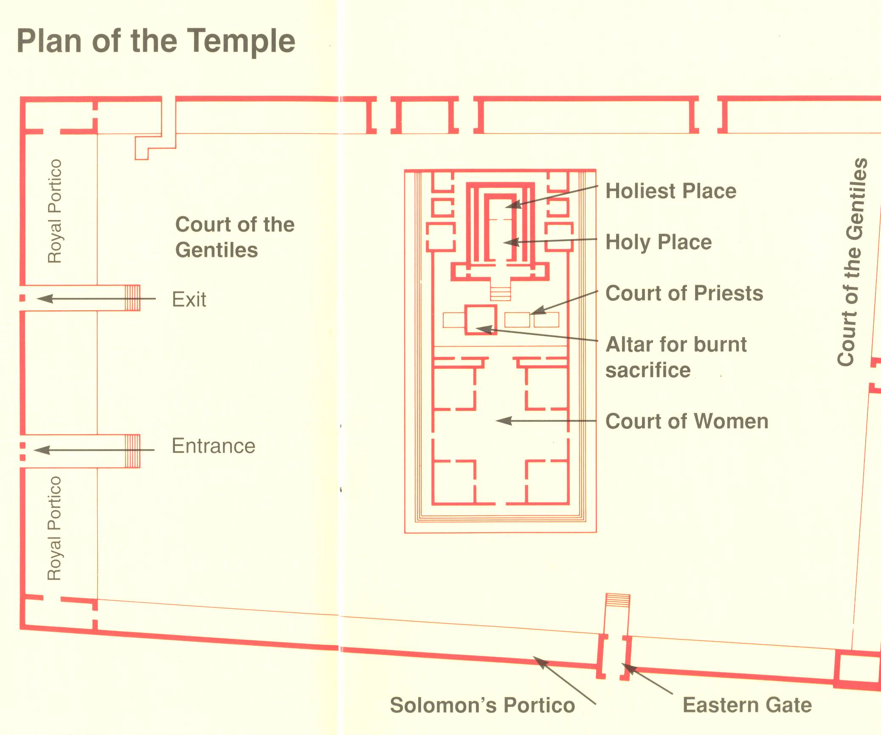

The general temple area is shown in this plan view. It is called the hieron, in Greek. The central part of the temple, the Holy Place and Holy of Holies, is called the naos in Greek. The area that Revelation chapter 11 is talking about – the naos - is this area that includes the Holy Place and the Holy of Holies. It is this word – the naos - that John writes as being the temple of heaven here in verse 19. On earth, the ark of the covenant was located in the Holy of Holies. On earth, only the high priest went into the Holy of Holies, and then only once a year. There was a thick curtain a few inches thick which kept the ark of the covenant, which was located in the Holy of Holies, out of view of everyone. In heaven, however, this holy of holies stood open such that John could see the heavenly ark of the covenant.

Now we need to take a bit of a detour to make sure we‘re all on the same page about this ark of the covenant…

The ark of the covenant was overlaid with gold, having two cherubim (a kind of angel) on the top. It had poles on each side to carry it, and which were required to remain attached. There were some special things inside of it, as well, which we will see more about in a minute. Scripture provides details about the Ark of the Covenant:

- It’s Construction: Exodus 25:9-22
- Who is to Carry it: Deuteronomy 10:8
- What is to be Beside it: Deuteronomy 31:26
- Where it was to be Placed: Hebrews 9:1-10
- What is to be Inside it: Hebrews 9:1-10
- The Earthly Ark was a Symbol of the Heavenly Reality: Isaiah 6:1-7; Hebrews 9:11-10:14

It also gives us a valuable truth, revealed in Isaiah 6 and retold here in Revelation 11, that is, that the earthly ark was a symbol of the heavenly reality. The earthly ark was clearly to represent heavenly realities and spiritual truths:

    - The ark stood for the divine presence of God:
It is here the glory of God’s presence hovered over the mercy seat of the ark and from whence God would commune with Israel (Exodus 25:17-22; 30:6; Leviticus 16:2; Numbers 7:89; 2 Kings 19:15; Psalm 80:1)

(2) By its contents, the ark stood for God’s faithfulness (Deuteronomy 8:3; Matthew 4:4). It contained:
- the law or the tables of stone, which represented the whole law and guided the people as a way of life and pointed them to the Messiah
- Aaron’s rod that budded, which portrayed resurrection and God’s choice of leaders
- the pot of manna, which portrayed the person of Christ as the bread of life and showed them God’s daily provision

(3) The ark stood for God’s holiness, grace, and love (Acts 7:44; Exodus 16:33; 32:15; 38:21; Numbers 1:50, 53; 17:7-10; Hebrews 9:1-5):
- The tables of stone declared the perfect holiness of God
- The sprinkling of blood by the high priest on the mercy seat showed that God’s holiness could only be satisfied by the shedding of blood
- This foreshadowed the person and work of Christ on the cross as did the whole ritual of the tabernacle, priesthood, and the sacrifices

Then we read of the lightning, hear the thunder, and are told of an earthquake and hailstorms. We’ve seen this in Exodus 19 and 20 in the Old Testament. We’ve also seen this described in Revelation chapters 4 and 8, and we’ll see it again in Revelation chapter 16. These Old Testament and very Jewish images show up throughout the Tribulation period.

But there is something in this verse that is very precious to us a church age believers.
What we see in this verse is that the heavenly reality of the temple and the ark of the covenant are untouchable by those on earth and by any influence on the earth. The first temple, the one Solomon had built almost 1000 years before Christ’s 1st coming, was destroyed by Nebuchadnezzar in the 6th century BC. It’s treasures were carried off to Babylon. Then the second temple was built. The second temple was violated over a century and a half before Christ’s first coming. A pig was sacrificed on the altar, in honor of Jupiter, by a pagan Gentile. Twice Jesus cleared the outer temple courts of moneychangers and sacrificial animal salesmen. Eventually the Romans came in 70 AD and totally destroyed the second temple.

Let’s face it: Earthly temples, however beautiful, are just plain vulnerable. They can get ruined, robbed, abused and desecrated. The Lord, however, has taken care of all that vulnerability for us as believers. He has made our position in Christ to be untouchable in the heavenlies. We have been seated with Christ, and there is nothing anybody else can do to damage, corrupt, remove or in any way diminish that position! Absolutely nothing! We have a hope, a faith, a future, an identity, a relationship that this world cannot reproduce and cannot damage or wreck or corrupt. Paul, in 2 Corinthians 3:18, even talks about our beholding the Lord Jesus as the very means of being transformed from glory to glory, and not only do earthly trials and troubles not do anything to diminish what the Lord has for us in the heavenlies, the Lord uses them to grow our dependence upon Him!

So it’s a good thing John has told us about the heavenly temple. It’s one more marvelous reminder that we can set our mind and our heart and our hope on what cannot be faded, rusted, moth-eaten, stolen, or lost. John reminds us that the covenant and the temple are His – God’s. Where we are seated with Christ is a lot more secure and real than this place where our bodies are located for the time being. How much better to live there, dealing with this world’s matters from that real and secure place where we are seated with Christ, rather than calling from this place for God to send some help to here

