Revelation 12:1-6 – The Woman, The Child, The Dragon

We are stepping into the Revelation 12:1-14:20 interlude

While the seventh trumpet judgment immediately opens up the next seven bowl (or vial) judgments, the things revealed in Revelation 12:1-14:20 do not take place just in the specific time between the seventh trumpet judgment and the first bowl judgment. Instead Revelation 12:1-14:20 will present things that extend across various spans of time, and will draw from events and passages that are mostly in the Old Testament, in order to give us a fuller and more insightful perspective on the events of the Tribulation period.

We are stepping into a sweeping panoramic drama

This passage will draw upon various books of the Bible, extending all the way back to Genesis, and will include truths from a number of the Old Testament prophets. This passage will bring forward phrases and insights from the book of Psalms, as well as the book of Job. We will find that though these six verses draw from many ancient Old Testament passages, they will also reveal a truth never before seen in all of Scripture.
In doing so, this passage will sometimes put these long-revealed truths in ways never before seen in Scripture. What John has written by the inspiration of the Holy Spirit is indeed a prophetic masterpiece.

What we’re going to see in Revelation Chapter 12

- Israel, through troubles, will bring forth the Messiah at His first coming.
- Satan will lead a failed rebellion of angels, so that one third of the angels will be cast to earth for a time.
- Satan will fail to kill the Messiah in His first coming.
- Left with but 3½ years of the Tribulation, Satan will focus his attack upon the nation of Israel, which is another evidence of a rapture prior to this point, since the church is not present to be the subject of Satan’s attack.
- Israel will flee to the desert and be spared by God’s merciful, faithful, almighty and sovereign hand.
- Failing again, Satan will persecute Israel until the end.

This passage begins with, “A great sign appeared in heaven…”.

1 A great sign appeared in heaven: a woman clothed with the sun, and the moon under her feet, and on her head a crown of twelve stars;

From the very first words, we gather that John is writing about something that is not a minor detail, or even a significant part of the picture, but ‘a great sign’. This is really, really huge in its significance. Further, we do not see that this just about the next events happening on earth during the Tribulation period, but about events spanning all of time up to the time of Christ’s second coming. Just as there are seven signs in John 1-11, so there are seven signs in Revelation 12-19. This the first of them, and the only good one.

Now there have been at least a few proposals regarding the identity of the ‘woman’ in Revelation 12:1:

- The woman is Mary
- The woman is the Church
- The woman is Israel and the Church
- The woman is Israel

Of these, the evidence points to Israel as the best understanding of what John wrote, and the reasons for this are:

- The rest of the verse, “a woman clothed with the sun, and the moon under her feet, and on her head a crown of twelve stars”, is so obviously drawn from Joseph’s dream about his family, including Jacob the head of Israel and its tribes, in Genesis 37:9, 10.
- The rest of the passage provides details that fit with what the Old Testament prophets predicted for Israel, but could not have predicted for the Church, since it was not revealed until the New Testament epistles (Ephesians 3:1-12; 5:32).
- Neither Mary nor the Church did or will do geographically or in time what is spoken of in this passage and in the Old Testament prophets. Israel’s location, citizenship and blessings are earthly, whereas the Church’s location, citizenship and blessings are heavenly.
- The Church did not give birth to Christ, but rather Christ’s death, burial and resurrection gave birth to the Church.
- As we’ll soon see, the Old Testament prophets portrayed Israel as being in labor with child, but the church was never portrayed in the same way.
The Woman is the Nation of Israel

Jacob = Sun The The
Rachel = Moon Nation Woman
12 Sons = 12 Stars of of
Genesis 37:9,10 Israel Chapter 12

The woman is with child (vs. 2), the child being one who rules with a rod of iron (vs. 5; Psalm 2:8, 9; Revelation 2:27; 12:5; 19:15). This is Christ, the Messiah, who was born from the nation of Israel (Genesis 49:9-10; 2 Samuel 7:16; Matthew 1:1-25; Luke 1:30-33).

=
=
2 and she was with child; and she cried out, being in labor and in pain to give birth.

This verse is further confirmation that the woman is Israel. Israel is portrayed in these seven passages by three different prophets as being a woman in labor. Three of those passages are in a context that refers to the Messiah (Christ) in His 1st and/or 2nd coming.

Israel Portrayed as a Woman in Labor

- Isaiah 26:17 *
- Jeremiah 4:31
- Jeremiah 6:24
- Jeremiah 13:21
- Jeremiah 22:23
- Jeremiah 30:6 *
- Micah 4:9-5:3 *

* These passages are in a context referring to the Messiah in His 1st and/or 2nd coming.

From the time just before the birth of Christ to the decades after Christ ascended, Israel had both major national traumas, as well as specific attacks directed toward Christ:

- The Roman takeover of Israel in 63 BC
- The brief Parthian takeover of Israel from the Romans in 40 BC
- The subsequent Roman removal of the Parthians, followed by making Herod the king
- Various tax revolts, including one in or close to the year of Christ’s birth, most of which began in Galilee (see also Acts 22:38)
- Periodic disruptive tax registrations, which began about the time of the birth of Christ
- Herod killing the infants of Bethlehem
- The ‘taxes to Caesar’ question was posed to Christ because of the pain of Roman rule
- The final revolt of Israel and its powerful suppression by the Romans in 66-70 AD

3 Then another sign appeared in heaven: and behold, a great red dragon having seven heads and ten horns, and on his heads were seven diadems.

The dragon in Revelation is mentioned in 12:3, 4, 7 (twice), 9, 13, 16, 17; 13:1, 2, 4, 11; 16:13 and 20:2. Who is that dragon? Revelation makes the identification very clear:

Revelation 12:9
And the great dragon was thrown down, the serpent of old who is called the devil and Satan, who deceives the whole world…

Revelation 20:1, 2
Then I saw an angel coming down from heaven, holding the key of the abyss and a great chain in his hand. 2 And he laid hold of the dragon, the serpent of old, who is the devil and Satan…
The Great Red Dragon – What do those words mean?

- “Great”: magnitude of influence
- “Red”: his murderous & blood thirsty character (John 8:44)
- “Dragon”: his ferocious and intensely cruel nature
- “Having 7 heads and 10 horns”: relates him to the 10 nation confederation - the tyrannical system of the beast (13:1; Daniel 7:7, 20, 24)
- “Seven diadems”: diabolical power

Right now Satan appears as an angel of light (2 Corinthians 11:14), masking his true nature. In the Tribulation Satan will be revealed for what he really is!

4 And his tail swept away a third of the stars of heaven and threw them to the earth. And the dragon stood before the woman who was about to give birth, so that when she gave birth he might devour her child.

This is the one place where we are told how many, or at least what fraction, of the angels sided with Satan when he fell by challenging God’s unique place in the heavenlies. Here are some of the passages that make it clear that this is what the passage is talking about:

Revelation 12:4a, 7-9

And his tail swept away a third of the stars of heaven and threw them to the earth [fallen angels]… 7 And there was war in heaven, Michael and his angels waging war with the dragon. The dragon and his angels waged war, 8 and they were not strong enough, and there was no longer a place found for them in heaven. 9 And the great dragon was thrown down, the serpent of old who is called the devil and Satan, who deceives the whole world; he was thrown down to the earth, and his angels were thrown down with him.

Satan sought to foil God’s plan and intent that Christ be the King of Israel and the savior of the whole world. Among other attempts to do so, Satan worked through Herod to have the infants of Bethlehem killed, among whom Christ was intended by Herod and by Satan to be among the murdered infants.

5 And she gave birth to a son, a male child, who is to rule all the nations with a rod of iron; and her child was caught up to God and to His throne.

This one verse is a quick summary of the four gospels and the first part of Acts Chapter 1. This verse, in, “…a son, a male child, who is to rule all the nations with a rod of iron…”, also draws from the prophecies of Psalm 2, given about 1000 years before the birth of Christ.

Colossians 3:1
Therefore if you have been raised up with Christ, keep seeking the things above, where Christ is, seated at the right hand of God.

Psalm 2: A Psalm of the Tribulation

David speaking to us…
2 "The kings of the earth take their stand and the rulers take counsel together against the LORD and against His Anointed [Messiah]…"

God speaking to us…
4 "But as for Me, I have installed My King Upon Zion [in Jerusalem], My holy mountain."…

The Father speaking to the Son…
8 'Ask of Me, and I will surely give the nations as Your inheritance, and the very ends of the earth as Your possession. 9 'You shall break them with a rod of iron, You shall shatter them like earthenware.'"

6 Then the woman fled into the wilderness where she had a place prepared by God, so that there she would be nourished for one thousand two hundred and sixty days.

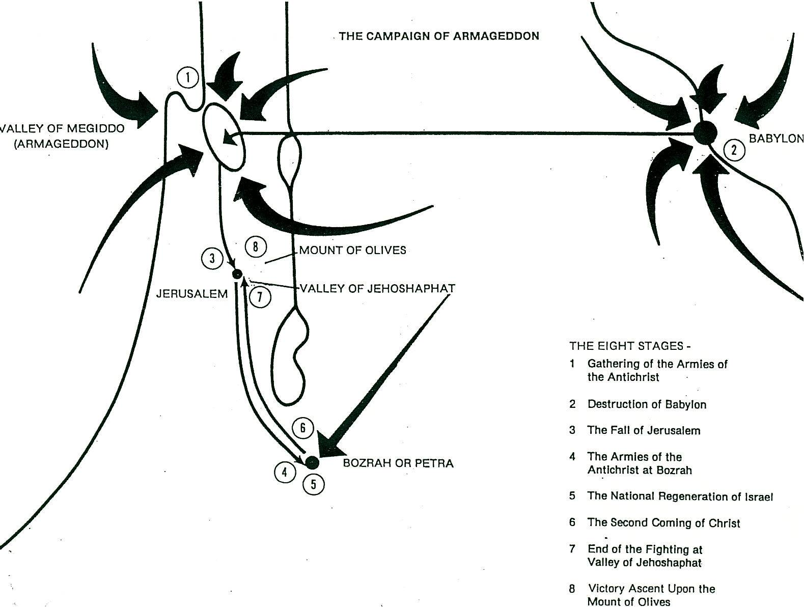
From Footsteps of the Messiah by Arnold Fruchtenbaum, used by permission
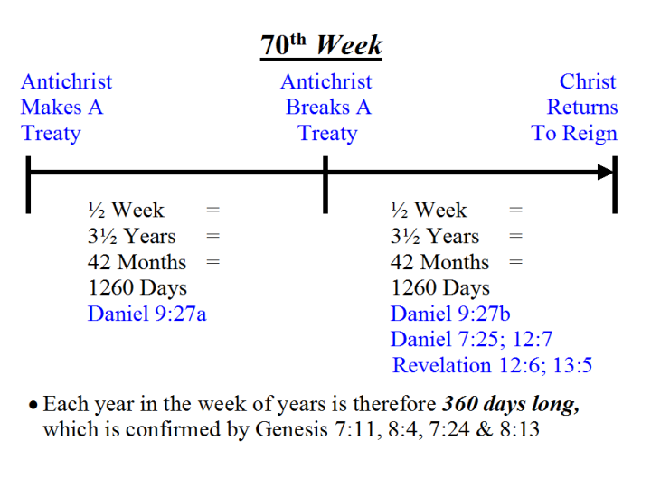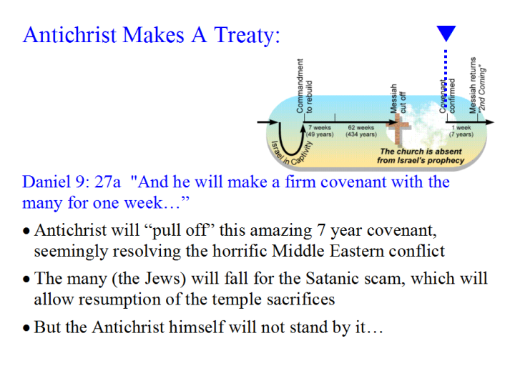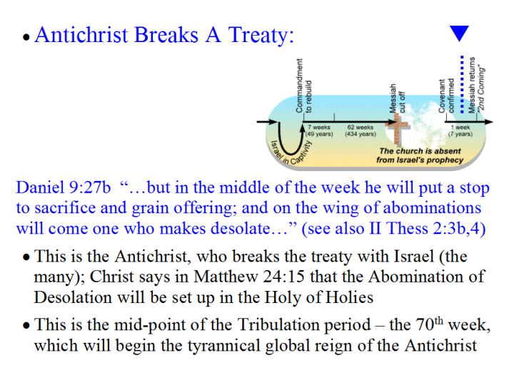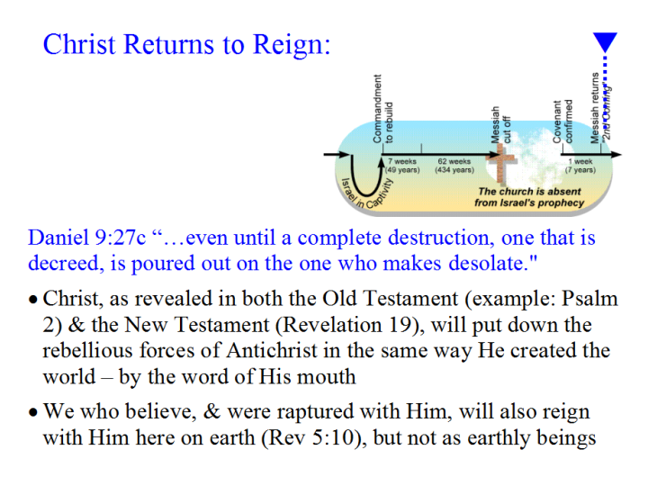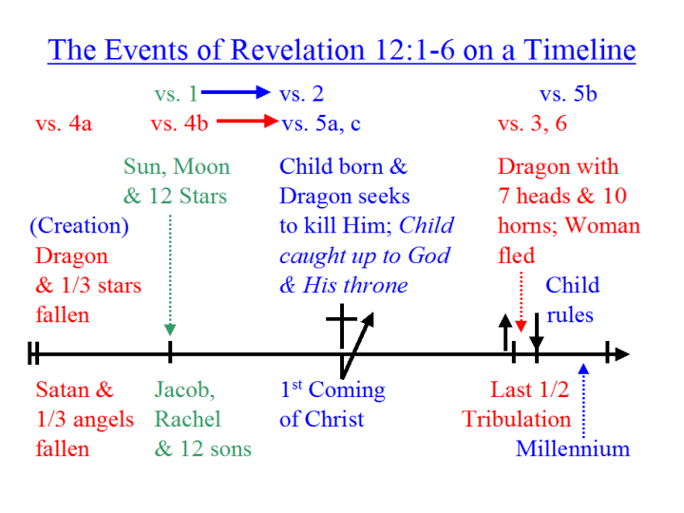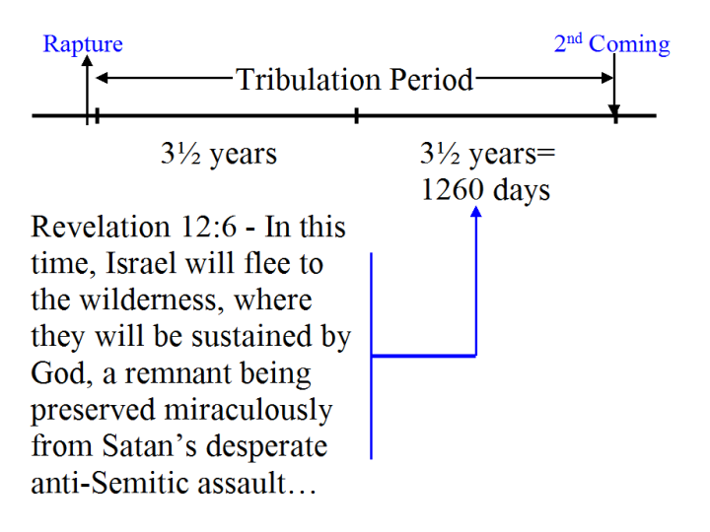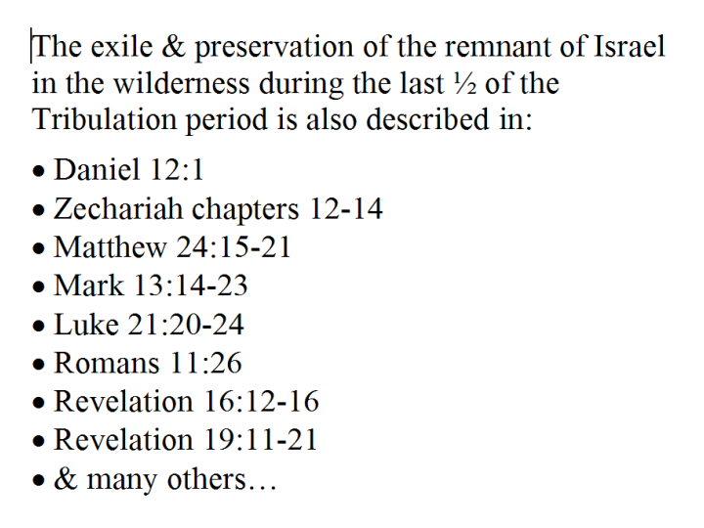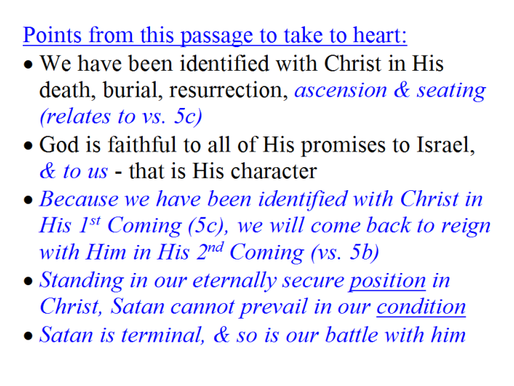

Genesis 37:9-10, “9 Now he had still another dream, and related it to his brothers, and said, "Lo, I have had still another dream; and behold, the sun and the moon and eleven stars were bowing down to me. 10 He related it to his father and to his brothers; and his father rebuked him and said to him, "What is this dream that you have had? Shall I and your mother and your brothers actually come to bow ourselves down before you to the ground?”
Job 38:4-7, “4 Where were you when I laid the foundation of the earth? Tell Me, if you have understanding, 5 who set its measurements? Since you know. Or who stretched the line on it? 6 "On what were its bases sunk? Or who laid its cornerstone, 7 when the morning stars sang together And all the sons of God shouted for joy?” [Note that in verse 7 the angels are called ‘stars’].

