Revelation 13:1-10 – A Beast From The Sea

Introducing… the beast

The coming of the beast to kill the two witnesses in Revelation chapter11 is the first
mention of the beast in Revelation. That marks the half way point in the Tribulation period. Starting with the events of chapter12, we find that these chapters up through Revelation 19 are describing the last half of the Tribulation period. Though we see the Antichrist beginning to gather power as the first of the four horsemen in Revelation chapter6, where he is the rider of the white horse, at the middle of the Tribulation period the antichrist begins to reveal his true character – his true nature. He kills the two witnesses. He desecrates the temple in Israel, breaks the covenant with Israel, and begins to reveal his true nature.

The Holy Trinity & The Unholy Trinity

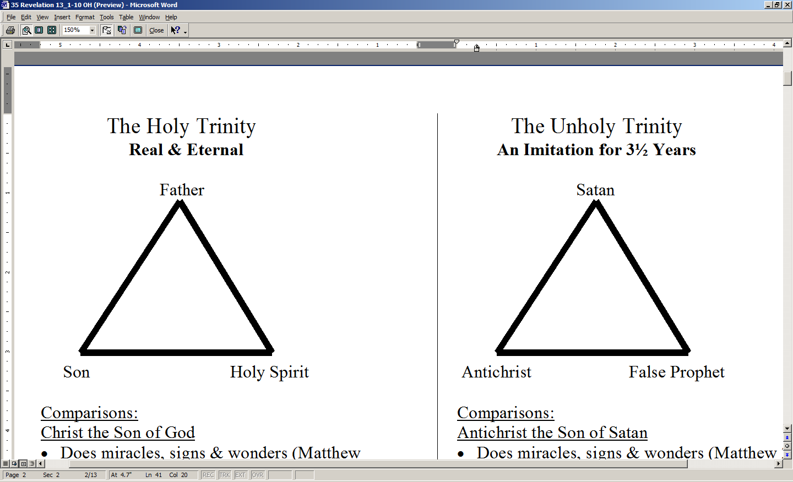

Above are two diagrams comparing the Holy Trinity, consisting of God the Father, God the Son and God the Holy Spirit, and the Unholy Trinity, consisting of Satan, the Antichrist, and the False Prophet. Notice that for each person of the Holy Trinity, there is a counterpart in the Unholy Trinity. These counterparts in the Unholy Trinity involve imitation of God in each person of the Trinity:

- As the Father sends the Son and Holy Spirit, Satan sends the Antichrist and the False Prophet.
- As the Holy Spirit directs us to Christ, so the False Prophet directs his followers to the Antichrist.
- Just as Christ receives His authority from the Father (John 17:1, 2) the Antichrist will get his authority from Satan (Revelation 13:4).

As we proceed through these chapters, we will no doubt see even more comparisons and contrasts between the Holy Trinity and the Unholy Trinity. Satan was introduced in Revelation chapter 12. Antichrist is the first beast, the beast from the sea, in Revelation 13:1-10. The false prophet is the second beast, the beast from the earth in Revelation 13:11-18.

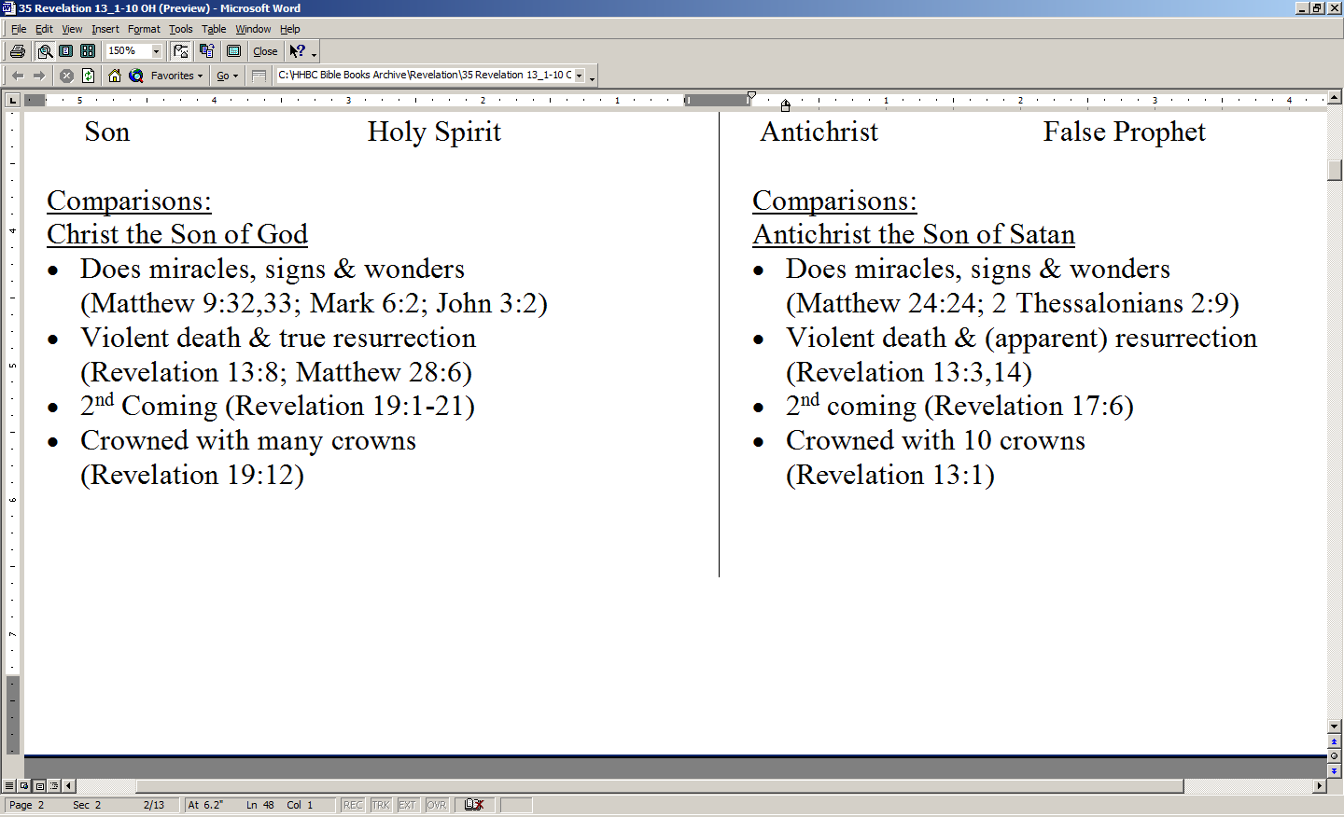

As shown in the above textbox, there are some direct comparisons that can be made between Christ and the Antichrist. There are things that are similar between Christ and the Antichrist, with certain obvious differences, of course. The reason for the similarities is that Satan has always desired to be like God – as revealed in Isaiah 14:14 and Ezekiel 28:6. But since Satan is an imposter, all he can do is mimic God. Regarding miracles, we’ve pointed out before that Christ performed miracles, in part, to validate in His first coming that He was and is the long-promised Messiah. Psalms and Isaiah both say the Messiah would heal the sick and the lame. The Antichrist appears to mimic the death and resurrection of Christ, and why doesn’t that surprise us? The things that were or will be characteristic of Christ’s first and second comings will characterize Satan’s attempt to mimic God in these last 3½ years of the Tribulation period – especially as relates to the Antichrist.

Just the same as there are comparisons, there are also contrasts between Christ and the Antichrist, and quite a number of these contrasts are listed on the accompanying supplement page. There are, in fact, too many contrasts for us to address in any detail this morning. Just to keep ourselves clear on these comparisons and contrasts, here is a brief definition of each that will help us understand better what is presented:

1) A comparison is a side-by-side view of things that are of the same category and have similar characteristics

2) A contrast is a side-by-side view of things that are of the same category but have markedly different characteristics

And now, a word about words:
We have used the word “Antichrist” to refer to this sinister personality who will surface during the Tribulation period, achieving temporary but overwhelming dominance during the last half of the Tribulation period. In truth, Antichrist is but one of the names of this diabolical being. Much of what we know about the antichrist comes from the book of Daniel, 2 Thessalonians chapter 2, and the book of Revelation.

The Antichrist is the first beast of Revelation chapter 13, and in the next several chapters of Revelation he will be referred to simply as “the Beast”, as he was in chapter 11 when he killed the two witnesses. The Greek prefix “anti” can mean either “against” or it can mean “instead of” or “in place of”. As we will see in this chapter, both of these meanings have significance, as this demonic trinity is there with the intent that they stand both against Christ – they are opposed to Him – and they seek to supplant or displace Christ – to replace Him.

One more point: The word which is translated “beast” here and elsewhere in Revelation is therion, meaning a “wild animal”. We’re not talking some cute cuddly furry little lap critter here. This is a beast…which would just as soon rip your guts out as look at you. That is why John uses this word. John wants us to know that this beast – this wild animal - is not tame, kindly, or looking out for the interests of any human being – he seeks his own interest – period! Any human being who gets in his way is dead meat – literally!

One of your supplements to this handout is a really great chart comparing Daniel chapter 7 with Revelation chapter 13. For the sake of time, we’ll leave it to you to dig deeper into these on your own. These have been important preliminaries, but enough of it – let’s turn our attention to the passage at hand

1 And the dragon stood on the sand of the seashore.
Then I saw a beast coming up out of the sea, having ten horns and seven heads, and on his horns were ten diadems, and on his heads were blasphemous names.

Now this verse is, in reality, a continuation of the last verse of Revelation chapter 12. John continues with the description of Satan, the devil, as “the dragon”. John is telling us that what follows is the dragon’s (that is, Satan’s) plan, for carrying out his attack against the Jews and believers in Christ. The scene that John paints for us with words is that of a seashore.

The Sea…Daniel 7:1-8

In the first year of Belshazzar king of Babylon Daniel saw a dream and visions in his mind as he lay on his bed; then he wrote the dream down and related the following summary of it. 2 Daniel said, "I was looking in my vision by night, and behold, the four winds of heaven were stirring up the great sea. 3 "And four great beasts were coming up from the sea, different from one another…

In verses 4-8, Daniel describes the four great Gentile world empires, all four being described as beasts coming from “the sea”. Then he describes the powerful leader of the final Gentile world empire: the Antichrist

The use of the picturesque word “sea” comes straight out of Daniel chapter 7. The word “sea” is used twice in Daniel chapter 7 for the Gentile world (that is, all those nations of people who are non-Jews, and it means the same here). Here the sea is pictured for us as the source of the first beast, the Antichrist. Now there have been diabolical men and even women over the centuries. Our minds might conjure up the names of Hitler, Rasputin, Herod the infant killer, Nero, Attilla the Hun, Idi Amin, and others. But those men, as evil as they were, were not like this one will be. This one will be far worse than them all.

John tells us that this beast has ten horns, seven heads and on the horns ten diadems. The ten horns are ten centers of power, as horns are uniformly a picture of power. We see the use of this word “horn” for power in the Old Testament prophets (see 16 Revelation – April 19, 2009 - Revelation 5:6-10 – page 4 of 6). To get the full background on where these ten horns, seven heads and ten diadems come from, we need to take a “rabbit-trail” into the book of Daniel and some related passages elsewhere:

(1) The leader of this confederation will make a seven-year covenant with Israel designed to give Israel protection in the land and solve the very volatile Israel-Arab dispute of the coveted land of Palestine (Daniel 9:27). This treaty begins Daniel’s 70th week, which we have come to call “the Tribulation period”.

- The white horse rider who conquers (gains control) by peace tactics, power politics, and by his charismatic personality and persuasive language, has already risen on the scene (see Revelation. 6:1-2; Daniel8:23-25; 1 Thessalonians 5:11f).

  - This brings about the ten nation confederation of Europe, a federation of nations that were once a part of the old Roman empire (see Daniel 2:42-44; 7:7-8, 20-24).
  - We have the potential for this in NATO and in the European Common Market – or it could take another form not currently in existence.

(3) Three kings of the confederacy rebel, but the rising dictator defeats them (Daniel 7:8, 20-25) and emerges as the leader.

Therefore, Antichrist (the Beast) is the head of ten crowned kings (ten horns and diadems*), which after the Antichrist’s suppression of a rebellion, is governed by seven leaders (seven heads*).

Revelation 13:1 finishes off with telling us that the heads of the beast have blasphemous names. For a name to be “blasphemous”, it must either speak against God or claim falsely to speak for God or to be God. Since we read here of “blasphemous names”, the meaning – which is confirmed by other context – is that the beast and his partners in crime will take on names of deity which belong to God Himself. Since this is a Satanic and Unholy Trinity, why should that surprise us?

2 And the beast which I saw was like a leopard, and his feet were like those of a bear, and his mouth like the mouth of a lion. And the dragon gave him his power and his throne and great authority.

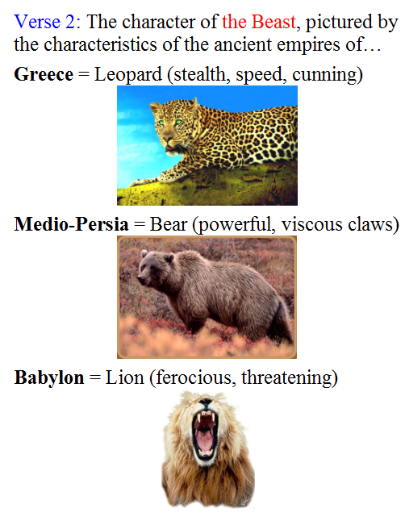
Now John begins to describe the Beast for us – this Antichrist. In doing so, John uses the images which come directly from the book of Daniel. In Daniel chapter 7 which we referred before, Daniel describes for us the kingdoms of the ancient world:

- Like Greece: like a leopard in its stealth, speed and cunning

- Like Medio-Persia: like a the feet of a bear – one swipe and you’re out of commission

- Like Babylon: like the mouth of a lion – one well –placed bite and you’re dead.

Notice this: the dragon (that is, Satan himself) is the one who gives the Antichrist his power and throne – his position - and his authority. This being is sold out to Satan. Satan is the one who empowers this Antichrist – the Beast.

Have you ever talked with someone, and in talking with him you soon figure out he is willing to pay any price, including at your expense, to get his way and maintain control? The Antichrist will be like that, only he will be gaining global control. He will stop at nothing to control the entire world. No price will be too much for him. He will sell out to Satan 100% to do it, and Satan will empower him.

3 I saw one of his heads as if it had been slain, and his fatal wound was healed. And the whole earth was amazed and followed after the beast;
4 they worshiped the dragon because he gave his authority to the beast; and they worshiped the beast, saying, "Who is like the beast, and who is able to wage war with him?"
In Revelation 13:3 we see that this Antichrist – the Beast - appears to carry out something like a death and resurrection. That is just one more way in which Satan carries out an imitation of what Christ has done in His death and resurrection. We’ll see evidence of this again in verse 14.

This display of apparently miraculous power will impress the world. Do you see that at the end of Revelation 13:3? It is not just some percentage of the world who is taken with the Beast, but the whole world will be amazed and follow after the Beast.

Verse 4 tells us what will be the result of the Beast’s impressive power and authority and now his apparent resurrection power. People will worship Satan, the one who gives authority and power to the Beast. People will worship the Beast, because his political and persuasive and authoritative and now miraculous power will be so very overwhelmingly impressive! Wow! Who on earth can hold a candle to this guy? He is going to get it together and he is going to hold it together and nobody can stop him!

And then there will be one-world religion. A person can have any doctrine he wants - even celebrate doctrinal diversity if he likes, so long as it makes room for worship of the Beast. One can have whatever practices he wants, so long as it exalts the Beast. One can even name Christ, as long as he recognizes that the Beast is Christ. The pressure to conform will be beyond imagination.

5 There was given to him a mouth speaking arrogant words and blasphemies, and authority to act for forty-two months was given to him.

We’ve already seen the word ‘blasphemies’. Now we see it described and underscored. The God of heaven will be denied and reviled. The god of the Beast – Satan – will take on the name and authority of God. This Beast will speak as if he were the last line of authority on planet earth – even the universe! But as we have seen before, his time of authority will be 42 months.

6 And he opened his mouth in blasphemies against God, to blaspheme His name and His tabernacle, that is, those who dwell in heaven.

This is giving us further explanation of the character of this ghastly Beast. He blasphemes God as if there were no consequences. He acts as if he were God and the God of heaven cannot touch him. However, take note of the last half of verse 6:

- He blasphemes those who dwell in heaven. Think of those who will dwell in heaven at this point in time- the last ½ of the Tribulation.
- He blasphemes God, of course, and we’ve seen that.
- He blasphemes the very angels who cast out Satan and his angels.
- He blasphemes the church – including us.

These include those whom Satan has failed to keep from God’s salvation.
7 It was also given to him to make war with the saints and to overcome them, and authority over every tribe and people and tongue and nation was given to him.

It was also allowed that the Beast (this object of the one-world religion) would initiate a major offensive against those who believe. This is not in reference to the church believers of this present age, since they have been taken out to be with Christ. But it does refer to saints, which is a name applied to all those who believe of all time – even in the Old Testament times. You will find the word “saints” in the Old Testament, and all throughout the New Testament. But the word “church” does not occur in all of the chapters that take place in and describe the Tribulation period (that is, Revelation chapters 6-19). Tribulation saints are a major target, and will stand out in that they will refuse to join in with the one-world religion that is taking shape quickly in this time.

The fact that after mentioning the word church or churches about 20X in the 1st 3 chapters of Revelation, John here writes “saints” is just one more indication that the church is not on the earth at this time.

Then we see reference to a phrase that indicates the Beast’s reach will be global indeed:
Every tribe, every people, every tongue, and every nation.

8 All who dwell on the earth will worship him, everyone whose name has not been written in the book of life of the Lamb who has been slain from the foundation of the world.

Here we see a great dividing line. There is a great mass of humanity, and these are the ones “who dwell on the earth”. We’ve noted before that this phrase shows up only in the Tribulation chapters of Revelation (chapters 6-19). “Those who dwell on the earth” is a Tribulation–specific phrase. The only exception to that is where the church is promised in Revelation 3:10:

"Because you have kept the word of My perseverance, I also will keep you from the hour of testing, that hour which is about to come upon the whole world, to test those who dwell on the earth.

The Tribulation-Specific Phrase:
“…those who dwell on the earth”

Prior to the Tribulation: Revelation 3:10 (see above)
__________________________________________________

During the Tribulation: Revelation 6:10
Revelation 8:13
Revelation 11:10
Revelation 13:8
Revelation 13:14
Revelation 17:2
Revelation 17:8
These who dwell on the earth will worship the Beast. Then the dividing line is made.
These are the ones whose names are not written in the book of life. We will not have time now to take a closer look at the “book of life”, but fortunately for us this subject will come up again in chapters 17, 20 and 21, so we will get a chance to look at that subject later if the Lord does not take us all home first.

What this verse does lay out is that the Lamb – Christ - has been slain from the foundation of the world. Christ’s sacrifice on our behalf was established from the foundation of the world. It was implemented in history when He was slain under Pontius Pilate. It was made effective in our personal history when we believed. It is being made reality in our daily lives as we take God at His word that we have been identified with Christ in that death. It will be totally fulfilled when the Lord takes us home to be with Him, when our condition is consistent with our position: totally and permanently.

9 If anyone has an ear, let him hear.

We should take careful note of something:
- When John was writing by the Lord’s inspiration to the seven churches in chapters 2 and 3, seven he wrote, “he who has an ear, let him hear what the Spirit says to the churches”.
- Now that John is writing about the Tribulation period, what does he write? “If anyone has an ear, let him hear”.

Do you see the difference? With the churches he uses the word “churches” and what he says assumes that there are those who have an ear. Now that we are reading about the Tribulation period, the appeal to the churches drops out, and we no longer read of “he who has an ear”, but rather, “if anyone has an ear…”. Why the change is the wording? The church is not present at this time. The church has been raptured.

10 If anyone is destined for captivity, to captivity he goes; if anyone kills with the sword, with the sword he must be killed. Here is the perseverance and the faith of the saints.

When we first read this verse, it sounds as if it is fatalistic…as if nobody could ever change. It sounds like whatever will happen will happen. But if we examine this verse very carefully, we find that it is saying that people will reap what they sow. The one who, as an instrument of the Beast, is carrying out captivity and death sentences will himself reap the consequences. For Tribulation saints, this verse points out that God is a God of justice, and the terrible inequities brought against the Tribulation saints are not to be seen as having no consequences: one way or another, the Tribulation saints will see the consequences of their actions brought back to them.

From an eternal standpoint, there is no injustice. God deals with every injustice…every one. That’s important for us to take to heart as well. Many of us have had injustices done to us or someone we love. We may have committed an injustice to someone else. Both those can be hard to live with…sometimes real hard.
What about those injustices? In the eternal picture, there is not a single unreconciled injustice. Every injustice will be repaid in this life, in the Lake of Fire, or on the cross, because God is a God who demands total and absolute justice, by His character. God can even grant mercy for injustices we have committed, thanks to the cross of Calvary. Even in our own lives, has not the Lord taken the penalty for sin upon Himself in satisfaction of the justice of God?

So now we have a ten verse introduction to the Beast - the Antichrist, but we are not done with this fellow. There are more verses and chapters yet to go which elaborate on his character and actions, and his spiritual and moral atrocities. So, what is a believer to do?
What is a believer to think? Should we go about trying our very best to figure out who this man is? Should we pour our daily energies into understanding his character and his diabolical schemes? Should we stock up on weapons and essentials so as to stand our ground against this despicably wicked and tyrannical and cruel man? Should we be looking feverishly for the Antichrist? No. Paul wrote this to Titus:

Titus 2:11-14
For the grace of God has appeared, bringing salvation to all men, 12 instructing us to deny ungodliness and worldly desires and to live sensibly, righteously and godly in the present age, 13 looking for the blessed hope and the appearing of the glory of our great God and Savior, Christ Jesus, 14 who gave Himself for us to redeem us from every lawless deed, and to purify for Himself a people for His own possession, zealous for good deeds.
________________________________________________________________________

Philippians 3:20-21
For our citizenship is in heaven, from which also we eagerly wait for a Savior, the Lord Jesus Christ; 21 who will transform the body of our humble state into conformity with the body of His glory, by the exertion of the power that He has even to subject all things to Himself.

